Factors Report 20080102-20161230

**1. alpha_135**

**截面指标累计曲线:**

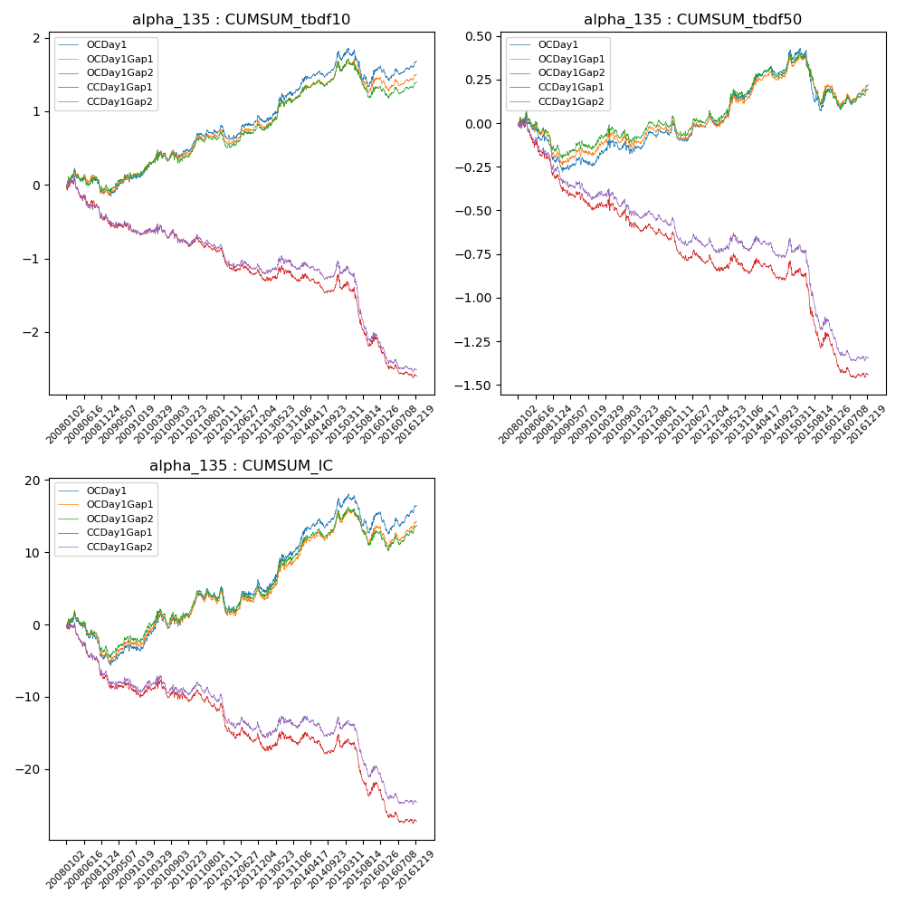

**因子换手率:** 10.54%

**截面指标_OCDay1:**

|  |  |  |  |  |  |  |  |  |
| --- | --- | --- | --- | --- | --- | --- | --- | --- |
| year | annret_tbdf10 | sharpe_tbdf10 | maxdd_tbdf10 | annret_tbdf50 | sharpe_tbdf50 | maxdd_tbdf50 | mean_IC | tstat_IC |
| 2008 | -0.07 | -0.36 | -0.29 | -0.2 | -2.18 | -0.25 | -0.02 | -2.01 |
| 2009 | 0.26 | 1.6 | -0.1 | -0.02 | -0.23 | -0.09 | 0.01 | 0.93 |
| 2010 | 0.27 | 1.29 | -0.13 | 0.08 | 0.8 | -0.1 | 0.02 | 1.49 |
| 2011 | 0.34 | 2.64 | -0.06 | 0.13 | 2.2 | -0.04 | 0.02 | 2.15 |
| 2012 | 0.11 | 0.74 | -0.17 | 0.02 | 0.33 | -0.1 | 0.0 | 0.09 |
| 2013 | 0.42 | 2.06 | -0.1 | 0.17 | 1.86 | -0.04 | 0.02 | 2.45 |
| 2014 | 0.51 | 3.18 | -0.08 | 0.23 | 2.88 | -0.05 | 0.03 | 3.28 |
| 2015 | -0.26 | -0.98 | -0.42 | -0.24 | -1.9 | -0.3 | -0.01 | -0.94 |
| 2016 | 0.12 | 0.97 | -0.19 | 0.04 | 0.6 | -0.12 | 0.01 | 0.82 |

**截面指标_CCDay1Gap1:**

|  |  |  |  |  |  |  |  |  |
| --- | --- | --- | --- | --- | --- | --- | --- | --- |
| year | annret_tbdf10 | sharpe_tbdf10 | maxdd_tbdf10 | annret_tbdf50 | sharpe_tbdf50 | maxdd_tbdf50 | mean_IC | tstat_IC |
| 2008 | -0.45 | -2.0 | -0.45 | -0.3 | -3.11 | -0.29 | -0.03 | -3.68 |
| 2009 | -0.18 | -1.12 | -0.24 | -0.17 | -2.32 | -0.19 | -0.01 | -1.19 |
| 2010 | -0.1 | -0.46 | -0.24 | -0.1 | -0.91 | -0.16 | -0.0 | -0.1 |
| 2011 | -0.16 | -1.24 | -0.19 | -0.07 | -1.16 | -0.1 | -0.01 | -1.19 |
| 2012 | -0.34 | -2.26 | -0.31 | -0.17 | -2.5 | -0.16 | -0.02 | -2.67 |
| 2013 | -0.09 | -0.42 | -0.2 | -0.05 | -0.5 | -0.11 | 0.0 | 0.02 |
| 2014 | 0.06 | 0.34 | -0.23 | 0.05 | 0.53 | -0.12 | 0.0 | 0.48 |
| 2015 | -0.88 | -3.35 | -0.63 | -0.44 | -3.17 | -0.39 | -0.03 | -2.92 |
| 2016 | -0.47 | -3.73 | -0.4 | -0.2 | -3.34 | -0.2 | -0.02 | -3.44 |

**风格暴露:**

|  |  |  |  |  |
| --- | --- | --- | --- | --- |
|  | long | short | corr_OCDay1 | corr_CCDay1Gap1 |
| liquidity10 | -0.72 | 0.73 | 0.46 | 0.43 |
| liquidity20 | -0.76 | 0.77 | 0.45 | 0.42 |
| liquidity5 | -0.63 | 0.64 | 0.46 | 0.43 |
| logmktcap | -0.0 | 0.01 | -0.05 | -0.04 |
| momentum15 | -1.04 | 1.04 | 0.63 | 0.63 |
| momentum30 | -2.06 | 2.06 | 0.88 | 0.9 |
| momentum5 | -0.11 | 0.12 | 0.25 | 0.25 |
| retvolatility30 | -0.72 | 0.73 | 0.37 | 0.32 |