Factors Report 20080102-20161230

**1. alpha_189**

**截面指标累计曲线:**

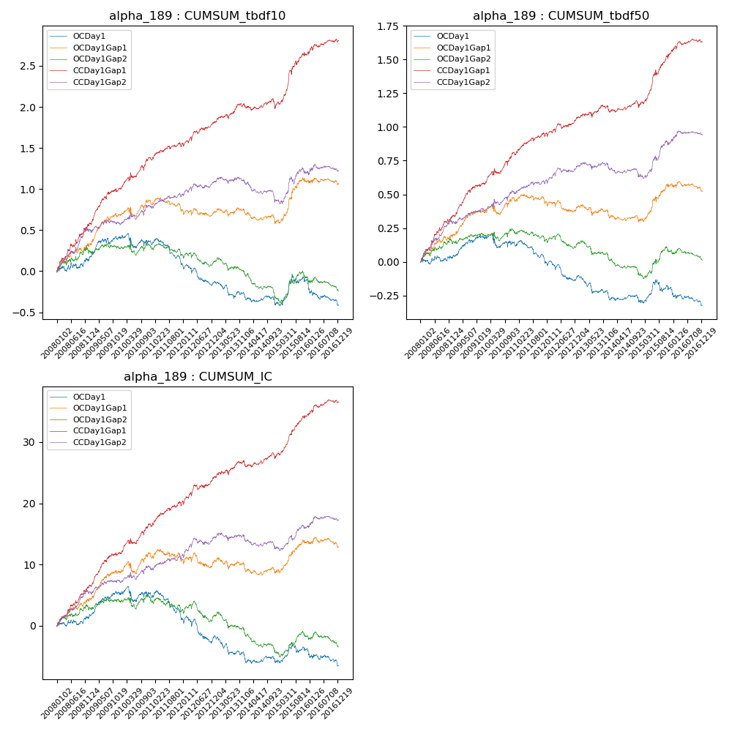

**因子换手率:** 49.04%

**截面指标_OCDay1:**

|  |  |  |  |  |  |  |  |  |
| --- | --- | --- | --- | --- | --- | --- | --- | --- |
| year | annret_tbdf10 | sharpe_tbdf10 | maxdd_tbdf10 | annret_tbdf50 | sharpe_tbdf50 | maxdd_tbdf50 | mean_IC | tstat_IC |
| 2008 | 0.13 | 0.96 | -0.07 | 0.03 | 0.41 | -0.04 | 0.01 | 0.92 |
| 2009 | 0.29 | 2.59 | -0.07 | 0.16 | 2.8 | -0.03 | 0.02 | 3.05 |
| 2010 | -0.07 | -0.52 | -0.17 | -0.06 | -0.79 | -0.1 | -0.0 | -0.21 |
| 2011 | -0.26 | -2.89 | -0.28 | -0.13 | -2.44 | -0.16 | -0.02 | -2.6 |
| 2012 | -0.24 | -2.56 | -0.24 | -0.11 | -2.01 | -0.14 | -0.01 | -2.04 |
| 2013 | -0.15 | -1.57 | -0.19 | -0.13 | -2.27 | -0.13 | -0.01 | -2.17 |
| 2014 | -0.1 | -1.17 | -0.12 | -0.06 | -1.22 | -0.06 | -0.0 | -0.91 |
| 2015 | 0.3 | 2.18 | -0.11 | 0.11 | 1.34 | -0.09 | 0.01 | 1.55 |
| 2016 | -0.32 | -2.88 | -0.28 | -0.14 | -2.31 | -0.13 | -0.01 | -2.13 |

**截面指标_CCDay1Gap1:**

|  |  |  |  |  |  |  |  |  |
| --- | --- | --- | --- | --- | --- | --- | --- | --- |
| year | annret_tbdf10 | sharpe_tbdf10 | maxdd_tbdf10 | annret_tbdf50 | sharpe_tbdf50 | maxdd_tbdf50 | mean_IC | tstat_IC |
| 2008 | 0.56 | 4.17 | -0.05 | 0.33 | 5.21 | -0.02 | 0.03 | 5.03 |
| 2009 | 0.45 | 4.5 | -0.04 | 0.25 | 4.45 | -0.02 | 0.02 | 4.61 |
| 2010 | 0.36 | 3.01 | -0.06 | 0.21 | 2.96 | -0.04 | 0.02 | 2.94 |
| 2011 | 0.19 | 2.31 | -0.05 | 0.16 | 3.24 | -0.03 | 0.02 | 3.23 |
| 2012 | 0.25 | 2.83 | -0.05 | 0.12 | 2.26 | -0.04 | 0.02 | 2.91 |
| 2013 | 0.21 | 2.3 | -0.05 | 0.07 | 1.25 | -0.04 | 0.01 | 1.83 |
| 2014 | 0.01 | 0.1 | -0.12 | 0.03 | 0.57 | -0.05 | 0.0 | 1.12 |
| 2015 | 0.63 | 4.43 | -0.05 | 0.39 | 4.75 | -0.04 | 0.03 | 5.38 |
| 2016 | 0.16 | 1.73 | -0.04 | 0.08 | 1.49 | -0.03 | 0.01 | 1.93 |

**风格暴露:**

|  |  |  |  |  |
| --- | --- | --- | --- | --- |
|  | long | short | corr_OCDay1 | corr_CCDay1Gap1 |
| liquidity10 | 0.25 | -0.24 | -0.28 | -0.16 |
| liquidity20 | 0.12 | -0.12 | -0.21 | -0.11 |
| liquidity5 | 0.39 | -0.38 | -0.33 | -0.2 |
| logmktcap | 0.08 | -0.08 | -0.04 | -0.11 |
| momentum15 | 0.79 | -0.79 | -0.51 | -0.5 |
| momentum30 | 0.61 | -0.61 | -0.46 | -0.43 |
| momentum5 | 0.83 | -0.82 | -0.44 | -0.4 |
| retvolatility30 | 0.14 | -0.13 | -0.19 | -0.06 |