Factors Report 20080102-20161230

**1. lfx-2**

**截面指标累计曲线:**

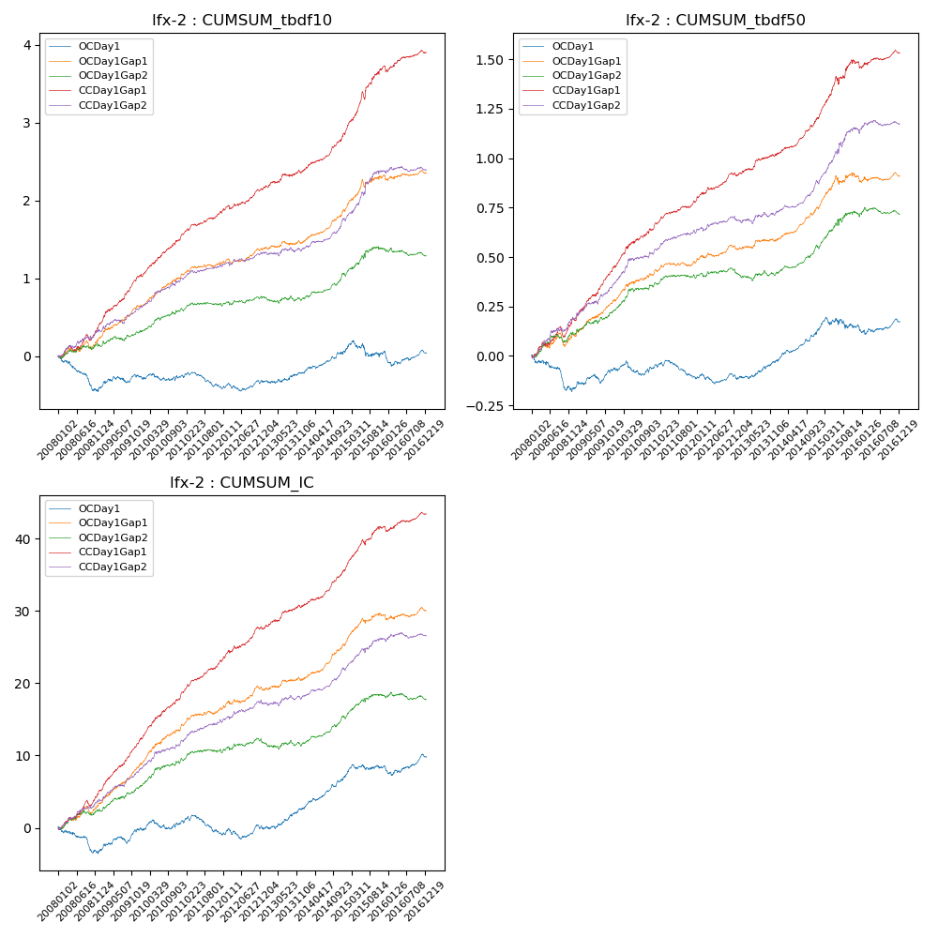

**因子换手率:** 68.55%

**截面指标_OCDay1:**

|  |  |  |  |  |  |  |  |  |
| --- | --- | --- | --- | --- | --- | --- | --- | --- |
| year | annret_tbdf10 | sharpe_tbdf10 | maxdd_tbdf10 | annret_tbdf50 | sharpe_tbdf50 | maxdd_tbdf50 | mean_IC | tstat_IC |
| 2008 | -0.41 | -3.79 | -0.38 | -0.16 | -3.09 | -0.17 | -0.01 | -2.92 |
| 2009 | 0.15 | 1.59 | -0.08 | 0.1 | 2.55 | -0.05 | 0.01 | 3.15 |
| 2010 | 0.01 | 0.07 | -0.09 | 0.01 | 0.24 | -0.07 | 0.0 | 0.75 |
| 2011 | -0.16 | -2.2 | -0.2 | -0.06 | -1.95 | -0.09 | -0.01 | -1.81 |
| 2012 | 0.1 | 1.25 | -0.1 | -0.0 | -0.05 | -0.05 | 0.0 | 0.88 |
| 2013 | 0.12 | 1.3 | -0.04 | 0.09 | 2.66 | -0.01 | 0.01 | 2.89 |
| 2014 | 0.27 | 3.17 | -0.04 | 0.15 | 4.62 | -0.01 | 0.02 | 4.85 |
| 2015 | -0.0 | -0.03 | -0.2 | 0.02 | 0.34 | -0.06 | 0.01 | 1.33 |
| 2016 | -0.02 | -0.16 | -0.17 | 0.02 | 0.61 | -0.04 | 0.01 | 1.45 |

**截面指标_CCDay1Gap1:**

|  |  |  |  |  |  |  |  |  |
| --- | --- | --- | --- | --- | --- | --- | --- | --- |
| year | annret_tbdf10 | sharpe_tbdf10 | maxdd_tbdf10 | annret_tbdf50 | sharpe_tbdf50 | maxdd_tbdf50 | mean_IC | tstat_IC |
| 2008 | 0.41 | 3.81 | -0.08 | 0.19 | 3.64 | -0.05 | 0.02 | 5.28 |
| 2009 | 0.63 | 6.62 | -0.02 | 0.27 | 6.6 | -0.01 | 0.03 | 7.8 |
| 2010 | 0.51 | 5.69 | -0.03 | 0.21 | 4.99 | -0.01 | 0.03 | 6.25 |
| 2011 | 0.31 | 4.58 | -0.03 | 0.12 | 4.17 | -0.01 | 0.02 | 5.96 |
| 2012 | 0.3 | 3.83 | -0.05 | 0.13 | 4.0 | -0.02 | 0.02 | 4.65 |
| 2013 | 0.24 | 2.6 | -0.04 | 0.11 | 3.14 | -0.01 | 0.01 | 3.47 |
| 2014 | 0.47 | 6.04 | -0.02 | 0.18 | 5.62 | -0.01 | 0.02 | 6.17 |
| 2015 | 0.86 | 5.83 | -0.1 | 0.29 | 4.55 | -0.04 | 0.02 | 5.74 |
| 2016 | 0.19 | 2.09 | -0.07 | 0.05 | 1.25 | -0.03 | 0.01 | 2.16 |

**风格暴露:**

|  |  |  |  |  |
| --- | --- | --- | --- | --- |
|  | long | short | corr_OCDay1 | corr_CCDay1Gap1 |
| liquidity10 | 0.01 | -0.01 | 0.22 | 0.17 |
| liquidity20 | 0.03 | -0.02 | 0.22 | 0.16 |
| liquidity5 | -0.02 | 0.03 | 0.21 | 0.17 |
| logmktcap | -0.03 | 0.04 | -0.19 | -0.16 |
| momentum15 | -0.14 | 0.15 | -0.03 | 0.03 |
| momentum30 | -0.11 | 0.12 | -0.01 | 0.02 |
| momentum5 | -0.22 | 0.22 | -0.09 | -0.04 |
| retvolatility30 | 0.0 | 0.0 | 0.24 | 0.17 |