Factors Report 20080102-20161230

**1. lfx-4**

**截面指标累计曲线:**

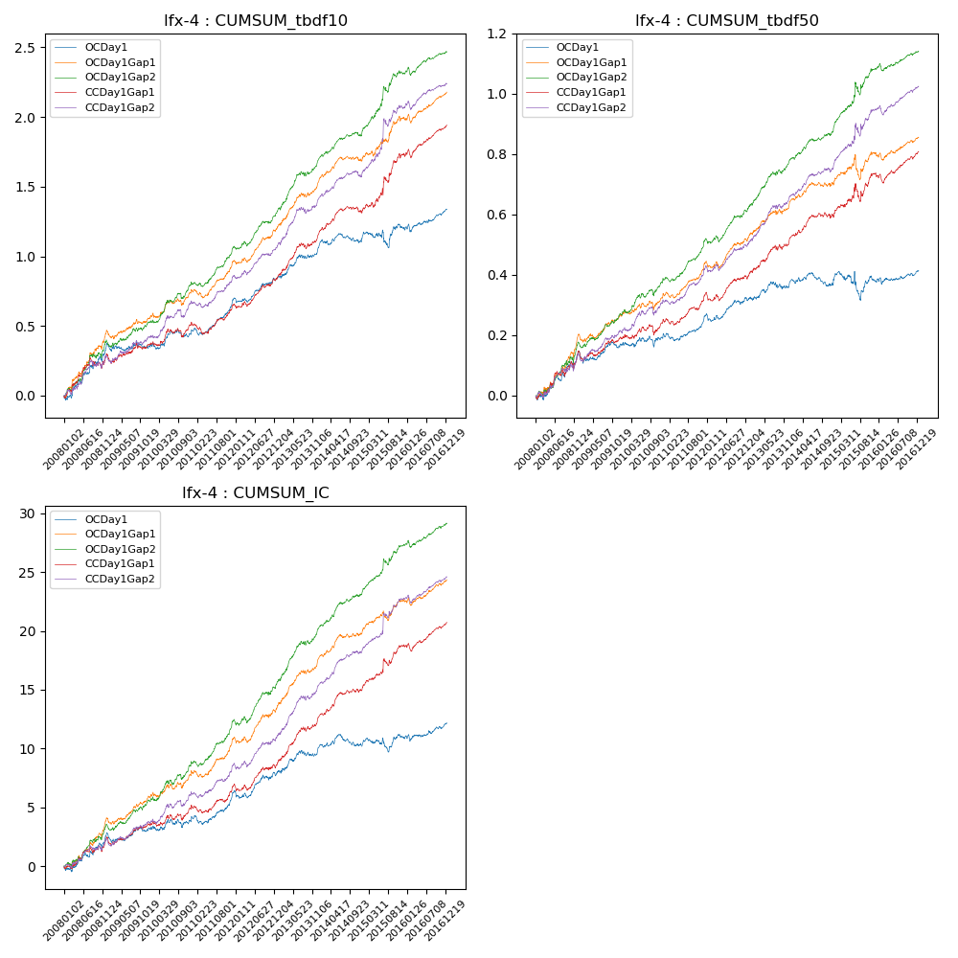

**因子换手率:** 38.57%

**截面指标_OCDay1:**

|  |  |  |  |  |  |  |  |  |
| --- | --- | --- | --- | --- | --- | --- | --- | --- |
| year | annret_tbdf10 | sharpe_tbdf10 | maxdd_tbdf10 | annret_tbdf50 | sharpe_tbdf50 | maxdd_tbdf50 | mean_IC | tstat_IC |
| 2008 | 0.37 | 3.69 | -0.04 | 0.15 | 3.26 | -0.03 | 0.01 | 3.17 |
| 2009 | -0.02 | -0.3 | -0.06 | 0.02 | 0.69 | -0.04 | 0.0 | 0.53 |
| 2010 | 0.12 | 1.55 | -0.06 | 0.04 | 1.0 | -0.04 | 0.0 | 1.13 |
| 2011 | 0.23 | 4.36 | -0.05 | 0.07 | 2.66 | -0.02 | 0.01 | 3.17 |
| 2012 | 0.14 | 2.68 | -0.03 | 0.05 | 1.75 | -0.03 | 0.01 | 1.91 |
| 2013 | 0.23 | 3.38 | -0.03 | 0.06 | 1.86 | -0.02 | 0.01 | 2.68 |
| 2014 | 0.04 | 0.73 | -0.07 | -0.01 | -0.5 | -0.04 | 0.0 | 0.25 |
| 2015 | 0.11 | 0.96 | -0.12 | 0.01 | 0.21 | -0.09 | 0.0 | 0.8 |
| 2016 | 0.13 | 2.29 | -0.06 | 0.03 | 1.4 | -0.02 | 0.01 | 1.92 |

**截面指标_CCDay1Gap1:**

|  |  |  |  |  |  |  |  |  |
| --- | --- | --- | --- | --- | --- | --- | --- | --- |
| year | annret_tbdf10 | sharpe_tbdf10 | maxdd_tbdf10 | annret_tbdf50 | sharpe_tbdf50 | maxdd_tbdf50 | mean_IC | tstat_IC |
| 2008 | 0.29 | 2.94 | -0.08 | 0.15 | 3.3 | -0.03 | 0.01 | 2.92 |
| 2009 | 0.07 | 1.1 | -0.06 | 0.04 | 1.45 | -0.03 | 0.0 | 1.7 |
| 2010 | 0.15 | 2.02 | -0.06 | 0.06 | 1.62 | -0.03 | 0.01 | 1.94 |
| 2011 | 0.14 | 2.43 | -0.07 | 0.1 | 3.69 | -0.02 | 0.01 | 2.91 |
| 2012 | 0.19 | 3.43 | -0.03 | 0.06 | 1.95 | -0.03 | 0.01 | 2.33 |
| 2013 | 0.33 | 4.87 | -0.04 | 0.13 | 3.91 | -0.02 | 0.02 | 5.29 |
| 2014 | 0.16 | 3.0 | -0.04 | 0.07 | 2.72 | -0.02 | 0.01 | 3.72 |
| 2015 | 0.41 | 3.35 | -0.05 | 0.14 | 2.26 | -0.06 | 0.02 | 3.47 |
| 2016 | 0.21 | 4.03 | -0.06 | 0.08 | 3.11 | -0.03 | 0.01 | 3.51 |

**风格暴露:**

|  |  |  |  |  |
| --- | --- | --- | --- | --- |
|  | long | short | corr_OCDay1 | corr_CCDay1Gap1 |
| liquidity10 | -0.01 | 0.02 | 0.01 | -0.03 |
| liquidity20 | -0.02 | 0.03 | -0.0 | -0.02 |
| liquidity5 | -0.0 | 0.01 | 0.01 | -0.04 |
| logmktcap | 0.09 | -0.09 | 0.12 | 0.05 |
| momentum15 | -0.05 | 0.05 | 0.15 | 0.07 |
| momentum30 | -0.02 | 0.02 | 0.18 | 0.09 |
| momentum5 | -0.05 | 0.06 | 0.08 | 0.04 |
| retvolatility30 | 0.03 | -0.02 | 0.05 | 0.03 |