Factors Report 20080102-20161230

**1. lfx-5**

**截面指标累计曲线:**

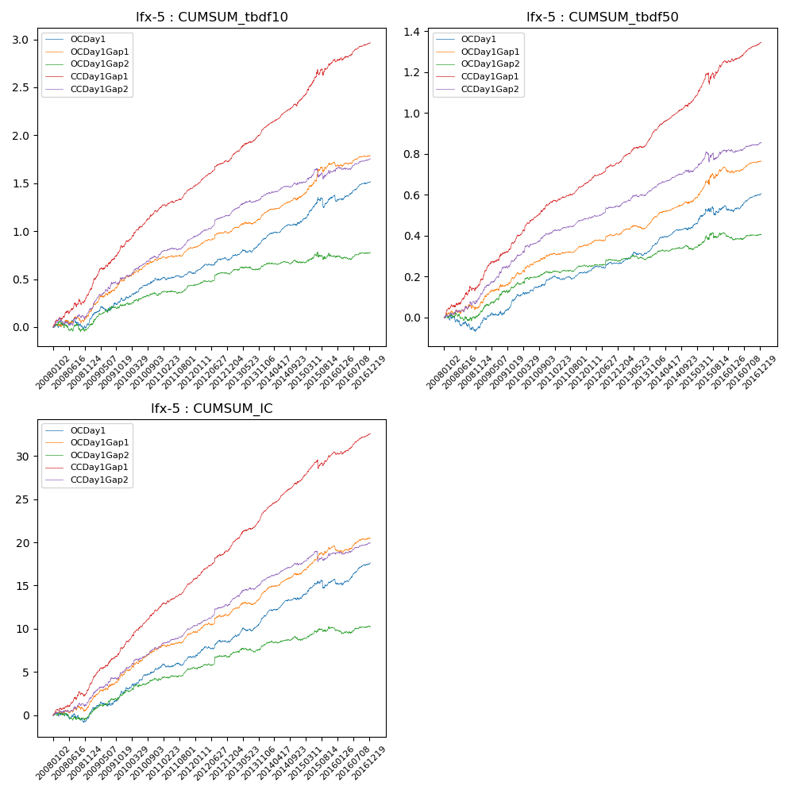

**因子换手率:** 39.37%

**截面指标_OCDay1:**

|  |  |  |  |  |  |  |  |  |
| --- | --- | --- | --- | --- | --- | --- | --- | --- |
| year | annret_tbdf10 | sharpe_tbdf10 | maxdd_tbdf10 | annret_tbdf50 | sharpe_tbdf50 | maxdd_tbdf50 | mean_IC | tstat_IC |
| 2008 | 0.02 | 0.25 | -0.11 | -0.05 | -1.17 | -0.08 | -0.0 | -0.37 |
| 2009 | 0.26 | 3.29 | -0.05 | 0.14 | 3.88 | -0.02 | 0.01 | 3.67 |
| 2010 | 0.21 | 3.57 | -0.02 | 0.1 | 3.46 | -0.01 | 0.01 | 4.12 |
| 2011 | 0.08 | 1.73 | -0.03 | 0.03 | 1.78 | -0.02 | 0.01 | 2.54 |
| 2012 | 0.14 | 3.11 | -0.03 | 0.05 | 2.17 | -0.01 | 0.01 | 2.81 |
| 2013 | 0.22 | 4.25 | -0.03 | 0.1 | 4.47 | -0.02 | 0.01 | 5.06 |
| 2014 | 0.16 | 3.46 | -0.02 | 0.08 | 3.56 | -0.01 | 0.01 | 3.83 |
| 2015 | 0.28 | 2.85 | -0.11 | 0.1 | 2.19 | -0.04 | 0.01 | 2.39 |
| 2016 | 0.16 | 2.73 | -0.05 | 0.06 | 2.58 | -0.03 | 0.01 | 3.29 |

**截面指标_CCDay1Gap1:**

|  |  |  |  |  |  |  |  |  |
| --- | --- | --- | --- | --- | --- | --- | --- | --- |
| year | annret_tbdf10 | sharpe_tbdf10 | maxdd_tbdf10 | annret_tbdf50 | sharpe_tbdf50 | maxdd_tbdf50 | mean_IC | tstat_IC |
| 2008 | 0.34 | 3.48 | -0.06 | 0.16 | 3.28 | -0.02 | 0.01 | 3.46 |
| 2009 | 0.5 | 6.34 | -0.02 | 0.21 | 5.9 | -0.01 | 0.02 | 6.74 |
| 2010 | 0.39 | 6.61 | -0.02 | 0.19 | 6.49 | -0.01 | 0.02 | 7.32 |
| 2011 | 0.23 | 5.72 | -0.02 | 0.09 | 4.77 | -0.01 | 0.01 | 6.92 |
| 2012 | 0.27 | 6.19 | -0.02 | 0.11 | 5.28 | -0.01 | 0.01 | 5.96 |
| 2013 | 0.35 | 7.19 | -0.01 | 0.16 | 7.04 | -0.01 | 0.02 | 7.96 |
| 2014 | 0.29 | 6.25 | -0.02 | 0.13 | 6.15 | -0.01 | 0.01 | 7.33 |
| 2015 | 0.42 | 3.89 | -0.07 | 0.2 | 3.42 | -0.06 | 0.01 | 3.47 |
| 2016 | 0.18 | 3.61 | -0.03 | 0.09 | 4.06 | -0.01 | 0.01 | 4.11 |

**风格暴露:**

|  |  |  |  |  |
| --- | --- | --- | --- | --- |
|  | long | short | corr_OCDay1 | corr_CCDay1Gap1 |
| liquidity10 | -0.02 | -0.01 | -0.05 | 0.01 |
| liquidity20 | -0.02 | -0.0 | -0.06 | 0.01 |
| liquidity5 | -0.01 | -0.02 | -0.04 | 0.05 |
| logmktcap | 0.12 | 0.09 | -0.01 | -0.02 |
| momentum15 | 0.02 | -0.03 | -0.05 | 0.03 |
| momentum30 | 0.01 | -0.02 | -0.1 | 0.04 |
| momentum5 | 0.03 | -0.03 | -0.03 | 0.06 |
| retvolatility30 | 0.0 | -0.01 | -0.08 | -0.03 |