Factors Report 20080102-20161230

**1. lfx-10**

**截面指标累计曲线:**

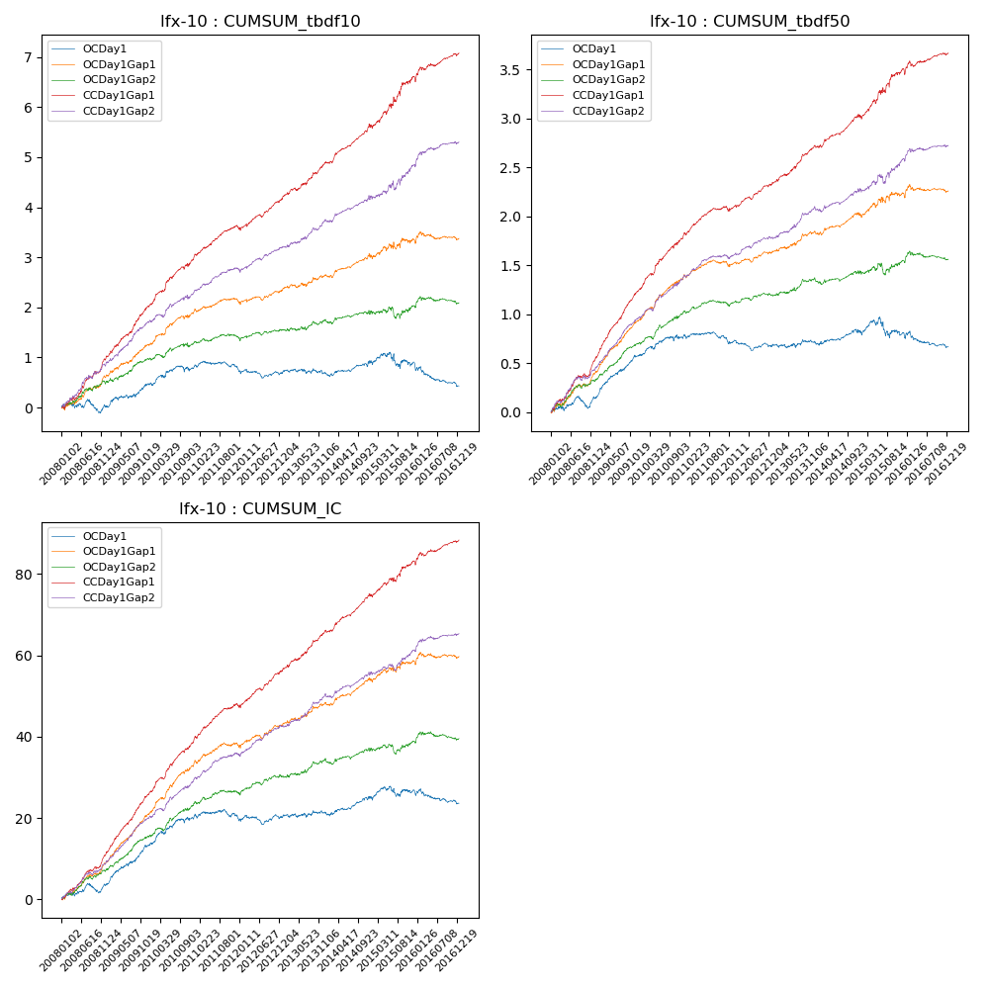

**因子换手率:** 52.14%

**截面指标_OCDay1:**

|  |  |  |  |  |  |  |  |  |
| --- | --- | --- | --- | --- | --- | --- | --- | --- |
| year | annret_tbdf10 | sharpe_tbdf10 | maxdd_tbdf10 | annret_tbdf50 | sharpe_tbdf50 | maxdd_tbdf50 | mean_IC | tstat_IC |
| 2008 | 0.02 | 0.08 | -0.24 | 0.15 | 1.46 | -0.12 | 0.01 | 1.67 |
| 2009 | 0.48 | 2.78 | -0.07 | 0.44 | 5.3 | -0.02 | 0.04 | 5.32 |
| 2010 | 0.34 | 1.86 | -0.12 | 0.19 | 2.16 | -0.04 | 0.03 | 3.06 |
| 2011 | -0.07 | -0.59 | -0.16 | -0.07 | -1.03 | -0.1 | -0.0 | -0.48 |
| 2012 | -0.05 | -0.39 | -0.16 | -0.04 | -0.62 | -0.1 | 0.0 | 0.34 |
| 2013 | -0.02 | -0.12 | -0.1 | 0.04 | 0.46 | -0.04 | 0.0 | 0.5 |
| 2014 | 0.2 | 1.48 | -0.07 | 0.1 | 1.37 | -0.03 | 0.01 | 2.1 |
| 2015 | -0.0 | -0.01 | -0.29 | -0.01 | -0.04 | -0.2 | 0.01 | 0.73 |
| 2016 | -0.46 | -2.69 | -0.38 | -0.14 | -1.68 | -0.16 | -0.01 | -1.63 |

**截面指标_CCDay1Gap1:**

|  |  |  |  |  |  |  |  |  |
| --- | --- | --- | --- | --- | --- | --- | --- | --- |
| year | annret_tbdf10 | sharpe_tbdf10 | maxdd_tbdf10 | annret_tbdf50 | sharpe_tbdf50 | maxdd_tbdf50 | mean_IC | tstat_IC |
| 2008 | 1.02 | 5.31 | -0.07 | 0.56 | 6.18 | -0.03 | 0.05 | 6.56 |
| 2009 | 1.05 | 6.41 | -0.04 | 0.7 | 9.27 | -0.02 | 0.06 | 8.96 |
| 2010 | 0.97 | 5.57 | -0.06 | 0.56 | 6.6 | -0.03 | 0.05 | 7.11 |
| 2011 | 0.55 | 4.34 | -0.07 | 0.25 | 3.89 | -0.05 | 0.03 | 4.68 |
| 2012 | 0.64 | 4.83 | -0.06 | 0.28 | 4.42 | -0.03 | 0.04 | 5.56 |
| 2013 | 0.72 | 4.6 | -0.06 | 0.39 | 5.09 | -0.02 | 0.04 | 5.18 |
| 2014 | 0.74 | 5.36 | -0.07 | 0.32 | 4.43 | -0.03 | 0.04 | 5.68 |
| 2015 | 0.96 | 3.43 | -0.1 | 0.47 | 3.41 | -0.05 | 0.03 | 3.38 |
| 2016 | 0.48 | 2.97 | -0.09 | 0.17 | 2.13 | -0.06 | 0.02 | 3.08 |

**风格暴露:**

|  |  |  |  |  |
| --- | --- | --- | --- | --- |
|  | long | short | corr_OCDay1 | corr_CCDay1Gap1 |
| liquidity10 | 0.1 | -0.11 | -0.07 | -0.08 |
| liquidity20 | 0.02 | -0.03 | -0.01 | -0.02 |
| liquidity5 | 0.28 | -0.29 | -0.14 | -0.15 |
| logmktcap | -0.0 | 0.01 | -0.11 | -0.06 |
| momentum15 | 0.93 | -0.93 | -0.59 | -0.56 |
| momentum30 | 0.6 | -0.6 | -0.47 | -0.43 |
| momentum5 | 1.95 | -1.94 | -0.87 | -0.87 |
| retvolatility30 | -0.0 | -0.01 | 0.03 | 0.04 |