Factors Report 20080102-20161230

**1. lfx-6**

**截面指标累计曲线:**

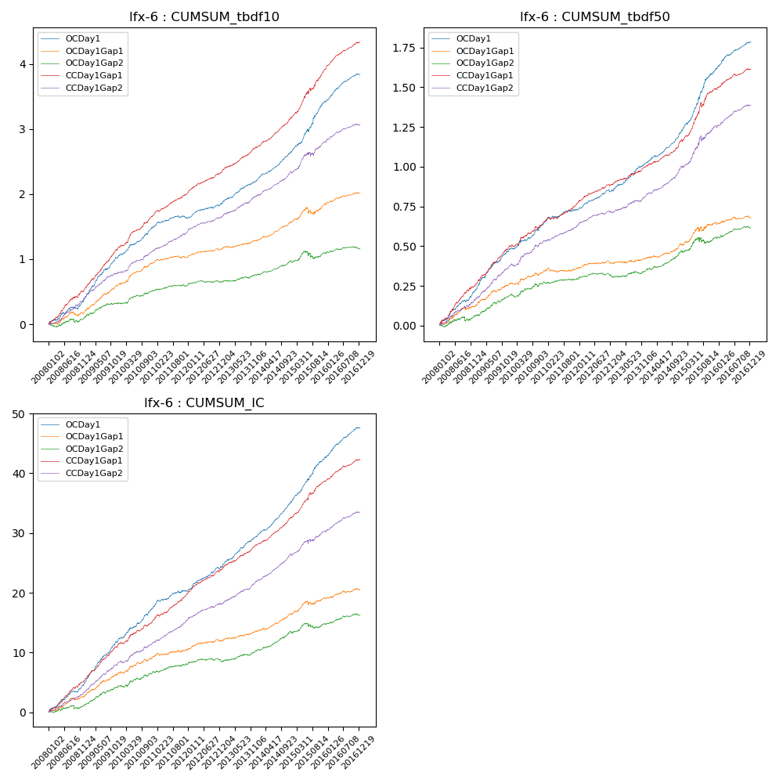

**因子换手率:** 52.26%

**截面指标_OCDay1:**

|  |  |  |  |  |  |  |  |  |
| --- | --- | --- | --- | --- | --- | --- | --- | --- |
| year | annret_tbdf10 | sharpe_tbdf10 | maxdd_tbdf10 | annret_tbdf50 | sharpe_tbdf50 | maxdd_tbdf50 | mean_IC | tstat_IC |
| 2008 | 0.35 | 4.88 | -0.04 | 0.21 | 6.63 | -0.01 | 0.02 | 7.0 |
| 2009 | 0.69 | 9.38 | -0.02 | 0.26 | 8.6 | -0.01 | 0.03 | 10.6 |
| 2010 | 0.45 | 7.11 | -0.02 | 0.17 | 5.26 | -0.01 | 0.02 | 6.87 |
| 2011 | 0.14 | 2.65 | -0.05 | 0.09 | 3.46 | -0.01 | 0.01 | 3.97 |
| 2012 | 0.23 | 4.7 | -0.02 | 0.12 | 5.57 | -0.01 | 0.02 | 6.25 |
| 2013 | 0.35 | 6.42 | -0.01 | 0.18 | 6.71 | -0.01 | 0.02 | 7.61 |
| 2014 | 0.44 | 9.53 | -0.01 | 0.2 | 8.06 | -0.01 | 0.02 | 10.21 |
| 2015 | 0.78 | 6.48 | -0.04 | 0.39 | 6.8 | -0.01 | 0.03 | 7.58 |
| 2016 | 0.42 | 8.09 | -0.02 | 0.17 | 6.3 | -0.01 | 0.02 | 7.81 |

**截面指标_CCDay1Gap1:**

|  |  |  |  |  |  |  |  |  |
| --- | --- | --- | --- | --- | --- | --- | --- | --- |
| year | annret_tbdf10 | sharpe_tbdf10 | maxdd_tbdf10 | annret_tbdf50 | sharpe_tbdf50 | maxdd_tbdf50 | mean_IC | tstat_IC |
| 2008 | 0.51 | 6.56 | -0.02 | 0.25 | 6.63 | -0.01 | 0.02 | 7.75 |
| 2009 | 0.66 | 10.06 | -0.01 | 0.25 | 8.1 | -0.01 | 0.03 | 9.52 |
| 2010 | 0.5 | 7.4 | -0.02 | 0.16 | 4.68 | -0.02 | 0.02 | 5.33 |
| 2011 | 0.34 | 6.95 | -0.02 | 0.12 | 4.98 | -0.02 | 0.02 | 6.7 |
| 2012 | 0.35 | 7.25 | -0.01 | 0.12 | 5.05 | -0.01 | 0.02 | 6.61 |
| 2013 | 0.38 | 7.34 | -0.02 | 0.12 | 4.71 | -0.01 | 0.02 | 6.83 |
| 2014 | 0.45 | 9.42 | -0.01 | 0.16 | 6.41 | -0.01 | 0.02 | 8.68 |
| 2015 | 0.74 | 7.08 | -0.05 | 0.32 | 6.22 | -0.03 | 0.02 | 7.21 |
| 2016 | 0.42 | 8.88 | -0.01 | 0.13 | 5.12 | -0.01 | 0.01 | 7.08 |

**风格暴露:**

|  |  |  |  |  |
| --- | --- | --- | --- | --- |
|  | long | short | corr_OCDay1 | corr_CCDay1Gap1 |
| liquidity10 | 0.03 | -0.02 | 0.18 | 0.11 |
| liquidity20 | 0.03 | -0.02 | 0.15 | 0.09 |
| liquidity5 | 0.02 | -0.02 | 0.19 | 0.12 |
| logmktcap | -0.01 | 0.01 | -0.13 | -0.01 |
| momentum15 | -0.03 | 0.04 | 0.09 | 0.09 |
| momentum30 | -0.02 | 0.03 | 0.06 | 0.03 |
| momentum5 | -0.06 | 0.07 | 0.15 | 0.08 |
| retvolatility30 | 0.03 | -0.03 | 0.13 | 0.07 |