Factors Report 20080102-20161230

**1. lfx-7**

**截面指标累计曲线:**

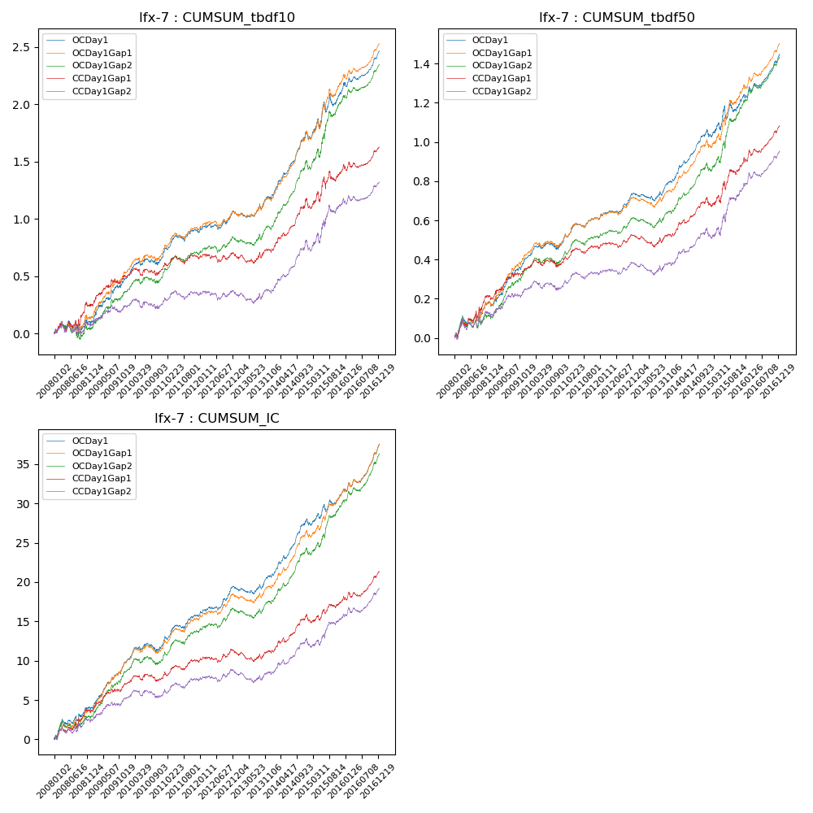

**因子换手率:** 8.31%

**截面指标_OCDay1:**

|  |  |  |  |  |  |  |  |  |
| --- | --- | --- | --- | --- | --- | --- | --- | --- |
| year | annret_tbdf10 | sharpe_tbdf10 | maxdd_tbdf10 | annret_tbdf50 | sharpe_tbdf50 | maxdd_tbdf50 | mean_IC | tstat_IC |
| 2008 | 0.09 | 0.72 | -0.08 | 0.16 | 2.29 | -0.04 | 0.02 | 2.67 |
| 2009 | 0.4 | 3.97 | -0.03 | 0.25 | 4.79 | -0.02 | 0.03 | 5.39 |
| 2010 | 0.19 | 2.26 | -0.06 | 0.08 | 1.92 | -0.04 | 0.01 | 1.88 |
| 2011 | 0.21 | 2.97 | -0.05 | 0.12 | 3.27 | -0.02 | 0.02 | 3.82 |
| 2012 | 0.18 | 2.55 | -0.05 | 0.13 | 3.84 | -0.02 | 0.01 | 3.71 |
| 2013 | 0.13 | 1.63 | -0.05 | 0.07 | 1.77 | -0.04 | 0.01 | 1.61 |
| 2014 | 0.58 | 7.11 | -0.02 | 0.27 | 6.32 | -0.02 | 0.03 | 6.83 |
| 2015 | 0.38 | 2.34 | -0.1 | 0.17 | 2.02 | -0.07 | 0.01 | 2.4 |
| 2016 | 0.32 | 4.45 | -0.04 | 0.22 | 5.08 | -0.02 | 0.02 | 5.67 |

**截面指标_CCDay1Gap1:**

|  |  |  |  |  |  |  |  |  |
| --- | --- | --- | --- | --- | --- | --- | --- | --- |
| year | annret_tbdf10 | sharpe_tbdf10 | maxdd_tbdf10 | annret_tbdf50 | sharpe_tbdf50 | maxdd_tbdf50 | mean_IC | tstat_IC |
| 2008 | 0.25 | 1.86 | -0.08 | 0.2 | 2.71 | -0.04 | 0.01 | 2.63 |
| 2009 | 0.25 | 2.5 | -0.05 | 0.16 | 3.02 | -0.02 | 0.01 | 3.37 |
| 2010 | 0.07 | 0.82 | -0.07 | 0.03 | 0.71 | -0.04 | 0.0 | 0.68 |
| 2011 | 0.08 | 1.2 | -0.07 | 0.07 | 2.05 | -0.03 | 0.01 | 2.34 |
| 2012 | 0.04 | 0.61 | -0.07 | 0.06 | 1.91 | -0.03 | 0.01 | 1.42 |
| 2013 | 0.03 | 0.39 | -0.08 | 0.0 | 0.09 | -0.06 | 0.0 | 0.02 |
| 2014 | 0.44 | 5.08 | -0.03 | 0.18 | 4.12 | -0.02 | 0.02 | 4.32 |
| 2015 | 0.28 | 1.7 | -0.1 | 0.19 | 2.47 | -0.04 | 0.01 | 1.65 |
| 2016 | 0.18 | 2.47 | -0.05 | 0.18 | 3.96 | -0.03 | 0.01 | 3.6 |

**风格暴露:**

|  |  |  |  |  |
| --- | --- | --- | --- | --- |
|  | long | short | corr_OCDay1 | corr_CCDay1Gap1 |
| liquidity10 | -0.25 | 0.23 | -0.03 | 0.0 |
| liquidity20 | -0.28 | 0.26 | -0.02 | 0.01 |
| liquidity5 | -0.23 | 0.2 | -0.06 | -0.02 |
| logmktcap | 1.12 | -0.9 | -0.32 | -0.34 |
| momentum15 | -0.08 | 0.07 | -0.07 | -0.04 |
| momentum30 | -0.11 | 0.11 | -0.11 | -0.07 |
| momentum5 | -0.01 | 0.01 | -0.07 | -0.04 |
| retvolatility30 | 0.12 | -0.12 | -0.23 | -0.19 |