Factors Report 20080102-20161230

**1. lfx-8**

**截面指标累计曲线:**

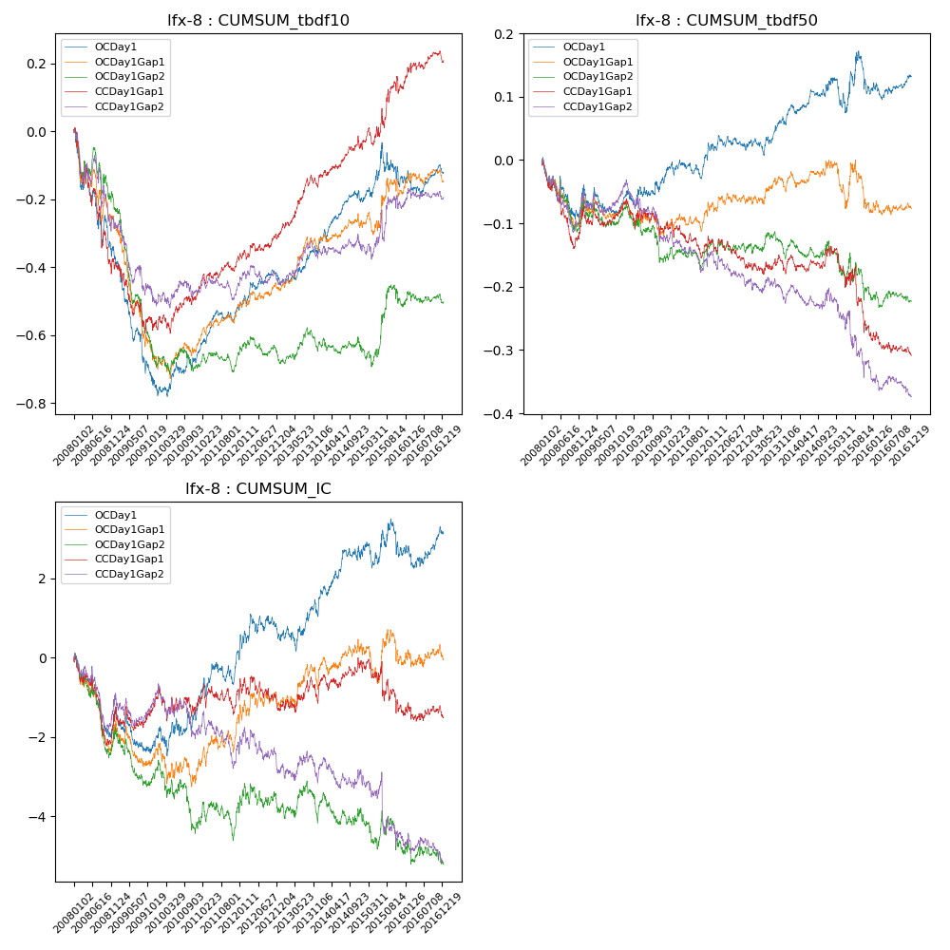

**因子换手率:** 44.09%

**截面指标_OCDay1:**

|  |  |  |  |  |  |  |  |  |
| --- | --- | --- | --- | --- | --- | --- | --- | --- |
| year | annret_tbdf10 | sharpe_tbdf10 | maxdd_tbdf10 | annret_tbdf50 | sharpe_tbdf50 | maxdd_tbdf50 | mean_IC | tstat_IC |
| 2008 | -0.37 | -3.05 | -0.32 | -0.04 | -0.9 | -0.09 | -0.01 | -1.51 |
| 2009 | -0.39 | -4.16 | -0.32 | -0.01 | -0.44 | -0.05 | -0.0 | -1.1 |
| 2010 | 0.1 | 1.44 | -0.04 | 0.03 | 0.81 | -0.03 | 0.0 | 0.74 |
| 2011 | 0.14 | 3.02 | -0.03 | 0.03 | 1.2 | -0.03 | 0.01 | 2.08 |
| 2012 | 0.08 | 1.6 | -0.04 | 0.01 | 0.4 | -0.02 | 0.0 | 0.4 |
| 2013 | 0.12 | 2.45 | -0.02 | 0.05 | 1.79 | -0.03 | 0.0 | 1.57 |
| 2014 | 0.12 | 2.38 | -0.03 | 0.05 | 1.87 | -0.01 | 0.0 | 1.86 |
| 2015 | 0.07 | 0.66 | -0.13 | -0.02 | -0.32 | -0.07 | -0.0 | -0.03 |
| 2016 | 0.01 | 0.22 | -0.07 | 0.03 | 1.05 | -0.03 | 0.0 | 0.79 |

**截面指标_CCDay1Gap1:**

|  |  |  |  |  |  |  |  |  |
| --- | --- | --- | --- | --- | --- | --- | --- | --- |
| year | annret_tbdf10 | sharpe_tbdf10 | maxdd_tbdf10 | annret_tbdf50 | sharpe_tbdf50 | maxdd_tbdf50 | mean_IC | tstat_IC |
| 2008 | -0.38 | -3.19 | -0.35 | -0.08 | -1.56 | -0.13 | -0.01 | -1.7 |
| 2009 | -0.19 | -1.97 | -0.19 | 0.01 | 0.35 | -0.03 | 0.0 | 0.61 |
| 2010 | 0.1 | 1.42 | -0.05 | -0.04 | -1.02 | -0.06 | -0.0 | -0.27 |
| 2011 | 0.11 | 2.31 | -0.03 | -0.02 | -0.82 | -0.06 | 0.0 | 0.65 |
| 2012 | 0.07 | 1.37 | -0.03 | -0.04 | -1.25 | -0.05 | -0.0 | -0.75 |
| 2013 | 0.18 | 3.19 | -0.04 | 0.01 | 0.28 | -0.03 | 0.0 | 0.95 |
| 2014 | 0.1 | 1.95 | -0.04 | 0.02 | 0.69 | -0.03 | 0.0 | 1.06 |
| 2015 | 0.16 | 1.53 | -0.06 | -0.13 | -2.13 | -0.13 | -0.01 | -1.26 |
| 2016 | 0.08 | 1.46 | -0.03 | -0.03 | -1.14 | -0.04 | -0.0 | -0.28 |

**风格暴露:**

|  |  |  |  |  |
| --- | --- | --- | --- | --- |
|  | long | short | corr_OCDay1 | corr_CCDay1Gap1 |
| liquidity10 | -0.06 | 0.06 | 0.08 | 0.06 |
| liquidity20 | -0.04 | 0.05 | 0.05 | 0.02 |
| liquidity5 | -0.07 | 0.08 | 0.11 | 0.1 |
| logmktcap | 0.04 | -0.03 | -0.05 | 0.05 |
| momentum15 | -0.13 | 0.13 | 0.25 | 0.29 |
| momentum30 | -0.09 | 0.1 | 0.18 | 0.18 |
| momentum5 | -0.19 | 0.2 | 0.29 | 0.27 |
| retvolatility30 | -0.03 | 0.03 | 0.0 | -0.05 |