Factors Report 20080102-20161230

**1. lfx-9**

**截面指标累计曲线:**

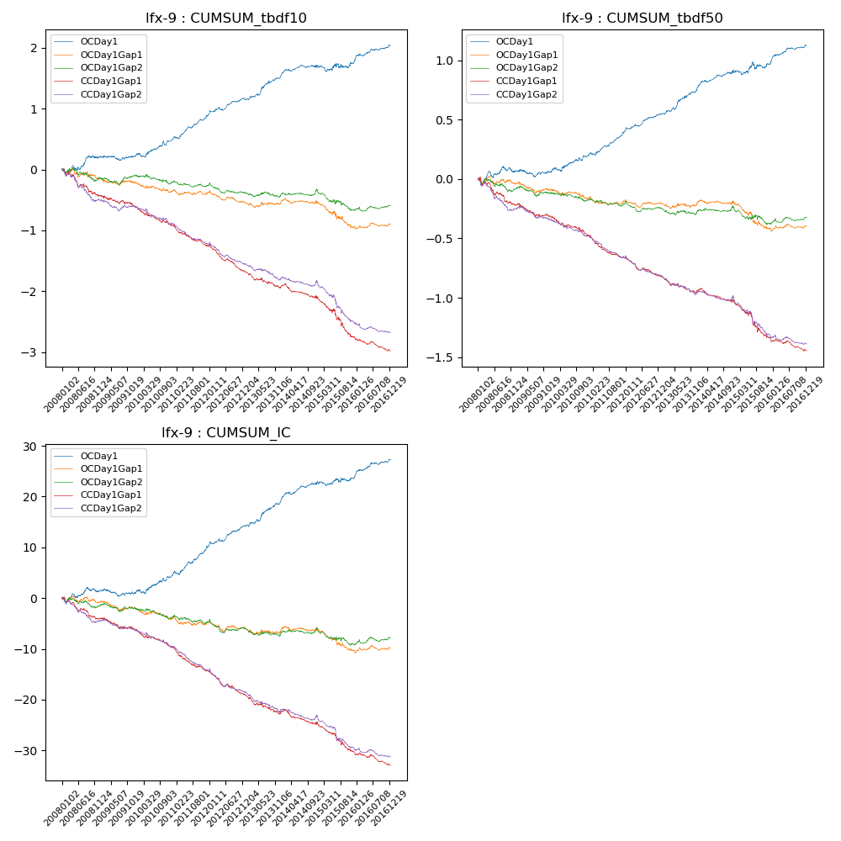

**因子换手率:** 67.47%

**截面指标_OCDay1:**

|  |  |  |  |  |  |  |  |  |
| --- | --- | --- | --- | --- | --- | --- | --- | --- |
| year | annret_tbdf10 | sharpe_tbdf10 | maxdd_tbdf10 | annret_tbdf50 | sharpe_tbdf50 | maxdd_tbdf50 | mean_IC | tstat_IC |
| 2008 | 0.19 | 1.24 | -0.11 | 0.06 | 0.73 | -0.06 | 0.0 | 0.77 |
| 2009 | 0.02 | 0.26 | -0.08 | 0.0 | 0.01 | -0.06 | -0.0 | -0.3 |
| 2010 | 0.27 | 2.51 | -0.07 | 0.14 | 2.34 | -0.03 | 0.01 | 2.5 |
| 2011 | 0.41 | 5.11 | -0.04 | 0.2 | 4.69 | -0.02 | 0.02 | 4.8 |
| 2012 | 0.28 | 3.56 | -0.05 | 0.15 | 4.04 | -0.02 | 0.02 | 3.88 |
| 2013 | 0.36 | 3.74 | -0.03 | 0.21 | 3.97 | -0.02 | 0.02 | 3.83 |
| 2014 | 0.2 | 2.28 | -0.05 | 0.17 | 3.76 | -0.02 | 0.02 | 3.68 |
| 2015 | 0.04 | 0.23 | -0.1 | 0.05 | 0.57 | -0.06 | 0.0 | 0.44 |
| 2016 | 0.28 | 3.31 | -0.03 | 0.16 | 3.55 | -0.01 | 0.01 | 3.45 |

**截面指标_CCDay1Gap1:**

|  |  |  |  |  |  |  |  |  |
| --- | --- | --- | --- | --- | --- | --- | --- | --- |
| year | annret_tbdf10 | sharpe_tbdf10 | maxdd_tbdf10 | annret_tbdf50 | sharpe_tbdf50 | maxdd_tbdf50 | mean_IC | tstat_IC |
| 2008 | -0.43 | -3.13 | -0.36 | -0.22 | -3.13 | -0.21 | -0.02 | -3.28 |
| 2009 | -0.2 | -1.89 | -0.19 | -0.11 | -2.08 | -0.11 | -0.01 | -2.1 |
| 2010 | -0.3 | -3.13 | -0.27 | -0.15 | -2.85 | -0.15 | -0.01 | -3.03 |
| 2011 | -0.34 | -4.25 | -0.3 | -0.19 | -4.58 | -0.18 | -0.02 | -4.39 |
| 2012 | -0.41 | -5.71 | -0.36 | -0.15 | -4.06 | -0.15 | -0.02 | -4.53 |
| 2013 | -0.28 | -3.04 | -0.25 | -0.14 | -2.84 | -0.14 | -0.02 | -3.32 |
| 2014 | -0.17 | -1.93 | -0.22 | -0.08 | -1.6 | -0.11 | -0.01 | -1.9 |
| 2015 | -0.65 | -4.06 | -0.49 | -0.31 | -3.57 | -0.27 | -0.02 | -4.41 |
| 2016 | -0.22 | -3.09 | -0.21 | -0.11 | -2.78 | -0.1 | -0.01 | -3.12 |

**风格暴露:**

|  |  |  |  |  |
| --- | --- | --- | --- | --- |
|  | long | short | corr_OCDay1 | corr_CCDay1Gap1 |
| liquidity10 | -0.34 | 0.31 | 0.34 | 0.34 |
| liquidity20 | -0.26 | 0.23 | 0.27 | 0.3 |
| liquidity5 | -0.45 | 0.42 | 0.39 | 0.36 |
| logmktcap | 0.24 | -0.02 | -0.08 | -0.21 |
| momentum15 | -0.53 | 0.51 | 0.46 | 0.33 |
| momentum30 | -0.44 | 0.42 | 0.37 | 0.27 |
| momentum5 | -0.71 | 0.7 | 0.43 | 0.36 |
| retvolatility30 | -0.16 | 0.14 | 0.15 | 0.21 |