Factors Report 20080102-20161230

**1. lfx-11**

**截面指标累计曲线:**

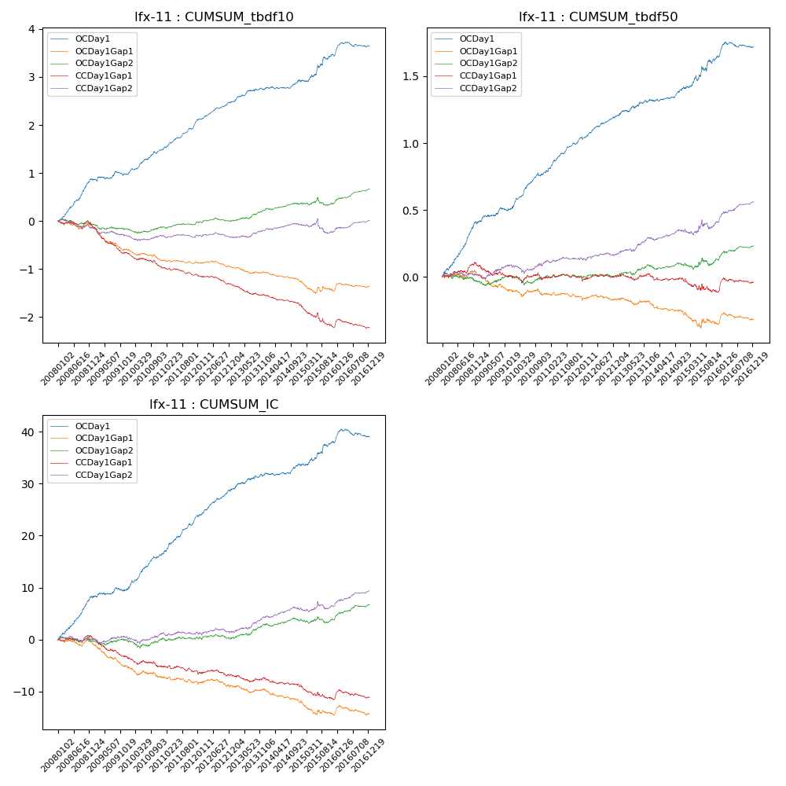

**因子换手率:** 80.31%

**截面指标_OCDay1:**

|  |  |  |  |  |  |  |  |  |
| --- | --- | --- | --- | --- | --- | --- | --- | --- |
| year | annret_tbdf10 | sharpe_tbdf10 | maxdd_tbdf10 | annret_tbdf50 | sharpe_tbdf50 | maxdd_tbdf50 | mean_IC | tstat_IC |
| 2008 | 0.85 | 7.28 | -0.04 | 0.4 | 6.81 | -0.02 | 0.03 | 7.24 |
| 2009 | 0.12 | 1.18 | -0.08 | 0.11 | 2.33 | -0.02 | 0.01 | 1.43 |
| 2010 | 0.52 | 5.62 | -0.04 | 0.28 | 5.77 | -0.02 | 0.03 | 6.18 |
| 2011 | 0.61 | 8.15 | -0.02 | 0.25 | 6.78 | -0.01 | 0.03 | 7.29 |
| 2012 | 0.39 | 5.72 | -0.02 | 0.16 | 4.74 | -0.02 | 0.02 | 5.36 |
| 2013 | 0.29 | 3.39 | -0.04 | 0.13 | 2.84 | -0.02 | 0.01 | 2.91 |
| 2014 | 0.16 | 2.07 | -0.05 | 0.09 | 2.35 | -0.02 | 0.01 | 1.87 |
| 2015 | 0.54 | 3.04 | -0.06 | 0.24 | 2.99 | -0.04 | 0.02 | 2.77 |
| 2016 | 0.19 | 2.36 | -0.1 | 0.07 | 1.84 | -0.04 | 0.0 | 1.2 |

**截面指标_CCDay1Gap1:**

|  |  |  |  |  |  |  |  |  |
| --- | --- | --- | --- | --- | --- | --- | --- | --- |
| year | annret_tbdf10 | sharpe_tbdf10 | maxdd_tbdf10 | annret_tbdf50 | sharpe_tbdf50 | maxdd_tbdf50 | mean_IC | tstat_IC |
| 2008 | -0.12 | -1.08 | -0.15 | 0.09 | 1.63 | -0.02 | 0.0 | 0.27 |
| 2009 | -0.56 | -5.87 | -0.43 | -0.09 | -1.85 | -0.09 | -0.02 | -3.8 |
| 2010 | -0.3 | -3.4 | -0.27 | -0.01 | -0.13 | -0.05 | -0.01 | -1.64 |
| 2011 | -0.13 | -2.1 | -0.15 | 0.0 | 0.07 | -0.03 | -0.0 | -0.95 |
| 2012 | -0.21 | -3.26 | -0.19 | 0.02 | 0.44 | -0.03 | -0.0 | -0.69 |
| 2013 | -0.23 | -2.94 | -0.22 | 0.01 | 0.18 | -0.04 | -0.0 | -0.79 |
| 2014 | -0.22 | -3.31 | -0.2 | -0.05 | -1.27 | -0.05 | -0.01 | -2.02 |
| 2015 | -0.43 | -3.03 | -0.39 | -0.07 | -1.01 | -0.1 | -0.01 | -2.05 |
| 2016 | -0.03 | -0.35 | -0.18 | 0.06 | 1.55 | -0.04 | 0.0 | 0.27 |

**风格暴露:**

|  |  |  |  |  |
| --- | --- | --- | --- | --- |
|  | long | short | corr_OCDay1 | corr_CCDay1Gap1 |
| liquidity10 | 0.11 | -0.1 | -0.21 | -0.2 |
| liquidity20 | 0.07 | -0.06 | -0.19 | -0.17 |
| liquidity5 | 0.17 | -0.16 | -0.22 | -0.21 |
| logmktcap | 0.01 | -0.01 | 0.12 | 0.11 |
| momentum15 | 0.28 | -0.27 | -0.23 | -0.3 |
| momentum30 | 0.2 | -0.19 | -0.21 | -0.24 |
| momentum5 | 0.46 | -0.46 | -0.21 | -0.29 |
| retvolatility30 | 0.09 | -0.09 | -0.21 | -0.14 |