Factors Report 20080102-20161230

**1. lfx-12**

**截面指标累计曲线:**

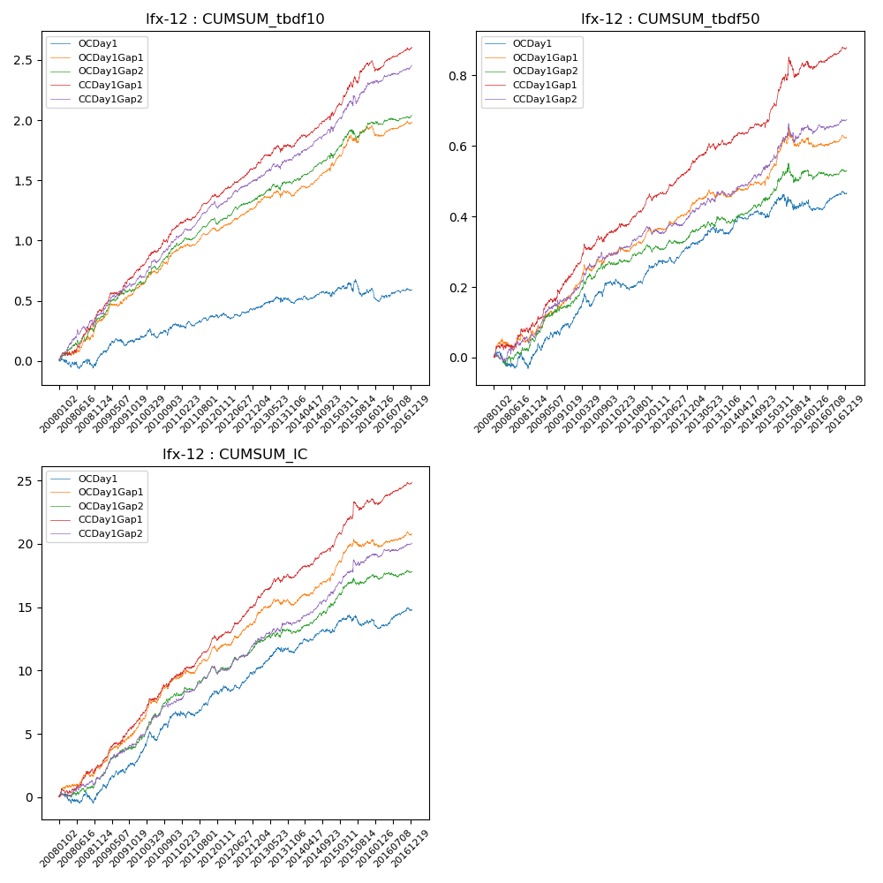

**因子换手率:** 61.4%

**截面指标_OCDay1:**

|  |  |  |  |  |  |  |  |  |
| --- | --- | --- | --- | --- | --- | --- | --- | --- |
| year | annret_tbdf10 | sharpe_tbdf10 | maxdd_tbdf10 | annret_tbdf50 | sharpe_tbdf50 | maxdd_tbdf50 | mean_IC | tstat_IC |
| 2008 | 0.02 | 0.22 | -0.08 | 0.0 | 0.1 | -0.05 | 0.0 | 0.32 |
| 2009 | 0.16 | 2.12 | -0.06 | 0.1 | 2.76 | -0.02 | 0.01 | 3.31 |
| 2010 | 0.12 | 1.52 | -0.07 | 0.11 | 2.84 | -0.04 | 0.01 | 3.92 |
| 2011 | 0.08 | 1.29 | -0.04 | 0.05 | 1.62 | -0.03 | 0.01 | 2.22 |
| 2012 | 0.05 | 0.82 | -0.05 | 0.06 | 2.22 | -0.02 | 0.01 | 2.08 |
| 2013 | 0.05 | 0.64 | -0.05 | 0.04 | 1.25 | -0.02 | 0.01 | 1.91 |
| 2014 | 0.09 | 1.22 | -0.05 | 0.05 | 1.73 | -0.02 | 0.01 | 2.47 |
| 2015 | 0.03 | 0.23 | -0.13 | 0.04 | 0.75 | -0.04 | 0.0 | 1.04 |
| 2016 | 0.0 | 0.01 | -0.09 | 0.03 | 0.95 | -0.03 | 0.0 | 1.34 |

**截面指标_CCDay1Gap1:**

|  |  |  |  |  |  |  |  |  |
| --- | --- | --- | --- | --- | --- | --- | --- | --- |
| year | annret_tbdf10 | sharpe_tbdf10 | maxdd_tbdf10 | annret_tbdf50 | sharpe_tbdf50 | maxdd_tbdf50 | mean_IC | tstat_IC |
| 2008 | 0.41 | 4.14 | -0.03 | 0.09 | 2.06 | -0.02 | 0.01 | 3.0 |
| 2009 | 0.35 | 4.53 | -0.02 | 0.15 | 3.97 | -0.01 | 0.01 | 4.96 |
| 2010 | 0.37 | 5.08 | -0.03 | 0.12 | 3.59 | -0.02 | 0.02 | 4.89 |
| 2011 | 0.25 | 4.78 | -0.02 | 0.1 | 3.85 | -0.01 | 0.01 | 4.58 |
| 2012 | 0.23 | 4.55 | -0.02 | 0.08 | 3.36 | -0.01 | 0.01 | 4.07 |
| 2013 | 0.19 | 2.33 | -0.06 | 0.08 | 2.54 | -0.02 | 0.01 | 2.94 |
| 2014 | 0.26 | 3.74 | -0.03 | 0.06 | 2.32 | -0.02 | 0.01 | 4.09 |
| 2015 | 0.44 | 4.41 | -0.05 | 0.17 | 3.17 | -0.06 | 0.02 | 4.14 |
| 2016 | 0.13 | 2.28 | -0.07 | 0.04 | 1.61 | -0.02 | 0.01 | 2.62 |

**风格暴露:**

|  |  |  |  |  |
| --- | --- | --- | --- | --- |
|  | long | short | corr_OCDay1 | corr_CCDay1Gap1 |
| liquidity10 | 0.01 | 0.0 | -0.03 | -0.05 |
| liquidity20 | 0.01 | -0.0 | -0.02 | -0.06 |
| liquidity5 | 0.0 | 0.01 | -0.04 | -0.07 |
| logmktcap | -0.01 | 0.02 | 0.02 | 0.01 |
| momentum15 | -0.08 | 0.09 | 0.05 | 0.11 |
| momentum30 | -0.07 | 0.08 | 0.09 | 0.07 |
| momentum5 | -0.08 | 0.09 | -0.04 | -0.02 |
| retvolatility30 | 0.04 | -0.04 | -0.03 | -0.07 |