Factors Report 20080102-20161230

**1. lfx-13**

**截面指标累计曲线:**

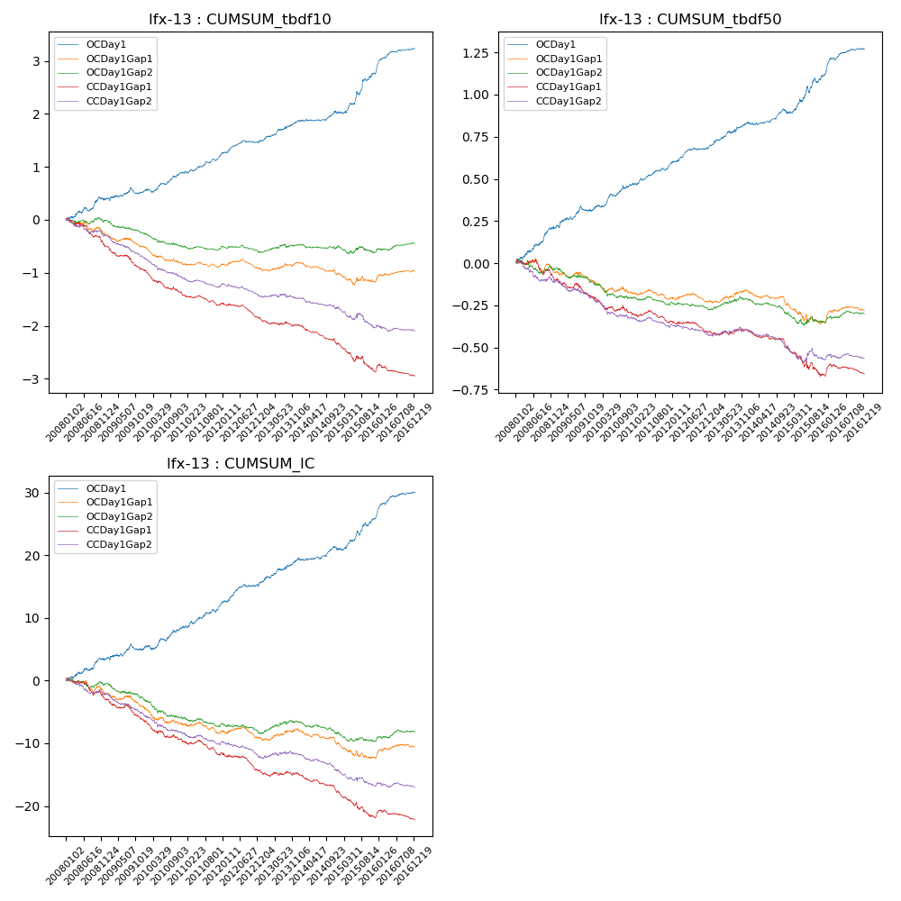

**因子换手率:** 75.91%

**截面指标_OCDay1:**

|  |  |  |  |  |  |  |  |  |
| --- | --- | --- | --- | --- | --- | --- | --- | --- |
| year | annret_tbdf10 | sharpe_tbdf10 | maxdd_tbdf10 | annret_tbdf50 | sharpe_tbdf50 | maxdd_tbdf50 | mean_IC | tstat_IC |
| 2008 | 0.39 | 2.67 | -0.07 | 0.21 | 4.03 | -0.02 | 0.01 | 2.9 |
| 2009 | 0.14 | 1.18 | -0.11 | 0.11 | 2.31 | -0.03 | 0.01 | 1.44 |
| 2010 | 0.36 | 3.29 | -0.07 | 0.15 | 3.31 | -0.02 | 0.01 | 2.91 |
| 2011 | 0.36 | 4.1 | -0.04 | 0.13 | 3.88 | -0.02 | 0.02 | 3.82 |
| 2012 | 0.24 | 3.11 | -0.05 | 0.1 | 3.4 | -0.01 | 0.01 | 3.43 |
| 2013 | 0.39 | 3.66 | -0.04 | 0.14 | 3.56 | -0.01 | 0.02 | 3.55 |
| 2014 | 0.16 | 1.81 | -0.05 | 0.06 | 1.88 | -0.02 | 0.01 | 1.83 |
| 2015 | 0.76 | 4.23 | -0.06 | 0.23 | 3.65 | -0.04 | 0.02 | 4.05 |
| 2016 | 0.46 | 4.98 | -0.03 | 0.15 | 4.28 | -0.02 | 0.02 | 4.74 |

**截面指标_CCDay1Gap1:**

|  |  |  |  |  |  |  |  |  |
| --- | --- | --- | --- | --- | --- | --- | --- | --- |
| year | annret_tbdf10 | sharpe_tbdf10 | maxdd_tbdf10 | annret_tbdf50 | sharpe_tbdf50 | maxdd_tbdf50 | mean_IC | tstat_IC |
| 2008 | -0.49 | -3.71 | -0.42 | -0.1 | -1.87 | -0.12 | -0.01 | -2.72 |
| 2009 | -0.47 | -4.24 | -0.38 | -0.11 | -2.39 | -0.11 | -0.01 | -3.41 |
| 2010 | -0.47 | -4.52 | -0.38 | -0.1 | -2.27 | -0.1 | -0.01 | -3.18 |
| 2011 | -0.15 | -2.01 | -0.19 | -0.04 | -1.31 | -0.07 | -0.01 | -2.02 |
| 2012 | -0.29 | -3.61 | -0.25 | -0.06 | -1.77 | -0.07 | -0.01 | -2.86 |
| 2013 | -0.14 | -1.34 | -0.15 | 0.01 | 0.15 | -0.03 | -0.0 | -0.52 |
| 2014 | -0.36 | -4.48 | -0.31 | -0.1 | -3.11 | -0.1 | -0.01 | -3.87 |
| 2015 | -0.51 | -3.23 | -0.43 | -0.17 | -2.49 | -0.17 | -0.02 | -3.66 |
| 2016 | -0.1 | -0.98 | -0.21 | 0.01 | 0.27 | -0.06 | -0.0 | -0.48 |

**风格暴露:**

|  |  |  |  |  |
| --- | --- | --- | --- | --- |
|  | long | short | corr_OCDay1 | corr_CCDay1Gap1 |
| liquidity10 | -0.0 | 0.01 | -0.12 | -0.07 |
| liquidity20 | -0.01 | 0.02 | -0.12 | -0.05 |
| liquidity5 | 0.03 | -0.03 | -0.11 | -0.06 |
| logmktcap | -0.02 | 0.02 | 0.06 | 0.06 |
| momentum15 | 0.25 | -0.24 | -0.1 | -0.11 |
| momentum30 | 0.18 | -0.17 | -0.12 | -0.08 |
| momentum5 | 0.46 | -0.45 | -0.02 | -0.01 |
| retvolatility30 | 0.0 | 0.0 | -0.09 | -0.03 |