Factors Report 20080102-20161230

**1. alpha_060**

**截面指标累计曲线:**

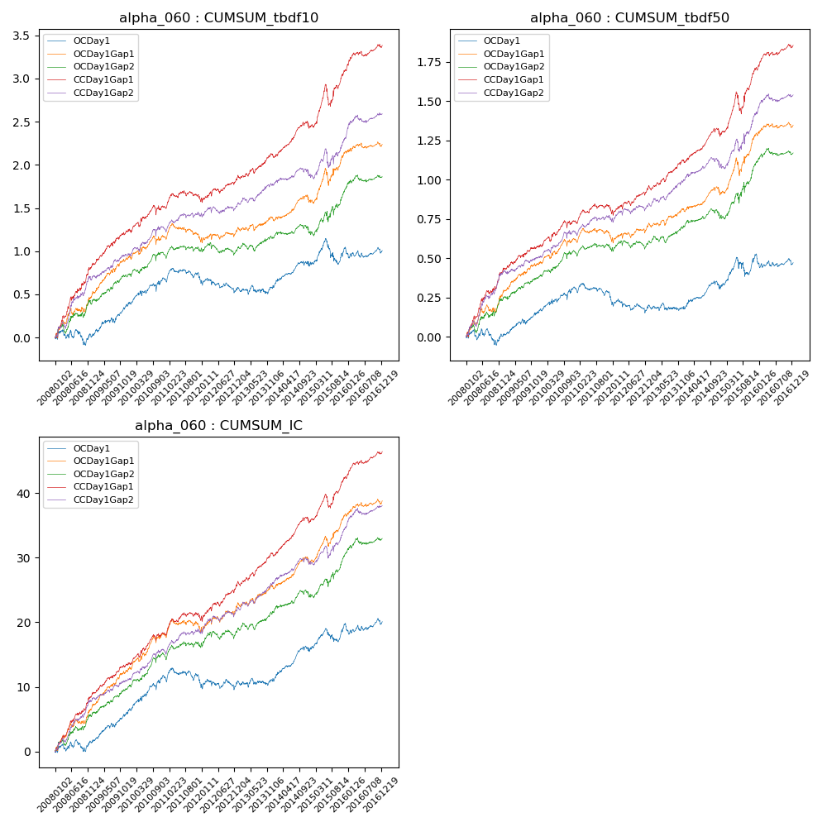

**因子换手率:** 60.09%

**截面指标_OCDay1:**

|  |  |  |  |  |  |  |  |  |
| --- | --- | --- | --- | --- | --- | --- | --- | --- |
| year | annret_tbdf10 | sharpe_tbdf10 | maxdd_tbdf10 | annret_tbdf50 | sharpe_tbdf50 | maxdd_tbdf50 | mean_IC | tstat_IC |
| 2008 | 0.02 | 0.1 | -0.17 | 0.01 | 0.08 | -0.1 | 0.01 | 0.87 |
| 2009 | 0.38 | 3.23 | -0.06 | 0.16 | 2.76 | -0.03 | 0.02 | 3.6 |
| 2010 | 0.28 | 2.15 | -0.09 | 0.14 | 2.25 | -0.04 | 0.02 | 3.3 |
| 2011 | -0.03 | -0.29 | -0.15 | -0.09 | -1.8 | -0.12 | -0.01 | -0.94 |
| 2012 | -0.09 | -0.83 | -0.16 | -0.03 | -0.47 | -0.09 | 0.0 | 0.3 |
| 2013 | 0.02 | 0.19 | -0.1 | -0.0 | -0.05 | -0.05 | 0.0 | 0.35 |
| 2014 | 0.24 | 2.36 | -0.06 | 0.12 | 2.09 | -0.05 | 0.02 | 3.31 |
| 2015 | 0.2 | 1.13 | -0.27 | 0.21 | 2.12 | -0.12 | 0.02 | 2.47 |
| 2016 | -0.02 | -0.17 | -0.1 | -0.04 | -0.76 | -0.07 | 0.0 | 0.4 |

**截面指标_CCDay1Gap1:**

|  |  |  |  |  |  |  |  |  |
| --- | --- | --- | --- | --- | --- | --- | --- | --- |
| year | annret_tbdf10 | sharpe_tbdf10 | maxdd_tbdf10 | annret_tbdf50 | sharpe_tbdf50 | maxdd_tbdf50 | mean_IC | tstat_IC |
| 2008 | 0.82 | 5.1 | -0.04 | 0.42 | 5.15 | -0.02 | 0.04 | 5.72 |
| 2009 | 0.43 | 3.84 | -0.03 | 0.16 | 2.79 | -0.02 | 0.02 | 4.01 |
| 2010 | 0.27 | 2.19 | -0.11 | 0.16 | 2.62 | -0.05 | 0.02 | 3.36 |
| 2011 | 0.05 | 0.54 | -0.12 | 0.04 | 0.82 | -0.06 | 0.01 | 1.38 |
| 2012 | 0.28 | 2.67 | -0.05 | 0.17 | 3.03 | -0.03 | 0.02 | 3.8 |
| 2013 | 0.28 | 2.81 | -0.06 | 0.18 | 3.54 | -0.03 | 0.02 | 3.94 |
| 2014 | 0.32 | 3.18 | -0.08 | 0.16 | 2.85 | -0.05 | 0.02 | 4.05 |
| 2015 | 0.66 | 3.49 | -0.23 | 0.42 | 3.95 | -0.13 | 0.03 | 3.99 |
| 2016 | 0.29 | 3.06 | -0.06 | 0.15 | 3.2 | -0.02 | 0.02 | 3.87 |

**风格暴露:**

|  |  |  |  |  |
| --- | --- | --- | --- | --- |
|  | long | short | corr_OCDay1 | corr_CCDay1Gap1 |
| liquidity10 | -0.31 | 0.31 | 0.08 | 0.18 |
| liquidity20 | -0.42 | 0.42 | 0.15 | 0.23 |
| liquidity5 | -0.16 | 0.16 | 0.02 | 0.14 |
| logmktcap | 0.88 | -0.87 | -0.45 | -0.48 |
| momentum15 | 0.6 | -0.59 | -0.45 | -0.42 |
| momentum30 | 0.46 | -0.46 | -0.38 | -0.32 |
| momentum5 | 0.89 | -0.88 | -0.56 | -0.46 |
| retvolatility30 | -0.17 | 0.17 | 0.16 | 0.25 |