Factors Report 20080102-20161230

**1. alpha_125**

**截面指标累计曲线:**

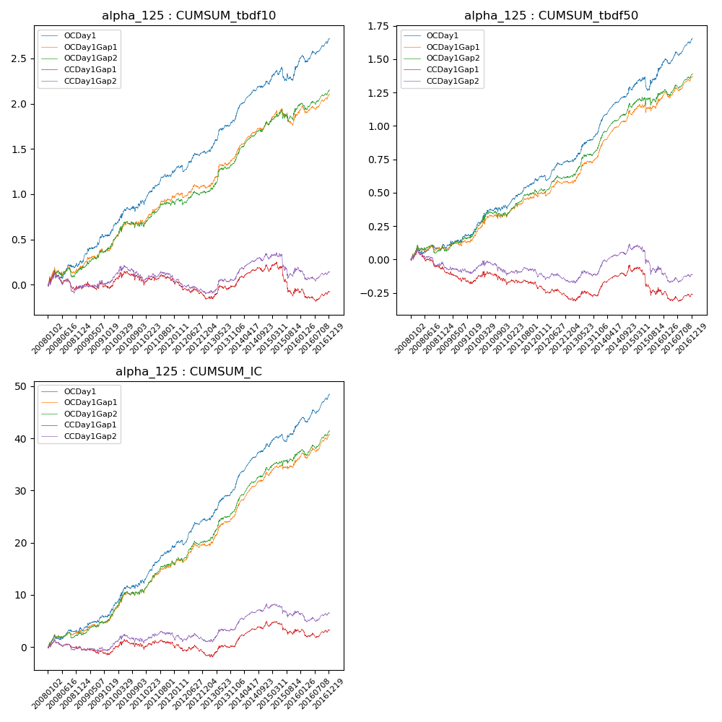

**因子换手率:** 30.27%

**截面指标_OCDay1:**

|  |  |  |  |  |  |  |  |  |
| --- | --- | --- | --- | --- | --- | --- | --- | --- |
| year | annret_tbdf10 | sharpe_tbdf10 | maxdd_tbdf10 | annret_tbdf50 | sharpe_tbdf50 | maxdd_tbdf50 | mean_IC | tstat_IC |
| 2008 | 0.24 | 2.0 | -0.08 | 0.1 | 1.56 | -0.06 | 0.01 | 2.57 |
| 2009 | 0.35 | 3.67 | -0.03 | 0.11 | 1.95 | -0.03 | 0.01 | 2.79 |
| 2010 | 0.34 | 3.14 | -0.06 | 0.19 | 2.72 | -0.04 | 0.02 | 3.54 |
| 2011 | 0.32 | 3.9 | -0.05 | 0.19 | 3.89 | -0.03 | 0.03 | 4.72 |
| 2012 | 0.24 | 3.06 | -0.07 | 0.15 | 3.25 | -0.04 | 0.02 | 4.32 |
| 2013 | 0.38 | 4.24 | -0.02 | 0.23 | 3.81 | -0.02 | 0.03 | 4.35 |
| 2014 | 0.41 | 5.46 | -0.02 | 0.33 | 6.27 | -0.02 | 0.03 | 6.89 |
| 2015 | 0.19 | 1.43 | -0.14 | 0.14 | 1.52 | -0.1 | 0.02 | 2.38 |
| 2016 | 0.28 | 3.61 | -0.08 | 0.22 | 4.39 | -0.04 | 0.02 | 4.91 |

**截面指标_CCDay1Gap1:**

|  |  |  |  |  |  |  |  |  |
| --- | --- | --- | --- | --- | --- | --- | --- | --- |
| year | annret_tbdf10 | sharpe_tbdf10 | maxdd_tbdf10 | annret_tbdf50 | sharpe_tbdf50 | maxdd_tbdf50 | mean_IC | tstat_IC |
| 2008 | -0.04 | -0.31 | -0.19 | -0.07 | -0.98 | -0.14 | -0.0 | -0.09 |
| 2009 | 0.02 | 0.18 | -0.09 | -0.09 | -1.69 | -0.12 | -0.0 | -0.73 |
| 2010 | 0.07 | 0.66 | -0.11 | 0.01 | 0.19 | -0.07 | 0.01 | 0.99 |
| 2011 | -0.02 | -0.24 | -0.08 | -0.05 | -1.04 | -0.05 | -0.0 | -0.18 |
| 2012 | -0.16 | -2.16 | -0.16 | -0.08 | -1.86 | -0.08 | -0.01 | -1.23 |
| 2013 | 0.12 | 1.35 | -0.05 | 0.02 | 0.33 | -0.04 | 0.01 | 1.1 |
| 2014 | 0.22 | 2.87 | -0.04 | 0.21 | 3.68 | -0.03 | 0.02 | 3.94 |
| 2015 | -0.26 | -1.92 | -0.32 | -0.19 | -2.14 | -0.2 | -0.01 | -1.1 |
| 2016 | -0.03 | -0.35 | -0.13 | -0.02 | -0.38 | -0.07 | 0.0 | 0.07 |

**风格暴露:**

|  |  |  |  |  |
| --- | --- | --- | --- | --- |
|  | long | short | corr_OCDay1 | corr_CCDay1Gap1 |
| liquidity10 | -0.79 | 0.79 | 0.66 | 0.64 |
| liquidity20 | -0.78 | 0.79 | 0.64 | 0.63 |
| liquidity5 | -0.75 | 0.75 | 0.66 | 0.63 |
| logmktcap | 0.8 | -0.79 | -0.38 | -0.41 |
| momentum15 | -0.79 | 0.8 | 0.5 | 0.47 |
| momentum30 | -1.14 | 1.15 | 0.62 | 0.62 |
| momentum5 | -0.26 | 0.26 | 0.26 | 0.23 |
| retvolatility30 | -0.45 | 0.46 | 0.51 | 0.49 |