Factors Report 20080102-20161230

**1. alpha_153**

**截面指标累计曲线:**

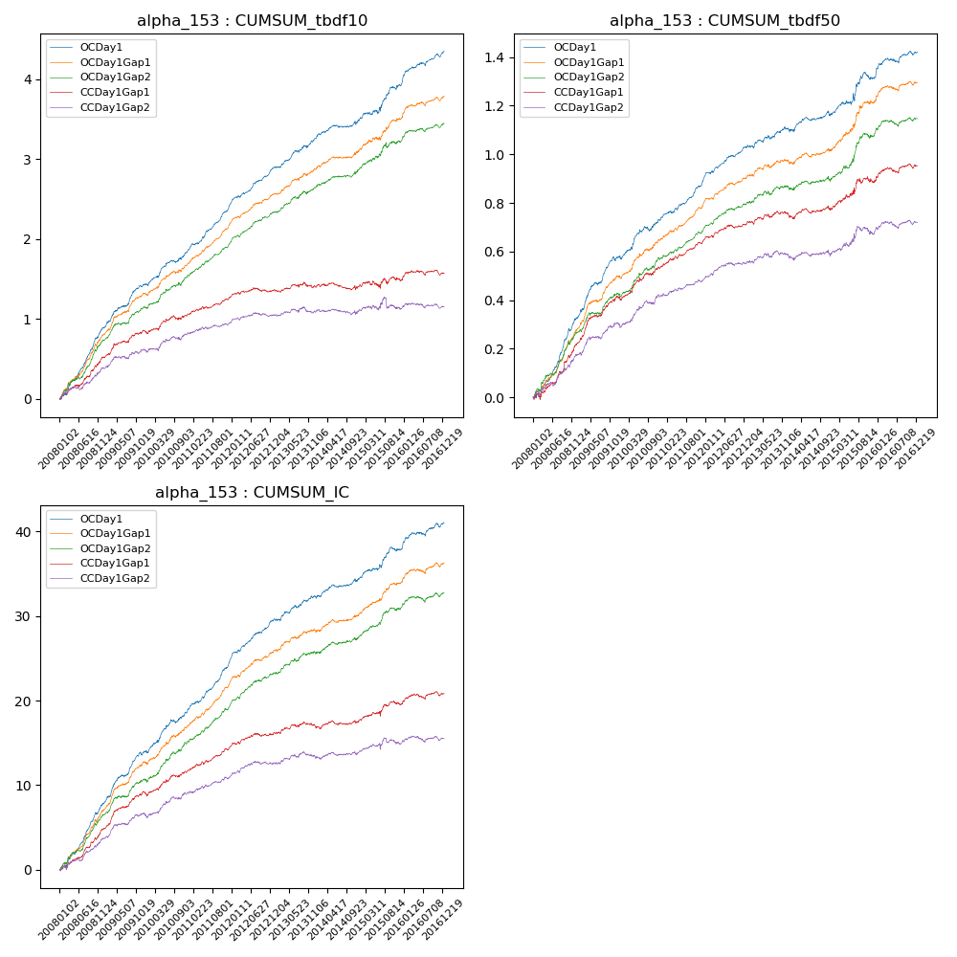

**因子换手率:** 31.56%

**截面指标_OCDay1:**

|  |  |  |  |  |  |  |  |  |
| --- | --- | --- | --- | --- | --- | --- | --- | --- |
| year | annret_tbdf10 | sharpe_tbdf10 | maxdd_tbdf10 | annret_tbdf50 | sharpe_tbdf50 | maxdd_tbdf50 | mean_IC | tstat_IC |
| 2008 | 0.89 | 8.77 | -0.02 | 0.32 | 7.4 | -0.02 | 0.03 | 8.39 |
| 2009 | 0.55 | 6.68 | -0.02 | 0.25 | 6.96 | -0.02 | 0.03 | 7.33 |
| 2010 | 0.43 | 4.78 | -0.03 | 0.16 | 4.16 | -0.02 | 0.02 | 5.07 |
| 2011 | 0.59 | 8.45 | -0.02 | 0.17 | 6.57 | -0.01 | 0.03 | 8.01 |
| 2012 | 0.45 | 6.93 | -0.02 | 0.13 | 5.28 | -0.01 | 0.02 | 6.28 |
| 2013 | 0.37 | 4.54 | -0.03 | 0.07 | 2.27 | -0.02 | 0.01 | 3.48 |
| 2014 | 0.22 | 2.74 | -0.04 | 0.06 | 2.05 | -0.02 | 0.01 | 2.68 |
| 2015 | 0.45 | 3.48 | -0.05 | 0.15 | 2.53 | -0.03 | 0.01 | 3.64 |
| 2016 | 0.42 | 5.22 | -0.04 | 0.1 | 3.14 | -0.02 | 0.01 | 3.74 |

**截面指标_CCDay1Gap1:**

|  |  |  |  |  |  |  |  |  |
| --- | --- | --- | --- | --- | --- | --- | --- | --- |
| year | annret_tbdf10 | sharpe_tbdf10 | maxdd_tbdf10 | annret_tbdf50 | sharpe_tbdf50 | maxdd_tbdf50 | mean_IC | tstat_IC |
| 2008 | 0.52 | 4.78 | -0.04 | 0.22 | 4.28 | -0.03 | 0.02 | 5.06 |
| 2009 | 0.31 | 3.73 | -0.03 | 0.19 | 5.13 | -0.01 | 0.02 | 5.11 |
| 2010 | 0.23 | 2.48 | -0.05 | 0.13 | 3.53 | -0.01 | 0.01 | 3.32 |
| 2011 | 0.21 | 3.34 | -0.03 | 0.11 | 4.59 | -0.01 | 0.01 | 4.28 |
| 2012 | 0.09 | 1.33 | -0.05 | 0.07 | 2.78 | -0.01 | 0.01 | 2.17 |
| 2013 | 0.04 | 0.51 | -0.07 | 0.03 | 0.95 | -0.02 | 0.0 | 1.05 |
| 2014 | 0.0 | 0.05 | -0.09 | 0.03 | 0.99 | -0.02 | 0.0 | 0.93 |
| 2015 | 0.08 | 0.62 | -0.09 | 0.11 | 1.98 | -0.03 | 0.01 | 1.9 |
| 2016 | 0.09 | 1.18 | -0.06 | 0.06 | 1.96 | -0.02 | 0.0 | 1.69 |

**风格暴露:**

|  |  |  |  |  |
| --- | --- | --- | --- | --- |
|  | long | short | corr_OCDay1 | corr_CCDay1Gap1 |
| liquidity10 | 0.36 | -0.36 | -0.15 | -0.18 |
| liquidity20 | 0.35 | -0.34 | -0.14 | -0.17 |
| liquidity5 | 0.35 | -0.35 | -0.14 | -0.19 |
| logmktcap | 0.01 | -0.01 | 0.16 | 0.11 |
| momentum15 | 0.23 | -0.22 | -0.15 | -0.22 |
| momentum30 | 0.28 | -0.28 | -0.15 | -0.23 |
| momentum5 | 0.06 | -0.05 | -0.05 | -0.17 |
| retvolatility30 | 0.36 | -0.35 | 0.0 | -0.04 |