Factors Report 20080102-20161230

**1. alpha_155**

**截面指标累计曲线:**

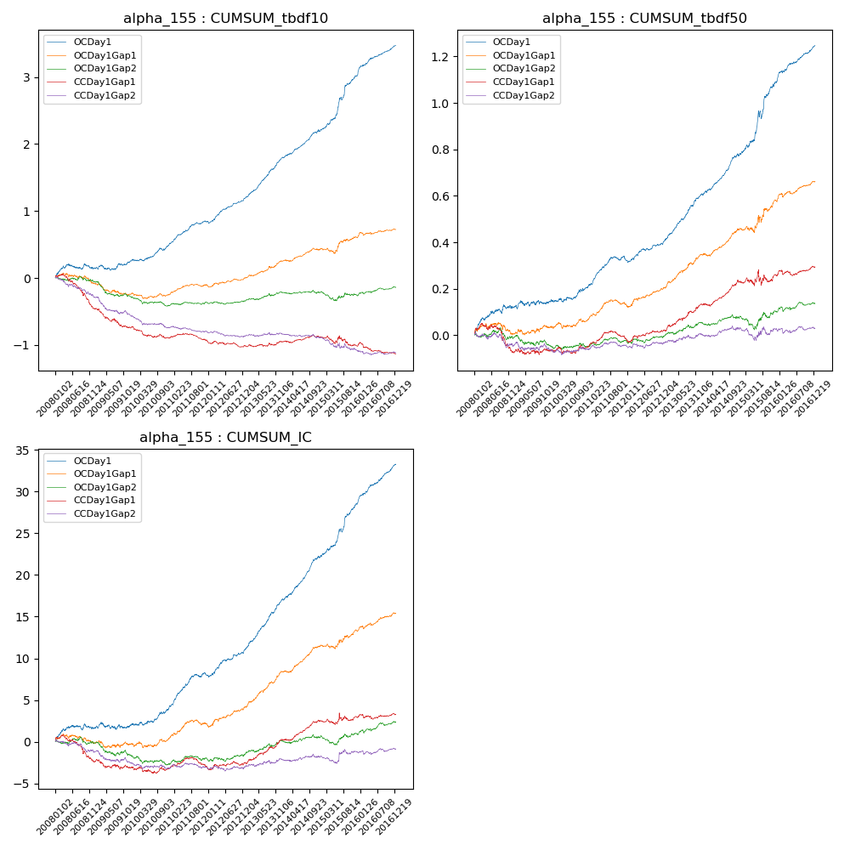

**因子换手率:** 65.58%

**截面指标_OCDay1:**

|  |  |  |  |  |  |  |  |  |
| --- | --- | --- | --- | --- | --- | --- | --- | --- |
| year | annret_tbdf10 | sharpe_tbdf10 | maxdd_tbdf10 | annret_tbdf50 | sharpe_tbdf50 | maxdd_tbdf50 | mean_IC | tstat_IC |
| 2008 | 0.15 | 1.37 | -0.08 | 0.12 | 2.82 | -0.02 | 0.01 | 1.82 |
| 2009 | 0.11 | 1.23 | -0.08 | 0.03 | 0.68 | -0.02 | 0.0 | 0.41 |
| 2010 | 0.25 | 3.14 | -0.04 | 0.06 | 1.81 | -0.02 | 0.01 | 2.3 |
| 2011 | 0.34 | 5.54 | -0.02 | 0.11 | 4.01 | -0.02 | 0.02 | 4.81 |
| 2012 | 0.35 | 5.58 | -0.03 | 0.08 | 3.25 | -0.01 | 0.01 | 3.9 |
| 2013 | 0.62 | 8.68 | -0.01 | 0.21 | 6.94 | -0.01 | 0.03 | 7.79 |
| 2014 | 0.4 | 5.92 | -0.03 | 0.17 | 5.95 | -0.01 | 0.02 | 6.93 |
| 2015 | 0.85 | 6.12 | -0.04 | 0.32 | 5.14 | -0.03 | 0.03 | 5.98 |
| 2016 | 0.43 | 6.01 | -0.02 | 0.15 | 5.84 | -0.01 | 0.02 | 6.75 |

**截面指标_CCDay1Gap1:**

|  |  |  |  |  |  |  |  |  |
| --- | --- | --- | --- | --- | --- | --- | --- | --- |
| year | annret_tbdf10 | sharpe_tbdf10 | maxdd_tbdf10 | annret_tbdf50 | sharpe_tbdf50 | maxdd_tbdf50 | mean_IC | tstat_IC |
| 2008 | -0.45 | -4.1 | -0.41 | -0.07 | -1.3 | -0.12 | -0.01 | -2.33 |
| 2009 | -0.29 | -3.36 | -0.26 | 0.0 | 0.14 | -0.03 | -0.0 | -1.0 |
| 2010 | -0.17 | -2.35 | -0.16 | 0.01 | 0.45 | -0.03 | -0.0 | -0.22 |
| 2011 | -0.04 | -0.73 | -0.11 | 0.03 | 1.36 | -0.04 | 0.0 | 0.36 |
| 2012 | -0.07 | -1.3 | -0.09 | 0.04 | 1.48 | -0.01 | 0.0 | 0.69 |
| 2013 | 0.06 | 0.96 | -0.03 | 0.11 | 3.9 | -0.01 | 0.01 | 3.97 |
| 2014 | 0.07 | 1.17 | -0.04 | 0.1 | 3.54 | -0.01 | 0.01 | 3.67 |
| 2015 | -0.12 | -1.11 | -0.15 | 0.03 | 0.42 | -0.07 | 0.0 | 0.42 |
| 2016 | -0.13 | -1.91 | -0.16 | 0.04 | 1.44 | -0.02 | 0.0 | 0.56 |

**风格暴露:**

|  |  |  |  |  |
| --- | --- | --- | --- | --- |
|  | long | short | corr_OCDay1 | corr_CCDay1Gap1 |
| liquidity10 | 0.01 | -0.0 | -0.01 | 0.04 |
| liquidity20 | 0.02 | -0.01 | -0.02 | 0.04 |
| liquidity5 | 0.07 | -0.06 | 0.01 | 0.06 |
| logmktcap | -0.03 | 0.04 | 0.05 | 0.03 |
| momentum15 | 0.09 | -0.09 | -0.02 | -0.07 |
| momentum30 | 0.07 | -0.07 | -0.06 | -0.07 |
| momentum5 | 0.21 | -0.2 | 0.07 | -0.01 |
| retvolatility30 | 0.03 | -0.03 | -0.01 | 0.07 |