Factors Report 20080102-20161230

**1. alpha_170**

**截面指标累计曲线:**

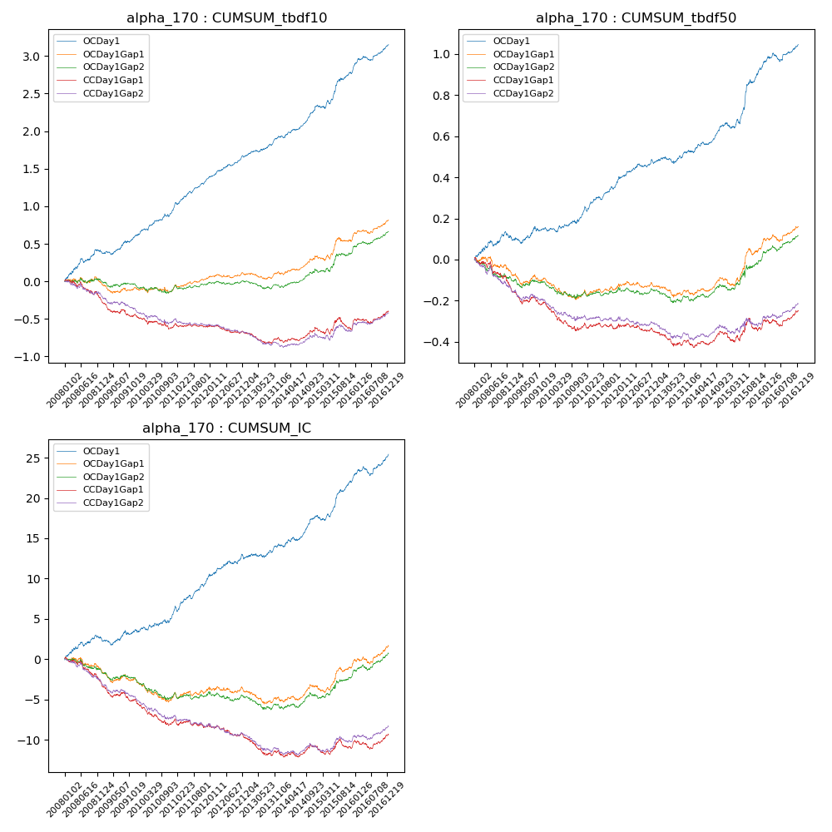

**因子换手率:** 42.85%

**截面指标_OCDay1:**

|  |  |  |  |  |  |  |  |  |
| --- | --- | --- | --- | --- | --- | --- | --- | --- |
| year | annret_tbdf10 | sharpe_tbdf10 | maxdd_tbdf10 | annret_tbdf50 | sharpe_tbdf50 | maxdd_tbdf50 | mean_IC | tstat_IC |
| 2008 | 0.4 | 4.02 | -0.05 | 0.11 | 2.41 | -0.03 | 0.01 | 2.85 |
| 2009 | 0.21 | 2.89 | -0.04 | 0.03 | 0.77 | -0.03 | 0.0 | 0.85 |
| 2010 | 0.35 | 4.56 | -0.04 | 0.08 | 2.43 | -0.02 | 0.01 | 2.63 |
| 2011 | 0.44 | 6.87 | -0.02 | 0.17 | 5.16 | -0.03 | 0.02 | 5.43 |
| 2012 | 0.29 | 4.87 | -0.02 | 0.08 | 2.45 | -0.02 | 0.01 | 2.52 |
| 2013 | 0.25 | 3.97 | -0.02 | 0.05 | 1.61 | -0.03 | 0.01 | 1.83 |
| 2014 | 0.42 | 6.02 | -0.03 | 0.14 | 4.55 | -0.01 | 0.02 | 4.67 |
| 2015 | 0.46 | 4.22 | -0.05 | 0.27 | 4.71 | -0.03 | 0.02 | 4.8 |
| 2016 | 0.36 | 4.97 | -0.05 | 0.11 | 3.06 | -0.04 | 0.01 | 3.61 |

**截面指标_CCDay1Gap1:**

|  |  |  |  |  |  |  |  |  |
| --- | --- | --- | --- | --- | --- | --- | --- | --- |
| year | annret_tbdf10 | sharpe_tbdf10 | maxdd_tbdf10 | annret_tbdf50 | sharpe_tbdf50 | maxdd_tbdf50 | mean_IC | tstat_IC |
| 2008 | -0.23 | -2.38 | -0.23 | -0.14 | -3.0 | -0.14 | -0.01 | -3.37 |
| 2009 | -0.24 | -3.12 | -0.22 | -0.09 | -2.56 | -0.09 | -0.01 | -3.4 |
| 2010 | -0.14 | -1.89 | -0.15 | -0.1 | -2.87 | -0.11 | -0.01 | -3.05 |
| 2011 | 0.03 | 0.48 | -0.05 | 0.02 | 0.57 | -0.03 | -0.0 | -0.14 |
| 2012 | -0.1 | -1.73 | -0.1 | -0.04 | -1.26 | -0.04 | -0.01 | -2.1 |
| 2013 | -0.1 | -1.62 | -0.14 | -0.06 | -1.78 | -0.07 | -0.01 | -2.67 |
| 2014 | 0.16 | 2.32 | -0.03 | 0.05 | 1.7 | -0.02 | 0.0 | 1.31 |
| 2015 | 0.03 | 0.26 | -0.15 | 0.04 | 0.67 | -0.06 | 0.0 | 0.1 |
| 2016 | 0.2 | 2.67 | -0.06 | 0.07 | 2.11 | -0.03 | 0.01 | 1.77 |

**风格暴露:**

|  |  |  |  |  |
| --- | --- | --- | --- | --- |
|  | long | short | corr_OCDay1 | corr_CCDay1Gap1 |
| liquidity10 | 0.25 | -0.24 | -0.27 | -0.22 |
| liquidity20 | 0.19 | -0.19 | -0.28 | -0.24 |
| liquidity5 | 0.32 | -0.32 | -0.26 | -0.23 |
| logmktcap | 0.07 | -0.06 | 0.07 | -0.0 |
| momentum15 | -0.09 | 0.1 | 0.03 | 0.01 |
| momentum30 | 0.02 | -0.01 | -0.04 | -0.07 |
| momentum5 | -0.2 | 0.2 | 0.16 | 0.12 |
| retvolatility30 | 0.22 | -0.22 | -0.26 | -0.23 |