Factors Report 20080102-20161230

**1. alpha_094**

**截面指标累计曲线:**

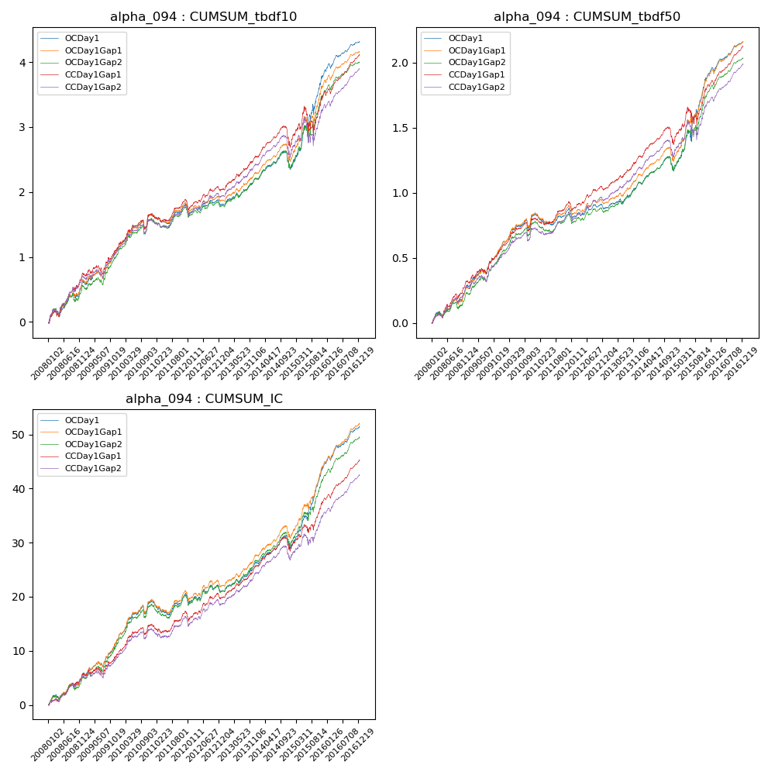

**因子换手率:** 3.17%

**截面指标_OCDay1:**

|  |  |  |  |  |  |  |  |  |
| --- | --- | --- | --- | --- | --- | --- | --- | --- |
| year | annret_tbdf10 | sharpe_tbdf10 | maxdd_tbdf10 | annret_tbdf50 | sharpe_tbdf50 | maxdd_tbdf50 | mean_IC | tstat_IC |
| 2008 | 0.62 | 3.93 | -0.1 | 0.29 | 4.08 | -0.05 | 0.02 | 3.99 |
| 2009 | 0.5 | 3.55 | -0.11 | 0.3 | 4.79 | -0.03 | 0.03 | 3.97 |
| 2010 | 0.54 | 3.85 | -0.13 | 0.25 | 3.79 | -0.07 | 0.03 | 4.39 |
| 2011 | 0.13 | 1.2 | -0.14 | 0.03 | 0.56 | -0.08 | 0.0 | 0.72 |
| 2012 | 0.02 | 0.23 | -0.13 | 0.02 | 0.41 | -0.06 | 0.0 | 0.55 |
| 2013 | 0.41 | 3.93 | -0.06 | 0.2 | 4.27 | -0.03 | 0.02 | 4.35 |
| 2014 | 0.14 | 1.05 | -0.25 | 0.09 | 1.44 | -0.11 | 0.01 | 1.87 |
| 2015 | 1.53 | 4.87 | -0.17 | 0.75 | 5.44 | -0.08 | 0.06 | 6.43 |
| 2016 | 0.44 | 4.93 | -0.07 | 0.25 | 6.74 | -0.03 | 0.03 | 6.66 |

**截面指标_CCDay1Gap1:**

|  |  |  |  |  |  |  |  |  |
| --- | --- | --- | --- | --- | --- | --- | --- | --- |
| year | annret_tbdf10 | sharpe_tbdf10 | maxdd_tbdf10 | annret_tbdf50 | sharpe_tbdf50 | maxdd_tbdf50 | mean_IC | tstat_IC |
| 2008 | 0.72 | 4.24 | -0.08 | 0.31 | 4.39 | -0.04 | 0.02 | 3.93 |
| 2009 | 0.41 | 2.65 | -0.13 | 0.25 | 3.69 | -0.04 | 0.02 | 2.4 |
| 2010 | 0.51 | 3.39 | -0.13 | 0.23 | 3.34 | -0.07 | 0.02 | 3.62 |
| 2011 | 0.19 | 1.72 | -0.1 | 0.11 | 2.09 | -0.04 | 0.01 | 1.47 |
| 2012 | 0.2 | 1.91 | -0.11 | 0.12 | 2.51 | -0.05 | 0.01 | 2.14 |
| 2013 | 0.53 | 4.81 | -0.04 | 0.26 | 5.21 | -0.02 | 0.02 | 4.97 |
| 2014 | 0.15 | 1.03 | -0.29 | 0.1 | 1.46 | -0.13 | 0.01 | 2.0 |
| 2015 | 0.84 | 2.43 | -0.39 | 0.45 | 3.27 | -0.13 | 0.04 | 4.23 |
| 2016 | 0.57 | 6.39 | -0.07 | 0.3 | 7.71 | -0.03 | 0.03 | 7.79 |

**风格暴露:**

|  |  |  |  |  |
| --- | --- | --- | --- | --- |
|  | long | short | corr_OCDay1 | corr_CCDay1Gap1 |
| liquidity10 | 0.4 | -0.42 | 0.01 | 0.05 |
| liquidity20 | 0.43 | -0.46 | 0.03 | 0.04 |
| liquidity5 | 0.38 | -0.4 | 0.01 | 0.05 |
| logmktcap | 1.49 | -1.26 | -0.64 | -0.63 |
| momentum15 | -0.09 | 0.09 | -0.03 | -0.0 |
| momentum30 | -0.04 | 0.03 | -0.04 | -0.05 |
| momentum5 | -0.11 | 0.11 | -0.02 | 0.05 |
| retvolatility30 | 0.33 | -0.33 | 0.13 | 0.14 |