Factors Report 20080102-20161230

**1. alpha_108**

**截面指标累计曲线:**

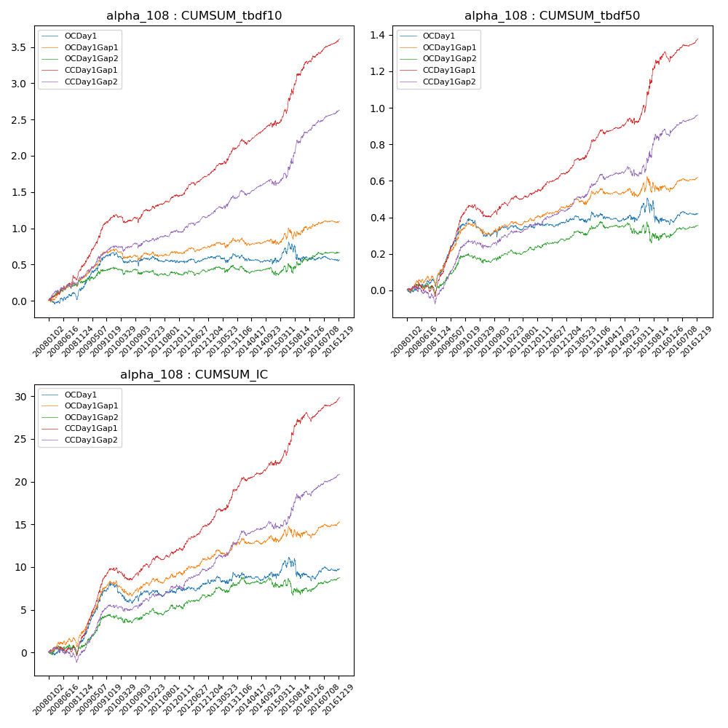

**因子换手率:** 45.94%

**截面指标_OCDay1:**

|  |  |  |  |  |  |  |  |  |
| --- | --- | --- | --- | --- | --- | --- | --- | --- |
| year | annret_tbdf10 | sharpe_tbdf10 | maxdd_tbdf10 | annret_tbdf50 | sharpe_tbdf50 | maxdd_tbdf50 | mean_IC | tstat_IC |
| 2008 | 0.16 | 1.36 | -0.1 | 0.09 | 1.67 | -0.04 | 0.01 | 1.23 |
| 2009 | 0.51 | 3.45 | -0.04 | 0.29 | 4.3 | -0.02 | 0.03 | 4.42 |
| 2010 | -0.08 | -0.75 | -0.18 | -0.04 | -0.67 | -0.09 | -0.0 | -0.62 |
| 2011 | -0.05 | -0.62 | -0.09 | 0.02 | 0.46 | -0.03 | 0.0 | 0.36 |
| 2012 | 0.07 | 0.89 | -0.06 | 0.02 | 0.72 | -0.02 | 0.0 | 0.88 |
| 2013 | 0.02 | 0.18 | -0.1 | 0.03 | 0.66 | -0.04 | 0.0 | 0.81 |
| 2014 | -0.07 | -0.72 | -0.11 | -0.03 | -0.64 | -0.04 | -0.0 | -0.26 |
| 2015 | 0.04 | 0.19 | -0.25 | -0.01 | -0.07 | -0.14 | 0.0 | 0.04 |
| 2016 | -0.03 | -0.39 | -0.07 | 0.04 | 1.18 | -0.02 | 0.0 | 1.07 |

**截面指标_CCDay1Gap1:**

|  |  |  |  |  |  |  |  |  |
| --- | --- | --- | --- | --- | --- | --- | --- | --- |
| year | annret_tbdf10 | sharpe_tbdf10 | maxdd_tbdf10 | annret_tbdf50 | sharpe_tbdf50 | maxdd_tbdf50 | mean_IC | tstat_IC |
| 2008 | 0.47 | 4.09 | -0.06 | 0.08 | 1.35 | -0.07 | 0.01 | 1.8 |
| 2009 | 0.71 | 5.3 | -0.03 | 0.39 | 6.5 | -0.01 | 0.03 | 6.43 |
| 2010 | 0.08 | 0.73 | -0.11 | 0.02 | 0.38 | -0.07 | 0.0 | 0.55 |
| 2011 | 0.18 | 2.18 | -0.04 | 0.06 | 1.96 | -0.02 | 0.01 | 2.13 |
| 2012 | 0.33 | 4.66 | -0.04 | 0.12 | 3.67 | -0.01 | 0.01 | 4.14 |
| 2013 | 0.47 | 4.34 | -0.04 | 0.22 | 4.86 | -0.01 | 0.02 | 4.93 |
| 2014 | 0.24 | 2.54 | -0.06 | 0.06 | 1.44 | -0.03 | 0.01 | 2.2 |
| 2015 | 0.83 | 4.12 | -0.07 | 0.37 | 3.46 | -0.04 | 0.02 | 3.44 |
| 2016 | 0.32 | 4.13 | -0.02 | 0.08 | 2.32 | -0.04 | 0.01 | 2.9 |

**风格暴露:**

|  |  |  |  |  |
| --- | --- | --- | --- | --- |
|  | long | short | corr_OCDay1 | corr_CCDay1Gap1 |
| liquidity10 | 0.13 | -0.12 | -0.22 | -0.17 |
| liquidity20 | 0.07 | -0.06 | -0.16 | -0.12 |
| liquidity5 | 0.22 | -0.21 | -0.29 | -0.25 |
| logmktcap | 0.04 | -0.04 | 0.03 | -0.03 |
| momentum15 | 0.34 | -0.33 | -0.46 | -0.44 |
| momentum30 | 0.19 | -0.19 | -0.35 | -0.28 |
| momentum5 | 0.54 | -0.53 | -0.53 | -0.51 |
| retvolatility30 | 0.06 | -0.05 | -0.15 | -0.11 |