Factors Report 20080102-20161230

**1. alpha_127**

**截面指标累计曲线:**

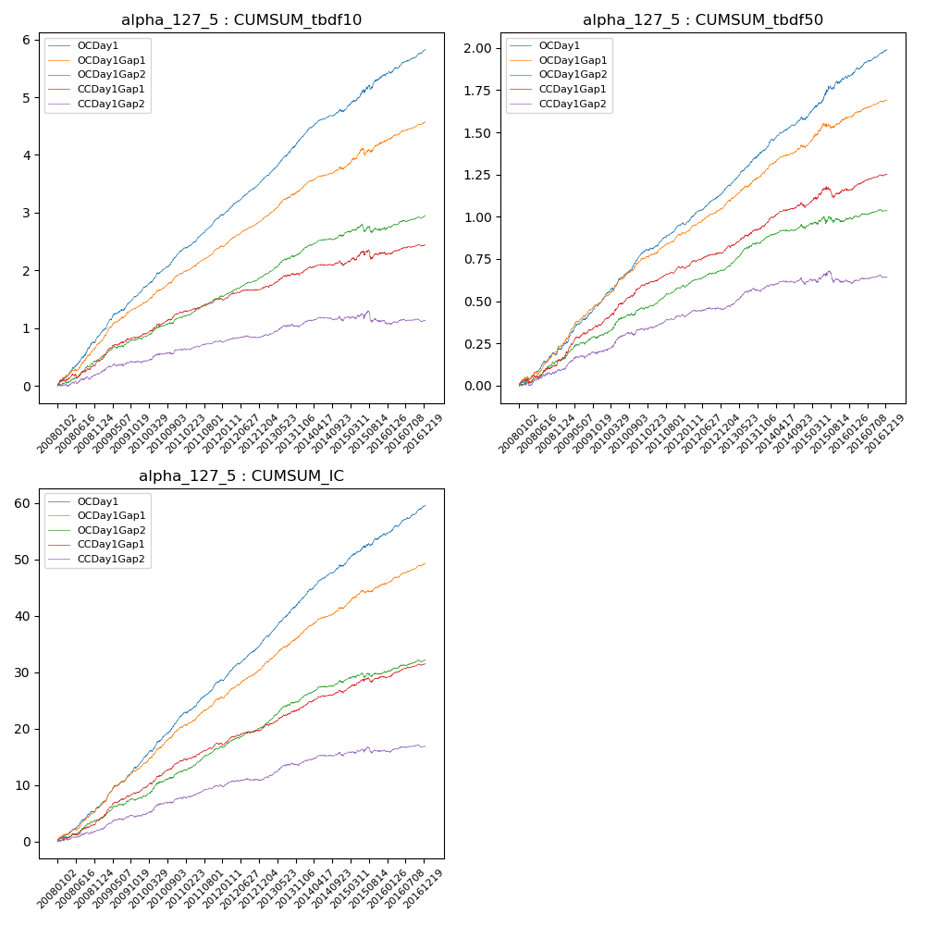

**因子换手率:** 44.42%

**截面指标_OCDay1:**

|  |  |  |  |  |  |  |  |  |
| --- | --- | --- | --- | --- | --- | --- | --- | --- |
| year | annret_tbdf10 | sharpe_tbdf10 | maxdd_tbdf10 | annret_tbdf50 | sharpe_tbdf50 | maxdd_tbdf50 | mean_IC | tstat_IC |
| 2008 | 0.86 | 7.56 | -0.03 | 0.21 | 4.71 | -0.02 | 0.02 | 6.07 |
| 2009 | 0.75 | 8.53 | -0.02 | 0.28 | 7.83 | -0.01 | 0.03 | 8.68 |
| 2010 | 0.73 | 9.35 | -0.01 | 0.29 | 7.97 | -0.01 | 0.03 | 9.37 |
| 2011 | 0.63 | 9.86 | -0.01 | 0.18 | 6.9 | -0.01 | 0.03 | 8.09 |
| 2012 | 0.61 | 9.25 | -0.01 | 0.19 | 7.18 | -0.01 | 0.03 | 8.63 |
| 2013 | 0.77 | 9.33 | -0.02 | 0.25 | 7.71 | -0.01 | 0.03 | 9.01 |
| 2014 | 0.43 | 5.6 | -0.04 | 0.18 | 5.83 | -0.02 | 0.02 | 7.09 |
| 2015 | 0.65 | 4.24 | -0.07 | 0.26 | 4.27 | -0.02 | 0.02 | 5.44 |
| 2016 | 0.43 | 5.55 | -0.03 | 0.16 | 5.7 | -0.01 | 0.02 | 6.36 |

**截面指标_CCDay1Gap1:**

|  |  |  |  |  |  |  |  |  |
| --- | --- | --- | --- | --- | --- | --- | --- | --- |
| year | annret_tbdf10 | sharpe_tbdf10 | maxdd_tbdf10 | annret_tbdf50 | sharpe_tbdf50 | maxdd_tbdf50 | mean_IC | tstat_IC |
| 2008 | 0.42 | 3.84 | -0.08 | 0.15 | 3.48 | -0.02 | 0.01 | 4.32 |
| 2009 | 0.44 | 4.95 | -0.03 | 0.21 | 5.67 | -0.01 | 0.02 | 6.31 |
| 2010 | 0.42 | 5.07 | -0.02 | 0.23 | 6.04 | -0.01 | 0.02 | 6.42 |
| 2011 | 0.23 | 3.74 | -0.02 | 0.11 | 4.51 | -0.01 | 0.01 | 4.42 |
| 2012 | 0.19 | 3.07 | -0.02 | 0.09 | 3.62 | -0.01 | 0.01 | 3.73 |
| 2013 | 0.28 | 3.22 | -0.04 | 0.15 | 4.64 | -0.01 | 0.02 | 4.53 |
| 2014 | 0.12 | 1.56 | -0.08 | 0.11 | 3.26 | -0.03 | 0.01 | 3.44 |
| 2015 | 0.23 | 1.41 | -0.15 | 0.11 | 2.07 | -0.07 | 0.01 | 2.79 |
| 2016 | 0.12 | 1.72 | -0.05 | 0.08 | 3.19 | -0.01 | 0.01 | 3.53 |

**风格暴露:**

|  |  |  |  |  |
| --- | --- | --- | --- | --- |
|  | long | short | corr_OCDay1 | corr_CCDay1Gap1 |
| liquidity10 | 0.11 | -0.1 | 0.1 | 0.13 |
| liquidity20 | 0.1 | -0.09 | 0.1 | 0.14 |
| liquidity5 | 0.12 | -0.11 | 0.1 | 0.12 |
| logmktcap | -0.02 | 0.02 | 0.06 | -0.02 |
| momentum15 | 0.08 | -0.07 | -0.03 | 0.02 |
| momentum30 | 0.07 | -0.07 | 0.01 | 0.08 |
| momentum5 | 0.07 | -0.07 | -0.04 | -0.02 |
| retvolatility30 | 0.11 | -0.1 | 0.18 | 0.21 |