Factors Report 20080102-20161230

**1. alpha_127**

**截面指标累计曲线:**

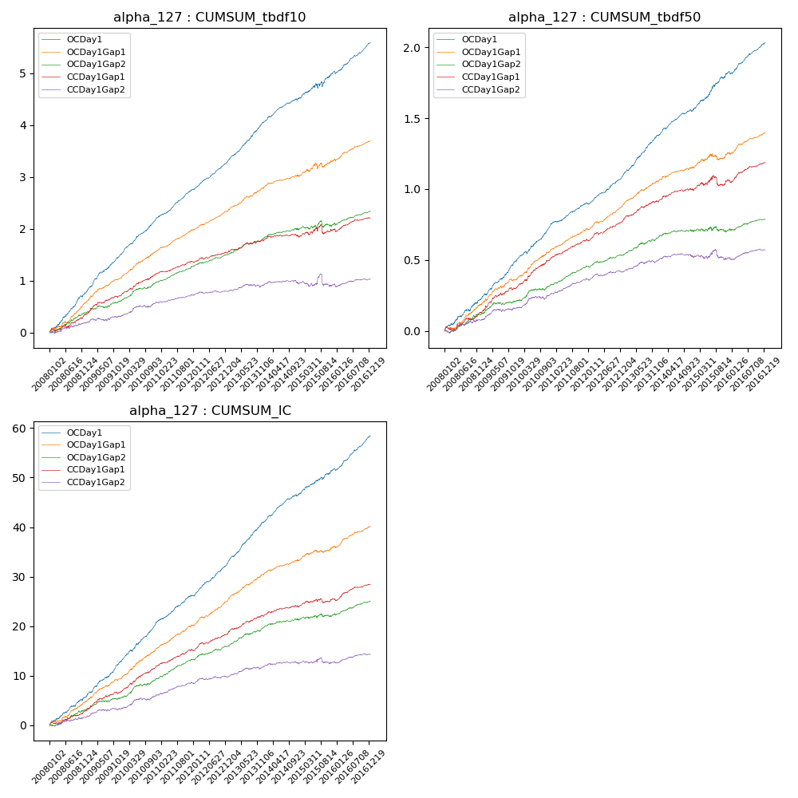

**因子换手率:** 64.56%

**截面指标_OCDay1:**

|  |  |  |  |  |  |  |  |  |
| --- | --- | --- | --- | --- | --- | --- | --- | --- |
| year | annret_tbdf10 | sharpe_tbdf10 | maxdd_tbdf10 | annret_tbdf50 | sharpe_tbdf50 | maxdd_tbdf50 | mean_IC | tstat_IC |
| 2008 | 0.76 | 6.72 | -0.03 | 0.22 | 4.71 | -0.01 | 0.02 | 5.48 |
| 2009 | 0.75 | 8.57 | -0.02 | 0.27 | 7.38 | -0.01 | 0.03 | 7.98 |
| 2010 | 0.7 | 9.26 | -0.01 | 0.26 | 7.26 | -0.02 | 0.03 | 8.63 |
| 2011 | 0.55 | 8.51 | -0.01 | 0.15 | 5.76 | -0.01 | 0.02 | 7.02 |
| 2012 | 0.56 | 9.05 | -0.01 | 0.2 | 7.24 | -0.01 | 0.03 | 8.23 |
| 2013 | 0.76 | 8.94 | -0.02 | 0.29 | 8.34 | -0.01 | 0.03 | 9.04 |
| 2014 | 0.47 | 6.93 | -0.03 | 0.18 | 6.14 | -0.01 | 0.02 | 7.26 |
| 2015 | 0.53 | 3.19 | -0.1 | 0.27 | 5.34 | -0.02 | 0.02 | 5.0 |
| 2016 | 0.55 | 7.27 | -0.05 | 0.2 | 6.81 | -0.02 | 0.03 | 8.21 |

**截面指标_CCDay1Gap1:**

|  |  |  |  |  |  |  |  |  |
| --- | --- | --- | --- | --- | --- | --- | --- | --- |
| year | annret_tbdf10 | sharpe_tbdf10 | maxdd_tbdf10 | annret_tbdf50 | sharpe_tbdf50 | maxdd_tbdf50 | mean_IC | tstat_IC |
| 2008 | 0.34 | 3.4 | -0.06 | 0.13 | 2.9 | -0.03 | 0.01 | 3.47 |
| 2009 | 0.38 | 4.64 | -0.02 | 0.18 | 4.53 | -0.02 | 0.02 | 4.95 |
| 2010 | 0.42 | 4.91 | -0.03 | 0.21 | 5.55 | -0.01 | 0.02 | 5.89 |
| 2011 | 0.23 | 3.99 | -0.01 | 0.13 | 4.91 | -0.01 | 0.01 | 4.6 |
| 2012 | 0.19 | 3.15 | -0.04 | 0.14 | 5.39 | -0.01 | 0.01 | 4.92 |
| 2013 | 0.22 | 2.91 | -0.04 | 0.14 | 4.22 | -0.01 | 0.01 | 4.27 |
| 2014 | 0.06 | 0.9 | -0.06 | 0.08 | 2.43 | -0.02 | 0.01 | 2.48 |
| 2015 | 0.16 | 0.98 | -0.17 | 0.07 | 1.14 | -0.07 | 0.01 | 1.67 |
| 2016 | 0.21 | 3.0 | -0.06 | 0.12 | 4.36 | -0.02 | 0.01 | 4.48 |

**风格暴露:**

|  |  |  |  |  |
| --- | --- | --- | --- | --- |
|  | long | short | corr_OCDay1 | corr_CCDay1Gap1 |
| liquidity10 | 0.05 | -0.04 | 0.06 | 0.11 |
| liquidity20 | 0.05 | -0.04 | 0.05 | 0.1 |
| liquidity5 | 0.06 | -0.05 | 0.08 | 0.1 |
| logmktcap | -0.01 | 0.02 | 0.01 | -0.07 |
| momentum15 | 0.03 | -0.02 | 0.02 | 0.07 |
| momentum30 | 0.03 | -0.02 | 0.01 | 0.08 |
| momentum5 | 0.04 | -0.04 | 0.03 | 0.04 |
| retvolatility30 | 0.06 | -0.05 | 0.12 | 0.15 |