Factors Report 20080102-20161230

**1. alpha_188**

**截面指标累计曲线:**

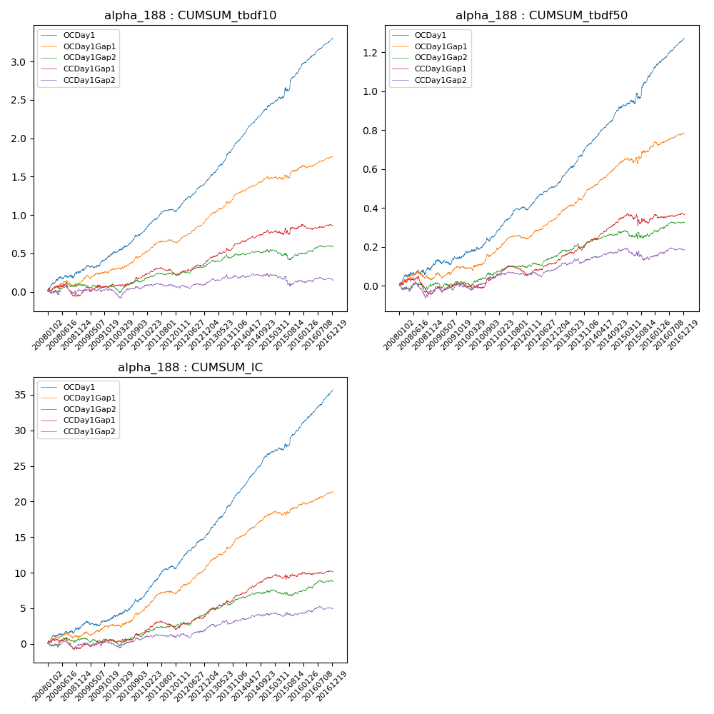

**因子换手率:** 70.61%

**截面指标_OCDay1:**

|  |  |  |  |  |  |  |  |  |
| --- | --- | --- | --- | --- | --- | --- | --- | --- |
| year | annret_tbdf10 | sharpe_tbdf10 | maxdd_tbdf10 | annret_tbdf50 | sharpe_tbdf50 | maxdd_tbdf50 | mean_IC | tstat_IC |
| 2008 | 0.26 | 2.53 | -0.04 | 0.09 | 1.87 | -0.03 | 0.01 | 2.29 |
| 2009 | 0.22 | 2.79 | -0.03 | 0.06 | 1.4 | -0.03 | 0.01 | 1.42 |
| 2010 | 0.3 | 3.77 | -0.02 | 0.11 | 2.59 | -0.02 | 0.01 | 3.06 |
| 2011 | 0.27 | 4.61 | -0.03 | 0.14 | 4.58 | -0.01 | 0.02 | 4.93 |
| 2012 | 0.39 | 6.71 | -0.02 | 0.13 | 5.25 | -0.01 | 0.02 | 6.05 |
| 2013 | 0.53 | 7.98 | -0.02 | 0.2 | 6.41 | -0.01 | 0.02 | 7.37 |
| 2014 | 0.46 | 7.79 | -0.02 | 0.19 | 6.83 | -0.01 | 0.02 | 7.97 |
| 2015 | 0.51 | 4.22 | -0.06 | 0.19 | 3.35 | -0.03 | 0.02 | 3.81 |
| 2016 | 0.38 | 7.15 | -0.01 | 0.17 | 6.77 | -0.01 | 0.02 | 7.84 |

**截面指标_CCDay1Gap1:**

|  |  |  |  |  |  |  |  |  |
| --- | --- | --- | --- | --- | --- | --- | --- | --- |
| year | annret_tbdf10 | sharpe_tbdf10 | maxdd_tbdf10 | annret_tbdf50 | sharpe_tbdf50 | maxdd_tbdf50 | mean_IC | tstat_IC |
| 2008 | -0.04 | -0.43 | -0.15 | -0.04 | -0.78 | -0.09 | -0.0 | -0.61 |
| 2009 | 0.13 | 1.67 | -0.05 | 0.04 | 1.2 | -0.03 | 0.0 | 1.3 |
| 2010 | 0.13 | 1.8 | -0.04 | 0.04 | 0.95 | -0.03 | 0.0 | 1.29 |
| 2011 | 0.02 | 0.45 | -0.08 | 0.02 | 0.68 | -0.04 | 0.0 | 0.96 |
| 2012 | 0.16 | 2.91 | -0.02 | 0.07 | 2.95 | -0.01 | 0.01 | 2.86 |
| 2013 | 0.24 | 3.53 | -0.04 | 0.09 | 3.33 | -0.02 | 0.01 | 3.72 |
| 2014 | 0.14 | 2.58 | -0.05 | 0.12 | 4.91 | -0.01 | 0.01 | 4.31 |
| 2015 | 0.1 | 0.92 | -0.08 | 0.0 | 0.04 | -0.06 | 0.0 | 0.66 |
| 2016 | 0.01 | 0.12 | -0.07 | 0.02 | 0.76 | -0.02 | 0.0 | 0.55 |

**风格暴露:**

|  |  |  |  |  |
| --- | --- | --- | --- | --- |
|  | long | short | corr_OCDay1 | corr_CCDay1Gap1 |
| liquidity10 | 0.01 | -0.01 | -0.01 | 0.06 |
| liquidity20 | 0.01 | -0.01 | -0.02 | 0.06 |
| liquidity5 | 0.01 | -0.01 | 0.02 | 0.1 |
| logmktcap | 0.0 | 0.0 | -0.0 | -0.05 |
| momentum15 | -0.0 | 0.01 | 0.07 | -0.02 |
| momentum30 | 0.0 | 0.0 | 0.01 | -0.01 |
| momentum5 | -0.03 | 0.04 | 0.14 | 0.09 |
| retvolatility30 | 0.01 | -0.01 | -0.04 | 0.07 |