Factors Report 20080102-20161230

**1. alpha_102**

**截面指标累计曲线:**

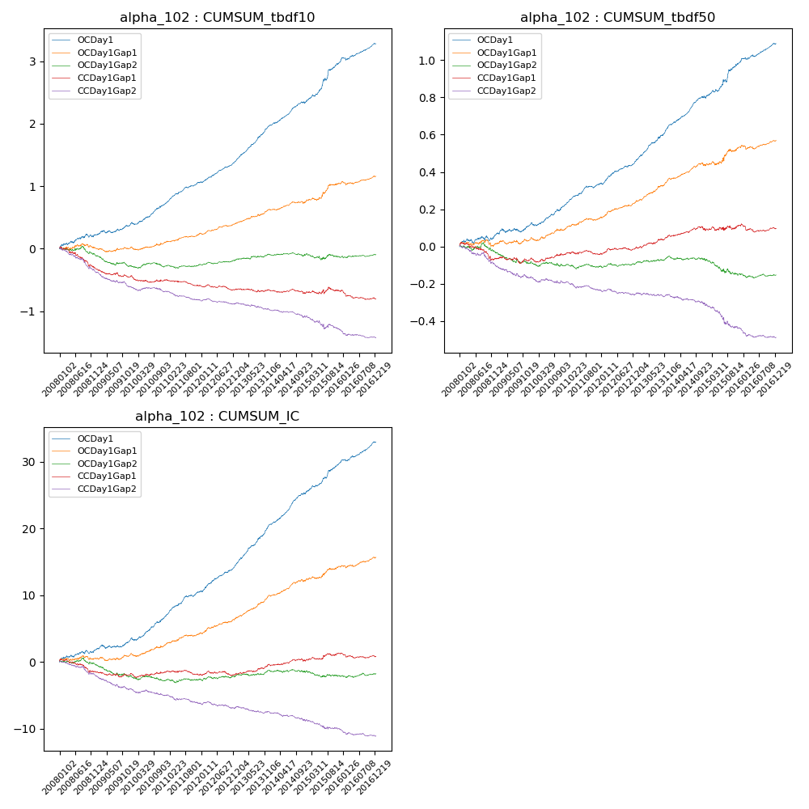

**因子换手率:** 51.33%

**截面指标_OCDay1:**

|  |  |  |  |  |  |  |  |  |
| --- | --- | --- | --- | --- | --- | --- | --- | --- |
| year | annret_tbdf10 | sharpe_tbdf10 | maxdd_tbdf10 | annret_tbdf50 | sharpe_tbdf50 | maxdd_tbdf50 | mean_IC | tstat_IC |
| 2008 | 0.23 | 2.51 | -0.05 | 0.06 | 1.68 | -0.03 | 0.01 | 2.4 |
| 2009 | 0.15 | 2.36 | -0.04 | 0.05 | 1.82 | -0.02 | 0.01 | 2.25 |
| 2010 | 0.34 | 5.29 | -0.04 | 0.11 | 3.96 | -0.02 | 0.01 | 5.04 |
| 2011 | 0.35 | 6.76 | -0.02 | 0.11 | 5.54 | -0.01 | 0.02 | 6.31 |
| 2012 | 0.34 | 6.84 | -0.01 | 0.12 | 5.69 | -0.01 | 0.02 | 6.23 |
| 2013 | 0.59 | 9.7 | -0.01 | 0.2 | 7.87 | -0.01 | 0.03 | 9.51 |
| 2014 | 0.36 | 6.17 | -0.03 | 0.14 | 6.06 | -0.01 | 0.02 | 7.54 |
| 2015 | 0.66 | 5.76 | -0.03 | 0.2 | 4.61 | -0.01 | 0.02 | 6.1 |
| 2016 | 0.28 | 4.72 | -0.04 | 0.1 | 4.58 | -0.01 | 0.01 | 5.48 |

**截面指标_CCDay1Gap1:**

|  |  |  |  |  |  |  |  |  |
| --- | --- | --- | --- | --- | --- | --- | --- | --- |
| year | annret_tbdf10 | sharpe_tbdf10 | maxdd_tbdf10 | annret_tbdf50 | sharpe_tbdf50 | maxdd_tbdf50 | mean_IC | tstat_IC |
| 2008 | -0.3 | -3.21 | -0.29 | -0.06 | -1.71 | -0.09 | -0.01 | -1.98 |
| 2009 | -0.15 | -2.33 | -0.14 | -0.01 | -0.26 | -0.03 | -0.0 | -0.78 |
| 2010 | -0.05 | -0.84 | -0.1 | 0.03 | 1.0 | -0.02 | 0.0 | 0.47 |
| 2011 | -0.08 | -1.72 | -0.1 | 0.01 | 0.36 | -0.02 | -0.0 | -0.41 |
| 2012 | -0.07 | -1.49 | -0.09 | 0.03 | 1.37 | -0.02 | -0.0 | -0.05 |
| 2013 | -0.02 | -0.27 | -0.05 | 0.07 | 2.78 | -0.01 | 0.01 | 2.44 |
| 2014 | -0.05 | -0.92 | -0.07 | 0.03 | 1.34 | -0.02 | 0.0 | 1.21 |
| 2015 | 0.04 | 0.42 | -0.07 | 0.03 | 0.6 | -0.02 | 0.0 | 1.49 |
| 2016 | -0.13 | -2.16 | -0.14 | -0.02 | -0.73 | -0.04 | -0.0 | -0.87 |

**风格暴露:**

|  |  |  |  |  |
| --- | --- | --- | --- | --- |
|  | long | short | corr_OCDay1 | corr_CCDay1Gap1 |
| liquidity10 | 0.03 | -0.02 | 0.12 | 0.11 |
| liquidity20 | 0.03 | -0.02 | 0.1 | 0.1 |
| liquidity5 | 0.04 | -0.03 | 0.14 | 0.12 |
| logmktcap | 0.0 | 0.01 | 0.03 | -0.01 |
| momentum15 | 0.04 | -0.03 | 0.12 | 0.06 |
| momentum30 | 0.03 | -0.02 | 0.12 | 0.07 |
| momentum5 | 0.06 | -0.06 | 0.1 | 0.05 |
| retvolatility30 | 0.02 | -0.01 | 0.14 | 0.15 |