Factors Report 20080102-20161230

**1. alpha_110**

**截面指标累计曲线:**

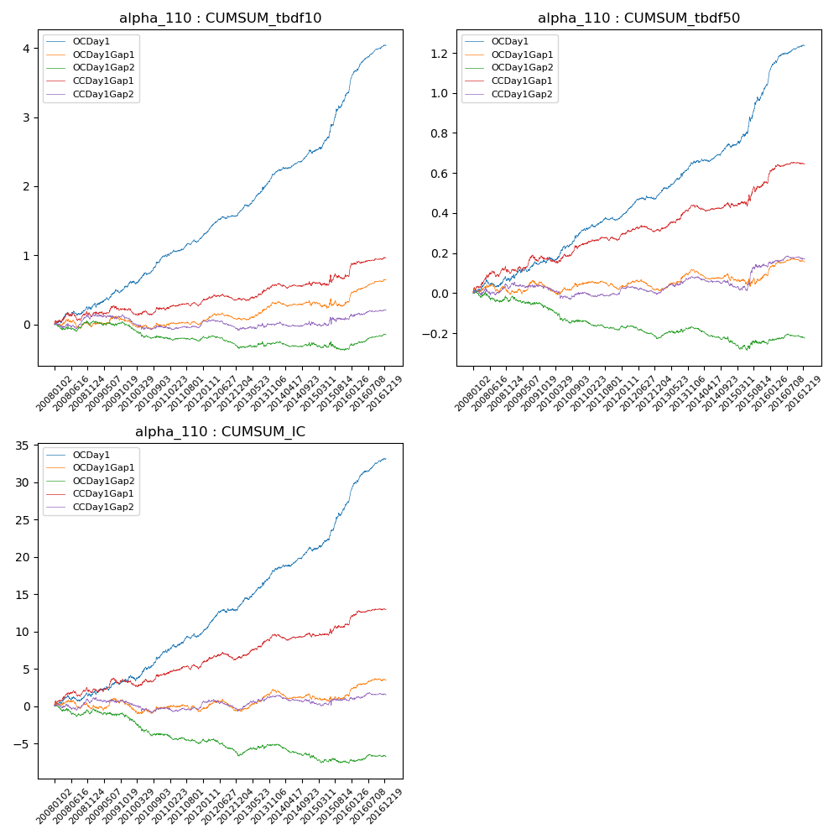

**因子换手率:** 70.19%

**截面指标_OCDay1:**

|  |  |  |  |  |  |  |  |  |
| --- | --- | --- | --- | --- | --- | --- | --- | --- |
| year | annret_tbdf10 | sharpe_tbdf10 | maxdd_tbdf10 | annret_tbdf50 | sharpe_tbdf50 | maxdd_tbdf50 | mean_IC | tstat_IC |
| 2008 | 0.24 | 1.91 | -0.06 | 0.06 | 1.34 | -0.04 | 0.01 | 1.36 |
| 2009 | 0.34 | 3.02 | -0.06 | 0.1 | 2.13 | -0.02 | 0.01 | 1.99 |
| 2010 | 0.42 | 3.87 | -0.05 | 0.15 | 3.5 | -0.02 | 0.01 | 3.07 |
| 2011 | 0.27 | 3.6 | -0.04 | 0.06 | 2.15 | -0.02 | 0.01 | 2.73 |
| 2012 | 0.36 | 4.63 | -0.03 | 0.11 | 3.65 | -0.02 | 0.01 | 3.72 |
| 2013 | 0.58 | 5.54 | -0.04 | 0.17 | 4.66 | -0.01 | 0.02 | 4.82 |
| 2014 | 0.31 | 3.77 | -0.05 | 0.08 | 2.51 | -0.02 | 0.01 | 3.08 |
| 2015 | 0.89 | 5.9 | -0.03 | 0.32 | 4.86 | -0.02 | 0.03 | 5.53 |
| 2016 | 0.67 | 7.37 | -0.03 | 0.19 | 5.75 | -0.01 | 0.02 | 6.83 |

**截面指标_CCDay1Gap1:**

|  |  |  |  |  |  |  |  |  |
| --- | --- | --- | --- | --- | --- | --- | --- | --- |
| year | annret_tbdf10 | sharpe_tbdf10 | maxdd_tbdf10 | annret_tbdf50 | sharpe_tbdf50 | maxdd_tbdf50 | mean_IC | tstat_IC |
| 2008 | 0.12 | 0.96 | -0.11 | 0.1 | 2.04 | -0.03 | 0.01 | 1.86 |
| 2009 | 0.11 | 0.98 | -0.07 | 0.07 | 1.73 | -0.03 | 0.01 | 1.46 |
| 2010 | -0.01 | -0.15 | -0.1 | 0.07 | 1.7 | -0.03 | 0.0 | 0.94 |
| 2011 | 0.13 | 1.79 | -0.05 | 0.05 | 1.61 | -0.02 | 0.01 | 1.88 |
| 2012 | 0.05 | 0.61 | -0.09 | 0.03 | 1.07 | -0.03 | 0.0 | 1.07 |
| 2013 | 0.19 | 2.11 | -0.04 | 0.12 | 3.52 | -0.01 | 0.01 | 3.39 |
| 2014 | 0.02 | 0.24 | -0.07 | -0.0 | -0.06 | -0.03 | -0.0 | -0.16 |
| 2015 | 0.12 | 0.83 | -0.11 | 0.11 | 1.94 | -0.03 | 0.01 | 1.46 |
| 2016 | 0.26 | 2.79 | -0.03 | 0.09 | 2.79 | -0.01 | 0.01 | 2.63 |

**风格暴露:**

|  |  |  |  |  |
| --- | --- | --- | --- | --- |
|  | long | short | corr_OCDay1 | corr_CCDay1Gap1 |
| liquidity10 | 0.01 | -0.01 | -0.02 | -0.0 |
| liquidity20 | 0.01 | -0.0 | -0.04 | -0.0 |
| liquidity5 | 0.03 | -0.03 | 0.01 | 0.02 |
| logmktcap | 0.01 | -0.0 | 0.01 | 0.0 |
| momentum15 | 0.12 | -0.11 | 0.06 | 0.02 |
| momentum30 | 0.08 | -0.08 | -0.01 | -0.03 |
| momentum5 | 0.2 | -0.19 | 0.19 | 0.13 |
| retvolatility30 | 0.01 | -0.0 | -0.04 | 0.02 |