Factors Report 20080102-20161230

**1. alpha_170**

**截面指标累计曲线:**

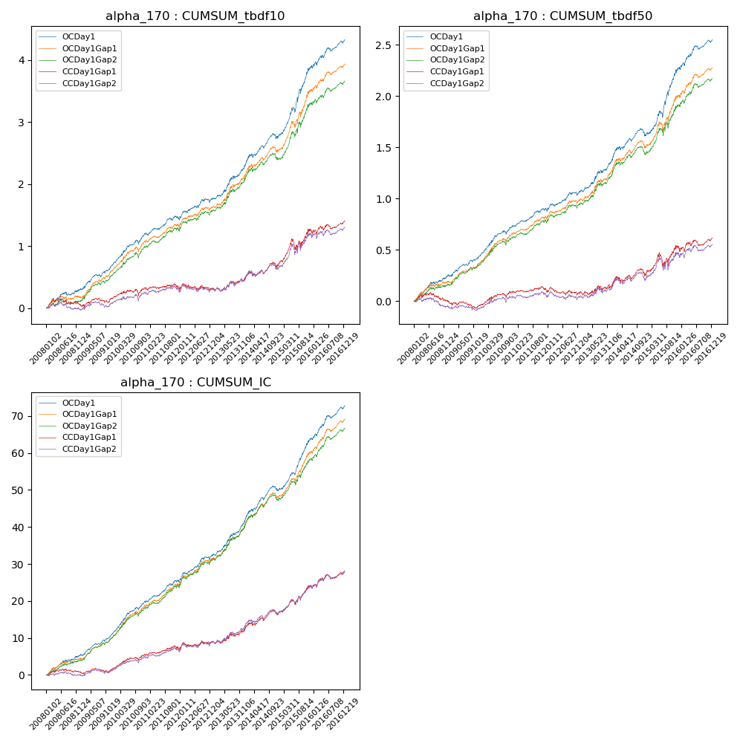

**因子换手率:** 21.29%

**截面指标_OCDay1:**

|  |  |  |  |  |  |  |  |  |
| --- | --- | --- | --- | --- | --- | --- | --- | --- |
| year | annret_tbdf10 | sharpe_tbdf10 | maxdd_tbdf10 | annret_tbdf50 | sharpe_tbdf50 | maxdd_tbdf50 | mean_IC | tstat_IC |
| 2008 | 0.3 | 2.77 | -0.05 | 0.24 | 3.57 | -0.03 | 0.02 | 4.04 |
| 2009 | 0.41 | 4.48 | -0.04 | 0.21 | 3.93 | -0.02 | 0.02 | 5.31 |
| 2010 | 0.5 | 4.86 | -0.07 | 0.29 | 4.62 | -0.04 | 0.04 | 5.75 |
| 2011 | 0.22 | 2.6 | -0.05 | 0.15 | 3.1 | -0.02 | 0.02 | 3.74 |
| 2012 | 0.33 | 3.0 | -0.06 | 0.18 | 3.04 | -0.03 | 0.03 | 4.11 |
| 2013 | 0.56 | 3.92 | -0.04 | 0.33 | 3.88 | -0.03 | 0.04 | 4.72 |
| 2014 | 0.46 | 3.58 | -0.08 | 0.23 | 2.91 | -0.07 | 0.03 | 4.3 |
| 2015 | 1.13 | 5.68 | -0.08 | 0.66 | 5.32 | -0.06 | 0.06 | 6.66 |
| 2016 | 0.45 | 3.46 | -0.06 | 0.28 | 3.64 | -0.04 | 0.04 | 4.92 |

**截面指标_CCDay1Gap1:**

|  |  |  |  |  |  |  |  |  |
| --- | --- | --- | --- | --- | --- | --- | --- | --- |
| year | annret_tbdf10 | sharpe_tbdf10 | maxdd_tbdf10 | annret_tbdf50 | sharpe_tbdf50 | maxdd_tbdf50 | mean_IC | tstat_IC |
| 2008 | 0.05 | 0.49 | -0.1 | -0.0 | -0.01 | -0.08 | 0.0 | 0.66 |
| 2009 | 0.11 | 1.09 | -0.07 | -0.04 | -0.68 | -0.07 | 0.0 | 0.88 |
| 2010 | 0.17 | 1.58 | -0.1 | 0.13 | 2.08 | -0.04 | 0.02 | 2.9 |
| 2011 | -0.04 | -0.43 | -0.09 | -0.01 | -0.26 | -0.06 | 0.0 | 0.76 |
| 2012 | 0.02 | 0.18 | -0.12 | -0.0 | -0.05 | -0.08 | 0.01 | 1.34 |
| 2013 | 0.17 | 1.13 | -0.06 | 0.09 | 0.98 | -0.05 | 0.02 | 1.81 |
| 2014 | 0.23 | 1.7 | -0.09 | 0.1 | 1.22 | -0.07 | 0.02 | 2.27 |
| 2015 | 0.53 | 2.47 | -0.18 | 0.24 | 1.78 | -0.14 | 0.03 | 3.52 |
| 2016 | 0.18 | 1.45 | -0.07 | 0.11 | 1.4 | -0.05 | 0.02 | 2.59 |

**风格暴露:**

|  |  |  |  |  |
| --- | --- | --- | --- | --- |
|  | long | short | corr_OCDay1 | corr_CCDay1Gap1 |
| liquidity10 | -1.14 | 1.14 | 0.76 | 0.77 |
| liquidity20 | -1.15 | 1.16 | 0.78 | 0.78 |
| liquidity5 | -1.08 | 1.08 | 0.76 | 0.76 |
| logmktcap | 1.15 | -1.14 | -0.64 | -0.67 |
| momentum15 | -0.24 | 0.24 | 0.15 | 0.13 |
| momentum30 | -0.32 | 0.33 | 0.21 | 0.17 |
| momentum5 | -0.05 | 0.06 | 0.02 | 0.02 |
| retvolatility30 | -1.26 | 1.27 | 0.81 | 0.81 |