Factors Report 20080102-20161230

**1. alpha_104**

**截面指标累计曲线:**

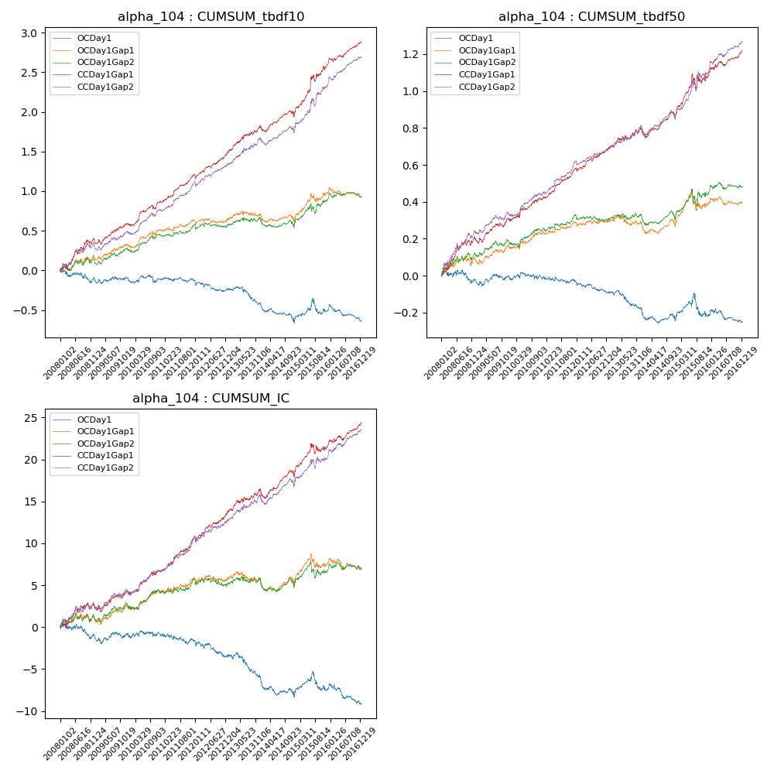

**因子换手率:** 37.39%

**截面指标_OCDay1:**

|  |  |  |  |  |  |  |  |  |
| --- | --- | --- | --- | --- | --- | --- | --- | --- |
| year | annret_tbdf10 | sharpe_tbdf10 | maxdd_tbdf10 | annret_tbdf50 | sharpe_tbdf50 | maxdd_tbdf50 | mean_IC | tstat_IC |
| 2008 | -0.09 | -0.68 | -0.16 | -0.02 | -0.29 | -0.07 | -0.0 | -0.62 |
| 2009 | -0.0 | -0.04 | -0.08 | 0.02 | 0.37 | -0.04 | 0.0 | 0.07 |
| 2010 | -0.02 | -0.2 | -0.1 | -0.01 | -0.27 | -0.04 | -0.0 | -0.18 |
| 2011 | -0.01 | -0.14 | -0.06 | -0.01 | -0.35 | -0.04 | -0.0 | -0.56 |
| 2012 | -0.11 | -1.3 | -0.14 | -0.06 | -1.6 | -0.07 | -0.01 | -1.62 |
| 2013 | -0.2 | -1.91 | -0.21 | -0.1 | -2.0 | -0.1 | -0.01 | -2.2 |
| 2014 | -0.24 | -2.58 | -0.22 | -0.06 | -1.35 | -0.07 | -0.01 | -2.03 |
| 2015 | 0.17 | 1.01 | -0.19 | 0.04 | 0.4 | -0.12 | 0.0 | 0.69 |
| 2016 | -0.14 | -1.73 | -0.2 | -0.04 | -0.92 | -0.07 | -0.01 | -1.69 |

**截面指标_CCDay1Gap1:**

|  |  |  |  |  |  |  |  |  |
| --- | --- | --- | --- | --- | --- | --- | --- | --- |
| year | annret_tbdf10 | sharpe_tbdf10 | maxdd_tbdf10 | annret_tbdf50 | sharpe_tbdf50 | maxdd_tbdf50 | mean_IC | tstat_IC |
| 2008 | 0.39 | 2.9 | -0.05 | 0.2 | 2.91 | -0.03 | 0.01 | 2.01 |
| 2009 | 0.2 | 2.1 | -0.06 | 0.11 | 2.37 | -0.03 | 0.01 | 1.66 |
| 2010 | 0.27 | 2.85 | -0.05 | 0.1 | 2.11 | -0.02 | 0.01 | 2.31 |
| 2011 | 0.35 | 4.62 | -0.02 | 0.17 | 4.38 | -0.01 | 0.02 | 4.35 |
| 2012 | 0.28 | 3.45 | -0.06 | 0.11 | 2.94 | -0.02 | 0.01 | 2.74 |
| 2013 | 0.33 | 3.02 | -0.03 | 0.1 | 1.87 | -0.02 | 0.01 | 1.98 |
| 2014 | 0.16 | 1.68 | -0.08 | 0.08 | 1.64 | -0.04 | 0.01 | 1.95 |
| 2015 | 0.63 | 3.72 | -0.09 | 0.23 | 2.29 | -0.08 | 0.01 | 2.1 |
| 2016 | 0.29 | 3.55 | -0.04 | 0.13 | 2.96 | -0.02 | 0.01 | 2.98 |

**风格暴露:**

|  |  |  |  |  |
| --- | --- | --- | --- | --- |
|  | long | short | corr_OCDay1 | corr_CCDay1Gap1 |
| liquidity10 | 0.56 | -0.55 | -0.59 | -0.57 |
| liquidity20 | 0.5 | -0.49 | -0.55 | -0.54 |
| liquidity5 | 0.59 | -0.58 | -0.61 | -0.57 |
| logmktcap | -0.13 | 0.14 | 0.18 | 0.2 |
| momentum15 | 0.45 | -0.44 | -0.49 | -0.45 |
| momentum30 | 0.33 | -0.32 | -0.42 | -0.42 |
| momentum5 | 0.44 | -0.43 | -0.34 | -0.27 |
| retvolatility30 | 0.4 | -0.4 | -0.43 | -0.41 |