**ASSIGNMENT COVER SHEET**

For use with online submission of assignments

Please complete all of the following details and then make this sheet the **first page of each file of your assignment – do not send it as a separate document.**

Your assignments must be submitted as either **Word documents, text documents with .rtf extension or as .pdf documents**. If you wish tosubmit in any other file format please discuss this with your lecturer well before theassignment submission date.

|  |  |
| --- | --- |
| Student Name: | **Ziyu Fei** |
| Student ID No.: | **24274656** |
| Unit Name: | ISYS3001 Managing Software Development |
| Unit Code: | ISYS3001 |
| Tutor’s name: | **Zhenjin Huang** |
| Assignment No.: | Assessment 2 |
| Assignment Title: | Practical Skills |
| Due date: | 22 September 2022 11:59 PM (AEST) |
| Date submitted: | **2023/9/25** |

Declaration:

*I have read and understand the Rules Relating to Awards ([Rule 3 Section 18 – Academic Misconduct Including Plagiarism](http://policies.scu.edu.au/view.current.php?id=00140" \l "s18)) as contained in the SCU Policy Library.   
I understand the penalties that apply for plagiarism and agree to be bound by these rules. The work I am submitting electronically is entirely my own work.*

|  |  |
| --- | --- |
| Signed: |  |
| (please type your name) |  |
| Date: |  |

# **（Screenshot presentation of GitHub.）**

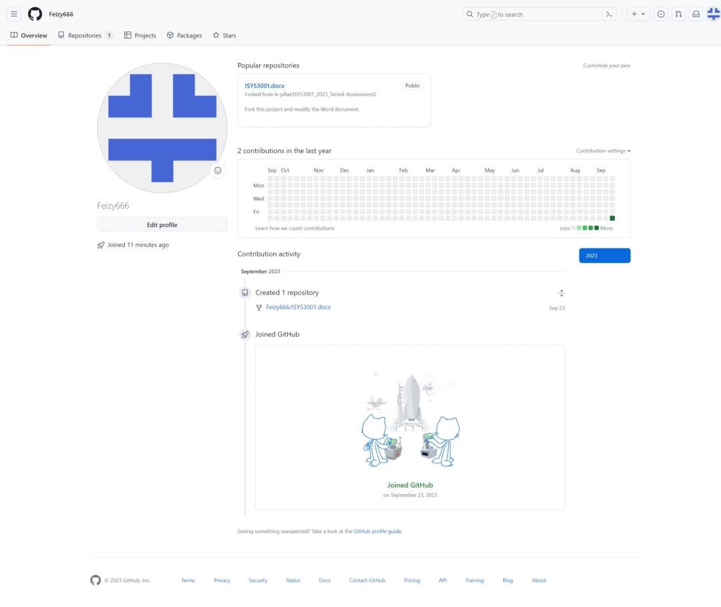

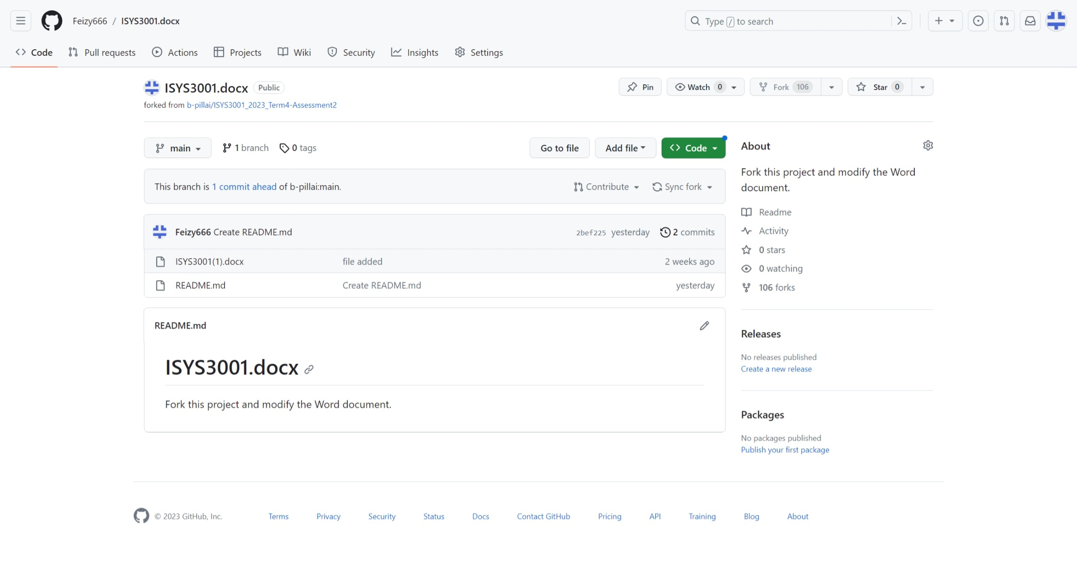

# *configuration management*

In order to simplify the development process and improve software development efficiency, the company provides the following suggestions for product deployment.

## *Change Management*

Firstly, conduct change analysis. In order to ensure that changes are controllable, software developers need to fully analyze the information of changes and measure the impact of change implementation on events; The second step is to conduct a change review, change information, and analyze issues related to software development; The third step in implementing change is to ensure that the software development and implementation are complete and thorough, followed by the change verification process, which aims to fully imitate the actual environment for verification and discover relevant change parties. The final change record mainly records the change control process and implementation process of the entire software development to ensure that the change process can be traced and experience can be formed.

## *Version management*

Generate new versions of the software. Centralized coordination and management of old versions of various software, adhering to recording the evolution process and various black holes of different versions, and managing different versions to record as little data as possible for each version. Software managers also need to ensure the logical consistency and relative independence of different versions of the software, so that the generation and disappearance of one version will not affect the content of subsequent versions. When switching versions, software users must ensure that the image of the object remains completely consistent with the specified version after specifying a new current version.

## 3.System building

Creating a system that can operate independently and has a good ecological health, such as continuous integration.In the process of information system development, the process of planning, designing, developing, testing, implementing, and maintaining the system using certain methodologies and technical means. Thus allowing developers to address these issues in time. Systems approaches like continuous integration allow early detection of conflict and facilitate ongoing collaboration throughout the development life cycle.This is a system engineering project that requires a series of methods and technical means to ensure the quality and reliability of the system. In the process of building an information system, attention needs to be paid to requirements analysis, system design, coding implementation, testing and verification, system implementation, and system maintenance in order to build a high-quality, reliable, and maintainable information system.

## 4.Release management

Release management is the stage where programmers supervise the development, testing, deployment, and support of software releases. Release management is very meaningful, as it is a service for protecting the living environment of software and using formal programs and inspections.Software developers should provide the most comprehensive end-to-end solution based on the company's situation, for planning, tracking, and publishing applications into production environments. With these products, companies can improve release visibility, increase release processes, reduce production downtime, and simplify compliance.For example, Deployment Automation can seamlessly automate deployment channels, shorten cycle time, and provide quick feedback on deployment and publishing throughout the entire environment. To support continuous delivery and production deployment, it provides the ability to automate the deployment and configuration of applications or services to the target environment in the deployment channel.

# *Request for Proposal (RFP)*

## Partner: Aussie Business Buzz (ABB)

# *Content*

|  |
| --- |
| 1.introduce |
| 2. Task object |
| *3.Partner requirements* |
| *4.technical requirement* |
| *5.Requirements proposed by the contractor* |
| *6.Fund composition* |
| *7.Implementation plan* |
| *8.Planned time* |
| *9.Submission address* |
| *10.Final Statement* |

## 1.introduce

This is Business Buzz (ABB) company in Australia, which sells digital products such as personal computers, laptops, telephones, routers, and provides digital repair and mobile device accessories. We also have 4 stores. In order to achieve sustainable development and expand business scale, there is an urgent need for an excellent and comprehensive integrated system to help the company achieve new goals. This request for proposal is hereby issued for assistance. Below are my requirements for the new integrated system. Please read them carefully.

2. Task object

**This proposal is to create an automated and self-healing integrated system for ABB to assist in the company's operational development. The following are the basic requirements for the new system:**

## *system description*

|  |  |
| --- | --- |
| ***System*** | ***Function*** |
| **Customer Relationship Database** | 1. Private storage of customer basic information (purchase records and transaction information) 2. Provide after-sales service and maintain repair records 3. Collect customer product reviews |
| **complete digital marketing system that connects online and offline** | 1. Building a complete digital marketing system that connects online and offline(Taobao Amazon) 2. Marketing system and database interoperability, big data recommendation |
| **inventory management system** | 1. Query inventory surplus and respond to various situations 2. Record the entry and exit records of goods 3. Integrated management of goods procurement, sales, inventory, financial receipt and payment, and customer accounts |
| **business communication system** | 1. Establish connections between various departments such as marketing, after-sales, and finance to avoid unexpected situations. 2. Ordering inventory, recruiting employees, and making other management decisions Policy |
| **information system for in-service personnel** | 1. Record employee salaries and bonus income 2. Record the company's financial expenses and profit and loss situation |

**Supplement**

The above are some requirements for the new integrated system that I have developed based on the company's needs. Our company hopes that the system has the advantages of strong interaction ability, wide coverage, and high execution efficiency. It can help ABB solve most of its current problems and also help the company expand in other areas in the future. It should ensure the efficient operation and data consistency of each branch, and seamless integration is a good choice.

## *Partner requirements*

**In order to achieve friendly cooperation, we have made the following requirements for the contractor:**

1. Contractors need to have 3-5 years of work experience.(It is best to list the outstanding achievements and cooperation backgrounds of the past decade)
2. Contractors are not allowed to have dishonest records.
3. After signing the agreement, the contractor should modify the new system according to our requirements.
4. Describe the supplier's experience and cognitive system in integrated systems, with a solid theoretical foundation

## *technical requirement*

**Contractors should develop new systems in accordance with the above basic requirements, and welcome new ideas and any solutions that are beneficial to the new system,There are several requirements:**

1. Integration: The system should support mutual communication between various parts, achieve data synchronization and integrity, and form an organic whole.
2. User interface: The system should have a clean and clear UI interface, and should not be too bright. Enable employees in various departments to easily navigate and submit work.
3. Data security: The system should ensure the top confidentiality and security of company information, and customer information also needs to be securely stored. A database should be added to prevent overload situations from occurring.
4. Transaction security: Add a transaction security channel to ensure safe transactions with customers.

## *(Additional)*

1. *The new system produced must comply with legal norms and be produced in accordance with legal procedures.*
2. *The budget is around 2 million yuan, and any new additional conditions will be discussed separately.*

## *Requirements proposed by the contractor*

**Our expectations for the new integrated system have some unreasonable settings. Contractors are welcome to raise constructive questions about the preset of our new system. If there are any issues, please point them out and provide suggestions. We can change our expectations for any shortcomings.**

1. We will adopt the suggestions and requirements as much as possible.
2. After reaching a preliminary cooperation agreement with the contractor, we will produce a more reasonable and detailed cooperation document.

## *Fund composition*

1. We will provide a detailed expenditure list, including expenses for raw material procurement, project development, project licensing, system maintenance, etc.
2. Award bonuses based on work efficiency and project expectations.

## *7.Implementation plan:*

I.Evaluate human resources, expected materials, salary settlement, and other budgets

II.Detailed management, SOP pipeline operation

## *8.Planned time:*

A) RFP Release Date: [September 24, 2023]

B) Proposal submission deadline: [October 25, 2023]

C) Supplier Selection and Notification: [October 25, 2023]

D) Project launch time: [November 9, 2023]

Declaration: ABB reserves the right to accept or reject any proposal, inquire or clarify, and modify options

## *9.Submission address:*

Suppliers who wish to participate in the cooperation should submit their proposal in electronic format (DOCX) to the【 2543190260@qq.com 】Submit a proposal. Overdue not waiting!

## *Final Statement*

**The review will be conducted according to the following guidelines:**

Firstly, meet ABB's expectations and concepts. Secondly, the proposed solution has technical feasibility and scalability. Finally, we will choose the group with the highest price competitiveness and cost-effectiveness. We hope that all companies will actively contribute and point out our existing problems. Win-win cooperation is our philosophy. Thank you!