|  |
| --- |
| FIRE BREATHING RUBBER DUCKIES |
| Tank Shooter |
| **A lone tank defending an entire squadron of sleeping soldiers.** |
| Version #0.5  All work Copyright © 2013 by Breathing Fire Rubber Duckies.  All rights reserved. |
| **Chris Bentley & Joel Murphy** |
|  |



|  |
| --- |
| August 8th 2012 |

Contents

Version History 3

Game Description 4

Controls 4

Interface Sketch 5

Screen Descriptions 6

Characters / Vehicles 7

Enemies 7

Scoring 8

Sound Index 8

Art/Multimedia Index 9

**Version History**

Current Version History can be seen at <https://github.com/Felanrod/Python_ProjectA_With_Chris_B>

**Game Description**

Tank Shooter is a shooter game in which you take control of a tank while you defend your HQ from soldiers that are trying to destroy HQ. You control your tank directly from a bird’s eye view and are capable of shooting to the infantry that approaches.

**Controls**

The player moves their tank forward and backwards with ‘W’ and ‘S’ buttons. They make the tank rotate left or right with the ‘A’ and ‘D’ buttons. The player aims the tank’s barrel with the mouse and fires shells with the ‘SPACEBAR’.

**Interface Sketch**

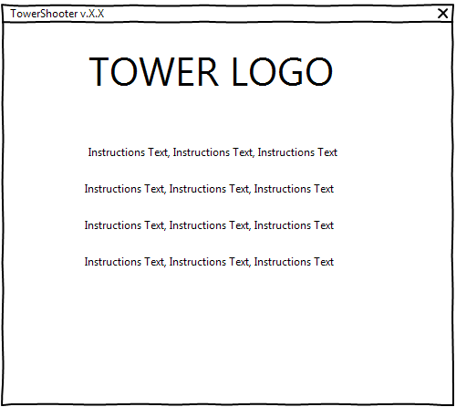

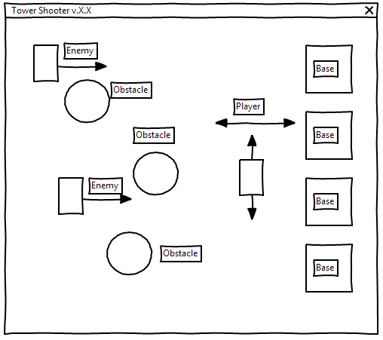

**Screen Descriptions**

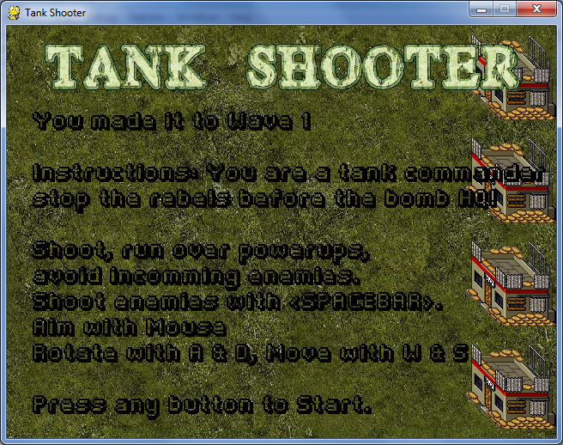

Introductory Screen and End Screen, a simple screen that displays the players controls is shown so the player knows how to play and what to defend.

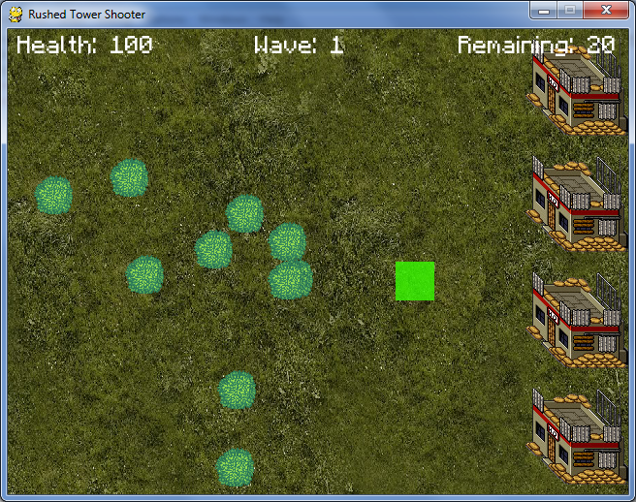

A remnant of our previous game, a grid allows the player to select it’s spawning location for the start of the game. After selecting a location the game starts. You can’t spawn in trees.

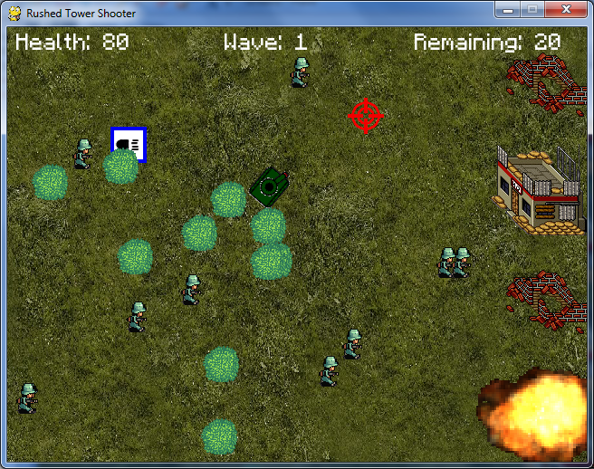

Game screen, this is where the game is played. Enemies come from the left trying to destroy your base. You can stop them by shooting at them.

**Characters / Vehicles**

The player is a tank. The tank has slow turning speed, and can only go in the direction it’s facing and it’s opposite. To maneuver the tank it must be rotated, however the cannon has free aim to wherever the mouse is pointed.

**Enemies**

The enemies are very simple AI that appear at a random location in the Y axis in the left side of the screen and constantly move towards the left, if they touch an intact HQ, they will detonate it. The enemies gain cover from trees making them impossible to shoot. Due to complications the only enemy in the game is a lightweight and will die in one shot.

**Scoring**

The scoring is based on how many waves you’ve lasted, each wave consists of destroying 20 enemy units, once 20 enemies have been destroyed you advance to the next wave, if all of your HQ’s are destroyed or if your tank takes too much damage, you lose and your game ends.

**Sound Index**

test.wav  
Music track for game.

**Art/Multimedia Index**



    