1) importo v.š. tikrinimas:

> library(urca)

> plot(log(iki))

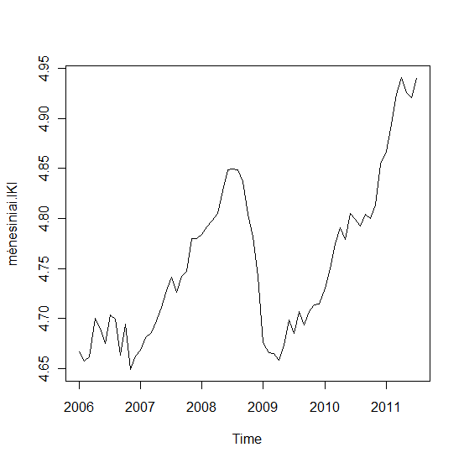

> liki.df=ur.df(log(iki),lags=5,selectlags="BIC",type="trend")

# parinkau trend, kadangi procesas panašus svyruojanytis apie tiesę

> summary(liki.df)

###############################################

# Augmented Dickey-Fuller Test Unit Root Test #

###############################################

Test regression trend

Call:

lm(formula = z.diff ~ z.lag.1 + 1 + tt + z.diff.lag)

Residuals:

Min 1Q Median 3Q Max

-0.046867 -0.009031 0.002292 0.010139 0.034616

Coefficients:

Estimate Std. Error t value Pr(>|t|)

(Intercept) 0.5509559 0.2030500 2.713 0.00887 **

z.lag.1 -0.1179118 0.0434605 -2.713 0.00888 **

tt 0.0003201 0.0001675 1.911 0.06123 .

z.diff.lag1 0.0889354 0.1225646 0.726 0.47115

z.diff.lag2 0.3120655 0.1229054 2.539 0.01397 *

z.diff.lag3 0.3646364 0.1275087 2.860 0.00598 **

---

Signif. codes: 0 ‘***’ 0.001 ‘**’ 0.01 ‘*’ 0.05 ‘.’ 0.1 ‘ ’ 1

Residual standard error: 0.0182 on 55 degrees of freedom

Multiple R-squared: 0.2607, Adjusted R-squared: 0.1935

F-statistic: 3.879 on 5 and 55 DF, p-value: 0.004406

Value of test-statistic is: -2.7131 2.7525 3.756

Critical values for test statistics:

1pct 5pct 10pct

tau3 -4.04 -3.45 -3.15

phi2 6.50 4.88 4.16

phi3 8.73 6.49 5.47

# testo reikšme (t-value prie z.lag.1) yra didesnė už 5% kritinę reikšmę (-2.713>-3.45), todėl procesas liki=log(iki) turi vienetinę šaknį, tik nežinau ar palikti trendą, kadangi p reikšmė pakankamai didelė.

2) vki v.š. tikrinimas:

> vkii=read.csv('C:/Users/Almute/paskaitom/pasiruošimas kursiniam darbui/data1/vki2.csv')

> vkii=vkii[,-1]

> vkii=ts(vkii,start=1991,freq=12)

> vki=window(vkii,start=2006,end=c(2011,7),freq=12)

> lvki=log(vki)

> plot(log(vki))

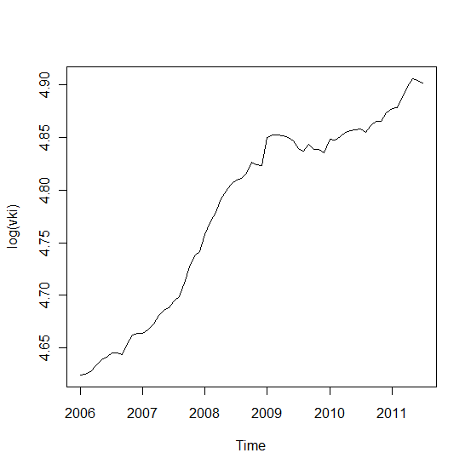

> lvki.df=ur.df(log(vki),lags=5,selectlags="BIC",type="drift")

# parinkau drift, kadangi procesas panašus į atsitiktinį klaidžiojimą su dreifu

> summary(lvki.df)

###############################################

# Augmented Dickey-Fuller Test Unit Root Test #

###############################################

Test regression drift

Call:

lm(formula = z.diff ~ z.lag.1 + 1 + z.diff.lag)

Residuals:

Min 1Q Median 3Q Max

-0.009496 -0.003595 -0.001457 0.003382 0.024025

Coefficients:

Estimate Std. Error t value Pr(>|t|)

(Intercept) 0.07550 0.04374 1.726 0.0896 .

z.lag.1 -0.01506 0.00911 -1.653 0.1036

z.diff.lag 0.22144 0.12661 1.749 0.0856 .

---

Signif. codes: 0 ‘***’ 0.001 ‘**’ 0.01 ‘*’ 0.05 ‘.’ 0.1 ‘ ’ 1

Residual standard error: 0.005787 on 58 degrees of freedom

Multiple R-squared: 0.103, Adjusted R-squared: 0.0721

F-statistic: 3.331 on 2 and 58 DF, p-value: 0.04272

Value of test-statistic is: -1.6534 7.405

Critical values for test statistics:

1pct 5pct 10pct

tau2 -3.51 -2.89 -2.58

phi1 6.70 4.71 3.86

# kadangi testo t statistika yra didesnė nei 5 % kritinė reikšmė (-1.653 > -2.89), tai nėra pagrindo atmesti $H_{0}$: procesas turi vienetinę šaknį.

3) palūkanų normos v.š. tikrinimas:

> pal=read.csv('C:/Users/Almute/paskaitom/pasiruošimas kursiniam darbui/data1/pal.csv',header=T)

> pal=ts(pal,start=c(2004,10),freq=12)

> pal=window(pal,start=c(2006,1),end=c(2011,7),freq=12)

> lpal=log(pal)

> plot(log(pal))

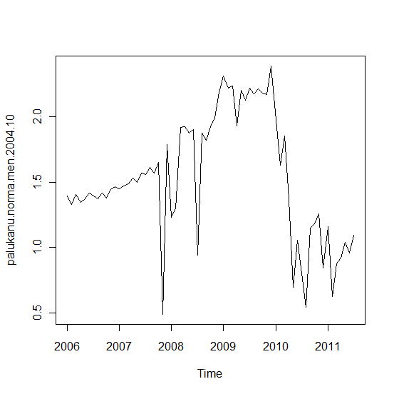

> lpal.df=ur.df(log(pal),lags=5,selectlags="BIC",type="drift")

# parinkau drift, kadangi procesas panašus į su nenuliniu vidurkiu ar(1) procesą (įtariama, kad tai atsitiktinis klaidžiojimas su dreifu)

> summary(lpal.df)

###############################################

# Augmented Dickey-Fuller Test Unit Root Test #

###############################################

Test regression drift

Call:

lm(formula = z.diff ~ z.lag.1 + 1 + z.diff.lag)

Residuals:

Min 1Q Median 3Q Max

-1.10465 -0.04406 0.04118 0.11963 0.66004

Coefficients:

Estimate Std. Error t value Pr(>|t|)

(Intercept) 0.22546 0.14599 1.544 0.127935

z.lag.1 -0.15049 0.09006 -1.671 0.100114

z.diff.lag -0.42054 0.12077 -3.482 0.000953 ***

---

Signif. codes: 0 ‘***’ 0.001 ‘**’ 0.01 ‘*’ 0.05 ‘.’ 0.1 ‘ ’ 1

Residual standard error: 0.3185 on 58 degrees of freedom

Multiple R-squared: 0.2828, Adjusted R-squared: 0.2581

F-statistic: 11.43 on 2 and 58 DF, p-value: 6.513e-05

Value of test-statistic is: -1.671 1.4192

Critical values for test statistics:

1pct 5pct 10pct

tau2 -3.51 -2.89 -2.58

phi1 6.70 4.71 3.86

# kadangi testo t statistika yra didesnė nei 5 % kritinė reikšmė (-1.671 > -2.89), tai nėra pagrindo atmesti $H_{0}$: procesas turi vienetinę šaknį.

4) minimalaus atlyginimo v.š. tikrinimas:

> min=read.csv('C:/Users/Almute/paskaitom/pasiruošimas kursiniam darbui/data1/min alga.csv',header=F)

> min=ts(min,start=1995,freq=12)

> min=window(min,start=2006,end=c(2011,7),freq=12)

> min=min[,-1]

> lmin=log(min)

> plot(log(min))

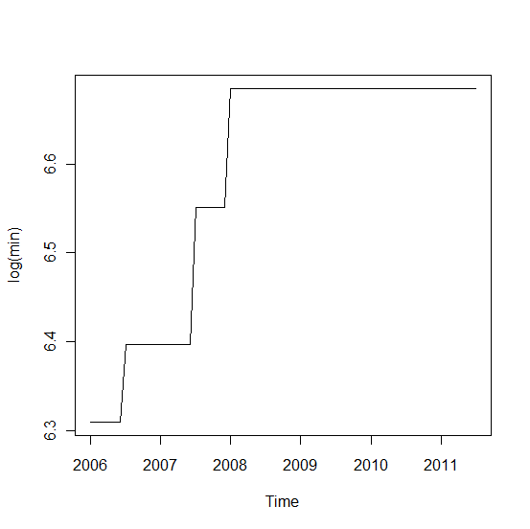

> lmin.df=ur.df(log(min),lags=5,selectlags="BIC",type="none")

> summary(lmin.df)

###############################################

# Augmented Dickey-Fuller Test Unit Root Test #

###############################################

Test regression none

Call:

lm(formula = z.diff ~ z.lag.1 - 1 + z.diff.lag)

Residuals:

Min 1Q Median 3Q Max

-0.006337 -0.006337 -0.006337 -0.006064 0.148086

Coefficients:

Estimate Std. Error t value Pr(>|t|)

z.lag.1 0.0009480 0.0005591 1.696 0.0952 .

z.diff.lag -0.0474165 0.1301672 -0.364 0.7170

---

Signif. codes: 0 ‘***’ 0.001 ‘**’ 0.01 ‘*’ 0.05 ‘.’ 0.1 ‘ ’ 1

Residual standard error: 0.02819 on 59 degrees of freedom

Multiple R-squared: 0.04647, Adjusted R-squared: 0.01415

F-statistic: 1.438 on 2 and 59 DF, p-value: 0.2457

Value of test-statistic is: 1.6957

Critical values for test statistics:

1pct 5pct 10pct

tau1 -2.6 -1.95 -1.61

# kadangi testo t statistika yra didesnė nei 5 % kritinė reikšmė (1.696 > -1.95), tai nėra pagrindo atmesti $H_{0}$: procesas turi vienetinę šaknį.

5) naftos kainos v.š. tikrinimas:

> nk=read.csv('C:/Users/Almute/paskaitom/pasiruošimas kursiniam darbui/data1/oil.txt',header=T)

> nk=ts(nk,start=2006,freq=12)

> nk=nk[,-1]

> lnk=log(nk)

> plot(log(nk))

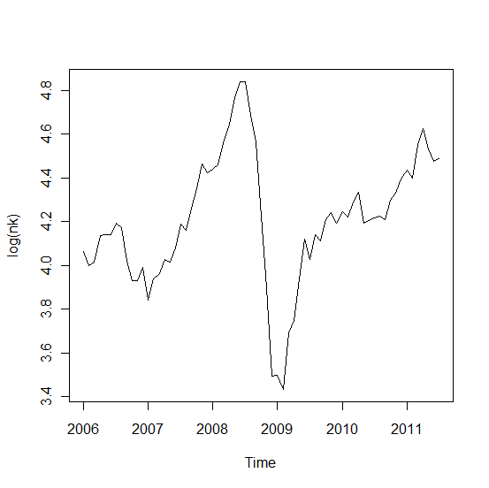

> lnk.df=ur.df(log(nk),lags=5,selectlags="BIC",type="drift")

> summary(lnk.df)

###############################################

# Augmented Dickey-Fuller Test Unit Root Test #

###############################################

Test regression drift

Call:

lm(formula = z.diff ~ z.lag.1 + 1 + z.diff.lag)

Residuals:

Min 1Q Median 3Q Max

-0.24644 -0.04402 0.02049 0.06178 0.17558

Coefficients:

Estimate Std. Error t value Pr(>|t|)

(Intercept) 0.65834 0.18866 3.490 0.000940 ***

z.lag.1 -0.15591 0.04474 -3.485 0.000954 ***

z.diff.lag1 0.32736 0.11640 2.812 0.006736 **

z.diff.lag2 0.40216 0.12316 3.265 0.001852 **

---

Signif. codes: 0 ‘***’ 0.001 ‘**’ 0.01 ‘*’ 0.05 ‘.’ 0.1 ‘ ’ 1

Residual standard error: 0.09775 on 57 degrees of freedom

Multiple R-squared: 0.3594, Adjusted R-squared: 0.3257

F-statistic: 10.66 on 3 and 57 DF, p-value: 1.158e-05

Value of test-statistic is: -3.485 6.0896

Critical values for test statistics:

1pct 5pct 10pct

tau2 -3.51 -2.89 -2.58

phi1 6.70 4.71 3.86

# kadangi testo t statistika nėra didesnė nei 5 % kritinė reikšmė (-2.89 > -3.485), tai su 5% tikimybe $H_{0}$:‘ procesas turi vienetinę šaknį ‘ atmetame.