Advanced Softwareengineering

Pet Project

Game Decision Tree

Felicitas König

(Matr-No. 886778)

Inhalt

1. Introduction 2

2. UML 2

2.1 Activity Diagram 2

3. Metrics 3

4. Clean Code Development 3

5. Build Management 3

6. Continuous Delivery 3

7. DSL 3

8. Functional Programming 3

# Introduction

The Game Decision Tree is a little program which should help to find a decision regarding to the evening or weekend plans. For now, the game is designed for two players and includes two steps of decisions. First the players choose one of three categories that reflects their mood. If they have chosen the same one, the game comes directly to the next step. If the chosen categories are different tic tac toe is played. A coin toss decides who may start first. After the category is chosen via tic tac toe, the players select an actual activity within this category. Is this option again the same, there is no need to compromise. However, if the activities are different, the players have to find a decision via rock-paper-scissors. Finally, you will have an independently decided evening or weekend plan and hopefully have a lot of fun.

The Game Decision Tree is still a very rudimental version and could be extended by e.g. more players, a whole data base of activities or concrete events/restaurants/other places in a specific city.

# UML

The UML diagrams a made with draw.io.

File: pet-project\uml

## 2.1 Activity Diagram

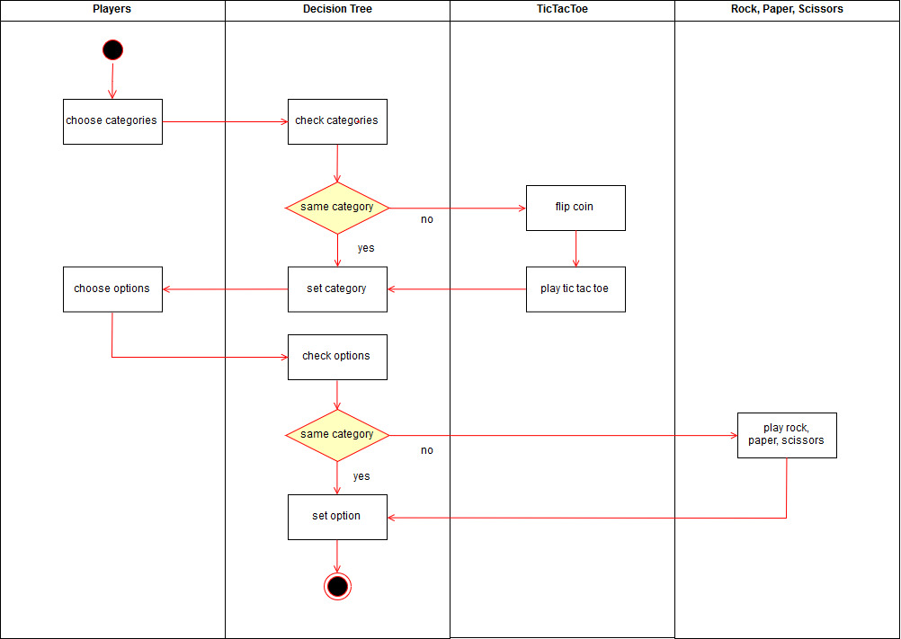

## 2.2 Class Diagram

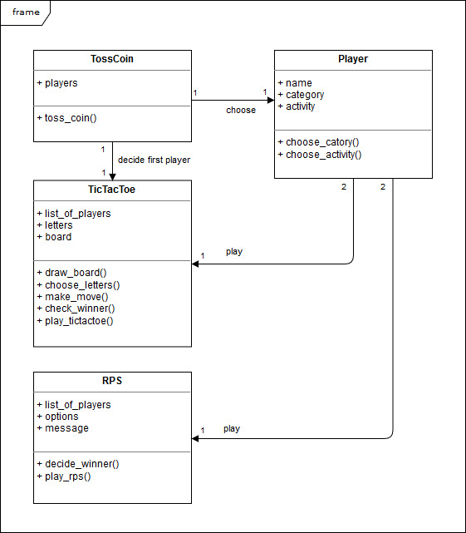

## 2.3 Component Diagram

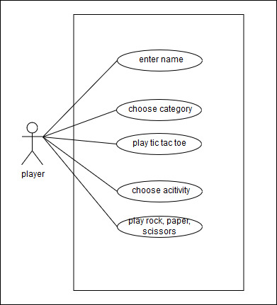

# Metrics

# Clean Code Development

# Build Management

# Continuous Delivery

# DSL

# Functional Programming