|  |
| --- |
| EMBBEDED SYSTEMS SPECIALIZATION PROGRAMM |
| G2 Task #1: Lin Frame |
| Communications Software Development for Embedded Environments |

|  |
| --- |
| **Feliciano Angulo Angulo**  Email: [se704751@iteso.mx](mailto:se704751@iteso.mx)  **Juan Pablo Garcia**  Email: [se716963@iteso.mx](mailto:se716963@iteso.mx)  **Jesus Íñiguez**  Email: [se717040@iteso.mx](mailto:student3_email@iteso.mx) |

**29/03/2018**

Embedded Systems Specialization Program

[www.sistemasembebidos.iteso.mx/alumnos](http://www.sistemasembebidos.iteso.mx/alumnos)

I T E S O A. C., Universidad Jesuita de Guadalajara

Periférico Sur Miguel Gómez Morín #8585, Tlaquepaque, Jalisco, México

Technical Report Number: ESE-O2014-001

® ITESO A.C.

|  |
| --- |
| ***Abstract:***  *This document shows how LIN protocol is implemented using an UART driver in in SAMV71 XPlained evaluation board. Lin and UART implementation are AUTOSAR compliant, whit this implementation is possible to transmit LIN frame through UART, Scope’s captures are included to show LIN frame from Tx line.* |
| ***Keywords:***  *LIN*  *UART*  *AUTOSAR*  *FRAME* |

# Table of Contents

Table of Contents ii

1. Table of Figures iii

2. Introduction 1

2.1. Requirements 1

2.1.1. Architecture 1

2.1.2. Implementation 1

3. Functional Description 3

3.1. AUTOSAR Implementation 3

3.2. LIN functions Implementation 5

3.2.1. State description 7

3.2.2. IDLE 7

3.2.3. SEND_BREAK 7

3.2.4. SEND_SYNC 7

3.2.5. SEND_PID 7

3.2.6. SEND_EOT 7

3.2.7. SEND_RESPONSE 7

4. Results 7

5. Conclusions 9

# **Table of Figures**

Figure 1 AUTOSAR file structure 3

Figure 2 AUTOSAR layers 4

Figure 3 Lin_Init implementation 5

Figure 4 Lin_SendFrame implementation 6

Figure 5 Lin_Isr implementation 6

Figure 6 LIN frame 7

Figure 7 Header capture from Oscilloscope 8

Figure 8 Bit time measure 8

Figure 9 Details of generated LIN frame 9

# Introduction

LIN (Local Interconnect Network) is a serial network protocol used for communication between components in vehicles. LIN implementation is based in UART/SCI hardware, so, when a microcontroller does not have a LIN peripheral integrated but a UART, it can be implemented over this UART easily.

The purpose of this work is to demonstrate the above description, Lin can be implemented over UART.

## Requirements

Provide a SW solution with defined interfaces that will allow to form the LIN Frame through the UART controller available in the SAM V71 controller.

Software must be based on the attached Base Project.

Requirements are as follows:

Transmit a single LIN frame sending a Break - Synch - and a Data Byte with a recurrence of 10ms.

### Architecture

The SW must be compliant with the AUTOSAR SW layered architecture, so a File Structure must be provided. This means that (if using UART interfaces) the UART driver interfaces will be at MCAL Layer and LIN interfaces will be at the ECU Abstraction Layer.

File Structure:

../source

->/bsw

->/mcal

->/com

->/uart

(uart files here)

->/ecual

->/com

->/linif

(lin files here)

->/services

->/system

->/scheduler

(scheduler files here)

Note: In the case that uart driver is used from the provider, file structure shall be kept AS IS.

### Implementation

The LIN functions to be provided are:

void Lin_Init (uint16_t LinBaudrate)

- This function will configure the lower layer UART driver

- Baudrate will as per LinBaudrate parameter

- Interrupts shall be configured for each data byte to be transmitted or received

- This function shall provide to the lower layer a function callback (Lin_Isr) to be invoked at any of the RX or TX UART interrupts

void Lin_SendFrame (uint8_t LinPid)

- This function will send a predefined header as per the LIN protocol with the rate define in the Lin_Init function.

- This function shall be asynchronous, i.e. it will trigger the "send command" and will continue its operation without waiting for the header to be completely sent over the bus.

- The header shall be composed in order of:

- 1. Break = (from 10 to 13 bit times) ideally >= 13 bit time

- 2. Synch = 0x55

- 3. ID = LinPid

In order to support the underlined LIN SW component, a state machine can be provided:

typedef enum

{

IDLE,

SEND_BREAK,

SEND_SYNC,

SEND_PID,

SEND_RESPONSE

}LinStateType;

The sequence shall be as follows (since no response shall be provided for this task)

IDLE -> SEND_BREAK -> SEND_SYNC -> SEND_PID -> IDLE

IDLE: No activity

SEND_BREAK: Send break process is about to start or in progress

SEND_SYNC: Send sync process is about to start or in progress

SEND_PID: Send pid process is about to start or in progress

Note: Lin_SendFrame will start the state machine by changing the state to SEND_BREAK as long as there is no a frame transmission/reception in progress.

void Lin_Isr(void)

- UART TX/RX interrupts:

- will invoke this function

- will serve as input transitions to manage the LIN state machine (transitions and actions)

# Functional Description

## AUTOSAR Implementation

To make implementation AUTOSAR compliant, the file structure was created according to requirement number 1, it can be seen in figure 1 with required files in specify folder.

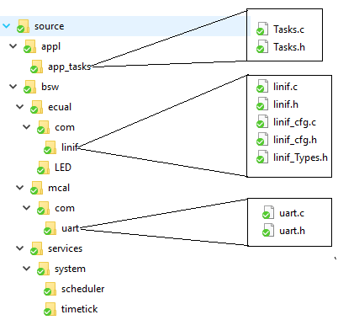

Figure 1 AUTOSAR file structure

Interaction between files showed in Figure 1, are based in AUTOSAR layer format, Figure 2 shows such layers, according to this, UART driver is part of MCAL, LIN is implemented as part of ECU Abstraction Layer and a 10 ms task is part of the application layer, all executions are controlled by the scheduler, which is part of service laver.

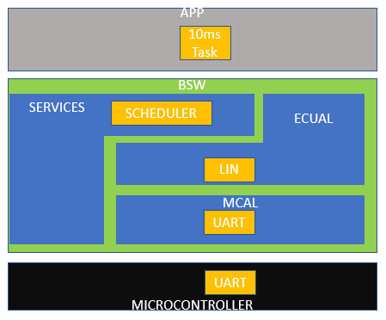

Figure 2 AUTOSAR layers

## LIN functions Implementation

There are 3 main function in Lin to be implemented according to requirement #2, Lin_Init, Lin_SendFrame and Lin_Isr,

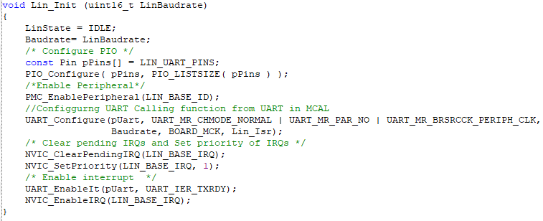

Figure 3 Lin_Init implementation

As was mentioned before, LIN implementation is in ECU abstraction layer, and according to AUTOSAR, lower interface(MCAL) must be call from here, in this case, needed function from UART driver must be called here, as can be seen in Figure 3, Lin_Init function initialize UART driver, first enabling used GPIO (details are in Table 2), then UART_Configure function is called to configure UART, and at the end interruptions are set.

Table 1 UART I/O Lines details

|  |  |  |  |
| --- | --- | --- | --- |
| Instance | Signal | IO Line | Peripheral |
| UART2 | URXD2 | PD25 | C |
| UART2 | UTXD2 | PD26 | C |

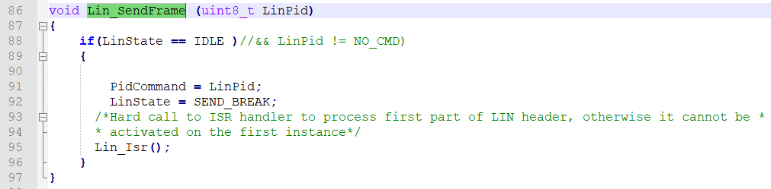

Figure 4 Lin_SendFrame implementation

Lin_SendFrame is set to initialize a LIN frame message transmission (see Figure 4), LIN frame transmission is implemented based in a state machine for send each part of the frame.

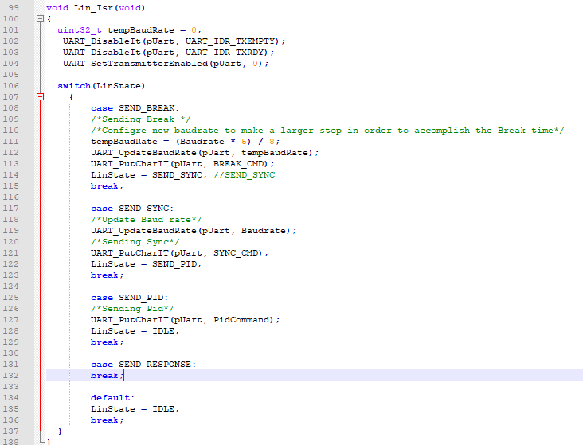

Figure 5 Lin_Isr implementation

In Figure 5 can be seen Lin_Isr function, there, is implemented a state machine for control LIN frame states, SEND_BREAK; SEND_SYNC, SEND_PID, SEND_EOT and SEND_RESPONSE. Those state are described in next section.

### State description

### IDLE

No transmission is done here.

### SEND_BREAK

Break is sent here, BREAK consist in a minimum of 13 recessive bits (0), since in a normal UART driver only can be send a max of 8 recessive bits, is necessary to reduce official LIN baud rate to make 8 recessive bits look like at least 13 recessive bits (reduction is done to 5/8 of official baud rate in order to make 8 bit times look like 13 bit times). Baud rate update is done in this state just before send BREAK_CMD (0x55) value.

### SEND_SYNC

Here basically is needed send the 0x55 sync byte, but because in previous STATE baud rate was reduced, here baud rate is set to the official LIN baud rate before send 0x55

### SEND_PID

Protected Identifiers is sent here just after SEND_SYNC finish.

### SEND_EOT

Not implemented

### SEND_RESPONSE

Not implemented

# Results

The complete LIN frame standard is showed in Figure 6, however, target in this work is only send the header (Break, Sync and PID).

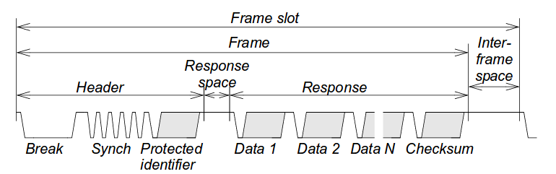

Figure 6 LIN frame

Using the oscilloscope is possible to capture Lin frame for validate that our implementation is sending the header according to the standard. Figure 7 shows the result.

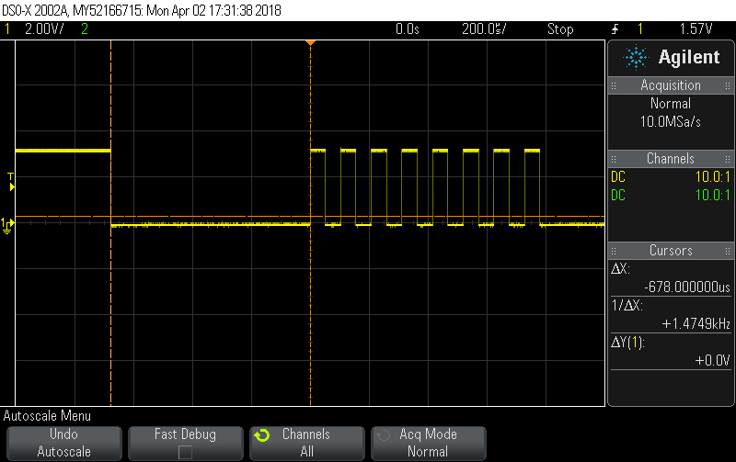

Figure 7 Header capture from Oscilloscope

In figure 7 cursors are measuring the BREAK as 678 microseconds, such measure corresponds to 13 bits in dominant state, since LIN baud rate was set to 19200, 1 bit time is 52 microseconds and 13 bit times are 676 microseconds. Bit time measure is showed in figure 8.

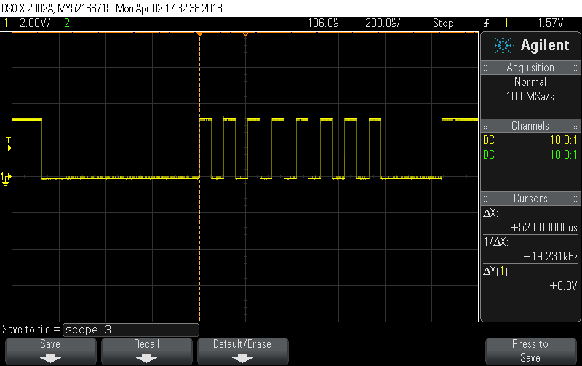

Figure 8 Bit time measure

Figure 9 shows how the header and all its parts are included in generated frame(Break, delimiter, synch byte and PID).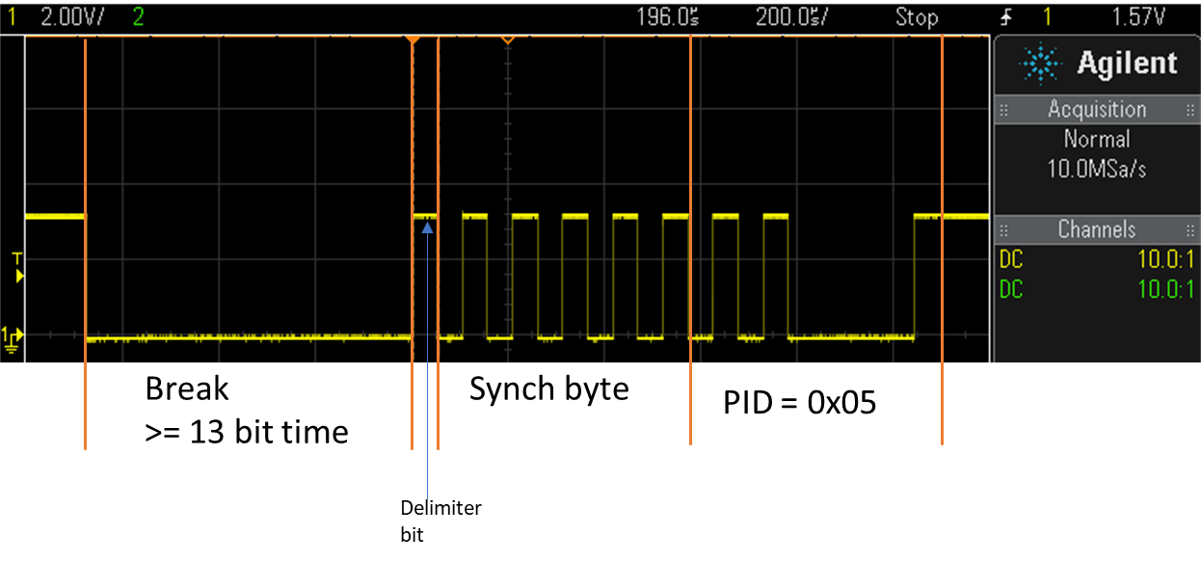

Figure 9 Details of generated LIN frame

# Conclusions

It was demonstrated that LIN frame can be sending using an UART driver since LIN is a Serial Based protocol.

So far, only the header was implemented, which is sent by a LIN master node, but this is a first step to create a complete LIN driver to be used by master and slave nodes.

Was demonstrated as well how usage of asynchronous function for send UART messages allows the CPU work in other task while the transmission is in progress.