|  |  |
| --- | --- |
| **Bloom taxonomy – cognitive dimension** | |
| Remembering | recognising and recalling |
| **Understanding** | Interpreting, Exemplifying, Classifying, Summarising, Inferring, Comparing, and Explaining. |
| **Applying** | Ability to execute algorithms, track and recognize their goals |
| Analyzing | Differentiating, Organising, and Attributing. |
| Evaluating | Checking and Critiquing |
| **Creating** | Ability to plan or produce programs or algorithms |

|  |  |  |  |  |  |  |
| --- | --- | --- | --- | --- | --- | --- |
|  | **Rembering** | **Understanding** | **Applyng** | **Analyzing** | **Evaluating** | **Creating** |
| **1.Loops** |  | **1** | **10-13** |  |  | **7** |
| **2.Parallelization** | **18** | **3** | **10-13** |  | **16** | **8** |
| **3.Coordination** | **17** | **2** | **10-13** |  | **16** | **7, 8** |
| **4.Conditionals** |  | **1** | **10-13** | **14** |  | **7** |
| **5.Operators** | **15** |  | **6, 10-13** | **15** |  | **7** |
| **6.Data/Variables** | **5** | **5** | **6, 10-13** | **14,15** |  | **7** |
| **7.Procedures** | **4** | **4** | **6** |  |  | **9** |

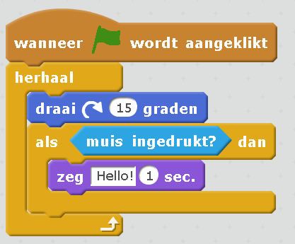

1. U1,4 What would the sprite with this code do once the green flag is clicked?
   1. **It turns around continuously and when the mouse is clicked it says Hello for 1 second**
   2. It turns around 15 degrees and when the mouse is clicked it says hello for one second
   3. It turns around continuously and says hello every one second
   4. It turns around saying hello and when the mouse is clicked it stops

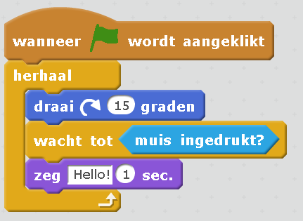

1. U3 Would this code make it behave similarly?
   1. Yes
   2. **No, with this it would turn only 15 degrees and then say hello and turn another 15 degrees whenever the mouse is clicked**
   3. No, with this it would turn continuously but stop when the mouse is clicked and say hello

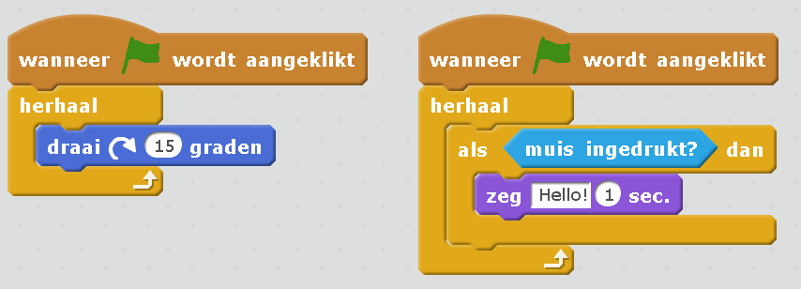

1. U2 Would this code make it behave similarly?
   1. **Yes**
   2. No, this would turn indefinitely and nothis would happen when mouse is clicked
   3. No, this would turn 15 degrees and then the second block would execute making it say hello when the mouse is clicked

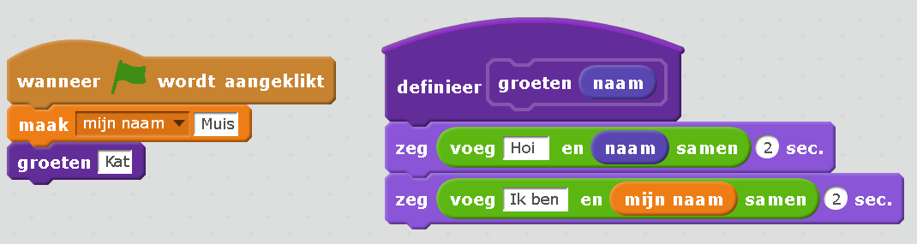

1. RU7Are there any custom blocks used in the example above? Which?
2. RU6Are any variables used in the example above? Which?
   1. No, there are no variables
   2. Yes, variable antwoord
   3. **Yes, variable antwoord in the first block and variable naam in the second**
3. Ap 5,6,7 What happens when we hit the green flag in the example above?
   1. **It will say “Hoi Kat” for 2 seconds and then “Ik ben Muis” for 2 seconds**
   2. It will say “Hoi Muis” for 2 seconds and then “Ik ben Kat” for 2 seconds
   3. It will say “Hoi naam” for 2 seconds and then “Ik ben Muis” for 2 seconds

For the following questions we will use the following project. It has 2 sprites, the basket and the apple. Here are their scripts:

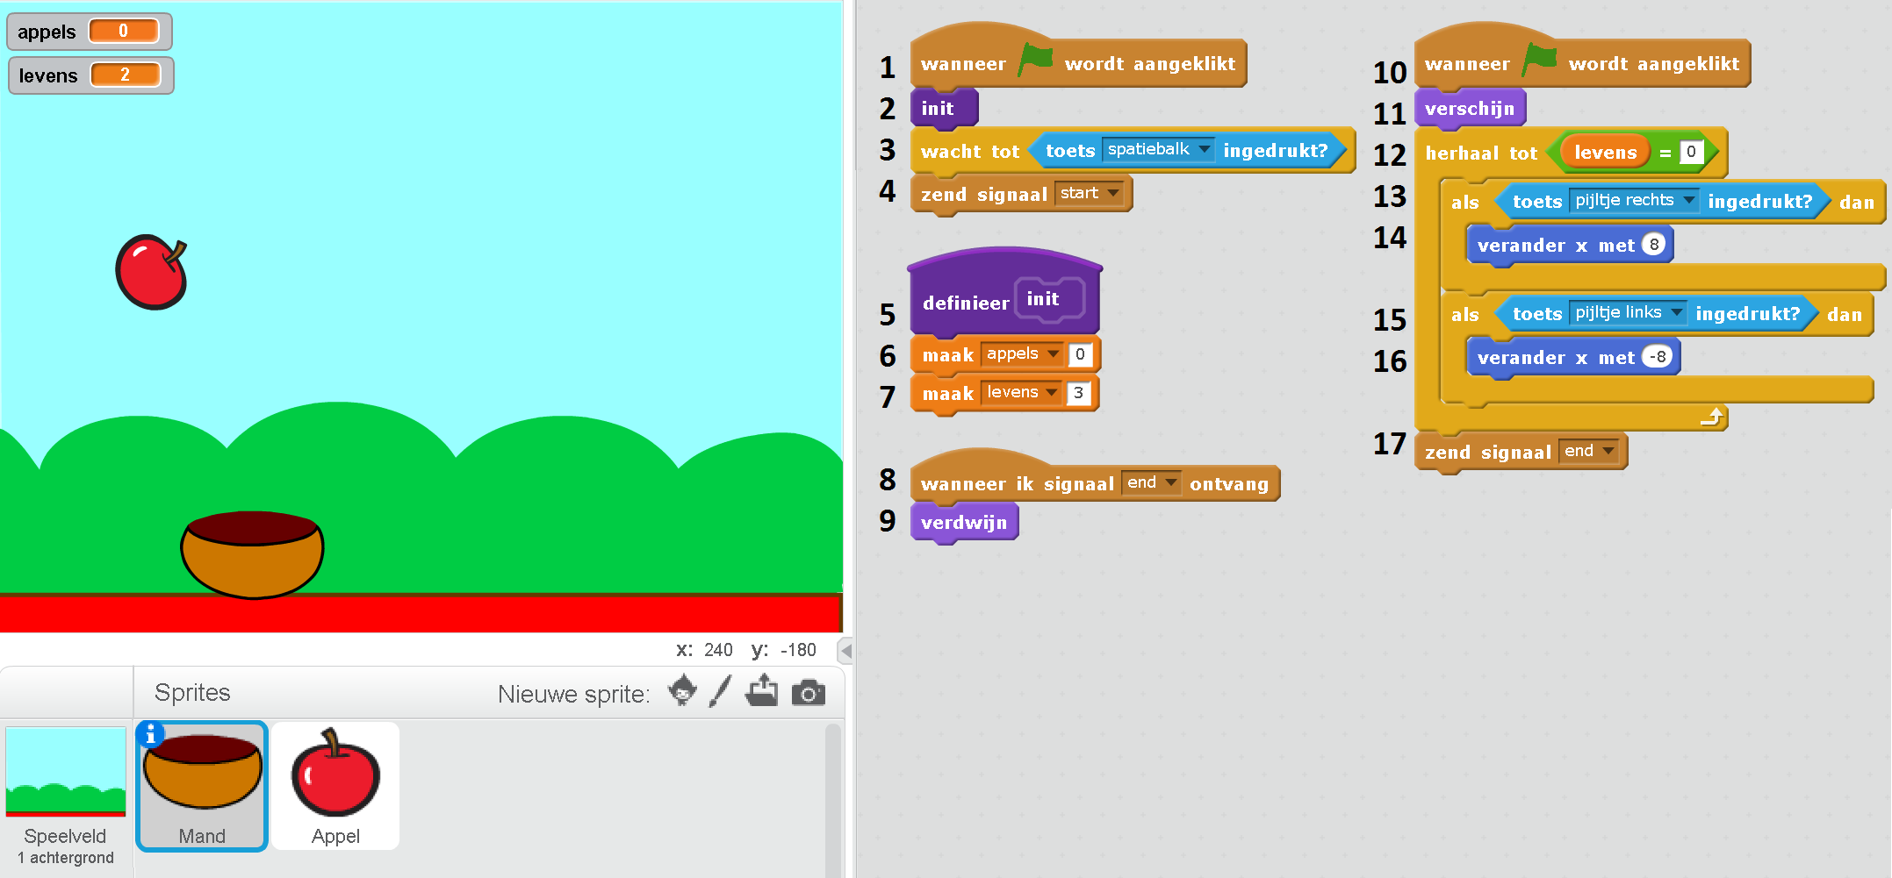

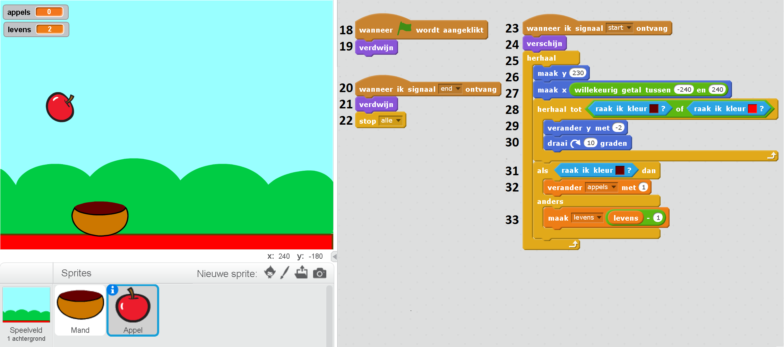

1. C1,3,4,5,6 We want the game to finish if a single apple falls down. Which of the following would accomplish that? (multiple choices possible)
   1. **Changing line 7 to maak levens 1**
   2. Changing line 6 to maak appels 1
   3. **Adding after line 2 a line maak levens 1**
   4. **Changing line 12 to herhaal tot levens = 2**
   5. Changing line 28 to herhaal tot raak ik kleur <red>
   6. **Changing line 33 to zend signal end**
   7. **Changing line 33 to maak levens levens – 3**
2. C2,3 Could you add a new code block in the Mand sprite to make the Mand zeg “Game over” when three apples have fallen down? Fill in the following:

Wanneer **…**

**Answer: wanneer ik signaal end ontvag**

**Zeg Game over**

1. C7 Could you write a function MoveWithArrows to call at line 13? Fill in the following:

Definneer …

**Answer: defineer MoveWithArrows**

**Als toets rechts ingedrukt dan… (lines 13 to 16)**

1. Ap3 When we hit the green flag and before doing anything else, what appears in the screen?
   1. Nothing
   2. Both the Mand and a falling Apple
   3. **Only the Mand**
2. Ap When does the game end?
   1. It does not, the Mand collects apples indefinitely
   2. When an apple falls down
   3. **When 3 apples fall down**
   4. Then 3 apples are in the Mand
3. Ap What happens with the Mand in this game? Click on all that apply (multiple choices possible)
   1. **The Mand moves only left and right with the arrows**
   2. The Mand moves in all directions with the arrows
   3. **The Mand cannot be moved until the space bar is clicked**
   4. The Mand does not disappear once it appears
   5. **The Mand disappears after 3 apples have fallen down**
   6. The Mand stops moving after 3 apples have fallen down
4. Ap What happens with the apple in this game? Click on all that apply (multiple choices possible)
   1. **Apples start falling after the space bar is clicked**
   2. Apples fall down from the upper left corner or the upper right corner
   3. Apples fall down indefinitely
   4. **A new apple appears every time an apple falls down or in the Mand**
   5. A new apple appears every time an apple falls in the Mand
5. An4,6 Which block determines when the levens are reduced or the appels variable is increased?
   1. **The als/anders block on line 31**
   2. Blocks on lines 32 and 33 that modify variables levens and appels
   3. Te custom block definition on line 5 that sets variables levens and appels
6. RAn5,6 That is the difference between block 32 verander appels met 1 and block 33 maak levens levens – 1
   1. **The first increases variable appels with 1 while the second decreases variable levens with 1**
   2. The first sets variable apples to 1 while the second decreases variable levens with 1
   3. The first increases variable appels with 1 while the second sets variable levens to – 1
7. E2,3 Blocks wanneer in signaal end ontvag on lines 8 and 20 handle the same signal. Could we merge them into one?
   1. Yes, we could merge them by removing blocks 8 and 9 since they are exactly the same as 20 and 21
   2. **No, we cannot merge them because they are located in different sprites and affect the appearance of the sprite they are located in**
   3. No, we cannot merge them because the end signal is sent form the Mand sprite and should be also handled in the Apple sprite
8. R3 Which blocks send signals and which blocks receive signals in the game?
   1. **Blocks 4 and 17 send signals and blocks 8, 20 and 23 receive signals**
   2. Blocks 4 and 17 send signals and blocks 1,8,10,18,20 and 23 receive signals
   3. Bocks 6 and 7 send signals and blocks 12, 32 and 33 receive signals
9. R2 Blocks 1 and 10 are the same (wanneer groen vlag wordt aangeklikt). Which will be executed first?
   1. Block 1, because it is declared first, and afterwards block 10
   2. Block 1, because it is declared first. Block 10 will not be executed.
   3. They will be executed at the same time