|  |  |
| --- | --- |
| **Bloom taxonomy – cognitive dimension** | |
| Remembering | recognising and recalling |
| **Understanding** | Interpreting, Exemplifying, Classifying, Summarising, Inferring, Comparing, and Explaining. |
| **Applying** | Ability to execute algorithms, track and recognize their goals |
| Analyzing | Differentiating, Organising, and Attributing. |
| Evaluating | Checking and Critiquing |
| **Creating** | Ability to plan or produce programs or algorithms |

|  |  |  |  |  |  |  |
| --- | --- | --- | --- | --- | --- | --- |
|  | **Rembering** | **Understanding** | **Applyng** | **Analyzing** | **Evaluating** | **Creating** |
| **1.Loops** |  |  |  |  |  |  |
| **2.Parallelization** |  |  |  |  |  |  |
| **3.Coordination** |  |  |  |  |  |  |
| **4.Conditionals** |  |  |  |  |  |  |
| **5.Operators** |  |  |  |  |  |  |
| **6.Data/Variables** |  |  |  |  |  |  |
| **7.Procedures** |  |  |  |  |  |  |

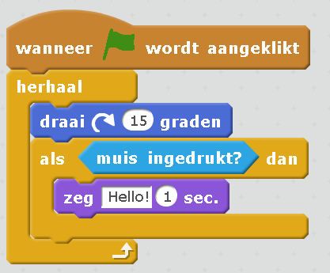

1. R4 When will the sprite with this code to say “Hello!”? What is the condition?
   1. Whenever it turns 15 degrees
   2. **Whenever the muis ingedrukt is**
   3. Whenever the green flag is clicked
2. U1,4 What would the sprite with this code do once the green flag is clicked?
   1. **It turns around continuously and every time the mouse is clicked it says Hello for 1 second**
   2. It turns around 15 degrees, when the mouse is clicked it says hello for one second, and then it stops
   3. It turns around continuously and says hello every one second
   4. It turns around saying hello and when the mouse is clicked it stops

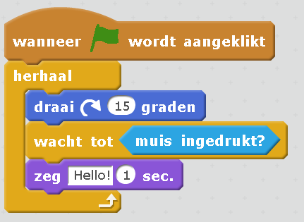

1. U3 Would this code make it behave similarly?
   1. Yes
   2. **No, with this it would turn only 15 degrees and then say hello and turn another 15 degrees whenever the mouse is clicked**
   3. No, with this it would turn continuously but stop when the mouse is clicked and say hello

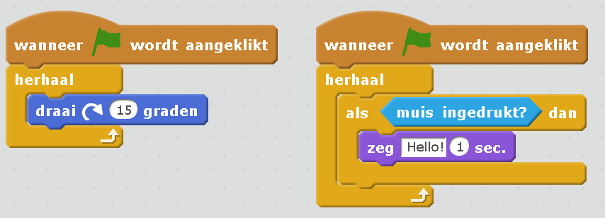

1. U2 Would this code make it behave similarly?
   1. **Yes**
   2. No, this would turn indefinitely and nothing would happen when mouse is clicked
   3. No, this would turn 15 degrees and then the second block would execute making it say hello when the mouse is clicked

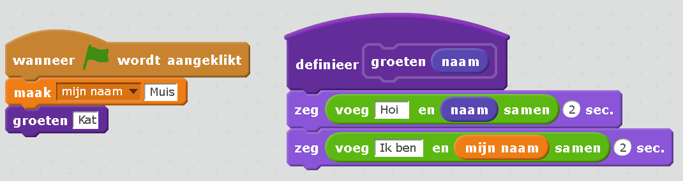

1. RU7Are there any custom blocks used in the example above? Which?
2. RU6Are any variables used in the example above? Which?
   1. No, there are no variables
   2. Yes, variable mijn naam
   3. **Yes, variable mijn naam and variable naam in the custom block**
3. Ap 5,6,7 What happens when we hit the green flag in the example above?
   1. **It will say “Hoi Kat” for 2 seconds and then “Ik ben Muis” for 2 seconds**
   2. It will say “Hoi Muis” for 2 seconds and then “Ik ben Kat” for 2 seconds
   3. It will say “Hoi naam” for 2 seconds and then “Ik ben Muis” for 2 seconds

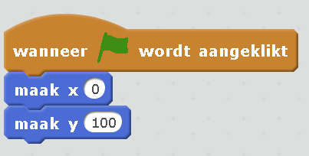

1. (extra question, to test if our assumption that xy is only for kids who have learned it in math first). Where will the Cat with the following code move to once the green flag is clicked?
   1. **Horizontally (x) to the center and vertically (y) towards the upper side**

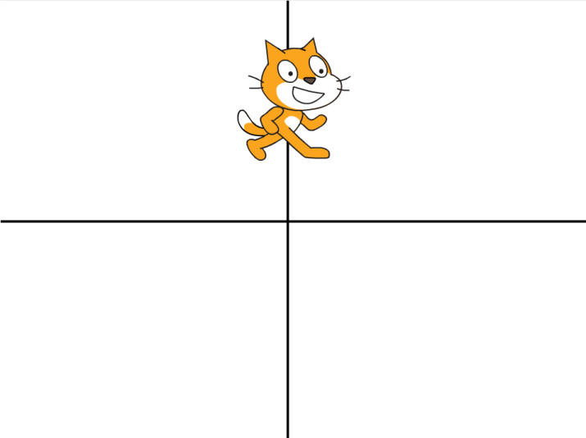

* 1. Vertically (x) to the center and horizontally (y) towards the right side

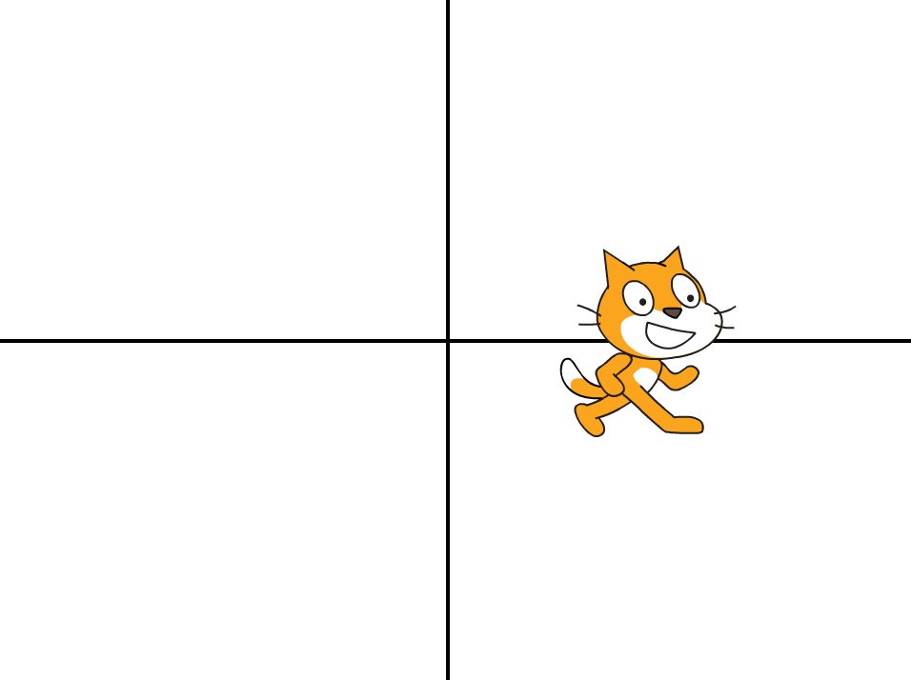

* 1. Horizontally (x) to the far left side and vertically (y) at position 100

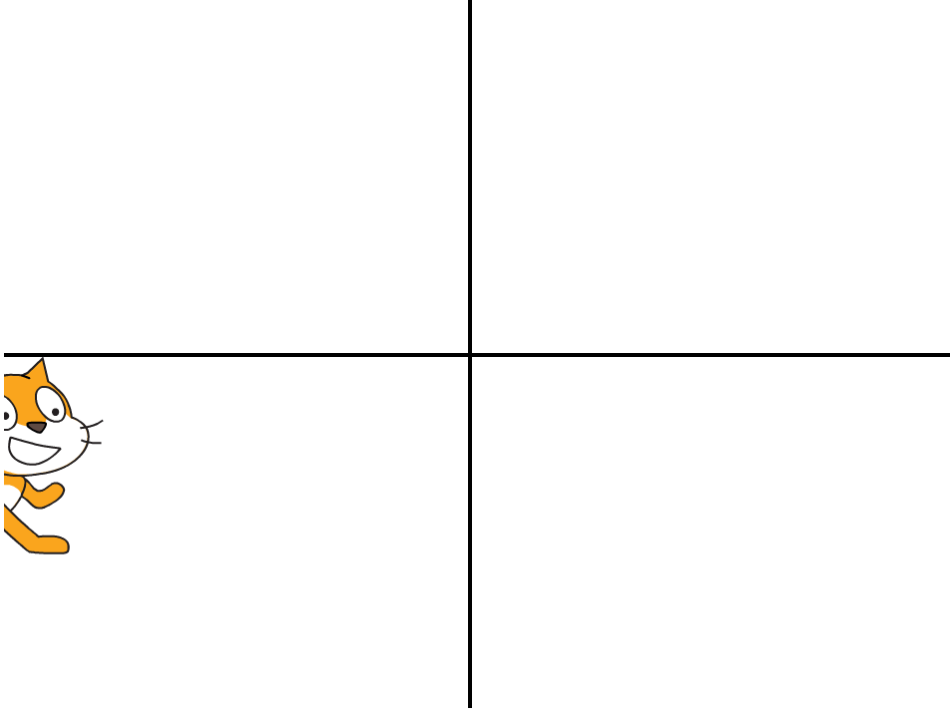

* 1. Vertically (x) to the far lower side and horizontally (y) at position 100

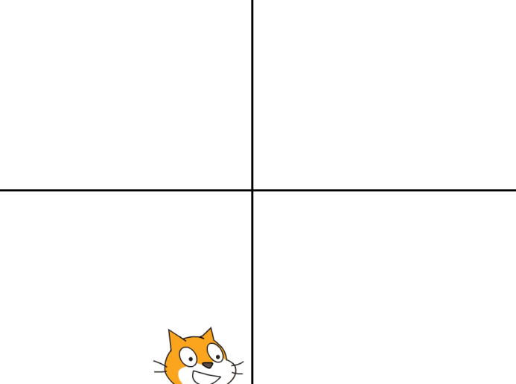



1. U5 What does this block do?
   1. It multiplies variable y with 15
   2. It adds 15 to variable y
   3. **It multiplies variable y with 10 and then adds 5**

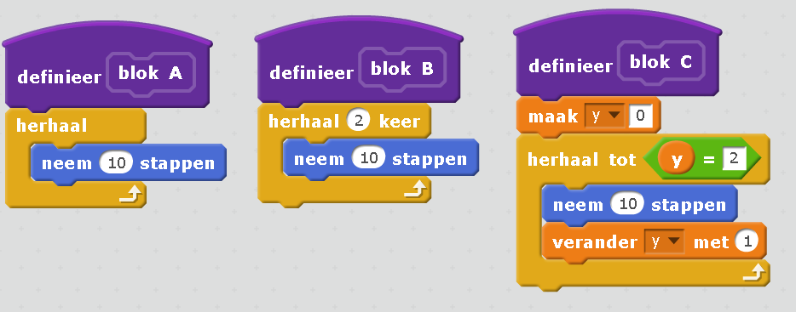

1. RAn1 What is the difference between blocks A and B?
   1. They Are the same
   2. **Blok A makes the sprite move indefinitely while blok B makes it move only 2 times**
   3. Blok A makes the sprite move once while B makes it move 2 times
2. An1,6 What is the difference between blocks B and C?
   1. **They Are the same, both will make the sprite move 2 times**
   2. Blok B makes the sprite move 2 times while Bloc C makes it move until y=2
   3. Blok B makes the sprite move 2 times while Bloc C makes it move indefinetly

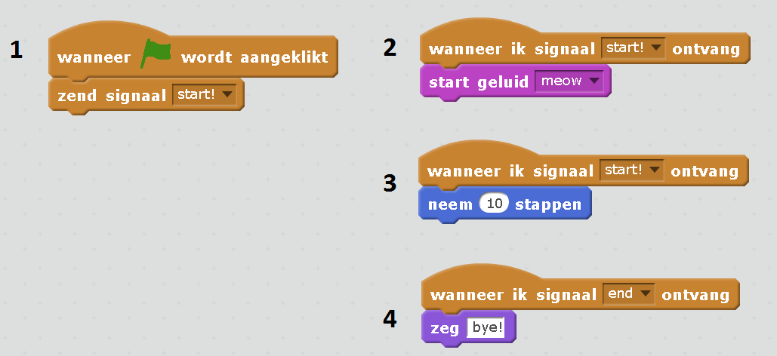

1. An2,3 In what order will blocks 1,2,3 and 4 be executed?
   1. First 1,2 and 3 and then 4
   2. **First 1, then 2 and 3**
   3. First 1, then 2 and 3 and then 4
2. An7 We want to create a sprite that jumps whenever the space or the up arrow is clicked. What is the difference between the following 2 implementations?

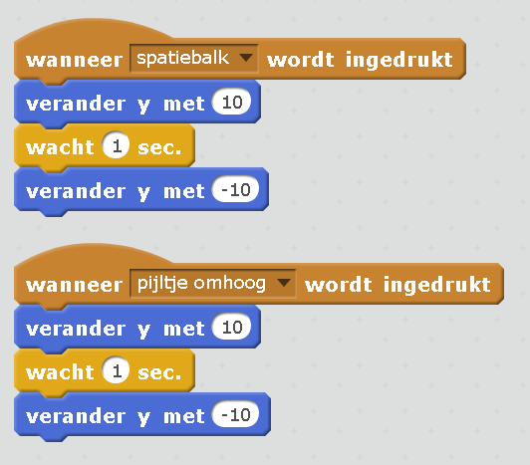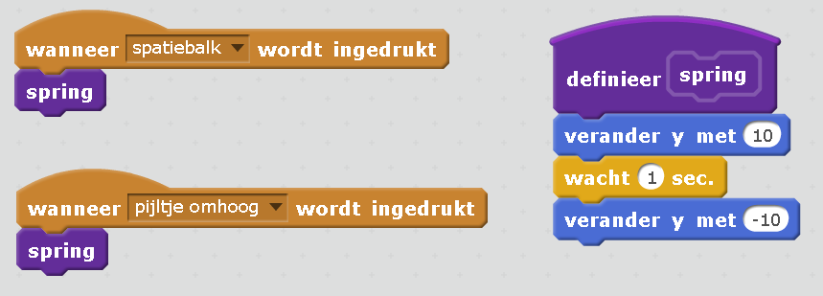

* 1. They first implementation will make the sprite jump when space or up are pressed but the second one not
  2. They first implementation will make the sprite jump when space or up are pressed but the second one will make it jump all the time
  3. **Both will work the same way, but the second one utilizes a custom block**

1. **E7** Which implementation do you think is the best one for this sprite?
   1. The first one because it is smaller and easier to write and modify
   2. **The second one because it groups similar pieces of functionality into reusable custom blocks**
2. E1,5,6 We want the sprite to say the multiplication table of 2 when the green flag is clicked

Will it do it with the following code?

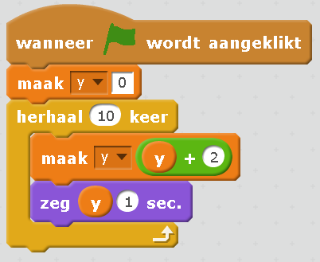

* 1. **Yes**
  2. No, it will say 0 for 10 times
  3. No, it will say 0,2,4,6,8….

1. E4 Will it do it with the following code?

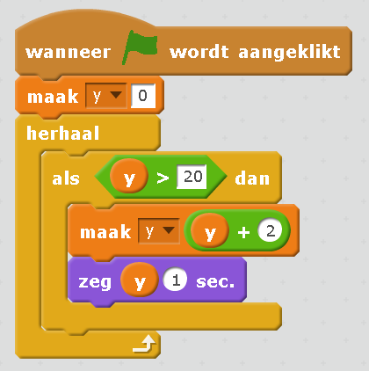

1. Yes
2. **No, it will say nothing**
3. No, it will say 20, 22, 24, …

For the following questions we will use the following project. It has 2 sprites, the basket and the apple. Here are their scripts:

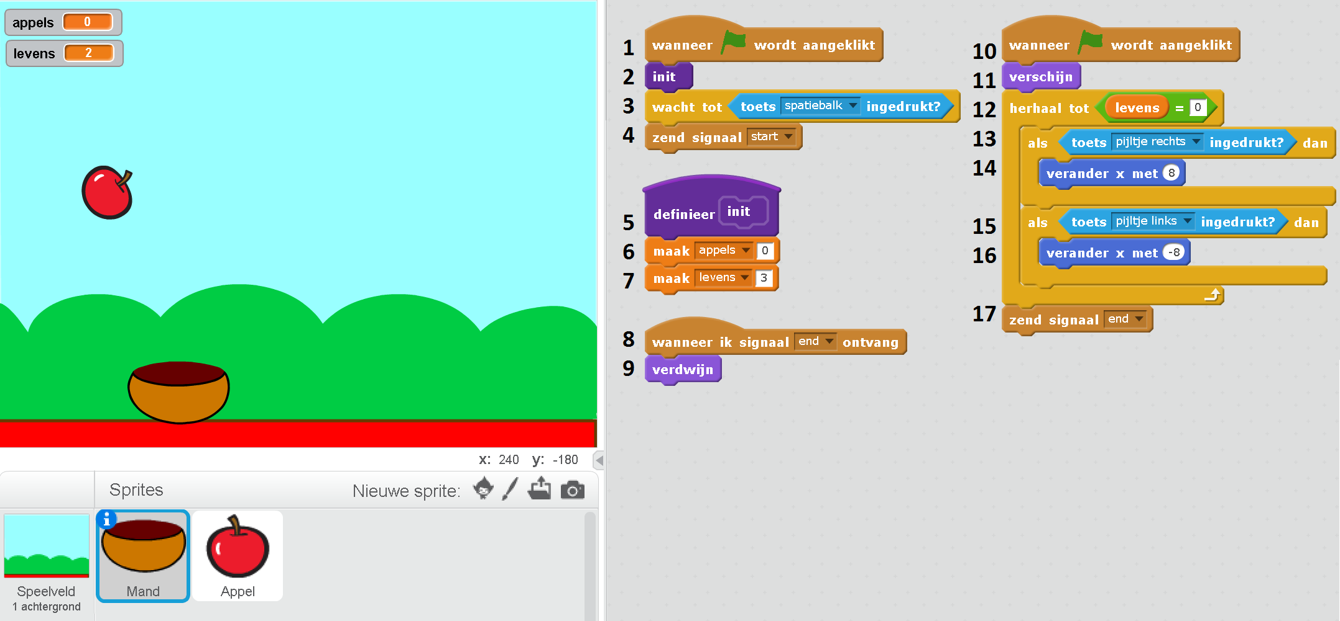

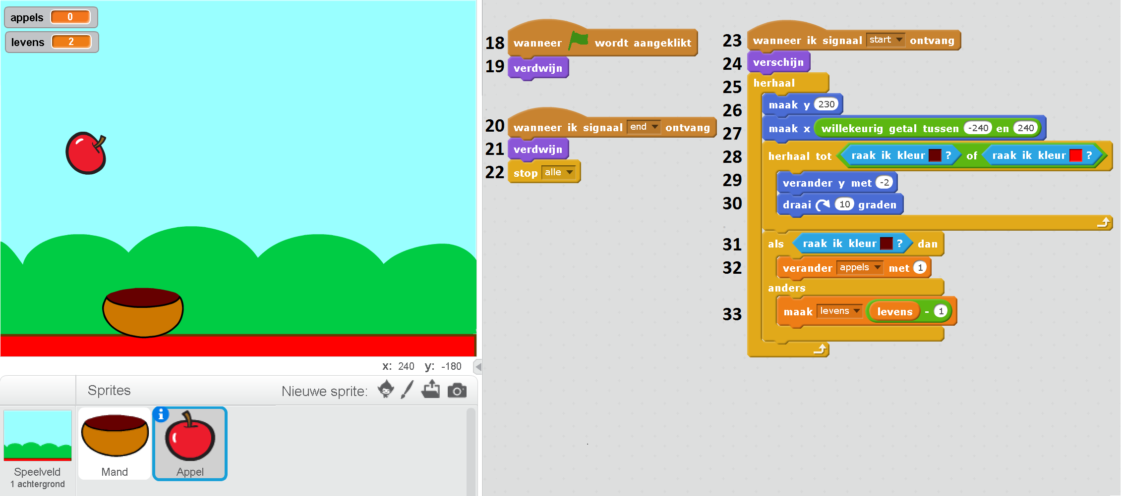

1. R3 Which blocks send signals and which blocks receive signals in the game?
   1. **Blocks 4 and 17 send signals and blocks 8, 20 and 23 receive signals**
   2. Blocks 4 and 17 send signals and blocks 1,8,10,18,20 and 23 receive signals
   3. Bocks 6 and 7 send signals and blocks 12, 32 and 33 receive signals
2. Ap3 When we hit the green flag and before doing anything else, what appears in the screen?
   1. Nothing
   2. Both the Mand and a falling Apple
   3. **Only the Mand**
3. Ap What happens with the apple in this game? Click on all that apply (multiple choices possible)
   1. **Apples start falling after the space bar is clicked**
   2. Apples fall down from the upper left corner or the upper right corner
   3. Apples fall down indefinitely
   4. **A new apple appears every time an apple falls down or in the Mand**
   5. A new apple appears every time an apple falls in the Mand
4. Ap When does the game end?
   1. It does not, the Mand collects apples indefinitely
   2. When an apple falls down
   3. **When 3 apples fall down**
   4. Then 3 apples are in the Mand
5. Ap What happens with the Mand in this game? Click on all that apply (multiple choices possible)
   1. **The Mand moves only left and right with the arrows**
   2. The Mand moves in all directions with the arrows
   3. **The Mand cannot be moved until the space bar is clicked**
   4. The Mand does not disappear once it appears
   5. **The Mand disappears after 3 apples have fallen down**
   6. The Mand stops moving after 3 apples have fallen down
6. An4,6 Which block determines when the levens are reduced or the appels variable is increased?
   1. **The als/anders block on line 31**
   2. Blocks on lines 32 and 33 that modify variables levens and appels
   3. Te custom block definition on line 5 that sets variables levens and appels
7. RAn5,6 That is the difference between block 32 verander appels met 1 and block 33 maak levens levens – 1
   1. **The first increases variable appels with 1 while the second decreases variable levens with 1**
   2. The first sets variable apples to 1 while the second decreases variable levens with 1
   3. The first increases variable appels with 1 while the second sets variable levens to – 1
8. E2,3 Blocks wanneer in signaal end ontvag on lines 8 and 20 handle the same signal. Could we merge them into one?
   1. Yes, we could merge them by removing blocks 8 and 9 since they are exactly the same as 20 and 21
   2. **No, we cannot merge them because they are located in different sprites and affect the appearance of the sprite they are located in**
   3. No, we cannot merge them because the end signal is sent form the Mand sprite and should be also handled in the Apple sprite
9. R2 Blocks 1 and 10 are the same (wanneer groen vlag wordt aangeklikt). Which will be executed first?
   1. Block 1, because it is declared first, and afterwards block 10
   2. Block 1, because it is declared first. Block 10 will not be executed.
   3. They will be executed at the same time
10. C1,3,4,5,6 We want the game to finish if a single apple falls down. Which of the following would accomplish that? (multiple choices possible)
    1. **Changing line 7 to maak levens 1**
    2. Changing line 6 to maak appels 1
    3. **Adding after line 2 a line maak levens 1**
    4. **Changing line 12 to herhaal tot levens = 2**
    5. Changing line 28 to herhaal tot raak ik kleur <red>
    6. **Changing line 33 to zend signal end**
    7. **Changing line 33 to maak levens levens – 3**
11. C2,3 Could you add a new code block in the Mand sprite to make the Mand zeg “Game over” when three apples have fallen down? Fill in the following:

Wanneer **…**

**Answer: wanneer ik signaal end ontvag**

**Zeg Game over**

1. C7 Could you write a function MoveWithArrows to call at line 13? Fill in the following:

Definneer …

**Answer: defineer MoveWithArrows**

**Als toets rechts ingedrukt dan… (lines 13 to 16)**