Title

Bruno Gustavo Chagas and Felipe Soares

**Abstract.**

**Keywords:**

1. Introduction
2. Fundamentals of Computer Supported Collaborative Work

For a better understanding of the topic, we can separately define collaborative work and communication technologies.

* 1. Collaborative Work

According to [1], collaborative work systems are strategies applied in groups of people, for them to work together in a more efficient way, where anyone can cooperate in several organization’s subjects. Using this kind of system, organizations are able to solve problems more effectively because of the interaction among different libraries of employee’s knowledge and their unique perspective.

* 1. Communication Technologies

According to [2], communication technology exists for people to communicate in a asynchronous way, so anyone is able to send and receive a message in a convenient time and in a convenient device. This fact leads people to work anywhere they want.

The technology has changed the way communication works, it brings the possibility of a human interacting with some device and the device to interact with the human, like a two-person communication. This technology can potentially reach many more people than face-to-face interaction.

1. Communication and Collaborative Work Tools

This section presents the use of five different tools, their main features and advantages and disadvantages.

* 1. Zoho Project

Zoho Projects is a suite with about 40 integrated tools to run several common business processes, like sales, marketing, finances, mail and collaboration, help desk, human resources and other managements. Which includes mobile, desktop and web apps.

The sales and marketing apps include CRM, survey, forms, sites, mail marketing and contact managements. It claims to help to close more business deals in less time.

The finance has accounting apps, like: Zoho Books, a accounting tool; Paypal and others payment tools integration; Zoho expense, which is a easier way for employee to report their expenses; Zoho Inventory, for companies to stay on top of their stock flow; Zoho Subscriptions, a customer subscriptions manager.

Email and collaboration apps aims to empower the collaborative way of work. It includes mail server, cloud storage, document app, spreadsheet app, presentation app, wiki management, project planner, notes app, team chat, agile methods app, bug manager and others.

Those are the main Zoho apps, but there is also: the help desk, which is an app to talk and solve the customers problems; the human resources app takes care of employee's database, travel management, recruitment and others.

Zoho seems to be a very resourceful tool, which includes several apps for integrated work through the main company’s departments. Follows Figura 1 which is a Zoho’s snapshot app.

**Fig. 1.** 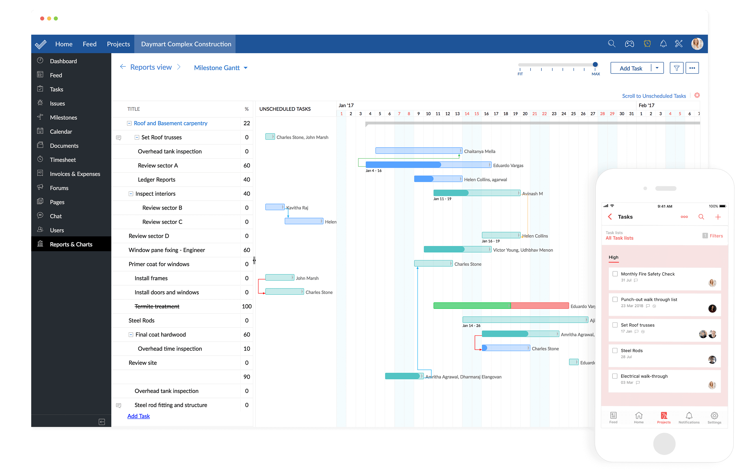

* 1. Adobe Connect

Adobe Connect is software for video conversations, as we see in Figure 2. Through web conference, the program offers the possibility of web meetings, classes or even webinars, facilitating the understanding of the users.

The software is divided into three versions: meetings, webinars and learning, available in variable prices.

* Meetings - Abobe Connect Meeting includes a possibility of access through different devices, as well as video editing and recording tools, always with security and privacy guarantee.
* Webinars - This service guarantees all the tools of its previous version besides delivering a more immersive experience and guarantee a complete events personalization.
* Learning - It also has all the advantages of its previous version, as well as an efficient way of managing classes. This version also has mobile compatibility.

**Fig. 2.** 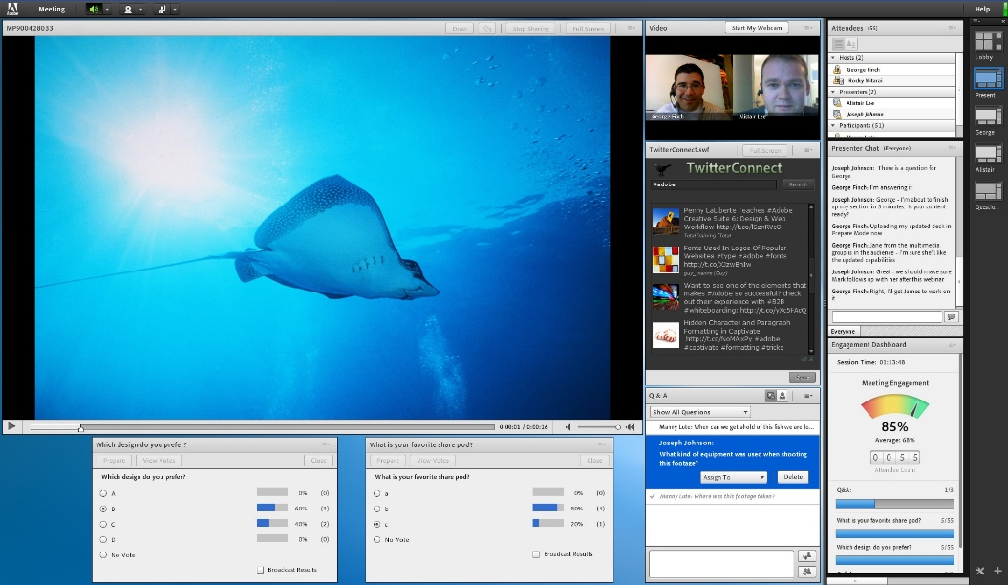

* 1. Slack

As [3] shows, Slack's main purpose is group work, connecting teams through applications, services and resources. With the Slack Workspace, the owner of the workspace can recruit an administrator to organize and lead a team, in this way both can invite more members to the team.

In order to facilitate the explanation, we can split Slack into five parts, “teams and workspaces”, “channels”, “messages”, “search” and “notifications”.

* Teams and workspaces – These areas are for people who work on a project every day. In Slack workspace the team makes the communication between its members with the purpose of finishing a certain work. In big companies there are several Slack Workspaces, being connected to each other, but worked independently.
* Channels – Slack Workspace is composed of several channels. It is in this channels that conversation takes place in an organized way. They can be private or public, making confidentiality easy for certain subject.
* Messages – All communication in Slack works with the use of messages, they also can be “direct messages”, facilitating communication with a particular person on your team.
* Search – Everything in Slack is searchable, messages and files.
* Notifications - Slack warns you of something that deserves your attention, as well as the possibility of notifications on your desktop. They can be customized, making channel priorities easier.

The Figure 3 shows the main window of Slack’s page.

**Fig. 3.** Slack’s main window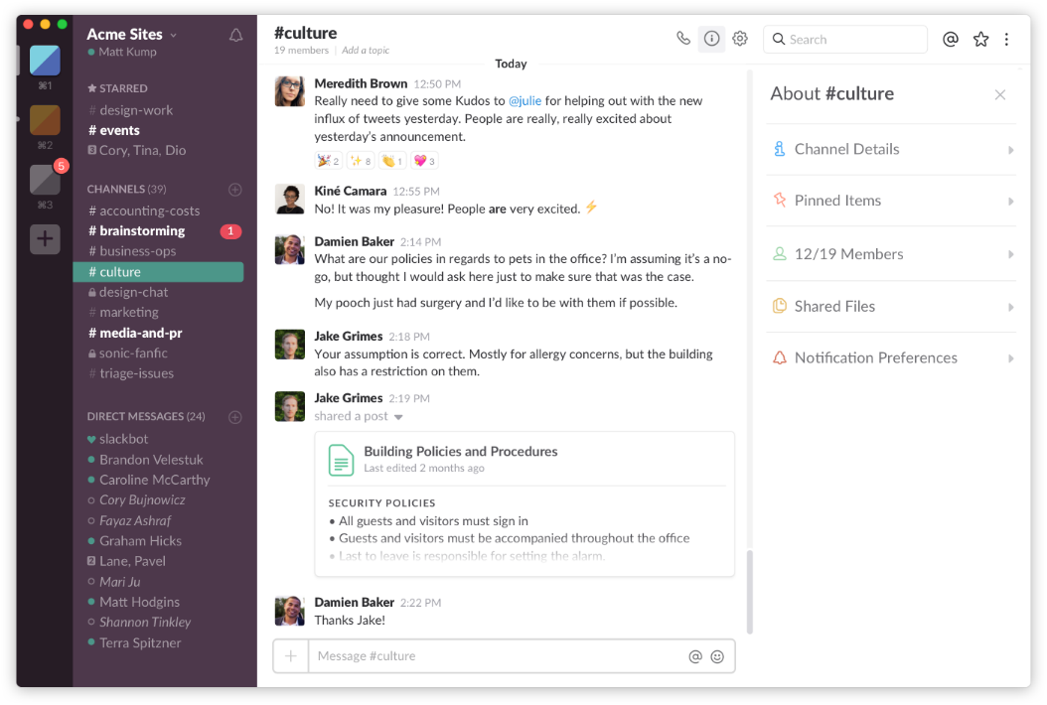

* 1. Trello

Trello works as a tool for organizing work in companies. Through their main panel, the boards contain cards that are organized in the form of tasks, and these can be divided among the specific members of a team, as we can see in Figure 4.

**Fig. 4.** 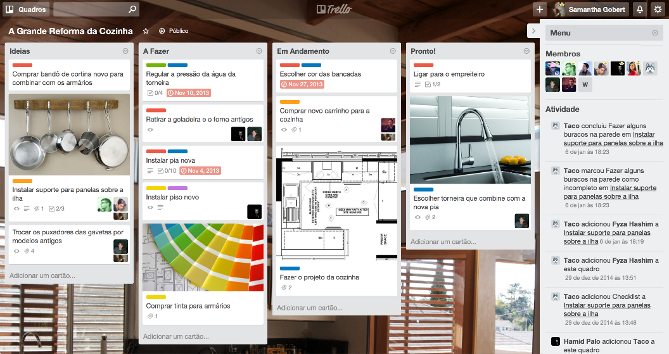

Cards may contain comments for discussions, checklists, labels, deadlines beyond the possibility of attaching files, where all this actions occur in real time.

Finally, the notification system allows the user to know all the modifications made to the cards.

* 1. Pipefy

Pipefy is a cloud-based process management platform. It allows to build and execute any type of workflow. It offers users to use the Kanban and Scrum methodologies for agile software development. Pipefy connects with over 400 apps through Zapier.

Pipefy is organized with boards and cards as we see in Figure 5, it has a predefined for the Kanban methodology and also generate reports of the existing cards. It is used with teams. It also has a feature which allows to make databases made by custom tables and custom records. It has a personalized way to see the cards, where each user is able to see the cards attached to it.

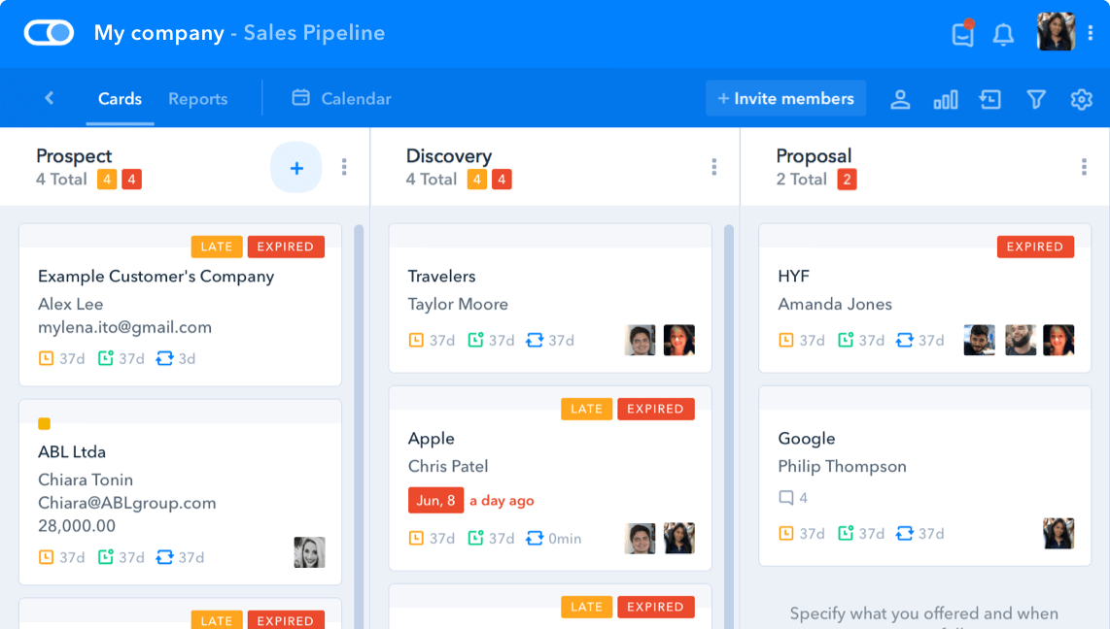

1. Conclusion

References

1. F. Buttle, "Customer Relationship Management", 2nd ed: Butterworth-Heinemann, 2008.
2. E. M. Rogers, “Communication Technology”: Simon and Schuster, 1986.