Exploração e descrição estatística dos dados de isótopos

Felipe

25/03/2022

Carregando pacotes de manipulação de dados.É necessário instalar os pacotes previamente antes de carregá-los, pacotes no R podem ser instalados usando install.packages(“nome do pacote”)

#  
#   
suppressPackageStartupMessages(library(plyr))  
suppressPackageStartupMessages(library(dplyr))  
suppressPackageStartupMessages(library(tidyr))  
suppressPackageStartupMessages(library(stringr))  
suppressPackageStartupMessages(library(stringi))  
suppressPackageStartupMessages(library(tidyverse))  
  
#exportando como arquivo html  
suppressPackageStartupMessages(library(knitr))  
  
#instalando e carregando pacotes de visualização   
  
suppressPackageStartupMessages(if(!require(devtools)) install.packages("devtools"))

## Warning: package 'devtools' was built under R version 4.1.3

## Warning: package 'usethis' was built under R version 4.1.3

devtools::install_github("kassambara/ggpubr")

## WARNING: Rtools is required to build R packages, but is not currently installed.  
##   
## Please download and install Rtools 4.0 from https://cran.r-project.org/bin/windows/Rtools/.

## Skipping install of 'ggpubr' from a github remote, the SHA1 (ac5a01f5) has not changed since last install.  
## Use `force = TRUE` to force installation

suppressPackageStartupMessages(library("ggpubr"))  
suppressPackageStartupMessages(library(corrplot))  
suppressPackageStartupMessages(library(RColorBrewer))

Carregando os dados:

data_isoperu <- read.csv("data_isoperu.csv",na.strings = "NA", sep = ";")  
data_isoperu <- data_isoperu %>% select(Site.ID:Citations)  
names(data_isoperu)

## [1] "Site.ID" "Site"   
## [3] "Location" "Region"   
## [5] "Period" "Start.BP.site"   
## [7] "End.BP.site" "Start.BP"   
## [9] "End.BP" "C14.Date"   
## [11] "C14..." "Start.BP.14c"   
## [13] "End.BP.14c" "Latitude"   
## [15] "Longitude" "Study.ID"   
## [17] "Individual.ID" "Sample.ID"   
## [19] "Averaged" "Sex"   
## [21] "Age" "Age_Cat"   
## [23] "C.b.coll." "N.b.coll."   
## [25] "C.N..bone." "CN.accept"   
## [27] "X..collagen.yield..bone." "elevation"   
## [29] "dist2coast" "d2coast_km"   
## [31] "elev.factor" "Temp_Mean"   
## [33] "Precip_Mean" "Temp_Mean_Seasonality"   
## [35] "Precip_Mean_Seasonality" "Temp_Mean.sd"   
## [37] "Precip_Mean.sd" "Temp_Mean_Seasonality.sd"   
## [39] "Precip_Mean_Seasonality.sd" "Demography.kde.14c"   
## [41] "Demography.kde.corr.14c" "Demography.kde.14c.sd"   
## [43] "Demography.kde.corr.14c.sd" "Citations"

#View(data_isoperu)

Checando normalidade nos dados por gráficos de densidade:

#isótopo de carbono  
ggdensity(data_isoperu$C.b.coll.,main = "Gráfico de densidade da consentração de carbono", xlab = "Carbono")

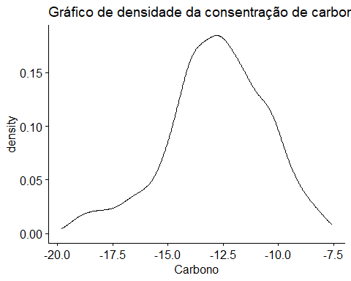

ggdensity(data_isoperu$N.b.coll.,main = "Gráfico de densidade da consentração de Nitrogênio", xlab = "Nitrogênio")

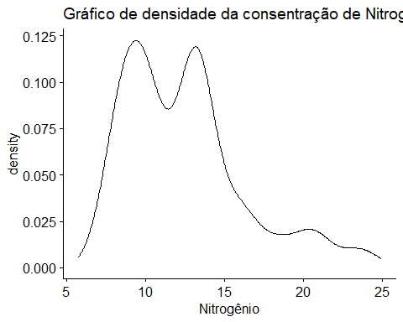

ggdensity(data_isoperu$Temp_Mean ,main = "Gráfico de densidade de temperatura média ", xlab = "Temperatura média")

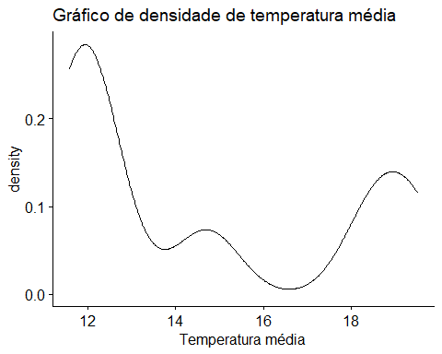

ggdensity(data_isoperu$Demography.kde.14c, main = "Gráfico de densidade demografia", xlab = "Densidade demográfica")

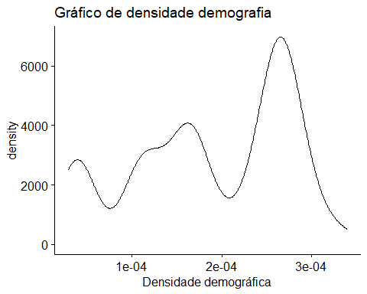

Testando normalidade com qqplot:

ggqqplot(data_isoperu$C.b.coll.)

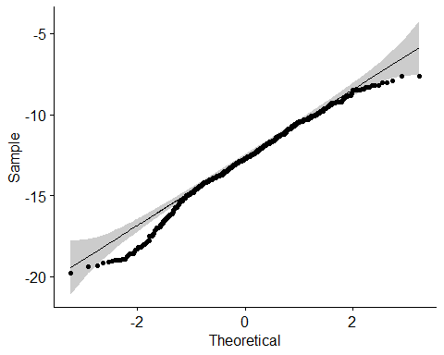

ggqqplot(data_isoperu$N.b.coll.)

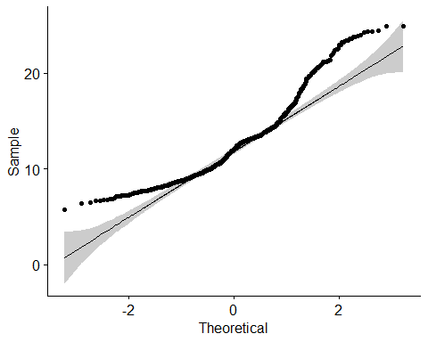

ggqqplot(data_isoperu$Demography.kde.14c)

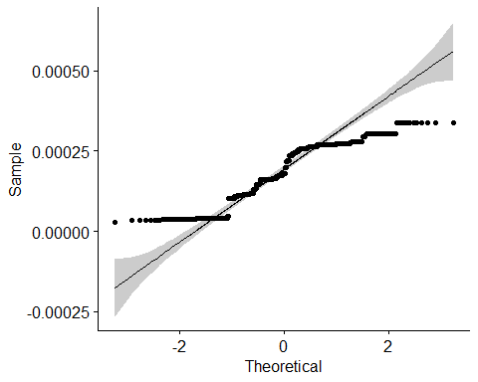

Realizando teste de normalidade pelo método Shapiro-Wilk

shapiro.test(data_isoperu$C.b.coll.)

##   
## Shapiro-Wilk normality test  
##   
## data: data_isoperu$C.b.coll.  
## W = 0.98422, p-value = 8.071e-08

shapiro.test(data_isoperu$N.b.coll.)

##   
## Shapiro-Wilk normality test  
##   
## data: data_isoperu$N.b.coll.  
## W = 0.92253, p-value < 2.2e-16

O teste indica que as amostras de Carbono e Nitrogênio não estão normalmente distribuidos

Plotando gráfico de correlação de Spearman entre carbono e nitrogênio

Relizando testes de correlação em variáveis de interesse:

dat.correl <- data_isoperu %>% select(C.b.coll.,N.b.coll.,Temp_Mean,Precip_Mean,Temp_Mean_Seasonality,Precip_Mean_Seasonality,Demography.kde.14c)  
  
#dat.correl_c <- data_isoperu %>% mutate(N.b.coll.=NULL) %>% select(Temp_Mean,Precip_Mean,Temp_Mean_Seasonality,Precip_Mean_Seasonality,Demography.kde.14c)  
  
  
  
#names(data_isoperu)  
  
correl <- cor(dat.correl,method = "spearman")  
round(correl,2)

## C.b.coll. N.b.coll. Temp_Mean Precip_Mean  
## C.b.coll. 1.00 0.14 0.10 0.10  
## N.b.coll. 0.14 1.00 0.27 -0.14  
## Temp_Mean 0.10 0.27 1.00 -0.39  
## Precip_Mean 0.10 -0.14 -0.39 1.00  
## Temp_Mean_Seasonality -0.08 -0.11 0.59 -0.70  
## Precip_Mean_Seasonality -0.20 -0.16 0.06 -0.82  
## Demography.kde.14c 0.04 -0.40 -0.40 -0.11  
## Temp_Mean_Seasonality Precip_Mean_Seasonality  
## C.b.coll. -0.08 -0.20  
## N.b.coll. -0.11 -0.16  
## Temp_Mean 0.59 0.06  
## Precip_Mean -0.70 -0.82  
## Temp_Mean_Seasonality 1.00 0.47  
## Precip_Mean_Seasonality 0.47 1.00  
## Demography.kde.14c -0.16 0.38  
## Demography.kde.14c  
## C.b.coll. 0.04  
## N.b.coll. -0.40  
## Temp_Mean -0.40  
## Precip_Mean -0.11  
## Temp_Mean_Seasonality -0.16  
## Precip_Mean_Seasonality 0.38  
## Demography.kde.14c 1.00

Plotando gráfico de correlação entre variáveis:

corrplot(correl, method = c("color"), type="upper", order="hclust",  
 col=brewer.pal(n=8, name="RdYlBu"))

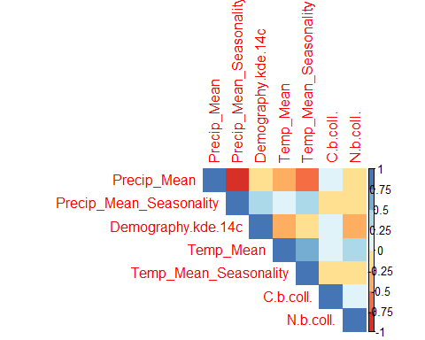

#correl <- cor(dat.correl_c,method = "pearson")  
#corrplot(correl, type="upper", order="hclust",  
 # col=brewer.pal(n=8, name="RdYlBu")

Testando correlação em períodos separados

#selecionando dados por período:  
#Periodo interméfdio primeiro (pip), Horizonte médio (hm), Período intermédio tardio(pit)  
  
#A base de dados mostra os períodos em inglês  
  
#pip  
data.cor.pip <- data_isoperu %>% filter(Period%in%c("Early Intermediate Period")) %>% select(C.b.coll.,N.b.coll.,Temp_Mean,Precip_Mean,Temp_Mean_Seasonality,Precip_Mean_Seasonality,Demography.kde.14c)  
  
#hm  
data.cor.hm <- data_isoperu %>% filter(Period%in%c("Middle Horizon")) %>% select(C.b.coll.,N.b.coll.,Temp_Mean,Precip_Mean,Temp_Mean_Seasonality,Precip_Mean_Seasonality,Demography.kde.14c)  
  
#pit  
  
data.cor.pit <- data_isoperu %>% filter(Period%in%c("Late Intermediate Period")) %>% select(C.b.coll.,N.b.coll.,Temp_Mean,Precip_Mean,Temp_Mean_Seasonality,Precip_Mean_Seasonality,Demography.kde.14c)

correl.pip <- cor(data.cor.pip,method = "spearman")  
round(correl.pip,2)

## C.b.coll. N.b.coll. Temp_Mean Precip_Mean  
## C.b.coll. 1.00 0.32 0.10 -0.24  
## N.b.coll. 0.32 1.00 0.30 -0.39  
## Temp_Mean 0.10 0.30 1.00 -0.78  
## Precip_Mean -0.24 -0.39 -0.78 1.00  
## Temp_Mean_Seasonality 0.02 0.27 0.82 -0.81  
## Precip_Mean_Seasonality -0.03 0.11 0.50 -0.78  
## Demography.kde.14c -0.02 -0.57 -0.46 0.19  
## Temp_Mean_Seasonality Precip_Mean_Seasonality  
## C.b.coll. 0.02 -0.03  
## N.b.coll. 0.27 0.11  
## Temp_Mean 0.82 0.50  
## Precip_Mean -0.81 -0.78  
## Temp_Mean_Seasonality 1.00 0.60  
## Precip_Mean_Seasonality 0.60 1.00  
## Demography.kde.14c -0.28 0.13  
## Demography.kde.14c  
## C.b.coll. -0.02  
## N.b.coll. -0.57  
## Temp_Mean -0.46  
## Precip_Mean 0.19  
## Temp_Mean_Seasonality -0.28  
## Precip_Mean_Seasonality 0.13  
## Demography.kde.14c 1.00

corrplot(correl.pip,method = c("color"), type="upper", order="hclust",  
 col=brewer.pal(n=8, name="RdYlBu"))

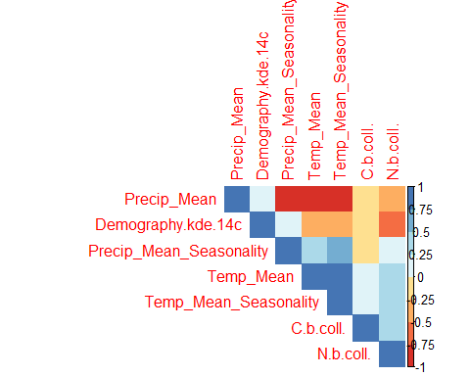

correl.hm <- cor(data.cor.hm,method = "spearman")  
round(correl.hm,2)

## C.b.coll. N.b.coll. Temp_Mean Precip_Mean  
## C.b.coll. 1.00 0.12 -0.07 0.27  
## N.b.coll. 0.12 1.00 0.38 0.01  
## Temp_Mean -0.07 0.38 1.00 -0.21  
## Precip_Mean 0.27 0.01 -0.21 1.00  
## Temp_Mean_Seasonality -0.18 0.00 0.38 -0.76  
## Precip_Mean_Seasonality -0.21 -0.12 0.20 -0.91  
## Demography.kde.14c 0.00 -0.30 0.15 -0.10  
## Temp_Mean_Seasonality Precip_Mean_Seasonality  
## C.b.coll. -0.18 -0.21  
## N.b.coll. 0.00 -0.12  
## Temp_Mean 0.38 0.20  
## Precip_Mean -0.76 -0.91  
## Temp_Mean_Seasonality 1.00 0.65  
## Precip_Mean_Seasonality 0.65 1.00  
## Demography.kde.14c 0.13 0.34  
## Demography.kde.14c  
## C.b.coll. 0.00  
## N.b.coll. -0.30  
## Temp_Mean 0.15  
## Precip_Mean -0.10  
## Temp_Mean_Seasonality 0.13  
## Precip_Mean_Seasonality 0.34  
## Demography.kde.14c 1.00

corrplot(correl.hm, method = c("color"), type="upper", order="hclust",  
 col=brewer.pal(n=8, name="RdYlBu"))

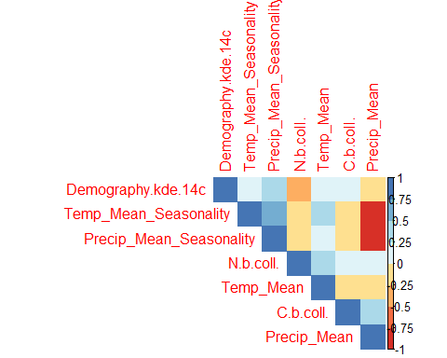

correl.pit <- cor(data.cor.pit,method = "spearman")  
round(correl.pit,2)

## C.b.coll. N.b.coll. Temp_Mean Precip_Mean  
## C.b.coll. 1.00 0.24 0.35 0.13  
## N.b.coll. 0.24 1.00 0.30 -0.13  
## Temp_Mean 0.35 0.30 1.00 -0.25  
## Precip_Mean 0.13 -0.13 -0.25 1.00  
## Temp_Mean_Seasonality -0.09 0.16 0.43 -0.73  
## Precip_Mean_Seasonality -0.18 -0.22 -0.30 -0.76  
## Demography.kde.14c 0.04 -0.18 -0.30 -0.16  
## Temp_Mean_Seasonality Precip_Mean_Seasonality  
## C.b.coll. -0.09 -0.18  
## N.b.coll. 0.16 -0.22  
## Temp_Mean 0.43 -0.30  
## Precip_Mean -0.73 -0.76  
## Temp_Mean_Seasonality 1.00 0.37  
## Precip_Mean_Seasonality 0.37 1.00  
## Demography.kde.14c -0.39 0.49  
## Demography.kde.14c  
## C.b.coll. 0.04  
## N.b.coll. -0.18  
## Temp_Mean -0.30  
## Precip_Mean -0.16  
## Temp_Mean_Seasonality -0.39  
## Precip_Mean_Seasonality 0.49  
## Demography.kde.14c 1.00

corrplot(correl.pit, method = c("color"), type="upper", order="hclust",  
 col=brewer.pal(n=8, name="RdYlBu"))

