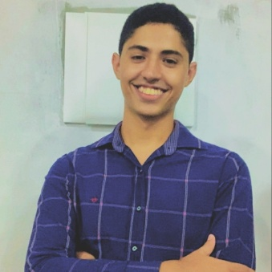
FELIPE GUSTAVO VIEIRA DE ALMEIDA

Fullstack Developer
28 years old, Castanhal - PA
Email: felipegustavotheboss@gmail.com | Phone: +55 (91) 99811-0782
LinkedIn: linkedin.com/in/fg-almeida | GitHub: github.com/FelipeG-Almeida

SUMMARY
Fullstack Developer with comprehensive training in both front-end and back-end technologies, continuously seeking to enhance skills and contribute to high-impact projects. Experienced in developing modern web applications with a focus on performance, security, and user experience.

EDUCATION
IFPA – Bachelor’s Degree in Computer Science Education – 03/2016 - 08/2020
IFPA – Technical Degree in Computer Networks – 03/2016 - 05/2017

LANGUAGES
English (writing: advanced | speaking: intermediate | reading: advanced)

PROFESSIONAL EXPERIENCE
Global Hitss
Fullstack Developer – 06/2025 - Present
Working as a fullstack developer on a security project for Petrobras. Responsible for application maintenance, implementation of new features requested by stakeholders, technology upgrades, and enhancing system security.
Technologies: Oracle DB, Java, Spring, Angular, AWS infrastructure.

Tua Agenda
Front-end Developer (Junior) – 08/2024 - 06/2025
Responsible for designing and implementing dynamic interfaces focused on usability and visual appeal. Worked with React, Next.js, and Styled-components.
Developed a platform that allows clients to register their businesses and services, enabling users to schedule appointments easily, with strong focus on performance and user experience (UX).

Artemis Corporation
Fullstack Developer (Junior) – 02/2023 - 03/2025
Responsible for designing and implementing a WhatsApp automation system using Java and Spring for APIs and business logic, and Angular for dynamic interfaces.
Developed a system enabling the creation of automated workflows and dynamic chatbots through a block-based interface.

COURSES AND ADDITIONAL TRAINING
• Web Fullstack Bootcamp – Labenu – 1000h – 2022-2023
• Java Backend Developer – Oracle Next Education (Oracle + Alura) – 400h – 2023
• Fullstack Developer – Santander Coders (DIO + Santander) – 200h – 2023

SKILLS
HTML/CSS, JavaScript/TypeScript, React, Next.js, Styled-components, Angular, Node.js, Java, Spring, Oracle DB, MySQL, PostgreSQL, Git/GitHub, AWS.
Experience with CSS frameworks and tools, relational databases, and version control systems.
Focused on best practices for security, performance, and accessibility in web applications.

