# **TITLE (A SHORT DESCRIPTION OF THE PROJECT, BEWEEN 8 AND 12 WORDS)**

|  |  |  |  |
| --- | --- | --- | --- |
| Name of first author  University (name in Spanish)  Country  E-mail at Eafit | Felipe Gil Macia  Universidad EAFIT  Colombia  fgilm@eafit.edu.co | Andrea Serna Universidad Eafit Colombia asernac1@eafit.edu.co | Mauricio Toro  Universidad Eafit  Colombia  mtorobe@eafit.edu.co |

**For each version of this report: 1. Detele all text in red. 2. Adjust spaces among words and paragraphs. 3. Change the color of all the texts to black.**

**Red text =** Comments

**Black text =** Andrea and Mauricio’s contribution

**Green text** = To complete for the 1st deliverable

**Blue text**  = To complete for the 2nd deliverable

**Violet text** = To complete for the 3rd deliverable

# **ABSTRACT**

To write an abstract, you should answer the following questions in a single paragraph: What is the problem? Why is the problem important? Which are the related problems? Which is the algorithm you proposed to solve the problem? What QUANTITATIVE results did you achieve? What are the conclusions of this work? The abstract should have **at most 200 words**. (*In this semester, you should summarize here execution times, and results of lowest risk path and shortest path*).

## **Keywords**

|  |
| --- |
| Constrainted shortest path, street sexual harassment,  secure-path identification, crime prevention. |

# **1. INTRODUCTION**

Explain the motivation, in the real world, that leads to the problem. Include some history of this problem. *(In this semester, motivation is why we need to calculate the shortest path without exceeding a weighted-average risk of harassment r and the path with lowest weighted-average risk of harassment without exceeding a distance d).*

# **1.1. Problem**

In a few words, explain the problem, the impact that this problem has in society and why it is useful to solve this problem. *(In this semester, the problem is to calculate the shortest path without exceeding a weighted-average risk of harassment r and the path with lowest weighted-average risk of harassment without exceeding a distance d).*

**1.2 Solution**

Explain, briefly, your solution to the problem *(In this semester, the solution are algorithms for constrained shortest paths. Which algorithms did you choose? Why?)*

**1.3 Article structure**

In what follows, in Section 2, we present related work to the problem. Later, in Section 3, we present the data sets and methods used in this research. In Section 4, we present the algorithm design. After, in Section 5, we present the results. Finally, in Section 6, we discuss the results and we propose some future work directions.

**2. RELATED WORK**

## In what follows, we explain four related works to path finding to prevent street sexual harassment and crime in general.

## Explain four (4) articles related to the problem described in Section 1.1. You may find the related problems in scientific journals. Consider Google Scholar for your search. *(In this semester, related work is path finding implementations to prevent street sexual-harassment and crime in general).*

## **3.1 Write a title for the first related problem**

You should mention the problem they solved, the algorithm they used, the results they obtained, and the ACM citation.

## **3.2 Write a title for the second related problem**

You should mention the problem they solved, the algorithm they used, the results they obtained, and the ACM citation.

## **3.3 Write a title for the third related problem**

You should mention the problem they solved, the algorithm they used, the results they obtained, and the ACM citation.

## **3.4 Wite a title for the fourth related problem**

You should mention the problem they solved, the algorithm they used, the results they obtained, and the ACM citation.

## **3. MATERIALS AND METHODS**

In this section, we explain how data was collected and processed and, after, different constrained shortest-path algorithm alternatives to tackle street sexual-harassment.

## **3.1 Data Collection and Processing**

The map of Medellín was obtained from Open Street Maps (OSM)[1] and downloaded using Python OSMnx API[2]. The (i) length of each segment, in meters; (2) indication wheter the segment is one way or not, and (3) well-known binary representation of geometries were obtained from metadata provided by OSM.

For this project, we calculated the linear combination that captures the maximum variance between (i) the fraction of households that feel insecure and (ii) the fraction of households with income below one minimum wage. These data were obtained from the quality of life survey, Medellín, 2017. The linear combination was normalized, using the maximum and minimum, to obtain values between 0 to 1. The linear combination was obtained using principal components analysis. The risk of harassment is defined as one minus the normalized linear combination. Figure 1 presents the risk of harrament calculated. Map is available at Github[3].

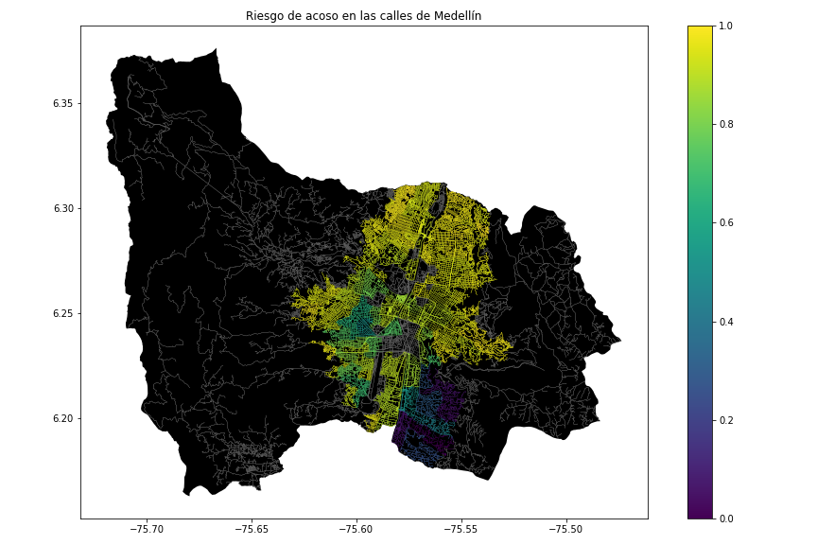**Figure 1.** Risk of sexual harassment calculated as a lineal combination of the fraction of households that feel insecure and the fraction of households with income below one minimum wage, obtained from Life Quality Survey of Medellín, in 2017.

## **3.2 Constrained Shortest-Path Alternatives**

## In what follows, we present different algorithms used for constrained shortest path. *(In this semester, examples of such algorithms are DFS, BFS, a modified version of Dijkstra, a modified version of A*, among others).*

**3.2.1 Name of the first algorithm**

Please explain the algorithm, its complexity and include your own vector figure designed in *https://www.lucidchart.com/* or equivalent.

**3.2.2 Name of the second algorithm**

Please explain the algorithm, its complexity and include your own vector figure designed in *https://www.lucidchart.com/* or equivalent.

**3.2.3 Name of the third algorithm**

Please explain the algorithm, its complexity and include your own vector figure designed in *https://www.lucidchart.com/* or equivalent.

**3.2.4 Name of the fourth algorithm**

Please explain the algorithm, its complexity and include your own vector figure designed in *https://www.lucidchart.com/* or equivalent.

## **4. ALGORITHM DESIGN AND IMPLEMENTATION**

## In what follows, we explain the data structures and the algorithms used in this work. The implementations of the data structures and algorithms are available at Github[4].

## **4.1 Data Structures**

## Explain the data structure that will be used to implement the constrained shortest path algorithm and make a figure explaining it. Do not use figures from the Internet. *(In this semester, example of the data structures are adjacency matrix, adjacency list, adjacency list using a dictionary).*

Data structure is presented in Figure 2.

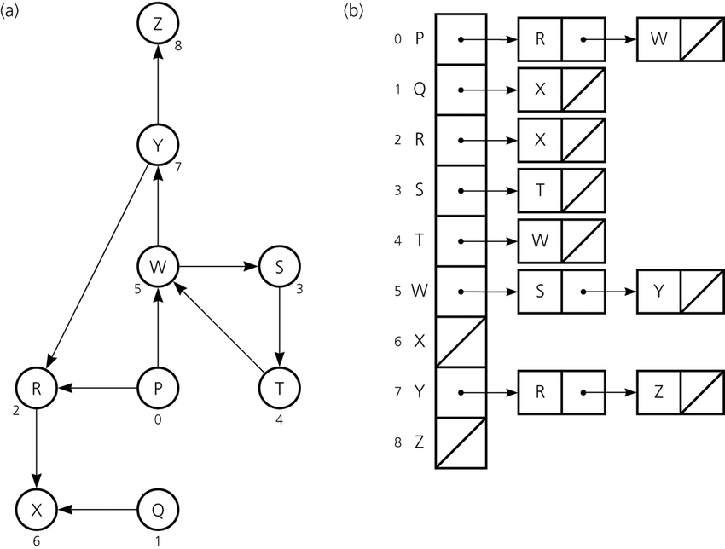**Figure 2:** An example of a street map is presented in (a) and its representation as an adjacency list in (b). (*Please, feel free to change this Figure if you use a different data structure*).

**4.2 Algorithms**

In this work, we propose algorithms for the constrained shortest-path problem. The first algorithm calculates the shortest path without exceeding a weighted-average risk of harassment *r*. The second algorithm calculates the path with the lowest weighted-average risk of harassment without exceeding a distance *d*.

**4.2.1 First algorithm**

Explain the design of the algorithm to calculate the shortest path without exceeding a weighted-average risk of harassment *r* and make your own figure. Do not use figures from the Internet, make your own. *(In this semester, the algorithm could be DFS, BFS, a modified version of Dijkstra, a modified version of A*, among others ).* Algorithm is exemplified in Figure 3.

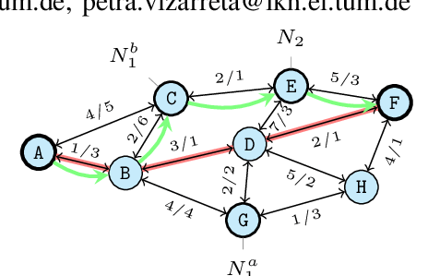**Figure 3:** Solving the constrained shortest-path problem with Deep First Search (DFS). (Please, feel free to change this Figure if you use a different algorithm).

**4.2.2 Second algorithm**

Explain the design of the algorithm to calculate calculates the path with the lowest weighted-average risk of harassment without exceeding a distance *d* and make your own figure. Do not use figures from the Internet, make your own. *(In this semester, the algorithm could be DFS, BFS, a modified version of Dijkstra, a modified version of A*, among others ).* Algorithm is exemplified in Figure 4.

**Figure 4:** Solving the constrained shortest-path problem with Deep First Search (DFS). (Please, feel free to change this Figure if you use a different algorithm).

**4.4** **Complexity analysis of the algorithms**

Explain, in your own words, the analysis, for the worst case, using O notation. How did you calculate such complexities? Please explain briefly.

|  |  |
| --- | --- |
| **Algorithm** | **Time Complexity** |
| Name of the algorithm | O(V2*E2) |
| Name of the second algorithm (in case you tried two) | O(E3*V*2V) |

**Table 1:** Time Complexity of the name of your algorithm, where V is… E is... *(Please explain what do V and E mean in this problem).*

|  |  |
| --- | --- |
| **Data Structure** | **Memory Complexity** |
| Name of the data structure | O(V*E*2E ) |
| Name of the second data structure (in case you tried two) | O(2E*2V) |

**Table 2:** Memory Complexity of the name of the data structure that your algorithm uses, where V is… E is... *(Please explain what do V and E mean in this problem).*

**4.5 Design criteria of the algorithm**

Explain why the algorithm was designed that way. Use objective criteria. Objective criteria are based on efficiency, which is measured in terms of time and memory. Examples of non-objective criteria are: “I was sick”, “it was the first data structure that I found on the Internet”, “I did it on the last day before deadline”, “it’s easier”, etc. Remember: This is 40% of the project grading.

**5. RESULTS**

In this section, we present some quantitative results on the shortest path and the path with lowest risk.

**5.1.1 Shortest-Path Results**

In what follows, we present the results obtained for the shortest path without exceeding a weighted-average risk of harassment *r* in Table 3.

|  |  |  |  |
| --- | --- | --- | --- |
| **Origin** | **Destination** | **Shortest Distance** | **Without Exceeding *r*** |
| Universidad EAFIT | Universidad de Medellín | ?? | 0.84 |
| Universidad de Antioquia | Universidad Nacional | ??? | 0.83 |
| Universidad Nacional | Universidad Luis Amigó | ?? | 0.85 |

**Table 3.** Shortest distances without exceeding a weighted-average risk of harassment *r*.

**5.1.2 Lowest Harassment-Risk Results**

In what follows, we present the results obtained for the path with lowest weighted-average harassment risk without exceeding a distance *d* in Table 4.

|  |  |  |  |
| --- | --- | --- | --- |
| **Origin** | **Destination** | **Lowest Harassment** | **Without Exceeding *d*** |
| Universidad EAFIT | Universidad de Medellín | ?? | 5,000 |
| Universidad de Antioquia | Universidad Nacional | ??? | 7,000 |
| Universidad Nacional | Universidad Luis Amigó | ?? | 6,500 |

**Table 3.** Lowest weighted-average harassment risk without exceeding a distance *d* (in meters).

**5.2 Algorithm Execution-Time**

In Table 4, we explain the relation of the average execution times for the queries presented in Table 3.

Compute execution time for the queries presented in Table 3. Report average execution times.

## 

|  |  |
| --- | --- |
|  | **Average execution times (s)** |
| Universidad EAFIT to Universidad de Medellín | 100.2 s |
| Universidad de Antioquia to Universidad Nacional | 800.1 s |
| *Universidad Nacional to Universidad Luis Amigó* | 845 s |

## **Table 4:** Execution times of the algorithm name *(Please write the name of the algorithm, for instance, DFS, BFS, a modified A*)* for the queries presented in Table 3.

## **6. CONCLUSIONS**

Explain the results obtained. Are shortest paths significantly different from paths with lowest harassment-risk? How is this useful for the city? Are execution times reasonable to use this implementation in a real-life situation?

**6.1 Future work**

Answer, what would you like to improve in the future? How would you like to improve your algorithm and its implementation? Will you continue this projects by further working on Optimization? Statistics? Web development? Machine learning? Virtual Reality? How?

# **ACKNOWLEDGEMENTS**

Identify the kind of acknowledgment you want to write: for a person or for an institution. Consider the following guidelines: 1. Name of teacher is not mentioned because he is an author. 2. You should not mention authors of articles that you have not contacted. 3. You should mention students, teachers from other courses that helped you.

As an example: This research was supported/partially supported by [Name of Foundation, Grant maker, Donor].

We thank for assistance with [particular technique, methodology] to [Name Surname, position, institution name] for comments that greatly improved this manuscript.

The authors are greateful to Prof. Juan Carlos Duque, from Universidad EAFIT, for providing data from Medellín Life Quality Survey, from 2017, processed into a Shapefile.

# **REFERENCES**

Reference sourced using ACM reference format. Read ACM guidelines in <http://bit.ly/2pZnE5g>

As an example, consider this two references:

1.Adobe Acrobat Reader 7, Be sure that the references sections text is Ragged Right, Not Justified. <http://www.adobe.com/products/acrobat/>.

2. Fischer, G. and Nakakoji, K. Amplifying designers’ creativity with domainoriented design environments. in Dartnall, T. ed. Artificial Intelligence and Creativity: An Interdisciplinary Approach, Kluwer Academic Publishers, Dordrecht, 1994, 343-364.

Please remove the references above, they are only an example.

1. <https://www.openstreetmap.org/>
2. https://osmnx.readthedocs.io/
3. [https://github.com/mauriciotoro/ST0245Eafit/tree/master/  
   proyecto/Datasets](https://github.com/mauriciotoro/ST0245Eafit/tree/master/proyecto/Datasets)/
4. <http://www.github.com/> ????????? /.../proyecto/