Hardware in the Loop Validation
Hardware-in-the-loop (HIL) simulation is a type of real time simulation. HIL simulation shows how the controller responds to realistic virtual signals. It is also used to check if the model of the physical system (plant) is valid.
The complexity of the plant under control is included in test and development by adding a mathematical representation of all related dynamic systems. These mathematical representations are referred to as the plant simulation.

FIGURE HERE

HIL simulation include emulation of sensors and actuators which act as the interface between the modeled plant and the embedded system under test. The value of each emulated sensor is controlled by the HIL simulation and read by the embedded system under test. Likewise, the embedded system outputs signals that are sent to the actuators on the plant simulation. Changes in the signal sent to the actuator results in changes to variable values in the plant simulation.
Summing up, a HIL simulation is used to test the control technique chosen in a given application. With the use of a real-time computer as a virtual representation of the physical system and a real implementation of the controller used, one can test the embedded system before using it in a real hardware with actual components.
In this work, a Typhoon HIL 402 Hardware-in-the-loop system, shown in Fig. 1, is used to test the different control techniques proposed to control the current injected into the grid. Typhoon HIL 402 has the specifications shown in Table 1.
Fig. 1 Typhoon HIL 402
Table 1- Specifications of HIL 402 from Typhoon HIL
HIL402 technical details.
Processor | 4 cores
Channels | 16 x Analog inputs (AI)  16 x Analog outputs (AO)  32 x Digital inputs (DI)  32 x Digital outputs (DO)
Resolution | 16 bit
Analog IO voltage range | ± 10 V
Built-in scope | Yes
Machine models support | Basic  Advanced
Connectivity | USB  Ethernet
Compatibility | HIL DSP Interface  HIL Breakout board  HIL dSpace Interface  HIL uGrid DSP Interface
Software | HIL Control Center

The model used to represent the photovoltaic micro inverter feeding a resistive load with nominal power of 250 W is built in Typhoon HIL Control Center, and is shown in Fig. 2.
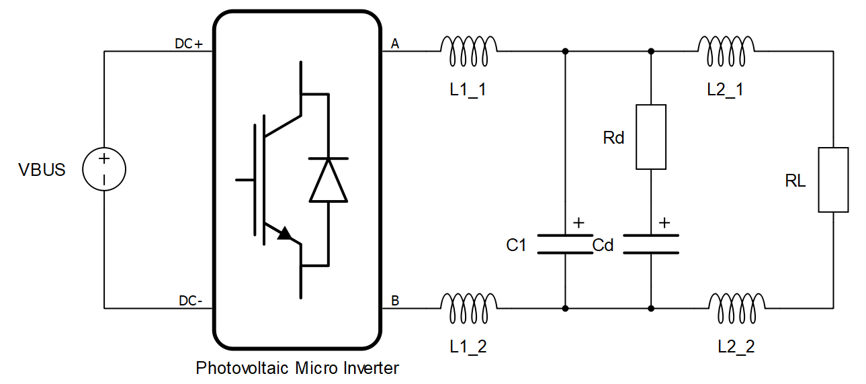
Fig. 2. Model of the micro inverter built in Typhoon HIL Control Center
There are two options for controlling the Photovoltaic Micro Inverter switches of Fig. 2: through digital inputs or using an internal modulator. Using HIL digital inputs means that the micro controller will command the inverter and, thus, the control technique that will be used in the physical prototype can be first tested in the HIL device.
- Validation of the micro inverter model with a resistive load
In order to validate the model that will be used in HIL simulation, the circuit shown in Fig. 2 is compared with the same circuit simulated in PSIM.
  - Open-Loop Operation with resistive load
The first method of validation of the HIL simulated system is the circuit shown in Fig. 2, connected to a resistive load, operating in open-loop. Figure 1 illustrates the current flowing through the inductors L2_1 and L2_2, which is the same current that is injected in the load.
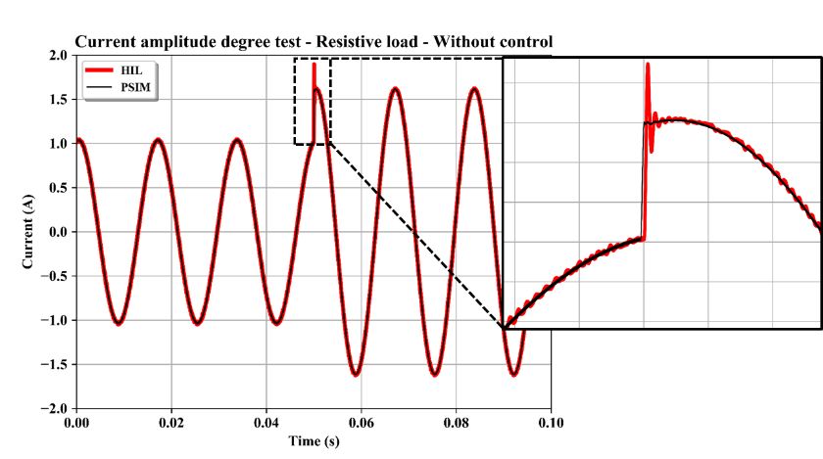
Figure 1- Comparison between HIL and PSIM simulated results
Approximately at a simulation time of 50 ms, the amplitude of the current is changed from 1 A to 1.6 A.
The comparison shows that, when the system is operating in a steady-state, the response from HIL is similar to the response from PSIM.
However, when the amplitude of the current suddenly changes, one can observe that the two responses differ from each other. Therefore, the dynamic response of the HIL system is slightly different from the numeric-computer simulated system.
The difference in the HIL simulated system dynamic response may be explained by the fact that the simulation in the HIL system is optimized to run in real time.
By simulating a system in real time, in order to reproduce a large quantity of details from the real circuit, the simulation time step have to be smaller enough.
Reducing calculation time steps in HIL simulators is critical, especially if simulating lower power circuits or circuits with very low damping [Validation Method for Hardware-in-the-Loop Simulation Models]. Faster calculation can be achieved with simpler models or lower resolution.

  - Independent Closed-Loop Operation with resistive load
The second method of validation of the HIL simulated system is the circuit shown in Fig. 2, connected to a resistive load, operating in closed-loop with the same control structure.
Both systems are simulated under the PI control technique associated with a Feed-forward gain calculated in the previous chapter. The PI control continuous -time transfer function is shown again in [Eq. xxx].

