**Mathematical modeling of System**

A single input – single output (SISO) feedback control system can be represented by a block diagram as shown in FIGURE X:



Where:

$G(s)$– is the transfer function that represents the system model;

$C(s)$– is the transfer function that represents the system control;

$H(s)$– is the feedback dynamics;

$Ref(s)$– is the reference signal;

$y(s)$– is the output signal.

A reference signal is compared to the feedback variable and an error signal is generated. The error signal is then sent to the system control block, which provides a control action. The control action is responsible to act in the system in order to bring the output variable to a value as close as possible to the reference signal, i.e. reducing the deviation to zero or a small value.

In order to design the control, it is necessary to know the static and dynamics characteristics of every element that composes the system to be controlled. Thus, one must obtain the mathematic model that represents the converter used in this application.

According to (KENSKI) the converter can be separated in three different parts: DC stage, switching stage, and AC stage. The monophasic micro inverter with damped LCL filter is represented in FIGURE X:



Fonte: Diogo Kenski, dissertação

The conventional classic modeling approach cannot deal with the circuit represented by the FIGURE X since it is non-linear due to its switching elements.

The first step in modeling the converter is to substitute the switching elements of the converter by their equivalent large signal average circuit model. By doing that, one eliminates the non-linear characteristic of the commutated circuit and obtains a model that has a linear behavior when operating near an equilibrium point.



The equivalent average circuit of the full-bridge inverter can be represented by the circuit shown in FIGURE X, which is not yet a linear representation since the controlled voltage and current sources are products of two time variant variables ( $d\left(t\right)$**and $V_{bus}(t))$**  or ( $d(t)$**and $I_{L}(t)$** ).



In order to obtain a linear representation for the full-bridge inverter one must use the small-ripple approximation. This technique linearize the time-variant variables around a operation point, considering that these variables do not vary from that point unless by some small disturbances. These approximations are represented by EQ. XXX:

This technique consists in assuming that the capacitor’s voltage and inductors’ current have a small ripple that can be considered a DC value.

$$i_{L2}\left(t\right)≅I_{L2}+{\tilde{i}}_{L2}$$

$$d\left(t\right)≅D+\tilde{d}$$

$$V_{bus}\left(t\right)≅V_{BUS}+{\tilde{v}}_{bus}$$

Where ${\tilde{i}}_{L2}$, $\tilde{d}$, and ${\tilde{v}}_{bus}$ are small deviations from the operating point.

Using these approximations, the current dependent source in the average circuit may be written as:

$$d\left(t\right).i_{L1}\left(t\right)=\left(D+\tilde{d}\right).(I_{L2}+{\tilde{i}}_{L2})$$

$$=\underset{order 0}{\underbrace{D.I_{L2}}}+\underset{order 1}{\underbrace{D.{\tilde{i}}_{L2}+I_{L2}.\tilde{d}}}+\underset{order 2}{\underbrace{\tilde{d}.{\tilde{i}}_{L2}}}$$

The order zero term represent the DC operating point. The first order terms are the terms that impose dynamics in the converter.

Since and are, by definition, very small deviations, the second order term of EQUATION X above, which is a product of two very small values, is even smaller and can be discarded from the equation.

Likewise, the voltage dependent source in the average circuit may be written as:

$$d\left(t\right).V_{bus}\left(t\right)=\left(D+\tilde{d}\right).(V_{BUS}+{\tilde{v}}_{bus})$$

$$=\underset{order 0}{\underbrace{D.V_{BUS}}}+\underset{order 1}{\underbrace{D.{\tilde{v}}_{bus}+V_{BUS}.\tilde{d}}}+\underset{order 2}{\underbrace{\tilde{d}.{\tilde{v}}_{bus}}}$$

The zero order term represent the DC operating point. The first order terms are the terms that impose dynamics in the converter.

Since and are, by definition, very small deviations, the second order term of EQUATION X above, which is a product of two very small values, is even smaller and can be discarded from the equation.

The considerations made above yields EQUATION X, which represents the current dependent source, and EQUATION X, which represents the voltage dependent source of the circuit in FIGURE X.

$$d\left(t\right).i_{L1}\left(t\right)=\underset{order 0}{\underbrace{D.I_{L2}}}+\underset{order 1}{\underbrace{D.{\tilde{i}}_{L2}+I_{L2}.\tilde{d}}}$$

$$d\left(t\right).V_{bus}\left(t\right)=\underset{order 0}{\underbrace{D.V_{BUS}}}+\underset{order 1}{\underbrace{D.{\tilde{v}}_{bus}+V_{BUS}.\tilde{d}}}$$

Separating the zero order terms from the first order terms, the circuit presented in FIGURE X can be redrawn as the circuit presented in FIGURE X.

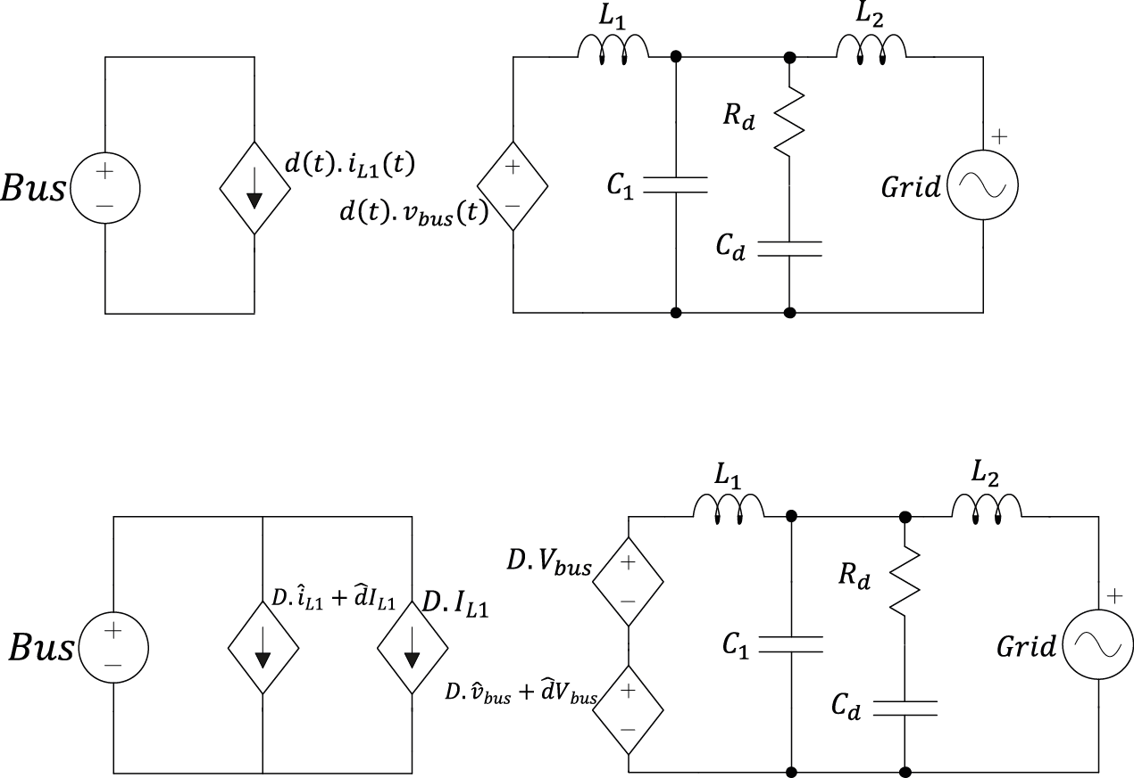

As this circuit is considered to be linear around its operating point, all theories of linear systems can be done in its analysis. The next step is using the superposition principle to separate the circuit according to the sources that feed it.

The superposition principle, also known as superposition property, states that, for all linear systems, the net response caused by two or more stimuli is the sum of the responses that would have been caused by each stimulus individually. So that if input A produces response X and input B produces response Y then input (A + B) produces response (X + Y).





In order to find the transfer function that represents the dynamic behavior of the circuit represented in FIGURE X, the impedance of the damped-LCL filter is to be founded.

Applying Laplace, one can replace the elements of the damped LCL filter by impedances dependent of the frequency variable ($s$). The grid source can be considered as a short-circuit due to the superposition principle mentioned above. The equivalent model used to find the transfer function of the grid current related to the duty cycle is shown in FIGURE XXX.

$$Z_{L1}=s.L_{1}$$

$$Z_{C1}=\frac{1}{s.C_{1}}$$

$$Z_{C2}=R_{d}+\frac{1}{s.C_{2}}$$

$$Z_{L2}=s.L_{2}$$

It is possible to associate the two capacitive impedances in order to obtain a single damped capacitive branch. This association yields EQUATION X:

$$Z_{C}=\frac{C_{d}.R_{d}.s+1}{s(s.C_{d}.R_{d}.C_{1}+C_{d}+C_{1})}$$

The transfer function that relates the duty cycle with the current in the second inductor is given by:

$$\frac{i_{L2}}{d}=\frac{Bus.Z_{C}}{Z_{1}.Z_{2}+Z_{2}.Z_{3}+Z_{1}.Z_{3}}$$

Rewriting this transfer function in terms of the passive elements yields EQUATION X:

$$\frac{i_{L2}}{d}=\frac{b_{1}.s+b_{0}}{a_{4}.s^{4}+a_{3}. s^{3}+a_{2}.s^{2}+a_{1}.s+a_{0}}$$

$b_{1}=Bus.R_{d}.C_{d}$;

$b_{0}=Bus$;

$a_{4}=L_{1}.L_{2}.C_{1}.C_{d}.R_{d}$;

$a3=L_{1}.L_{2}(C_{1}+C_{d})$;

$a_{2}=C_{d}.R_{d}(L_{1}+L_{2})$;

$a_{1}=L_{1}+L_{2}$;

$a_{0}=0$;

In order to validate this transfer function, the circuit shown in FIGURE XX is simulated in the software PSIM using the tool ‘AC sweep’. The comparison between the AC sweep response and the transfer function bode diagram is shown in FIGURE X.

This comparison show that, for a large frequency range, the results are very similar. Therefore, the transfer function obtained through the mathematic modeling is considered to be valid.

