**Experimental Verification**

In this chapter, experimental verification is conducted in the PV microinverter in order to compare and validate the simulation results produced in chapters [CAPÍTULOS ANTERIORES]. To obtain the experimental results needed, it is considered:

* The measurement waveforms were taken using the scope DSO-X 4054-A, from Keysight Technologies;
* The harmonic and Power Factor analysis were performed with the power analyzer WT1800 from Yokogawa;
* The experimental test were conducted by means of the DC power supply from Regatron (600V – 20A), in order to emulate the PV module at DC-DC converter input.

Hardware

The hardware employed to perform the experimentation is the two-staged photovoltaic microinverter proposed in [Thiago DISSERTACAO] and shown in [FIGURE XXX].

Table 1 presents the main operating characteristics of the dc-ac stage of the prototype. Table 2 lists the passive components employed to filter out the high frequency in the inverter operation of the microinverter.

Table 1- System specification for electric circuit and control of dc-ac stage of the prototype

|  |  |
| --- | --- |
| **Description** | **Value** |
| Rated Average Power | 250 W |
| Switching frequency | 100 kHz |
| Bus Voltage | 420V |
| Input Voltage | 20-40 V |
| Peak grid voltage | 311 V |
| Peak grid current | 1.607 A |
| Grid frequency | 60 Hz |
| Peak-to-peak carrier amplitude | 1 V |
| Modulator gain | 1 |
| Grid current sensor | 1 |
| Bus voltage sensor | 1 |
| Peak reference sinusoidal – PLL | 1 |
| Sampling frequency | 50 kHz |

Table 2- Filter components employed in the dc-ac stage of the prototype

|  |  |
| --- | --- |
| **Component** | **Value** |
| Capacitance bus | 50 µF |
| Inductance L1 | 180 µH |
| Inductance L2 | 1.2 mH |
| Capacitance C1 | 1 µF |
| Capacitance Cd | 1 µF |
| Resistance Rd | 15 Ω |

Table 1 presents the main operating characteristics of the dc-dc stage of the prototype. Table 2 lists the passive components employed to filter out the high frequency in the inverter operation of the microinverter.

Table 3- System specification for electric circuit and control of dc-dc stage of the prototype

|  |  |
| --- | --- |
| **Description** | **Value** |
| Rated Average Power | 250 W |
| Switching frequency | 100 kHz |
| Bus Voltage | 420V |
| Input Voltage | 20-40 V |
| Peak-to-peak carrier amplitude | 1 V |
| Modulator gain | 1 |
| PV voltage sensor | 1 |
| Bus voltage sensor | 1 |

Table 4- Filter components employed in the dc-dc stage of the prototype

|  |  |
| --- | --- |
| **Component** | **Value** |
| Capacitance PV | 60 µF |
| Inductance L1 | 54.5 µH |
| Inductance L2 | 2.81 mH |
| Magnetizing Inductance | 54.3 µH |
| Leakage Inductance | 0.27 µH |
| Turns Ratio | 1:7.2 |
| Capacitance C1 | 20 µF |
| Capacitance Cd | 10 µF |
| Capacitance Cd | 1 µF |

Digital Control Implementation

The control strategies designed for the operation of the microinverter was digitally implemented in a TMS320F28069 DSP (Digital Signal Processor) from Texas Instrument.

The current measurement was implemented with the employment of a Hall effect current sensor (ACS724LLCTR-05B-T). The voltage measurements were performed with a resistor voltage divider. These signals are conditioned into the analog circuitry conditioning that is acquired by means the analog-to-digital converter. Then, the DSP is responsible for reading these signals, process and adequate them, calculate the implemented control law, and refresh the PWM signals that feed the gate drivers circuits that command the switches in the power stage of the inverter.

PI – Proportional + Integrator

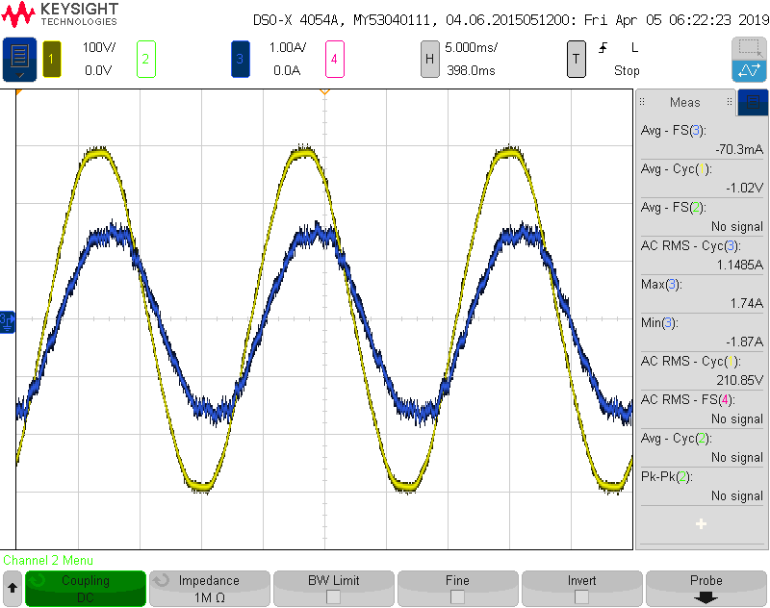

PR – Proportional + Resonant

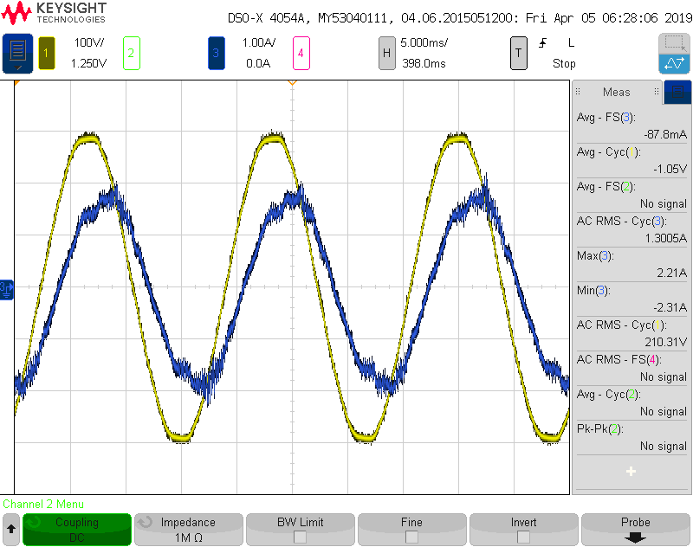

MR – Multi-resonant

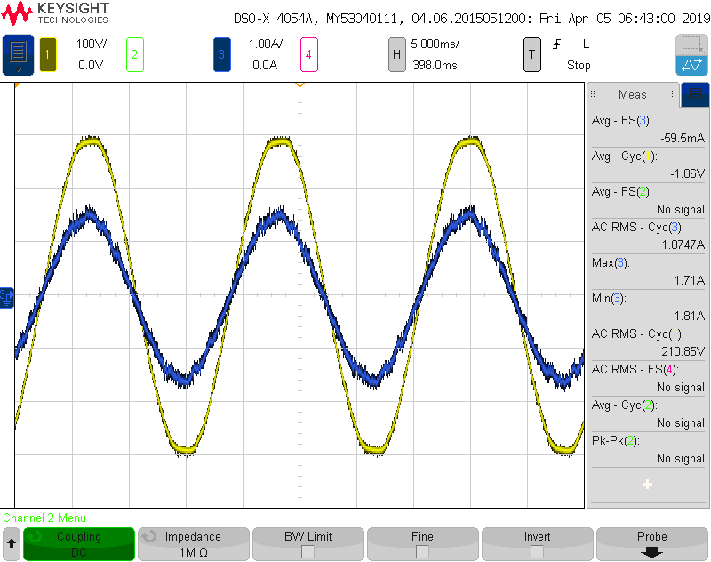

Repetitive

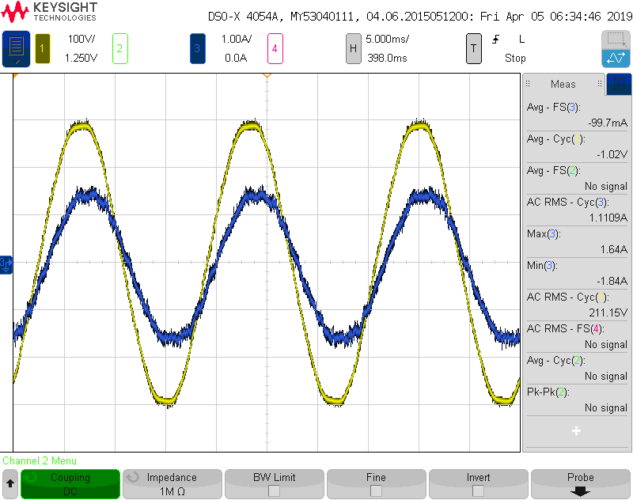

PI – Proportional + Integrator + Feedforward

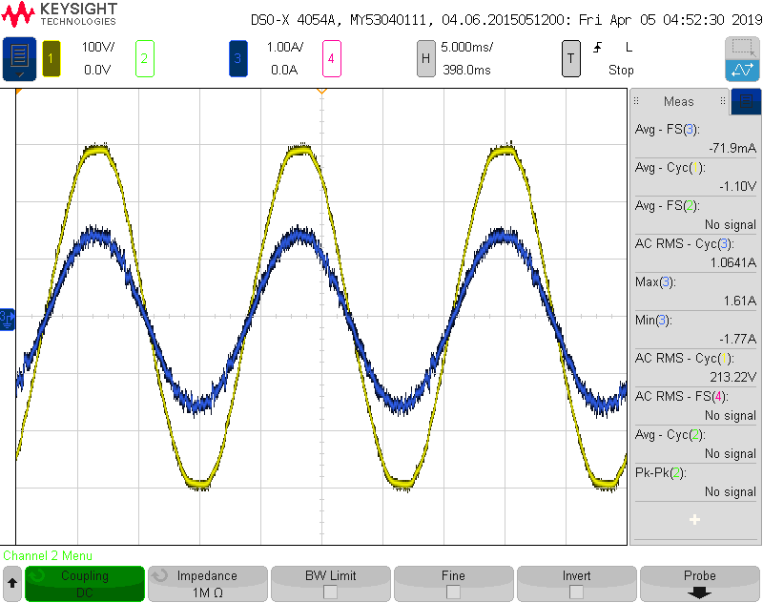

PR – Proportional + Resonant + Feedforward

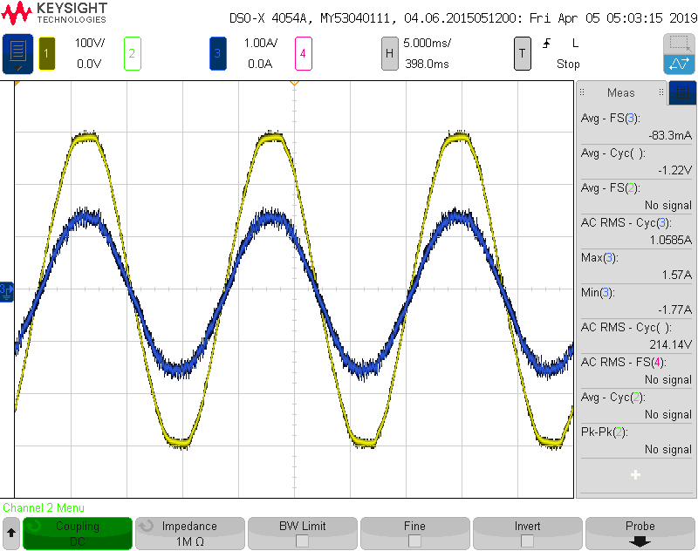

MR – Multi-resonant + Feedforward

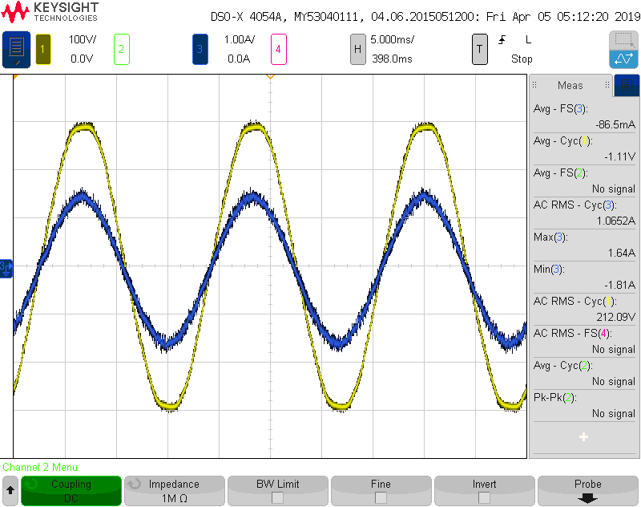

Repetitive + Feedforward

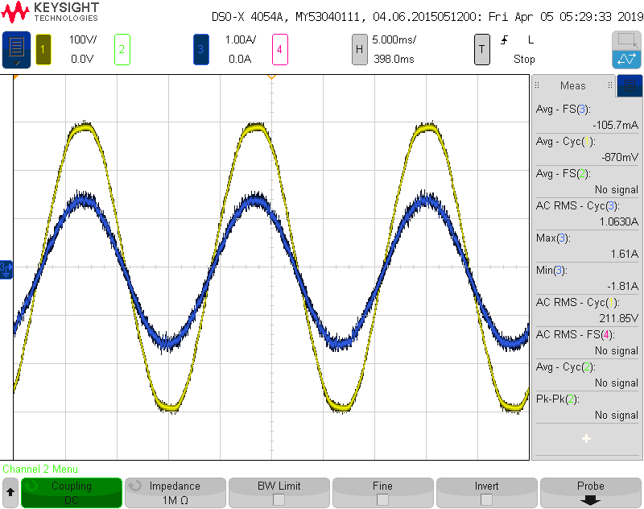

|  |  |  |  |  |  |  |
| --- | --- | --- | --- | --- | --- | --- |
|  | | | | | | |
| Control | THD (250W) | PF (250W) | THD (125W) | PF (125W) | Memory | Execution time |
| PI | 5.44% | 0.931 |  |  |  |  |
| PR | 6.53% | 0.816 |  |  |  |  |
| MR | 3.35% | 0.996 |  |  |  |  |
| Rep | 3.97% | 0.962 |  |  |  |  |
| Prop+FF | 6.97% | 0.958 | 14.16% | 0.898 |  |  |
| PI+FF | 2.03% | 0.998 | 4.79% | 0.996 |  |  |
| PR+FF | 2.31% | 0.999 | 5.93% | 0.996 |  |  |
| MR+FF | 1.78% | 0.997 | 2.80% | 0.996 |  |  |
| Rep+FF | 1.75% | 0.998 | 4.54% | 0.996 |  |  |