Brief Commentary: A Framework for Detecting AI Agents in Online Research

Felipe M. Affonso

Forthcoming, Journal of Consumer Research

Felipe M. Affonso (felipe.affonso@okstate.edu) is Assistant Professor of Marketing, Spears School of Business, Oklahoma State University, 316 Business Building, Stillwater, OK 74078, USA. Felipe gratefully acknowledges Chris Janiszewski for comments on an early version of this article, Andrew Gordon for insightful conversations on AI agent detection and data collection, and the JCR review team for insightful comments. Supplementary materials are included in the Web Appendix accompanying the online version of this article. Please address correspondence to Felipe M. Affonso.

ABSTRACT

Online behavioral research assumes survey responses come from humans, yet vision-enabled AI agents can now autonomously complete surveys by capturing screenshots, processing questions, and submitting responses. Because these agents perceive the same rendered visual content that humans see, traditional detection methods are ineffective. This article introduces the Cognitive Trap Framework: researchers can transform architectural constraints of vision-language models into survey questions where the correct answers are simultaneously difficult for AI agents but easily processed by humans. Six traps derived from computer science benchmarks demonstrate the framework. Against 1,007 human participants (Prolific) and 526 researcher-deployed AI agents (e.g., ChatGPT Agent, Google Project Mariner), cognitive traps detected 97.1% of agents (vs. 2.3% with traditional attention checks), while flagging only 4.1% of humans. Pre-registered replications on Amazon MTurk and CloudResearch Connect demonstrate cross-platform effectiveness, and validation against 34 frontier models spanning two years reveals that model improvement is non-monotonic because each new architecture reconfigures which constraints it resolves and which it introduces. The framework can thus generate new cognitive traps as AI agent models evolve, and a public repository provides researchers with validated traps ready for deployment.
Keywords: survey methodology, data quality, fraud detection, artificial intelligence, large multimodal models

Consider Tommy, a Prolific participant who passed all verification checks when joining the platform. He cleared bank-grade identity verification, built a strong record across hundreds of approved submissions, and maintained the approval rating that gives him priority access to studies with more stringent data quality requirements. On a busy Wednesday afternoon, juggling work deadlines and childcare logistics, Tommy opens Perplexity Comet (or ChatGPT Agent) and instructs the AI to browse his Prolific account and complete all the available surveys. The AI agent autonomously navigates his account, identifies a survey about product preferences, accepts it, captures screenshots of each question, processes them through vision-language models, generates responses matching his demographic profile, and submits. Tommy collects payment while the agent handles everything, including maintaining a copy of the survey completion code. Despite the researcher’s extensive survey pretesting, careful scale selection from the literature, multiple rounds of proofreading, and pilot testing, Tommy has never read a single question.
This opening example represents one point on a spectrum of vision-enabled AI fraud possibilities, ranging from individuals manually pasting survey URLs into ChatGPT Agent to organized operations deploying agents across dozens of simultaneous browser instances, each managing multiple participant accounts and completing surveys in parallel across platforms.
Recent work has begun documenting this emerging threat, with researchers observing LLM-mediated responses in up to 45% of submissions in some studies (Rilla et al. 2025), while Westwood (2025) demonstrates that autonomous synthetic respondents can achieve a 99.8% pass rate across 6,000 attention check trials in a controlled evaluation of LLMs. The scope of AI-mediated survey responses is now well documented (Phillips 2026), yet the research to date documents the threat but proposes no concrete detection solution beyond demanding transparency from participant panels or reverting to controlled laboratory recruitment.
Vision-enabled AI agents differ from earlier text-based AI interfaces in two consequential ways. First, earlier models such as GPT-3.5 are text-only large language models (LLMs), while current models such as GPT-5.2, Gemini 3 Pro, and Claude Sonnet 4.6 are large multimodal models (LMMs) that process visual content and other modalities. Second, and more consequentially, LMMs can now be accessed through agent-based frameworks (ChatGPT Agent, Perplexity Comet, Google Project Mariner, among others) that enable autonomous operations where the AI fully controls web browsers, navigates pages, clicks buttons, fills forms, and submits responses with minimal to zero human involvement. These tools currently enable low-cost autonomous survey completion, and their adoption trajectories suggest that what is technically possible for a determined individual today can become scalable within months.
This article introduces the Cognitive Trap Framework for detecting vision-enabled AI fraud in behavioral research. The framework’s core idea is that architectural constraints in vision-language models, documented through the computer science benchmarking ecosystem, can be transformed into simple survey questions where humans succeed through natural cognitive processing while large multimodal models fail due to their structural characteristics. Specifically, this article demonstrates the framework by exploiting five such constraints from computer science benchmarks, transforming them into visual survey questions, and validating detection performance against human participants across three platforms, 34 vision-enabled large multimodal models, and researcher-deployed AI agents across four agent platforms.
The following sections present each stage of this process. Five constraints yield six cognitive traps (Table 1) validated against 34 models spanning nearly two years (Figure 2), where model improvement is shown to be non-monotonic: accuracy drops from 30.4% in early models to 15.7% in mid-generation before recovering to 31.8% in the latest cohort, because each new architecture reconfigures which constraints it resolves and which it introduces. Although Westwood (2025) suggests that AI agent detection solutions are likely to be fleeting, our validation suggests that model improvement is not necessarily uniform. A pre-registered deployment with 1,007 humans and 526 AI agents demonstrates that cognitive traps detect 97.1% of agents while flagging only 4.1% of humans (Tables 3 and 4), with replications on Amazon MTurk and CloudResearch Connect confirming cross-platform effectiveness. All stimuli, analysis code, and data are available at https://osf.io/f2jhx/, and an ongoing public Cognitive Trap Repository provides researchers with validated traps ready for deployment (https://FelipeMAffonso.github.io/cognitive-trap-repository).

DATA QUALITY THREATS IN ONLINE SURVEYS

Data quality threats in online surveys historically fell into two categories: human-based and technical. Human-based threats include click farm workers paid pennies per completion to rush through surveys (Hara et al. 2018; Moss et al. 2023), participants using VPNs to access geographically restricted studies (Kennedy et al. 2020), and individual respondents who grow distracted or careless (Chmielewski and Kucker 2020; Oppenheimer, Meyvis, and Davidenko 2009). Researchers counter these threats with familiar and widespread detection methods: instructional manipulation checks that embed hidden instructions in lengthy text (Oppenheimer et al. 2009), memory checks asking participants to recall study details, obvious answer questions with unambiguous correct responses, completion time analysis (Malhotra 2008), and mouse movement patterns identifying multitasking (Acien et al. 2022; Iliou et al. 2021). These methods work because they target the behavioral signatures of human inattention: skipping instructions, rushing through questions, failing to remember earlier content, or showing careless response patterns.
Technical threats involve automated systems, such as simple bots and scripts, that try to complete surveys without any human sitting at the screen. These bots do not see what is on the screen the way people would; they read the survey’s underlying HTML code directly and fill in form fields automatically. Researchers counter this with HTML honeypots, hidden form fields, and CSS-based traps that show up in the code but do not appear on the screen (Bonnamy et al. 2025; Goodrich et al. 2023), as well as CAPTCHAs designed to distinguish humans from automated systems (Searles et al. 2023). These methods work because they exploit the gap between reading raw code and actually seeing the rendered visual survey.
Vision-enabled AI agents break both detection logics because they match neither threat model. Unlike simple bots, vision-enabled agents can perceive surveys through screenshots of the actual rendered page, meaning they do not necessarily interact with hidden HTML elements where technical traps reside. Unlike inattentive humans, agents process complete text carefully as their core function, maintaining consistent attention through model inference across every survey page (Ouyang et al. 2022). They can read every word, follow embedded instructions, maintain consistent responses, and generate contextually appropriate answers. Traditional detection methods fail because they target threats that agents simply do not exhibit (web appendix A provides an empirical evaluation of AI agents and traditional detection methods).
This is a problem that cannot be easily solved by AI companies such as OpenAI and Anthropic. They cannot completely block survey completion without harming legitimate automation uses, and even if they did, users could easily reframe requests via prompt engineering (e.g., “I’m pilot testing this survey, please answer it as a regular respondent”). In addition, survey platforms cannot know for certain whether someone is using an AI agent or monitor what happens once the participant goes from the platform (e.g., MTurk) to the survey (e.g., Qualtrics). A notable exception is Prolific, who has begun developing proprietary behavioral detection tools that analyze real-time interaction patterns during survey completion. Prolific’s authenticity checks, for instance, can achieve 100% agent detection in controlled testing, and their evaluation independently confirmed that the cognitive traps developed in this article also detect all tested agents with 100% sensitivity (Gordon 2026). However, platform-level solutions require specific survey tool integrations (e.g., currently limited to Qualtrics on Prolific), depend on proprietary infrastructure that researchers cannot inspect or reproduce, and remain unavailable across most recruitment environments.
Researchers who collect data through MTurk, CloudResearch Connect, Gorilla, or self-hosted surveys need detection methods they control directly within the survey instrument. The documented architectural constraints of vision-language models provide this type of foundation, producing systematic processing differences from human cognition that can be translated into visual survey questions functioning within any survey tool, independent of platform infrastructure. Thus, while traditional approaches remain useful for catching inattentive humans, and some platform-level tools offer valuable complementary protection where available, the cognitive trap framework provides a portable, transparent, and perennial methodology that researchers can embed directly in their surveys and deploy regardless of recruitment platform.

THE COGNITIVE TRAP FRAMEWORK: FOUNDATIONS AND IMPLEMENTATION

The Cognitive Trap Framework provides a methodology for detecting vision-enabled AI agents by exploiting architectural constraints in vision-language models. The framework proceeds through four steps: (1) identify architectural constraints from computer science literature, (2) design survey-compatible visual questions that exploit these constraints, (3) validate against models and humans, and (4) deploy in research contexts. We present each step with its conceptual foundation followed by our concrete implementation. The framework’s main value lies in the replicable process for generating detection mechanisms, which remains effective even if individual traps become obsolete: as long as computer science researchers benchmark models against human capabilities, they document what models can and cannot do, and behavioral researchers can translate those documented limitations into new survey questions. A complete methodological tutorial with extended examples appears in web appendix B.

FIGURE 1. THE COGNITIVE TRAP FRAMEWORK
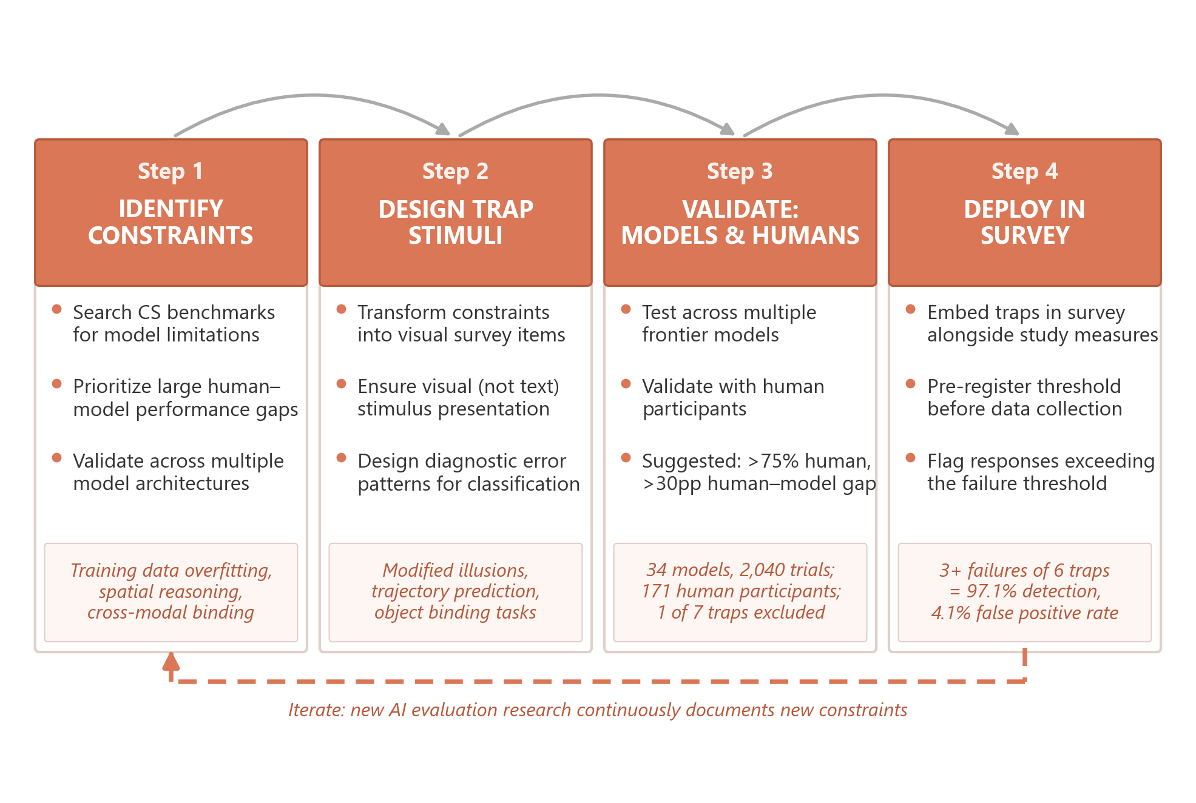
NOTE. — Light orange boxes show results from our implementation. The cycle is ongoing: new AI evaluation research documents new constraints, generating new traps.

Step 1: Identify Architectural Constraints

The process begins with systematic research of computer science benchmarks and vision-language model evaluations for documented architectural constraints showing either large performance gaps between models and humans or systematic model failures irrespective of human benchmarks. Such constraints are ubiquitous because a key goal of artificial intelligence research is to build machines that think like people (Lake et al. 2017), and research across multiple fields investigates how models perform on human-like capabilities such as intuitive physics, causal reasoning, and spatial judgments (Schulze Buschoff et al. 2025). When these evaluations reveal that models fail at tasks humans accomplish effortlessly, they document exploitable constraints.
We recommend prioritizing constraints that show large human-model performance gaps, are validated across multiple model architectures (ensuring the constraint reflects a general limitation across architectures), and are amenable to implementation through standard survey stimuli. We identified five constraints meeting these criteria through systematic search of AI and computer science literature (see web appendix B for the full search methodology and extended descriptions). Training data overfitting occurs when learned statistical regularities about familiar visual patterns override actual perception, causing models to report canonical illusion patterns even when obvious visual deviations are present (Shinozaki et al. 2025; Ullman 2024). Spatiotemporal reasoning requires integrating visual information across temporal frames to predict motion, where models achieve only 63.5% accuracy versus 99.7% for humans (Zhou et al. 2025). Spatial reasoning with mental simulation involves constructing imaginary paths and computing geometric relationships, tasks on which models achieve near-zero accuracy while humans perform effortlessly (Qi et al. 2025; Stogiannidis, McDonagh, and Tsaftaris 2025). Cross-modal binding requires identifying which single object possesses multiple combined features, and because models process different feature types through separate pathways, they achieve only 58–61% accuracy where humans exceed 95% (Campbell et al. 2024; Kamath, Hessel, and Chang 2023). Compositional counting demands simultaneously filtering by multiple attributes while counting, a combination that models fail to execute across many objects (Guo et al. 2025).

Step 2: Design Survey-Compatible Implementations (Cognitive Traps)

Each identified constraint must be transformed into a visual survey question that forces processing through the constrained pathways. These “cognitive traps” function analogously to attention checks: both measure underlying constructs imperfectly, with various sources of measurement error. Whereas attention check failures may reflect distraction or rushing, cognitive trap failures reflect inability to perform simple integrated visual processing that most adults accomplish effortlessly, such as binding features to objects, computing geometric relationships, and extrapolating trajectories. Two design criteria should guide the transformation. First, the stimulus must be visual: constraints should be presented through rendered images because text descriptions would be processed through the language pathway, potentially circumventing the constraint. Second, the failure patterns should be diagnostic: implementations must produce specific, interpretable errors when models fail, enabling researchers to distinguish architectural failures from random guessing.
We implemented seven visual stimuli operationalizing the five constraints. Table 1 illustrates two representative examples. All seven implementations with exact stimuli, questions, and response options are available in web appendix B and the Cognitive Trap Repository.

TABLE 1. REPRESENTATIVE COGNITIVE TRAP IMPLEMENTATIONS
Modified Muller-Lyer Training Data Overfitting  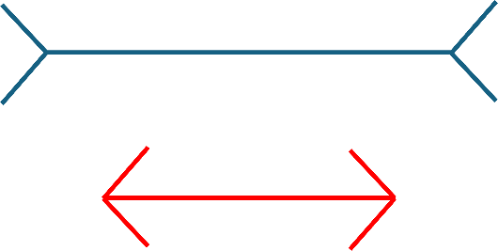  Adapted from Ullman (2024). This modified Muller-Lyer illusion presents two lines with arrowhead endpoints where the blue line (above) is objectively longer than the red line (below). Participants are asked which line is longer. The correct answer is the blue line (A*), but models typically report that both lines are equal, defaulting to the canonical Muller-Lyer pattern where lines only appear different but are actually equal. Because models have memorized this pattern from training data, they apply it indiscriminately even when the perceptual property differs. | The Moving Robot Spatiotemporal Reasoning  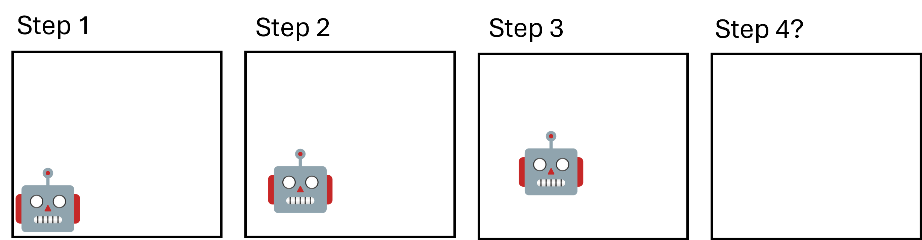  The four-frame sequence above shows a robot moving progressively toward the center of a square with constant speed and trajectory, with Step 4 left empty. Participants predict where the robot will be on Step 4. The correct answer is mostly around the center (E*), but models typically predict incorrect quadrant locations, failing to integrate visual motion information across the temporal sequence. Humans effortlessly extrapolate the trajectory, while models achieve only 63.5% accuracy on this class of spatiotemporal prediction versus 99.7% for humans (Zhou et al. 2025).
Surrounded Planets Cross-Modal Binding  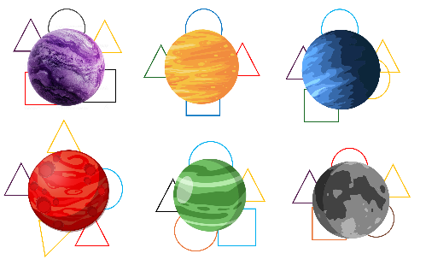  Six colored planets are each surrounded by several geometric shapes. Five planets have 5 shapes surrounding them; one planet has only 4. The task requires counting shapes around each planet and identifying the one with fewer shapes. Models struggle to correctly bind shapes to specific planets when visual elements overlap and occlude each other. | Colliding Oranges Spatial Reasoning  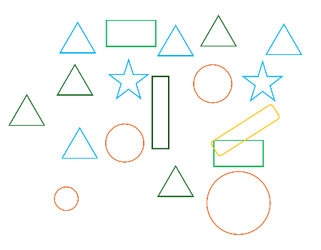  A set of shapes in a 2D display where the participant predicts which objects would collide if the largest circle moved in a straight line toward the smallest circle. This requires mental simulation of physical movement and spatial reasoning about object positions and sizes.
Three implementations targeting training data overfitting were adopted from Ullman (2024), who introduced the concept of “illusion-illusions”: modified versions of canonical visual illusions where the perceptual property matches reality, eliminating the illusory mismatch. The Modified Café Wall presents dividing lines between offset rows of squares that are genuinely diagonal, the Modified Muller-Lyer presents two lines with arrowhead endpoints where one is objectively longer (Table 1), and the Modified Ebbinghaus presents two central circles surrounded by context circles where one is genuinely larger. In each case, models default to the canonical illusion response (lines are straight, lines are equal, circles are equal) because they have memorized these patterns from training data, overriding the visual evidence actually present in the image.
Four additional traps were developed from scratch through iterative pretesting against frontier models, with initial versions refined until current models showed systematic failures. The Moving Robot (Table 1) shows a four-frame sequence of a robot approaching the center of a square with constant speed and trajectory, then asks participants to predict its location on the blank fourth frame, exploiting models’ inability to integrate motion information across temporal frames. The Colliding Oranges displays colored shapes and asks which objects lie in the straight-line path of a moving circle, requiring geometric mental simulation that models cannot perform. The Surrounded Planets presents six colored planets each enclosed by varying numbers of geometric shapes and asks participants to identify which planet has fewer surrounding shapes, requiring simultaneous binding of color, spatial proximity, and count. The Shape Overload asks participants to determine which shape type appears in the most different colors and then count all instances of that shape, combining attribute filtering with counting across many objects.

Step 3: Validate Against Models and Humans

The validation establishes whether cognitive traps reliably produce model failures and human successes. We suggest two retention criteria to guide this assessment. Human performance should exceed 75% accuracy, ensuring tasks remain within normal visual-cognitive capabilities (this threshold balances obviously easy tasks with tasks requiring deliberation, and researchers concerned about false positives may raise it to 80-85%, accepting reduced detection sensitivity). Human performance should also exceed pooled model performance by at least 30 percentage points, a gap representing a large effect size (Cohen’s h = 0.65-0.80) that provides robustness to measurement error and model improvements. These thresholds reflect informed judgment from validation experience rather than formal simulations. We describe the full validation methodology in web appendix A.
Human Validation. We recruited 202 participants from Prolific (45.5% female, M_{age} = 41.75) who completed all seven traps embedded within a survey taking approximately 7 minutes. After filtering 31 participants who failed at least one traditional attention check, 171 attentive participants remained. These participants averaged 86.8% accuracy across the six retained traps, with all six exceeding the 75% threshold (range: 77.2% for Moving Robot to 91.8% for Surrounded Planets).
Initial Model Validation. We validated all seven cognitive traps against six frontier vision-language models (at the time of validation), with each model completing 10 independent trials per trap through standalone chat sessions (Table 2). Six traps satisfied both retention criteria. The seventh, Shape Overload (compositional counting), failed: human accuracy was only 46.8% (below the 75% threshold) and the human-model gap was 6.8 percentage points (below the 30pp threshold), so it was excluded from deployment (see web appendix B, Section B.4).
TABLE 2. COGNITIVE TRAP VALIDATION RESULTS
Cognitive Trap | Human | GPT-5.1 | GPT-5.1† | Gemini 2.5 Pro | Gemini 2.5 Flash | Claude Sonnet 4.5 | Claude Haiku 4.5 | Pooled
Modified Cafe Wall | 84.8% | 0% | 20% | 0% | 0% | 40% | 30% | 15.0%
Modified Muller-Lyer | 90.1% | 0% | 30% | 0% | 0% | 0% | 0% | 5.0%
Modified Ebbinghaus | 90.1% | 10% | 60% | 30% | 0% | 60% | 80% | 40.0%
The Moving Robot | 77.2% | 0% | 40% | 0% | 0% | 0% | 0% | 6.7%
Colliding Oranges | 86.5% | 40% | 80% | 30% | 0% | 30% | 10% | 31.7%
Surrounded Planets | 91.8% | 70% | 80% | 20% | 0% | 30% | 20% | 36.7%
Shape Overload | 46.8% | 20% | 70% | 50% | 10% | 50% | 40% | 40.0%
Average | 86.8% | 20.0% | 51.7% | 13.3% | 0.0% | 26.7% | 23.3% | 22.5%
NOTE.——Human sample: 171 Prolific participants who passed all attention checks. Ten independent trials per trap per model (420 total). † = extended thinking variant. Pooled = average across all six models. Average = mean accuracy across the six retained traps (excludes Shape Overload). All six retained traps exceed both retention criteria (human >75%, human-model gap >30pp). Shape Overload (italicized) failed both criteria and was excluded; see web appendix B.4.

Expanded Model Validation. To assess whether model improvements erode trap effectiveness over time, we expanded testing of the six retained traps to 34 vision-language models spanning March 2024 through February 2026 (2,040 trials total). Researchers applying the framework only need to validate against models available at deployment, but this nearly two-year span provides a longitudinal view of trap durability as architectures improve. All six retained traps continued to satisfy both retention criteria, with human-model gaps ranging from 41.9 to 76.0 percentage points. Full results for all 34 models appear in web appendix C.
Two patterns in the expanded validation provide insight on whether models are improving over time in such a way that cognitive traps will become obsolete (Figure 2). First, model performance is non-monotonic within product lines. GPT-4o-mini (July 2024, 36.7%) substantially outperforms GPT-4.1 (April 2025, 5.0%), released ten months later, and Gemini 2.0 Flash (31.7%) outperforms its direct successor Gemini 2.5 Flash (1.7%) by a factor of nearly 19. Second, models show extreme heterogeneity across traps, with no model passing all six. This heterogeneity persists even within a single constraint category: among the three training data overfitting traps, Claude Opus 4.6 achieves 100% on Muller-Lyer but 0% on Cafe Wall and Ebbinghaus, while GPT-5.2 with extended thinking shows the opposite pattern (100% on Cafe Wall and Ebbinghaus but 0% on Muller-Lyer). These irregular capability profiles mean that a diversified battery provides robust detection even within a constraint category, because models that overcome one implementation typically fail on others.

FIGURE 2. COGNITIVE TRAP PASS RATES ACROSS 34 VISION-LANGUAGE MODELS

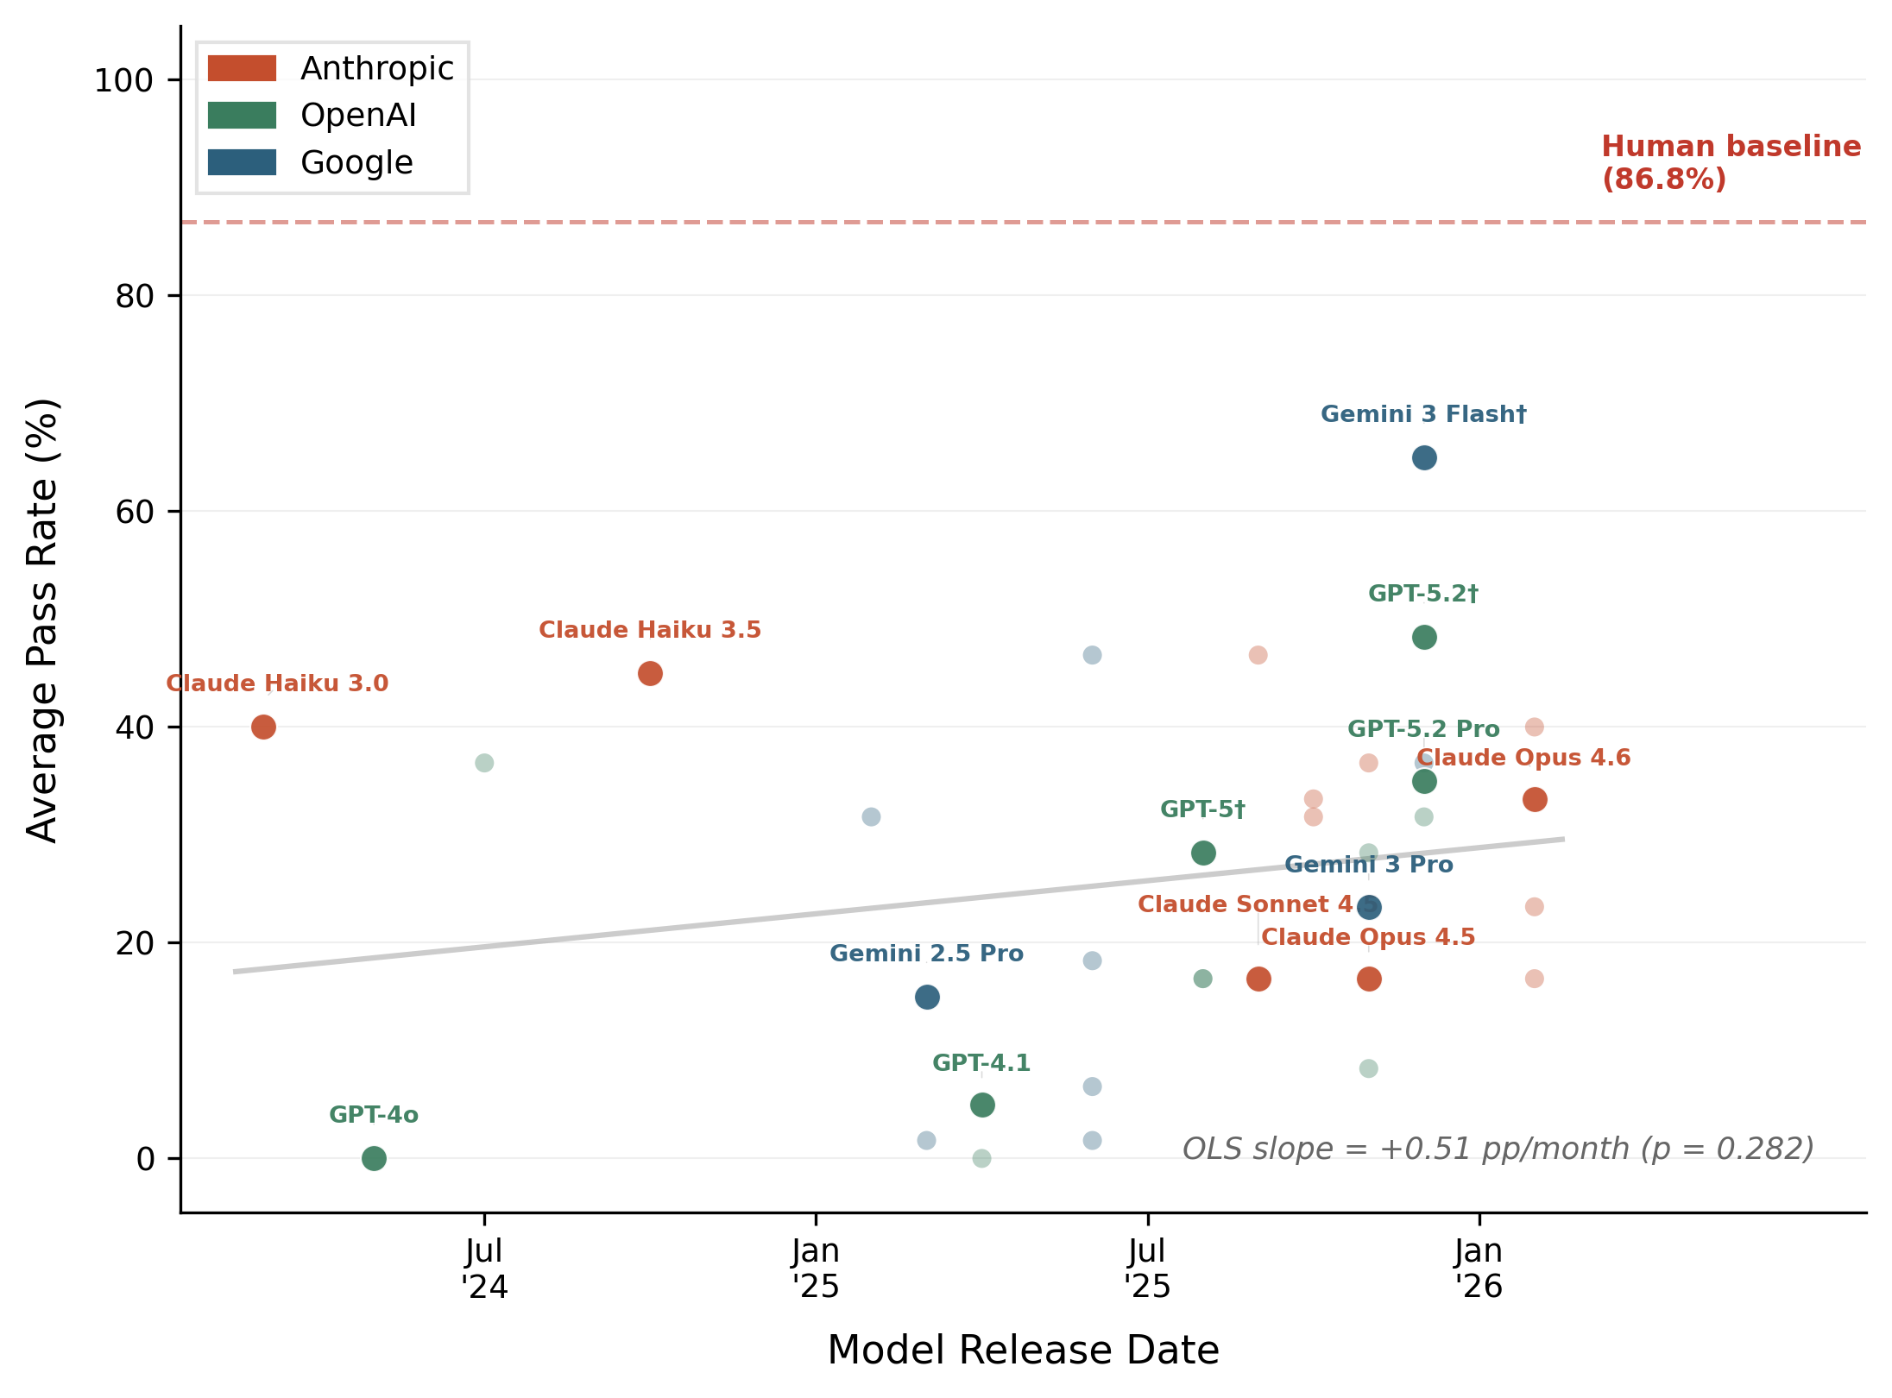
NOTE. — Average cognitive trap pass rate (%) for 34 vision-language models plotted against release date. Each dot represents one model colored by provider (Anthropic, OpenAI, Google), with frontier models labeled. The OLS trend line shows no significant overall improvement (+0.51 pp/month, p = .282). The dashed line marks the 86.8% average human baseline on the six retained traps. The best-performing model (Gemini 3 Flash with extended thinking, 65.0%) remains 21.8 percentage points below human performance. Full model-level results appear in web appendix C.

Step 4: Deploy in Research Context

Having identified constraints, designed implementations, and validated performance, researchers embed cognitive traps within their actual surveys, establish classification thresholds based on research priorities, and apply the classification rule to flag suspected agents. The goal of our main study is to validate this method.

DETECTING AI AGENTS IN ONLINE RESEARCH: VALIDATION ON PROLIFIC

This study provides a demonstration of the framework’s Step 4 while validating its method. Its primary outcomes are detection rates, false positive rates, and the optimal classification threshold for balancing sensitivity against specificity. While Steps 1-3 provide everything researchers need to develop cognitive traps for their own deployment, we extended beyond typical implementation by deploying 526 autonomous AI agents across four distinct AI agent platforms to directly test whether cognitive traps detect actual agents completing surveys autonomously through browsers. This study was preregistered (https://aspredicted.org/s4nh6y.pdf).

Method

Participants (Humans). We recruited 1,007 participants from Prolific (52.7% female, M_{age} = 44.79) who completed a consumer decision-making survey taking approximately 7 minutes in exchange for $1.40 compensation. Vision screening revealed 1.2% reporting uncorrected vision impairments and 1.4% reporting color blindness or color vision deficiency. These participants were included in primary analyses but examined separately in robustness checks.

Participants (Machines). We deployed 526 vision-enabled AI agents individually across Google Project Mariner (n = 134), Perplexity Comet (n = 131), ChatGPT Agent (n = 129), and the Claude Sonnet 4.5 model via Cursor Agent (n = 132). These represent mainstream vision-enabled agents currently being adopted by consumers. Each agent operated through separate browser instances that autonomously navigated to the survey, captured screenshots, processed visual content, generated responses, and submitted without human intervention beyond initial deployment or occasional adjustments (e.g., resolving CAPTCHA on platforms where the agent could not do so autonomously). The agent deployment represents methodological validation: we deployed agents to complete our own research survey designed specifically to test detection methods, analogous to pilot testing using available tools. Detailed deployment methodology, including exact prompts and agent-specific behaviors, appears in web appendix B.

Procedure. The survey was conducted using Qualtrics and included a conceptual replication of the choice deferral effect (Dhar 1997) using laptops. Participants (or agents) were randomly assigned to two conditions: choice set with equally attractive options (high trade-off conflict) versus choice set with a clearly dominant option (low trade-off conflict). Dhar (1997) demonstrates that preference uncertainty, which occurs when options are equally attractive, increases the propensity to defer choice. We expected to replicate this effect in humans but made no predictions for agents. After making their choice, participants completed the PANAS scale (with a straight-lining check), the six retained cognitive traps in randomized order, three traditional attention checks (IMC, obvious answer, memory), and demographics. The survey had Qualtrics’s reCAPTCHA v3 activated.

Results

Cognitive Trap Detection Performance. Cognitive traps substantially outperformed traditional attention checks in detecting researcher-deployed AI agents. Among the 526 deployed agents where ground truth is certain, we evaluated classification performance across all possible failure thresholds (1+ through 6/6; web appendix A). The three-failure threshold emerged as the optimal balance, detecting 511 agents (97.1% sensitivity) while flagging 41 of 1,007 presumed humans (4.1% false positive rate, assuming conservatively that no AI agents exist in the Prolific sample). When filtering to humans who passed all four traditional attention checks and reported no color blindness or visual impairment, 3.3% of humans were flagged (29/877), demonstrating that cognitive traps discriminate between humans and machines even among attentive, fully able participants. Traditional methods combined detected only 12 agents (2.3% sensitivity). Table 3 presents the full comparison, revealing a 95-percentage-point gap between methods that exploit architectural constraints and those that detect behavioral patterns.

TABLE 3. DETECTION METHOD PERFORMANCE AGAINST DEPLOYED AI AGENTS
Detection Method | Agents Detected | Detection Rate
Cognitive Traps (3+ failures) | 511 | 97.1%
Traditional Methods (Any) | 12 | 2.3%
- Instructional Manipulation Check | 1 | 0.2%
- Obvious Answer Check | 1 | 0.2%
- Memory Check | 4 | 0.8%
- Straight-lining Check | 7 | 1.3%
CAPTCHA (score < 0.5) | 24 | 4.6%
Fast Completion (< 40% median) | 1 | 0.2%
NOTE. — Cognitive trap threshold: failing 3 or more of 6 visual perception tasks. Traditional Methods (Any) = agents failing at least one traditional check.

The three-failure threshold was selected by evaluating all possible cut-points against the deployment data. Requiring only two failures achieves near-perfect agent detection (99.4%) but flags 13.3% of humans, a rate likely including many false positives. Requiring four failures reduces false positives to 1.9% but drops sensitivity to 89.2%, missing 57 agents. The sharp decline between 3+ and 4+ occurs because many agents pass exactly three traps while failing three, placing the three-failure threshold at a natural break in the score distribution where sensitivity exceeds 95% and the false positive rate remains below 5%. Researchers with different priorities can adjust this threshold: exploratory studies with large samples may tolerate the 2+ threshold’s higher false positive rate to maximize agent removal, while theory-testing studies with smaller samples might prefer the 4+ threshold’s lower false positive rate despite reduced sensitivity.

Individual Cognitive Traps. Individual cognitive traps showed substantial variation in both agent failure rates and human-agent discrimination (Table 4). The Modified Muller-Lyer and Cafe Wall produced agent failure rates above 94%, consistent with training data overfitting being a deeply embedded architectural constraint. Colliding Oranges and Surrounded Planets produced moderate failure rates (50-56%), suggesting that spatial reasoning and cross-modal binding constraints manifest less uniformly across model architectures. This heterogeneity validates the multi-trap battery approach: agents passing specific traps due to architectural advantages in particular model implementations typically failed others, ensuring high overall sensitivity despite variation in individual trap performance.

TABLE 4. INDIVIDUAL COGNITIVE TRAP PERFORMANCE: HUMAN VS. AGENT DISCRIMINATION
Trap | Agent Failure Rate | Human Pass Rate | Discrimination | χ² | p
Modified Muller-Lyer | 94.1% (495/526) | 92.8% (934/1007) | 86.9 pp | 1113.9 | <.001
Modified Cafe Wall | 94.9% (499/526) | 88.4% (890/1007) | 83.2 pp | 992.8 | <.001
Moving Robot | 99.6% (524/526) | 77.9% (784/1007) | 77.5 pp | 827.0 | <.001
Modified Ebbinghaus | 77.6% (408/526) | 95.6% (963/1007) | 73.2 pp | 886.9 | <.001
Surrounded Planets | 55.5% (292/526) | 96.5% (972/1007) | 52.0 pp | 554.5 | <.001
Colliding Oranges | 50.6% (266/526) | 88.7% (893/1007) | 39.2 pp | 283.4 | <.001
NOTE .— Discrimination = Human Pass Rate minus Agent Pass Rate. All chi-square tests significant at p < .001.

CAPTCHA Comparison. To benchmark cognitive traps against the most commonly available automated detection tool, we conducted an ROC-style analysis of reCAPTCHA v3 scores collected during our study. At the standard 0.5 threshold recommended by Google, CAPTCHA detected only 4.6% of agents (24/526), a rate comparable to traditional attention checks and far below cognitive traps. Lowering the threshold improves detection but at substantial cost: the optimal threshold maximizing Youden’s J was 0.90, which detected 93.9% of agents (494/526) but simultaneously flagged 12.4% of humans (125/1,007), a false positive rate three times higher than cognitive traps (12.4% vs. 4.1%) while detecting fewer agents (93.9% vs. 97.1%). The AUC was 0.898, indicating useful but imperfect discrimination. The underperformance reflects massive overlap in the score distributions: 75.5% of agents (397/526) clustered between 0.80-0.89, a range that also contained 8.4% of human participants. Full ROC analysis appears in web appendix D.

Diagnosticity Simulations. Using the deployment data, we simulated the sensitivity-specificity trade-off across all possible trap combinations to address a practical question: how many traps do researchers need? The answer depends on research priorities. For researchers concerned about survey length, as few as two traps (Modified Muller-Lyer and Moving Robot) with a both-must-fail threshold achieve 93.7% agent detection with only 2.6% false positives. Three traps (adding Surrounded Planets) with a two-failure threshold raise detection to 96.8% with 4.0% false positives. The optimal configuration by Youden’s J uses five traps (dropping Colliding Oranges), achieving 96.2% detection with only 2.6% false positives. Table WA-E1 in web appendix E presents the complete simulation results across all configurations.

Choice Deferral Results. Throughout this article, we have emphasized the cognitive trap as a detection method, but our design also enables a substantive research question: do AI agents exhibit choice effects similar to humans? The choice deferral effect (Dhar 1997) replicated cleanly, and the choice deferral study further demonstrates that cognitive traps maintain effectiveness even when participants receive flat compensation with no per-item rewards for trap performance, addressing concerns that detection accuracy depends on differential incentives. We analyzed results across three groups: humans who passed cognitive traps (n = 966), “humans” who failed cognitive traps (n = 41), and AI agents (n = 526). Among passed-trap humans, deferral rates differed substantially by condition: 5.2% deferred in the dominated condition compared to 24.0% in the conflict condition (χ²(1) = 66.83, p < .001), a 4.6-fold increase when facing interattribute tradeoffs versus a clearly dominated option that aligns with theoretical predictions. Among agents, deferral was near zero regardless of condition: 0.0% in dominated and 0.7% in conflict (χ²(1) = 0.46, p = .495). Agents do not experience the subjective uncertainty or discomfort with commitment that leads humans to defer under difficult conditions.
The 41 participants who failed cognitive traps showed an intermediate pattern: 5.3% deferral in dominated and 13.6% in conflict (χ²(1) = 0.14, p = .709), although the non-significant condition effect likely reflects low statistical power (n = 41). Their decision times were informative: in the conflict condition, failed-trap “humans” averaged 97.0 seconds (SD = 147.6), compared to 64.6 seconds for passed-trap humans (t = 1.26, p = .210) and 36.3 seconds for agents (t = 6.35, p < .001). These participants took substantially longer than agents while remaining statistically indistinguishable from passed-trap humans in decision time, CAPTCHA scores (0.971 vs. 0.972), and traditional attention check pass rates (97.6% vs. 99.6% on IMC). Their score distribution is also informative: 22 of 41 flagged participants (53.7%) scored exactly 3 out of 6, meaning they just barely crossed the failure threshold, while only 6 (14.6%) scored 0 or 1. Taken together, this pattern suggests that the 41 flagged individuals are genuine humans with lower visual-cognitive performance, providing evidence that the 4.1% flagging rate represents mostly false positives under current contamination conditions.
When examining choice preferences among participants who committed to a decision (excluding deferrals), agents and humans showed similar aggregate patterns in the conflict condition: humans selected Laptop A in 58.1% of committed choices versus agents at 60.5% (χ²(1) = 0.28, p = .597). This aggregate similarity, however, masks substantial platform-specific heterogeneity (χ²(3) = 75.69, p < .001): ChatGPT selected the first-presented option in 95.7% of trials while Claude selected the second option in 68.8%, indicating that different model architectures employ systematically different heuristics for resolving equipoise between comparably valued alternatives. Researchers should exercise caution when generalizing findings about “AI decision-making” from single-platform studies, as the behavioral signatures of autonomous agents vary substantially across platforms even while their uniform avoidance of deferral remains consistent. Complete choice deferral tables including the three-group breakdown and platform-specific results appear in web appendix F.

REPLICATION ON AMAZON MTURK AND CLOUDRESEARCH CONNECT

The Prolific study validated the cognitive trap method, establishing detection rates, false positive rates, and optimal threshold configurations as its primary outcomes (because the Prolific study's purpose was to validate the method, a classification threshold could not be pre-registered before validation was complete). With that validation complete, a natural next step is to apply the method prospectively on different platforms with pre-registered classification criteria. We conducted two pre-registered replications: one on Amazon Mechanical Turk (MTurk; preregistration: https://aspredicted.org/sz87tb.pdf) and one on CloudResearch Connect (preregistration: https://aspredicted.org/ib99fx.pdf). Both pre-registrations specified the three-failure threshold (failing 3 or more of 6 traps) and a two-proportion z-test comparing flagging rates against the Prolific baseline, with exact decision rules justified by the Prolific validation results and the diagnosticity simulations. Although CloudResearch Connect evolved from the former TurkPrime service, the two platforms now maintain fully independent participant pools. Including both platforms provides a cleaner test of whether cognitive trap flagging rates reflect genuine platform differences in data quality rather than artifacts of the traps themselves.

MTurk Results

We pre-registered a target of 500 respondents. Although 500 workers accepted the HIT on MTurk, only 263 completed the Qualtrics survey. Many of the remaining workers submitted completion codes without actually opening the survey link, and others submitted random or shared codes, a pattern consistent with documented code-sharing practices on MTurk forums where workers circulate completion codes to collect payment without performing the task. Cognitive traps flagged 76.0% of the MTurk sample (200/263) using the pre-registered threshold, compared to 4.1% on Prolific (z = 26.51, p < .001). Only 1.9% of MTurk respondents scored 6/6 on the traps, versus 59.9% on Prolific.
The behavioral profile of the MTurk sample was consistent with widespread contamination: the instructional manipulation check showed an 84.4% pass rate (compared to 99.5% on Prolific), the obvious attention check showed only 55.9% (compared to 99.0% on Prolific and 99.8% among our deployed agents in the main study), reCAPTCHA scores averaged 0.635 (compared to 0.972 on Prolific), and choice deferral was near zero in both conditions (1.6% in conflict, 0.0% in dominated), mirroring the agent deferral pattern from the main study. The MTurk behavioral profile, however, does not match a purely agent-driven sample. Our deployed agents passed traditional attention checks at near-perfect rates (IMC 99.8%, obvious 99.8%), while MTurk respondents performed substantially worse on these same checks (84.4% and 55.9%), failing at tasks that both attentive humans and sophisticated LMM agents handle easily. At the same time, 44.5% of MTurk respondents flagged by cognitive traps passed all traditional attention checks, a profile consistent with vision-enabled agents that ace text-based screening while failing visual-cognitive tasks. These patterns suggest a heterogeneous mix of data quality threats on MTurk: some respondents whose profiles resemble sophisticated AI agents (passing traditional checks but failing cognitive traps), alongside others exhibiting the careless and invalid responding patterns documented by Kay (2025), who found that 96% of semantic antonym pairs were positively correlated on MTurk even after screening with standard attention checks. The mean cognitive trap score on MTurk (2.65) falls between our deployed agents (1.28) and Prolific humans (5.40), consistent with a platform where multiple types of problematic respondents coexist with a diminishing pool of genuine participants.

CloudResearch Connect Results

Cognitive traps flagged 1.8% of the CloudResearch Connect sample (9/506), significantly lower than Prolific (z = -2.35, p = .019). The 76.5% of respondents who scored 6/6, the 100% obvious attention check pass rate, and the reCAPTCHA mean of 0.984 indicate an attentive, high-quality sample. The choice deferral effect was replicated: 26.6% deferred in the conflict condition versus 6.7% in the dominated condition (χ²(1) = 34.74, p < .001), a 4.0-fold increase closely matching Prolific’s 4.6-fold increase. After removing the 9 flagged respondents, deferral rates were virtually unchanged (26.8% vs. 6.5%, p < .001), confirming that the flagged individuals had negligible impact on substantive findings.

Cross-Platform Comparison

The 42-fold gap in flagging rates between MTurk (76.0%) and CloudResearch Connect (1.8%) demonstrates that platform choice is a first-order determinant of data quality in online behavioral research, consistent with Kay (2025)’s conclusion that “the average dataset collected on MTurk simply cannot be trusted.” CloudResearch Connect produces flagging rates significantly lower than Prolific, while MTurk produces rates that approach but do not match our deliberately deployed agents (76.0% vs. 97.1%), consistent with cognitive traps discriminating between contaminated and clean platforms rather than producing false positives. The gap between MTurk and our deployed agents is itself informative: a purely agent-driven sample would produce near-universal cognitive trap failure with near-perfect traditional check performance, whereas the MTurk sample combines high trap failure with poor traditional check performance, suggesting contamination from multiple source types rather than a single class of sophisticated AI agents. The convergence of multiple independent indicators (trap performance, deferral patterns, attention checks, CAPTCHA scores) across four datasets strengthens this interpretation. Detailed results for both platforms, including individual trap rates, score distributions, behavioral profiles, and method independence analyses, appear in web appendix G.

GENERAL DISCUSSION

The Cognitive Trap Framework exploits architectural constraints in how vision-language models process integrated visual information, achieving 97.1% agent detection compared to 2.3% for traditional methods. These results demonstrate effectiveness under current conditions, but several questions bear on the framework’s practical deployment: its longevity as models improve, the current economics of AI survey fraud, implementation guidance, and directions for future development.

The Arms Race

Social science often lags behind practice, studying phenomena after they have already reshaped the world. Here, there is an opportunity to document and understand change as it unfolds, because the threat to survey-based research is still nascent enough that preventive measures can be established before contamination becomes widespread. The cycle of developing traps, observing improvements that defeat them, and generating new traps from newly documented constraints will itself track the co-evolution of human ingenuity and machine capability. Researchers must be synchronized with the phenomenon, producing methods that are dynamic and adaptive even if they are not definitive.
Publishing detection methods does create strategic dynamics, because adversaries who know about cognitive traps could attempt to train models to defeat them. There are three factors that favor the dissemination of cognitive traps as an AI agent detection method. First, passing cognitive traps requires solving fundamental architectural limitations in how models process integrated visual information, which cannot be accomplished through prompt engineering or simple fine-tuning. Second, the framework enables continuous development of new traps from the same ongoing AI evaluation ecosystem, meaning defense can evolve as quickly as offense. Third, undetected contamination accumulating in published research poses a greater threat to scientific validity than the risk of disclosing detection methods, because studies currently analyze samples containing unknown agent proportions where effect sizes reflect mixtures of human psychology and model artifacts.
One important consideration is that any method that exploits current AI limitations faces the question of longevity. Across our 34 models spanning March 2024 through February 2026, an OLS regression of model-level accuracy on release date yields a slope of +0.51 percentage points per month (p = .282), indicating no statistically significant overall improvement (Figure 2). The best-performing model, Gemini 3 Flash with extended thinking, achieves 65% average accuracy, well below the 87% human baseline. Per-trap analysis reveals heterogeneous evolution consistent with the framework’s design logic: two traps show significant accuracy declines over time (Modified Cafe Wall, β = −3.14, p = .003; Moving Robot, β = −1.51, p = .001), two show significant improvement (Colliding Oranges, β = +2.92, p = .006; Surrounded Planets, β = +2.71, p = .022), and two remain stable. This pattern of uneven, trap-specific evolution supports maintaining a diversified battery rather than relying on any single detection item.
Furthermore, computational expenditure does not predict accuracy: neither cost per trial nor inference time correlates significantly with trap performance across models (web appendix H). In addition, the generational trajectory is non-monotonic. The average cognitive trap accuracy drops from 30.4% in early models to 15.7% in mid-generation models before recovering to 31.8% in the latest cohort. One possible explanation is that each new architecture reconfigures which constraints it resolves and which it introduces (web appendix H). Yet, cognitive traps may have a shelf life, and researchers who adopt them should expect to periodically update their detection batteries, just as antivirus software requires regular signature updates as threats evolve.
This article’s core position is that the framework’s durability rests on something more fundamental than any individual trap: the systematic connection to ongoing AI evaluation research. As long as computer science researchers benchmark models against human capabilities, they document what models can and cannot do. When specific constraints are resolved through architectural advances, new evaluations document new limitations. The four-step methodology applies to these newly documented constraints without methodological innovation, because the process of translating a benchmark finding into a survey question follows the same logic regardless of which particular constraint is being exploited.

Current Prevalence and the Economics of AI Survey Fraud

This research suggests that the actual AI contamination rate on Prolific may currently be near zero, likely because Prolific's identity verification creates barriers to operating fraudulent accounts at scale. The economics of AI survey fraud, however, already favor the attacker: completing one survey through a vision-enabled agent costs approximately $0.05-0.10 in API fees while earning $1.40 in participant compensation, yielding a 14-to-28-fold return per completion. As model costs continue declining (API prices have fallen roughly 10-fold over the past two years) and platform verification is circumvented, detection tools will become essential before contamination becomes widespread.

Practical Recommendations

Cognitive trap performance shows separation from traditional attention check performance (χ²(1) = 9.27, p = .002): 73.2% of participants failing cognitive traps passed all traditional checks, and 90.1% of participants failing traditional checks passed cognitive traps. Researchers concerned about both contamination sources should implement both method classes, using traditional checks to identify inattentive humans and cognitive traps to identify agents.
The diagnosticity simulations show that as few as two traps achieve over 93% detection with under 3% false positives, adding approximately one minute of survey time. Researchers can select a trap configuration and classification threshold from the complete simulation results (Table WA-E1 in web appendix E) based on their sensitivity-specificity priorities. Whichever configuration researchers choose, the threshold should be pre-registered before data collection.
Our Prolific study did not pre-register a threshold because that study validated the method itself. With validation complete, the MTurk and CloudResearch Connect replications demonstrated the prospective workflow: we pre-registered the three-failure threshold established by the Prolific validation before collecting any data. Researchers should establish validated human baselines while contamination remains measurable, positioning their research programs ahead of what will likely be an accelerating threat.
Decision times may provide additional detection signals that complement cognitive trap performance. Agent decision times on the choice page showed no condition sensitivity (M = 36.3 seconds in both dominated and conflict conditions; t = -0.02, p = .984), while humans took longer under conflict (M = 64.6 seconds vs. 53.3 seconds). This behavioral signature (identical processing time regardless of decision difficulty) is consistent with model inference that does not experience subjective conflict. Combining cognitive trap scores with response time patterns, along with metadata-based detection and behavioral biometrics where platform infrastructure permits, could further strengthen detection (Acien et al. 2022; Iliou et al. 2021; Panizza, Kyrychenko, and Roozenbeek 2026).

Reverse Traps

Our cognitive traps exploit tasks where AI fails while humans succeed, but the reverse direction also deserves attention. Panizza et al. (2026) propose incorporating tasks that are easy for AI but difficult for humans, such as rapid estimation problems or logical puzzles like the Monty Hall problem, and then evaluating whether respondents fail in characteristically human ways. Their argument is that this inverts the adversarial dynamic: instead of improving AI to pass human-easy tasks, attackers would need to deliberately constrain AI performance to mimic human limitations, which proves difficult even when agents are explicitly instructed to conceal their capabilities. A related possibility is pairing standard visual illusions (where humans tend to err) with their modified counterparts (where AI fails due to training data overfitting) within the same survey, creating diagnostic error signatures across item pairs. Several open questions remain before either approach can be deployed in practice. Human susceptibility to illusions and estimation errors varies across individuals, meaning that reverse items would need careful calibration to avoid misclassifying attentive humans. Paired designs also double the number of stimuli required. Future research should empirically validate whether these complementary detection axes provide sufficient additional discrimination to justify their costs.

Demographic Considerations

Cognitive trap failure rates show minimal demographic variation. Age, gender, and color blindness produced no significant associations with trap performance, alleviating concerns that cognitive traps would systematically exclude specific demographic groups. The only strong association was uncorrected vision impairment: 25.0% of participants reporting uncorrected impairments (n = 12) failed the threshold, compared to 3.8% for others, although 75% of vision-impaired participants still passed. We recommend that researchers include vision screening questions and adjust thresholds for participants reporting impairments. Full demographic analyses appear in web appendix I.

Limitations

Our validation faces several limitations that future research should address. First, we recruited human participants through Prolific’s standard verification without additional biometric confirmation, potentially introducing limited contamination into our ground truth sample. If agents exist in our “human” sample, this would strengthen our evidence, because the true detection performance would exceed what we report since agents would inflate our false positive estimate. Second, our cognitive traps target visual and cognitive processing, which may disadvantage participants with undiagnosed visual processing differences not captured by demographic screening. While our validation showed minimal demographic differences across age, gender, and color blindness, with only vision impairment showing a strong association, complex visual-cognitive tasks may affect populations differently. We recommend demographic-stratified validation before deploying traps in specific populations.
Third, platform heterogeneity in agent performance means that no single trap achieves uniformly high detection across all implementations: ChatGPT Agent and Perplexity Comet each produced small numbers of agents passing the three-failure threshold (8/129 and 7/131 respectively), while Google Mariner and Claude showed perfect detection. This variation underscores the importance of deploying multiple traps spanning different constraint categories. Fourth, we benchmark cognitive traps against CAPTCHA (the most widely available automated detection tool) but do not directly compare against metadata-based detection (IP analysis, device fingerprinting), behavioral biometrics (mouse trajectories, keystroke dynamics), or text-based AI classifiers. Cognitive traps are best viewed as complementary to these approaches. Fifth, the MTurk sample (N = 263) was substantially smaller than Prolific (N = 1,007) because many of the 500 workers who accepted the HIT submitted completion codes without actually completing the survey, and the 76.0% flagging rate precludes meaningful analysis of the clean subsample (n = 63). The CloudResearch Connect replication (N = 506) provides a cleaner platform comparison, but future research should assess cognitive trap performance across additional recruitment platforms and geographic populations.

CONCLUSION

The entire behavioral research literature depends on measuring genuine human behavior, and when autonomous agents can complete studies while passing all conventional quality checks, the validity of the scientific ecosystem is at stake. The Cognitive Trap Framework provides a methodology for continuous adaptation: as models improve and specific traps lose effectiveness, researchers apply the same four-step process to newly documented constraints from the ongoing AI evaluation ecosystem. The tools for autonomous survey completion are commercially available today and the economic incentives for fraud are present, but the architectural constraints that cognitive traps exploit are equally present, giving researchers a foundation for detection that evolves alongside the threat. As detection methods improve and are defeated, and new methods emerge in response, the resulting cycle will itself document the co-evolution of human ingenuity and machine capability. This framework provides a foundation for that ongoing process, and we hope it will also inspire the development of new methods.

DATA COLLECTION STATEMENT

The human validation study (202 Prolific participants completing all seven cognitive traps) was conducted in November 2025. The initial model validation, in which all seven cognitive traps were tested against six frontier vision-language models through standalone chat interface sessions (420 trials), was also conducted in November 2025. Data for the Prolific main study (1,007 human participants) were collected in November 2025 using Qualtrics. The 526 AI agent deployments (Google Project Mariner, Perplexity Comet, ChatGPT Agent, and Claude Sonnet 4.5 via Cursor Agent) were conducted on the author’s own Qualtrics survey instance in November 2025; no agents were deployed on live recruitment platforms. The expanded model validation, in which the six retained cognitive traps were tested against 34 vision-language models via programmatic API calls (2,040 trials), was conducted in February 2026. The MTurk replication (263 participants) and the CloudResearch Connect replication (506 participants) were both conducted in February 2026. All data were collected and analyzed by the author. Raw data, analysis code, agent deployment scripts, the Qualtrics survey file (.qsf), data dictionaries, and pre-registration documents are available on the Open Science Framework (https://osf.io/f2jhx/).

REFERENCES

Acien, Alejandro, Aythami Morales, Julian Fierrez, and Ruben Vera-Rodriguez (2022), “BeCAPTCHA-Mouse: Synthetic Mouse Trajectories and Improved Bot Detection,” Pattern Recognition, 127, 108643.
Bonnamy, James, Bethany Carr, Michelle D. Lazarus, and Clifford Connell (2025), “Survey Sabotage: Insights into Reducing the Risk of Fraudulent Responses in Online Surveys,” Anatomical Sciences Education, 18(8), 767–73.
Campbell, Declan, Sunayana Rane, Tyler Giallanza, Nicolò De Sabbata, Kia Ghods, Amogh Joshi, Alexander Ku, Steven M. Frankland, Thomas L. Griffiths, Jonathan D. Cohen, and Taylor Webb (2024), “Understanding the Limits of Vision Language Models Through the Lens of the Binding Problem,” in Proceedings of the 38th International Conference on Neural Information Processing Systems, Red Hook, NY, USA.
Chmielewski, Michael and Sarah C. Kucker (2020), “An MTurk Crisis? Shifts in Data Quality and the Impact on Study Results,” Social Psychological and Personality Science, 11(4), 464–73.
Dhar, Ravi (1997), “Consumer Preference for a No-Choice Option,” Journal of Consumer Research, 24(2), 215–31.
Goodrich, Brittney, Marieke Fenton, Jerrod Penn, John Bovay, and Travis Mountain (2023), “Battling Bots: Experiences and Strategies to Mitigate Fraudulent Responses in Online Surveys,” Applied Economic Perspectives and Policy, 45(2), 762–84.
Gordon, Andrew (2026), Authenticity Checks: How We Tested the Most Accurate Method for Identifying Agentic AI, Prolific.
Guo, Xuyang, Zekai Huang, Zhenmei Shi, Zhao Song, and Jiahao Zhang (2025), “Your Vision-Language Model Can’t Even Count to 20: Exposing the Failures of VLMs in Compositional Counting,” https://arxiv.org/abs/2510.04401.
Hara, Kotaro, Abigail Adams, Kristy Milland, Saiph Savage, Chris Callison-Burch, and Jeffrey P. Bigham (2018), “A Data-Driven Analysis of Workers’ Earnings on Amazon Mechanical Turk,” in Proceedings of the 2018 CHI Conference on Human Factors in Computing Systems, Montreal, QC, Canada: ACM, 1–14.
Iliou, Christos, Theodoros Kostoulas, Theodora Tsikrika, Vasilis Katos, Stefanos Vrochidis, and Ioannis Kompatsiaris (2021), “Detection of Advanced Web Bots by Combining Web Logs with Mouse Behavioural Biometrics,” Digital Threats: Research and Practice, 2(3), 1–26.
Kamath, Amita, Jack Hessel, and Kai-Wei Chang (2023), “What’s ‘up’ with Vision-Language Models? Investigating Their Struggle with Spatial Reasoning,” http://arxiv.org/abs/2310.19785.
Kay, Cameron S. (2025), “Why You Shouldn’t Trust Data Collected on MTurk,” Behavior Research Methods, 57, 340.
Kennedy, Ryan, Scott Clifford, Tyler Burleigh, Philip D. Waggoner, Ryan Jewell, and Nicholas J. G. Winter (2020), “The Shape of and Solutions to the MTurk Quality Crisis,” Political Science Research and Methods, 8(4), 614–29.
Lake, Brenden M., Tomer D. Ullman, Joshua B. Tenenbaum, and Samuel J. Gershman (2017), “Building Machines That Learn and Think Like People,” Behavioral and Brain Sciences, 40, e253.
Malhotra, N. (2008), “Completion Time and Response Order Effects in Web Surveys,” Public Opinion Quarterly, 72(5), 914–34.
Moss, Aaron J., Cheskie Rosenzweig, Jonathan Robinson, Shalom N. Jaffe, and Leib Litman (2023), “Is It Ethical to Use Mechanical Turk for Behavioral Research? Relevant Data from a Representative Survey of MTurk Participants and Wages,” Behavior Research Methods, 55(8), 4048–67.
Oppenheimer, Daniel M., Tom Meyvis, and Nicolas Davidenko (2009), “Instructional Manipulation Checks: Detecting Satisficing to Increase Statistical Power,” Journal of Experimental Social Psychology, 45(4), 867–72.
Ouyang, Long, Jeff Wu, Xu Jiang, Diogo Almeida, Carroll L. Wainwright, Pamela Mishkin, Chong Zhang, Sandhini Agarwal, Katarina Slama, et al. (2022), “Training Language Models to Follow Instructions with Human Feedback,” http://arxiv.org/abs/2203.02155.
Panizza, Folco, Yara Kyrychenko, and Jon Roozenbeek (2026), “Survey-Taking AI Tools Surpass Human Abilities. Here’s What We Can Do about It,” Nature, 650, 293–95.
Phillips, Sara (2026), “AI Chatbots Are Infiltrating Social-Science Surveys,” Nature, 650, 17.
Qi, Jianing, Jiawei Liu, Hao Tang, and Zhigang Zhu (2025), “Beyond Semantics: Rediscovering Spatial Awareness in Vision-Language Models,” http://arxiv.org/abs/2503.17349.
Rilla, Raluca, Tobias Werner, Hiromu Yakura, Iyad Rahwan, and Anne-Marie Nussberger (2025), “Recognising, Anticipating, and Mitigating LLM Pollution of Online Behavioural Research,” http://arxiv.org/abs/2508.01390.
Schulze Buschoff, Luca M., Elif Akata, Matthias Bethge, and Eric Schulz (2025), “Visual Cognition in Multimodal Large Language Models,” Nature Machine Intelligence, 7(1), 96–106.
Searles, Andrew, Yoshimichi Nakatsuka, Ercan Ozturk, Andrew Paverd, Gene Tsudik, and Ai Enkoji (2023), “An Empirical Study & Evaluation of Modern CAPTCHAs,” http://arxiv.org/abs/2307.12108.
Shinozaki, Taiga, Tomoki Doi, Amane Watahiki, Satoshi Nishida, and Hitomi Yanaka (2025), “Do Large Vision-Language Models Distinguish Between the Actual and Apparent Features of Illusions?” in Proceedings of the 47th Annual Meeting of the Cognitive Science Society
Stogiannidis, Ilias, Steven McDonagh, and Sotirios A. Tsaftaris (2025), “Mind the Gap: Benchmarking Spatial Reasoning in Vision-Language Models,” http://arxiv.org/abs/2503.19707.
Ullman, Tomer (2024), “The Illusion-Illusion: Vision Language Models See Illusions Where There Are None,” http://arxiv.org/abs/2412.18613.
Wen, Ximing, Mallika Mainali, and Anik Sen (2025), “How Well Can Vision-Language Models Understand Humans’ Intention? An Open-Ended Theory of Mind Question Evaluation Benchmark,” https://arxiv.org/abs/2503.22093.
Westwood, Sean J. (2025), “The Potential Existential Threat of Large Language Models to Online Survey Research,” Proceedings of the National Academy of Sciences, 122(47), e2518075122.
Zhou, Shijie, Alexander Vilesov, Xuehai He, Ziyu Wan, Shuwang Zhang, Aditya Nagachandra, Di Chang, Dongdong Chen, Xin Eric Wang, and Achuta Kadambi (2025), “VLM4D: Towards Spatiotemporal Awareness in Vision Language Models,” https://arxiv.org/abs/2508.02095.

HEADINGS LIST

1) DATA QUALITY THREATS IN ONLINE SURVEYS
1) THE COGNITIVE TRAP FRAMEWORK: FOUNDATIONS AND IMPLEMENTATION
2) Step 1: Identify Architectural Constraints
2) Step 2: Design Survey-Compatible Implementations (Cognitive Traps)
2) Step 3: Validate Against Models and Humans
2) Step 4: Deploy in Research Context
1) DETECTING AI AGENTS IN ONLINE RESEARCH: VALIDATION ON PROLIFIC
2) Method
3) Participants (Humans)
3) Participants (Machines)
3) Procedure
2) Results
3) Cognitive Trap Detection Performance
3) Individual Cognitive Traps
3) CAPTCHA Comparison
3) Diagnosticity Simulations
3) Choice Deferral Results
1) REPLICATION ON AMAZON MTURK AND CLOUDRESEARCH CONNECT
2) Amazon Mechanical Turk Results
2) CloudResearch Connect Results
2) Cross-Platform Comparison
1) GENERAL DISCUSSION
2) The Arms Race
2) Current Prevalence and the Economics of AI Survey Fraud
2) Reverse Traps
2) Demographic Considerations
2) Limitations
1) CONCLUSION

Unlike Tommy’s scenario, this is a hypothetical example, but one we (researchers who rely on online surveys) must be prepared for.
Researchers are encouraged to submit (i) their results using existing cognitive traps, and (ii) new cognitive traps to the repository.
Consistent with the iterative nature of this framework, there were other constraints which seemed promising during step 1 but were consistently solved by current AI models upon testing. For instance, research shows that LMMs struggle with theory of mind questions (Wen, Mainali, and Sen 2025), but the preliminary theory-of-mind cognitive traps we developed were quickly solved by 2025 models.
Cognitive traps test visual-cognitive integration, which raises accessibility considerations. Participants with visual impairments may legitimately fail these tasks. We recommend addressing this through measurement (vision screening questions) and sensitivity analysis.

