WEB APPENDIX

Brief Commentary: A Framework for Detecting AI Agents in Online Research

Felipe M. Affonso

TABLE OF CONTENTS
Web Appendix A: Complete Detection Performance
Web Appendix B: Framework Methodology and Agent Deployment
Web Appendix C: Full 34-Model Validation Results
Web Appendix D: CAPTCHA ROC Analysis
Web Appendix E: Diagnosticity Simulations
Web Appendix F: Choice Deferral Extended Results
Web Appendix G: Platform Replication Studies
Web Appendix H: Computational Cost and Efficiency Analysis
Web Appendix I: Demographic and Robustness Analyses

WEB APPENDIX A: COMPLETE DETECTION PERFORMANCE

A.1 Threshold Sensitivity Analysis
The choice of failure threshold involves a trade-off between sensitivity (detecting true agents) and specificity (avoiding false positives among humans). Table WA-A1 presents detection performance across all possible thresholds.
TABLE WA-A1: DETECTION PERFORMANCE ACROSS ALL THRESHOLDS
Threshold | Agent Detection | Human Flagging | Interpretation
1+ failures | 100.0% (526/526) | 40.1% (404/1007) | Perfect sensitivity but flags too many humans
2+ failures | 99.4% (523/526) | 13.3% (134/1007) | Near-perfect detection; likely many false positives
3+ failures | 97.1% (511/526) | 4.1% (41/1007) | Balanced threshold (selected)
4+ failures | 89.2% (469/526) | 1.9% (19/1007) | Conservative; misses 57 agents
5+ failures | 60.5% (318/526) | 0.6% (6/1007) | Very conservative; misses 208 agents
All 6 failures | 26.0% (137/526) | 0.2% (2/1007) | Extreme; detects only complete failures

The sharp drop between 3+ and 4+ thresholds (97.1% to 89.2%) indicates many agents pass exactly three traps. The 3+ threshold maintains greater than 95% sensitivity while flagging only 4.1% of humans. We selected this threshold because it achieves a positive predictive value of 92.6% (meaning flagged cases are likely genuine agents) while maintaining high sensitivity.
Researchers with different priorities might adjust the threshold. Exploratory studies with large samples can tolerate the 2+ threshold’s higher false positive rate (13.3%) to maximize agent removal. Theory-testing studies with smaller samples might prefer the 4+ threshold’s lower false positive rate (1.9%) despite reduced sensitivity (89.2%).

A.2 Traditional Method Performance
Table WA-A2 presents complete performance data for all traditional detection methods tested against the 526 known agents, confirming that methods designed for human inattention fail against vision-enabled agents.
TABLE WA-A2: COMPLETE DETECTION METHOD PERFORMANCE
Method | Detection Rate | Why It Failed
Cognitive Traps (3+) | 97.1% (511/526) | Exploits architectural constraints
Instructional Manipulation Check | 0.2% (1/526) | Agents read all text carefully
Obvious Answer Check | 0.2% (1/526) | Trivial comprehension for LMMs
Memory Check | 0.8% (4/526) | Re-process full context; no working memory
Straight-lining (PANAS) | 1.3% (7/526) | Generate contextually appropriate responses
Any Traditional Check | 2.3% (12/526) | Combined across all four checks
CAPTCHA (score < 0.5) | 4.6% (24/526) | Execute through real browsers with genuine interaction signals
Fast Completion (< 40% median) | 0.2% (1/526) | Model inference is genuinely slow

All 12 agents flagged by traditional checks also failed cognitive traps, meaning traditional methods added zero incremental detection beyond what cognitive traps already captured. The 42-fold performance gap (97.1% vs. 2.3%) demonstrates the fundamental difference between exploiting architectural constraints versus detecting behavioral patterns.

FIGURE WA-A1. DETECTION RATES ACROSS ALL METHODS TESTED AGAINST 526 DEPLOYED AI AGENTS
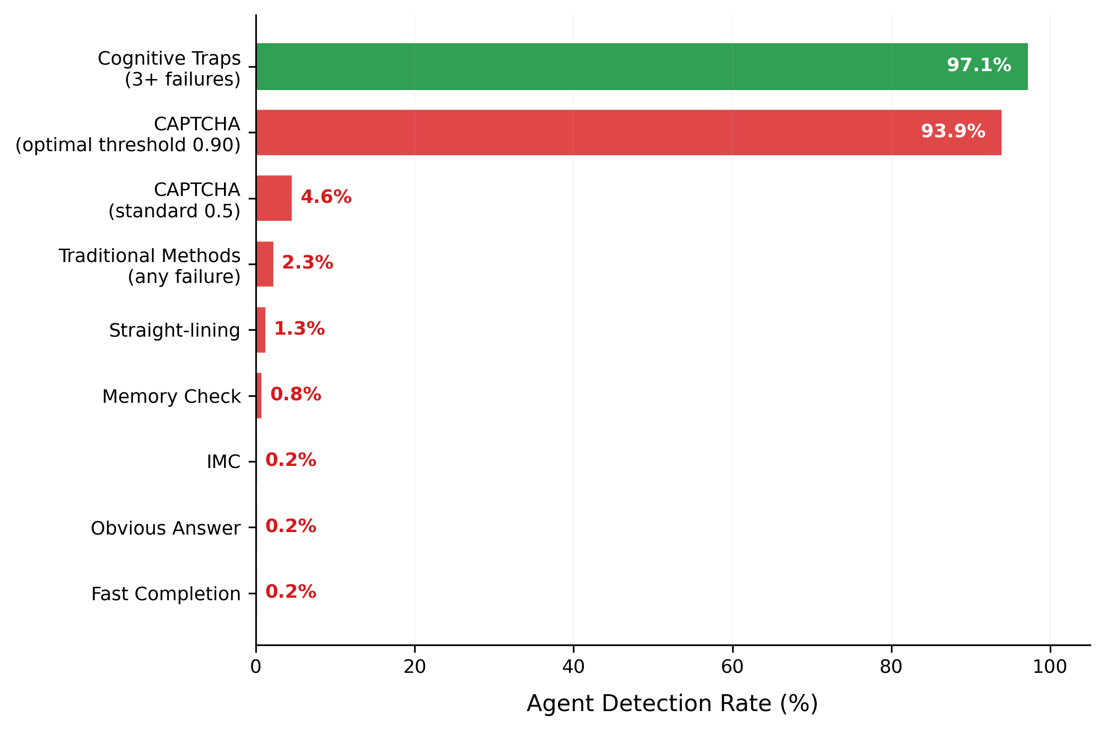
NOTE.——Cognitive traps (green, 97.1%) and CAPTCHA at the optimal 0.90 threshold (93.9%) are the only methods exceeding 5% detection. All traditional attention checks (IMC, obvious answer, memory, straight-lining) and timing analysis detect fewer than 2% of agents. CAPTCHA at the standard 0.5 threshold detects only 4.6%.

Importantly, although the ROC curve suggests that CAPTCHA at its optimal threshold (0.90, identified by Youden's J) achieves a detection rate comparable to cognitive traps, this comparison omits a critical difference in specificity: at that threshold, CAPTCHA produces a 12.4% false positive rate, three times the 4.1% rate of cognitive traps. The apparent parity in sensitivity thus comes at a substantially higher cost to legitimate respondents.

A.3 Why Traditional Methods Fail: Architectural Analysis
Traditional methods were designed for two threat models that do not match vision-enabled agent characteristics. The first targets simple automated bots that access HTML directly without rendering visual content and can be defeated by invisible elements, hidden form fields, and CSS-based traps. Vision-enabled agents can perceive rendered visual content through screenshots, and they do not need to access underlying code where hidden elements reside.
The second targets inattentive humans who skip instructions, rush through questions, or fail to recall earlier content. Vision-enabled agents process complete text carefully as their core function, maintaining consistent attention through model inference. They read every word, follow embedded instructions precisely, and generate contextually appropriate answers. Table WA-A3 contrasts human cognitive processes that traditional checks exploit against agent analogs that render those checks ineffective.
TABLE WA-A3: ARCHITECTURAL DIFFERENCES ENABLING EVASION
Human Process | Traditional Check Exploit | Agent Analog | Why Check Fails
Attention allocation | Detect when attention lapses | No attention; all text processed uniformly | Models don’t “attend” selectively
Working memory | Test recall of earlier content | No working memory; each inference processes full context | Models re-process the full context each time
Effort management | Detect effort-minimizing behaviors | No subjective effort; generation cost uniform | Models don’t experience effort
Motivation | Assume low motivation produces carelessness | No motivational states; response follows training | Models don’t have motivation
Reading strategy | Assume humans skim or skip | Complete text processing as architectural requirement | Models must process full input

Why Each Method Fails in Detail
Instructional manipulation checks embed hidden instructions in lengthy text to catch humans who skim without reading carefully (e.g., “To show you are paying attention, please select ‘Other’ and type ‘banana’”). Vision-language models process complete text before generating responses as their core function. Following embedded instructions represents trivial comprehension for language models, explaining the 99.8% agent pass rate.
Obvious answer checks ask questions with unambiguous correct responses (e.g., “How frequently do you have a fatal heart attack?” with “Never” as the correct answer). Language models trained on vast text corpora possess factual knowledge making these questions trivial. The 99.8% agent pass rate reflects that comprehending simple factual questions poses no challenge for systems designed specifically for language understanding.
Memory checks ask participants to recall earlier survey content, designed to catch distracted humans who fail to encode information. Agents treat recall questions as logical inference tasks, applying comprehension to the full context available in their processing window. The 99.2% pass rate reflects that agents encounter no difficulty with comprehension-based reasoning about stated content.
Straight-lining detection identifies participants who select identical responses to all items in a scale, designed to catch effort-minimizing humans. Agents generate contextually appropriate responses through natural language understanding, producing varied responses based on item content. The 98.7% pass rate reflects normal response variance without the uniform responding characteristic of disengaged participants.
CAPTCHA systems assign risk scores based on behavioral patterns accumulated across Google services. Agents operated through legitimate browsers (both local and on OpenAI and Google platforms), producing normal reCAPTCHA v3 scores. When encountering explicit challenges, agents could request brief human assistance then resume autonomous operation. The 95.4% pass rate using the standard 0.5 threshold reflects accumulated behavioral signals from legitimate browsing histories.
Timing analysis flags suspiciously fast completion. Vision-language model processing requires substantial time for screenshot capture (1-2s), API transmission (1-2s), model inference (2-10s), response parsing (1-2s), and form entry (1-2s). This produces realistic timing. Agents showed a median completion time of 597.5 seconds (10.0 minutes) compared to 371 seconds (6.2 minutes) for humans. Only 0.2% of agents were flagged for fast completion.

A.4 Individual Cognitive Trap Performance
Table WA-A4 provides detailed performance data for each trap showing how each constraint exploits different architectural limitations.
TABLE WA-A4: INDIVIDUAL COGNITIVE TRAP PERFORMANCE (MAIN STUDY)
Trap | Agent Failure | Human Pass | Discrimination | Constraint Exploited
Muller-Lyer | 94.1% (495/526) | 92.8% (934/1007) | 86.9 pp | Training data overfitting on canonical illusions
Cafe Wall | 94.9% (499/526) | 88.4% (890/1007) | 83.2 pp | Training data overfitting on canonical illusions
The Moving Robot | 99.6% (524/526) | 77.9% (784/1007) | 77.5 pp | Spatiotemporal reasoning (trajectory extrapolation)
Ebbinghaus | 77.6% (408/526) | 95.6% (963/1007) | 73.2 pp | Training data overfitting on canonical illusions
Surrounded Planets | 55.5% (292/526) | 96.5% (972/1007) | 52.0 pp | Cross-modal feature binding with occlusion
Colliding Oranges | 50.6% (266/526) | 88.7% (893/1007) | 39.2 pp | Spatial reasoning (geometric path computation)
NOTE. All differences significant at p < .001. Discrimination = Human Pass Rate minus (100% - Agent Failure Rate).

FIGURE WA-A2. HUMAN PASS RATES VERSUS AGENT PASS RATES FOR EACH COGNITIVE TRAP
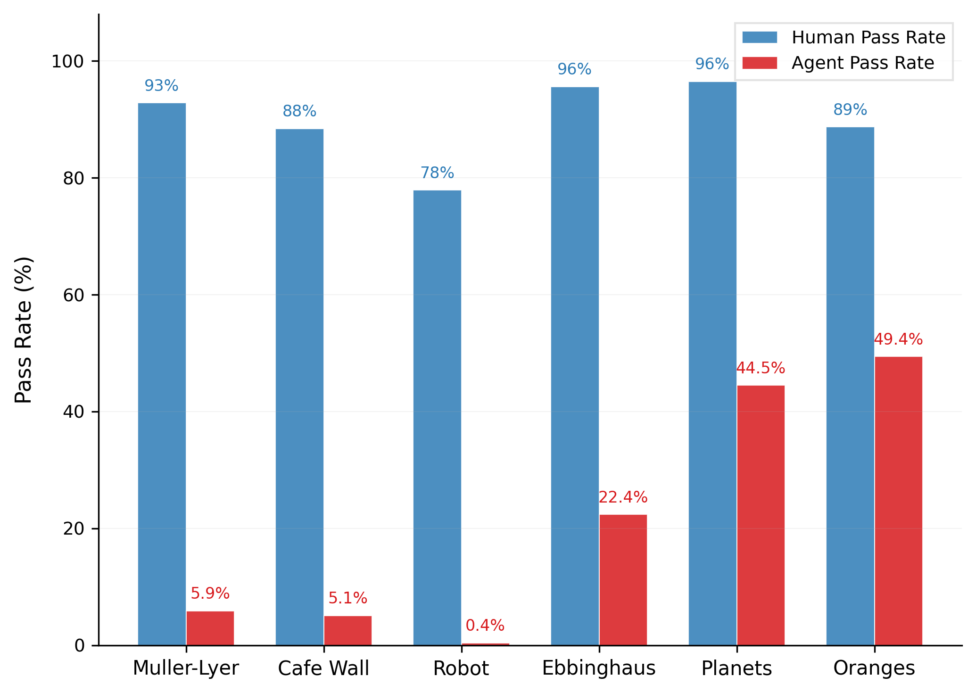
NOTE.——Traps ordered by discrimination (human-agent gap). The Moving Robot shows the highest agent failure (99.6%) with 77.5 pp discrimination, while Colliding Oranges shows the lowest discrimination (39.2 pp) because some agent platforms partially resolve its spatial reasoning constraint.

The illusion-based traps (Muller-Lyer, Cafe Wall, Ebbinghaus) showed highest agent failure rates (77.6-94.9%) because these canonical patterns appear extensively in training data from psychology textbooks and vision research. Models learn these patterns so thoroughly during pre-training that they report the illusion even when visual modifications remove it. The Moving Robot showed near-perfect agent failure (99.6%) because spatiotemporal reasoning requires constructing dynamic mental models of motion trajectories, a capability not achieved by feedforward architectures processing static images independently. The spatial reasoning traps (Surrounded Planets, Colliding Oranges) showed more moderate but substantial discrimination (39.2-52.0pp), with some platforms demonstrating better performance on these tasks, reflecting recent architectural improvements in spatial processing.

A.5 Platform-Specific Performance
Table WA-A5 shows detection rates for each agent platform using the 3+ threshold.
TABLE WA-A5: DETECTION RATES BY PLATFORM
Platform | N | Detected (3+) | Detection Rate | 95% CI
Google Project Mariner | 134 | 134 | 100.0% | [97.3, 100.0]
Claude Sonnet 4.5 | 132 | 132 | 100.0% | [97.2, 100.0]
Perplexity Comet | 131 | 124 | 94.7% | [89.3, 97.9]
ChatGPT Agent | 129 | 121 | 93.8% | [88.1, 97.3]
All Platforms | 526 | 511 | 97.1% | [95.4, 98.4]
NOTE. Chi-square test: χ²(3) = 16.0, p = .001.

Mariner and Claude showed perfect detection (100%), while Perplexity and ChatGPT allowed small numbers of agents to pass (7 and 8 respectively). This heterogeneity validates the multi-trap battery approach: agents passing specific traps due to platform-specific architectural advantages in particular implementations typically failed others.

FIGURE WA-A3. COGNITIVE TRAP SCORE DISTRIBUTIONS ACROSS FOUR AGENT PLATFORMS
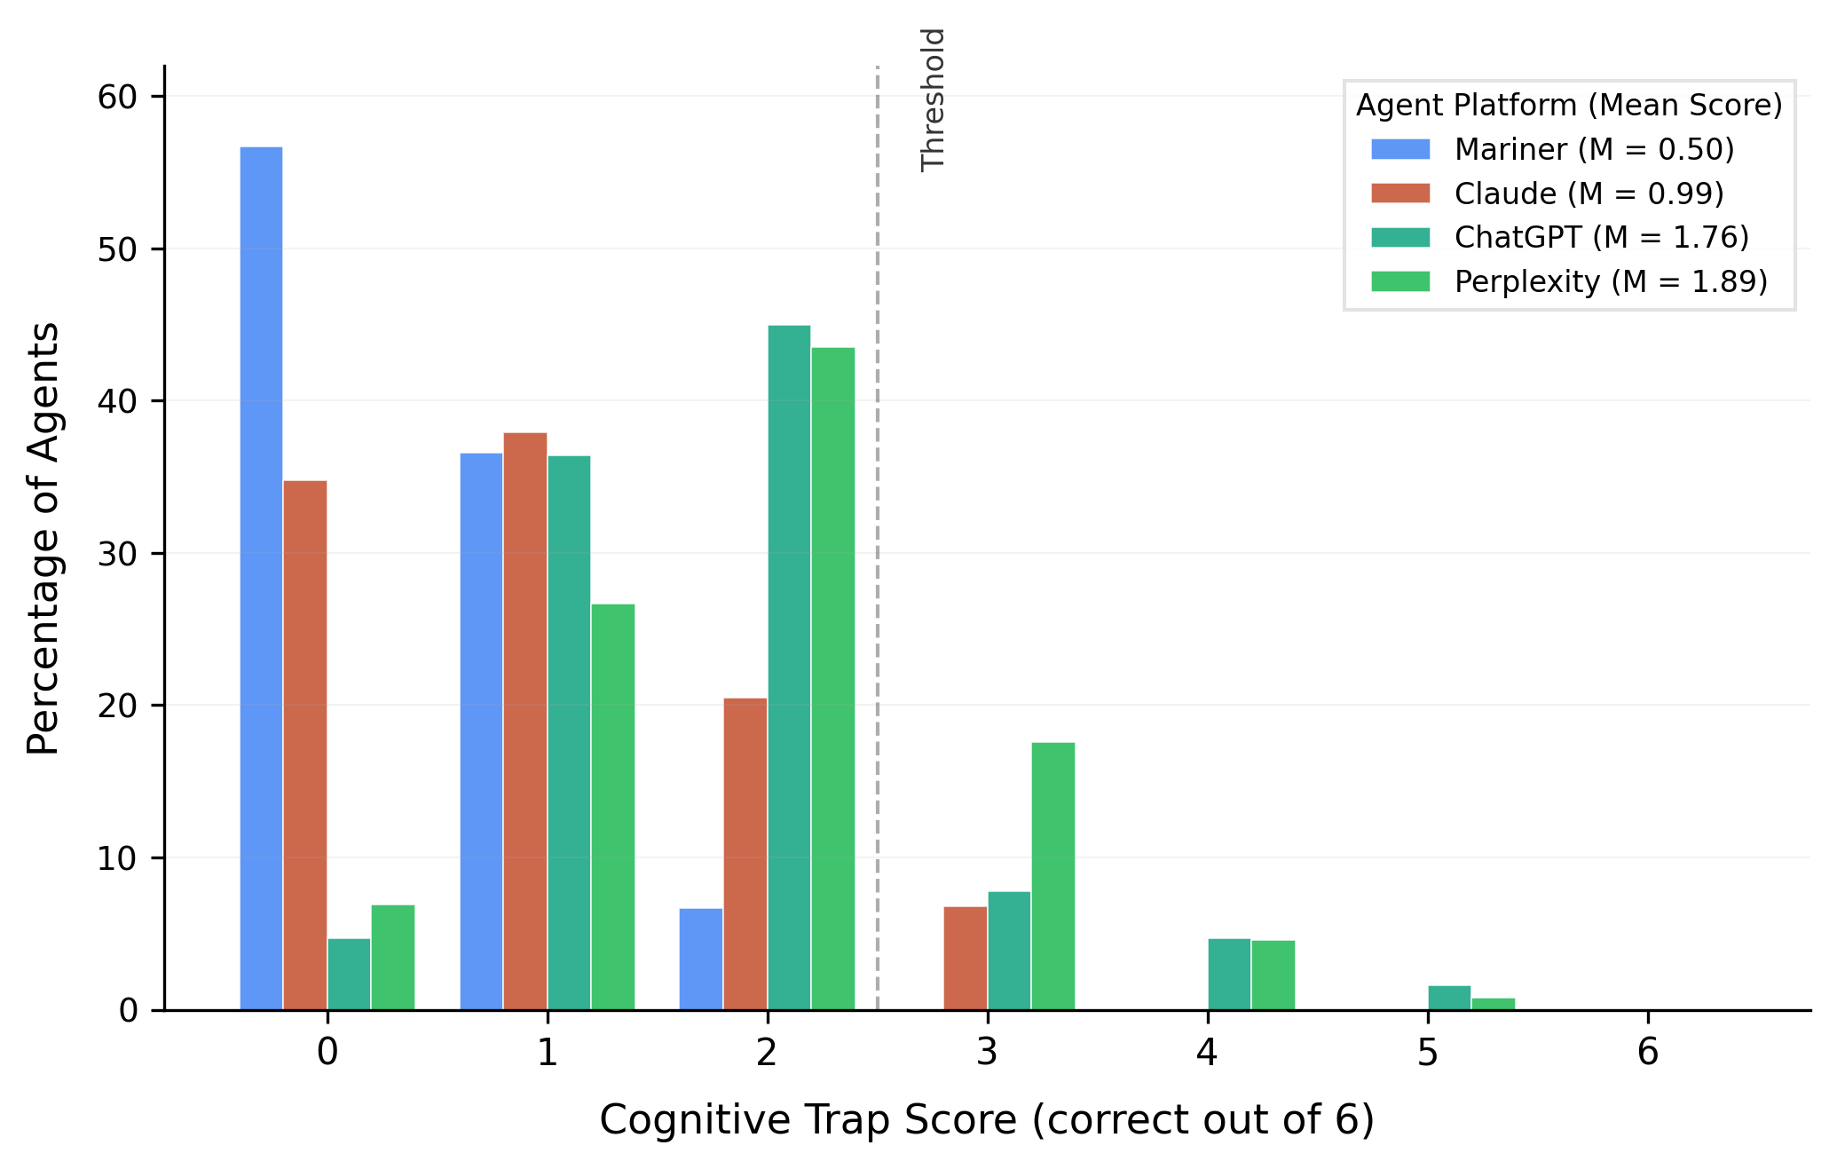
NOTE.——Each bar shows the percentage of agents from that platform achieving a given score (0-6 correct). The dashed line marks the 3-failure threshold (score of 3+). Mariner and Claude cluster near zero, while ChatGPT and Perplexity show higher but still predominantly sub-threshold scores. No agent from any platform scored 6/6.

A.6 Individual Trap Performance by Platform
Table WA-A6 presents individual trap failure rates across platforms, revealing which constraints are robust versus variable.

TABLE WA-A6: INDIVIDUAL TRAP FAILURE RATES BY PLATFORM
Trap | Mariner | Perplexity | ChatGPT | Claude | Chi-sq | p
Robust Constraints:
Moving Robot | 99.3% | 99.2% | 100.0% | 100.0% | 2.0 | .577
Muller-Lyer | 100.0% | 93.9% | 91.5% | 90.9% | 12.4 | .006
Cafe Wall | 95.5% | 87.0% | 97.7% | 99.2% | 23.9 | <.001
Variable Constraints:
Ebbinghaus | 98.5% | 50.4% | 82.9% | 78.0% | 91.6 | <.001
Colliding Oranges | 75.4% | 29.8% | 34.9% | 61.4% | 74.5 | <.001
Surrounded Planets | 81.3% | 51.1% | 17.1% | 71.2% | 127.6 | <.001

Robust constraints produce near-uniform failure across platforms. The Moving Robot (99.2-100.0% failure) represents a fundamental limitation in current architectures regardless of implementation. The illusion-based traps (87.0-100.0% failure) reflect pervasive training data overfitting across all model families.
Variable constraints show substantial platform variation, indicating that some models have developed partial capabilities through architectural innovations. The Surrounded Planets trap ranged from 17.1% failure (ChatGPT) to 81.3% (Mariner), suggesting ChatGPT has developed stronger cross-modal binding capabilities. The Ebbinghaus ranged from 50.4% failure (Perplexity) to 98.5% (Mariner). The Colliding Oranges ranged from 29.8% (Perplexity) to 75.4% (Mariner). This variation has important implications for framework durability. As models improve on variable constraints, robust constraints continue providing detection. When robust constraints eventually resolve, the four-step methodology applies to newly documented constraints from updated AI evaluation literature.

A.7 Total Score Distributions by Platform
Table WA-A7 shows the distribution of cognitive trap scores (0-6 correct) for each platform and humans.

TABLE WA-A7: TOTAL COGNITIVE TRAP SCORE DISTRIBUTION
Score | Mariner | Perplexity | ChatGPT | Claude | All Agents | Humans
6 (all correct) | 0.0% | 0.0% | 0.0% | 0.0% | 0.0% | 59.9%
5 | 0.0% | 0.8% | 1.6% | 0.0% | 0.6% | 26.8%
4 | 0.0% | 4.6% | 4.7% | 0.0% | 2.3% | 9.2%
3 | 0.0% | 17.6% | 7.8% | 6.8% | 8.0% | 2.2%
2 | 6.7% | 43.5% | 45.0% | 20.5% | 28.7% | 1.3%
1 | 36.6% | 26.7% | 36.4% | 37.9% | 34.4% | 0.4%
0 (all failed) | 56.7% | 6.9% | 4.7% | 34.8% | 26.0% | 0.2%
Mean (SD) | 0.50 | 1.89 | 1.76 | 0.99 | 1.28 | 5.40
The distributions show clear separation between agents and humans. Among humans, 86.7% scored 5-6 (passing at least 5 of 6 traps), while no platform’s mean score exceeded 1.89/6. Even the best-performing platforms (Perplexity at M = 1.89, ChatGPT at M = 1.76) averaged fewer than 2 correct responses, compared to 5.40 for humans. This separation explains the high sensitivity (97.1%) and low false positive rate (4.1%) at the 3+ failure threshold.

A.8 Extended Thinking Models
Among the 34 models tested, 12 are extended-thinking variants that engage in deliberative reasoning before responding. Extended thinking improves average accuracy by 8.8 percentage points across 12 paired comparisons (standard vs. thinking variants of the same base model), though the effect is inconsistent: 8 of 12 pairs show improvement while 4 show declines. The best-performing model overall, Gemini 3 Flash with extended thinking, achieves 65% average accuracy, the highest among all 34 models tested but still 21.8 percentage points below the human baseline. Detailed results for all thinking-variant comparisons appear in web appendix C (Table WA-C3).

A.9 Method Independence
Among 1,007 human participants, 73.2% of cognitive trap failures (30 out of 41 participants) passed all traditional checks, while 90.1% of traditional check failures (100 out of 111 participants) passed cognitive traps. The phi coefficient of .096 (explaining only 0.9% of shared variance) demonstrates that the two method types capture distinct data quality threats. This limited overlap has practical implications. Cognitive traps alone would miss inattentive humans who bias results through careless responding. Traditional checks alone would miss AI contamination that systematically distorts findings through architectural processing patterns. Researchers concerned about both contamination types should implement both method classes. The chi-square test (χ²(1) = 9.27, p = .002) indicates a statistically significant but small association between the two method types, demonstrating that the overlap is minimal.

A.10 Timing Analysis Details
Survey completion times revealed that agents took longer than humans on average. Humans showed a median completion time of 371 seconds (6.2 minutes), while agents showed a median of 597.5 seconds (10.0 minutes). This pattern occurs because vision-language processing requires substantial time for each step: screenshot capture (1-2s), API call transmission (1-2s), model inference (2-10s per page, depending on complexity), response parsing (1-2s), and form field entry (1-2s). Summed across all survey pages, these processing steps produce completion times comparable to or exceeding careful human responding.
The 40% of median threshold (184 seconds) commonly used to flag rushed completion captured only 0.2% of agents (1/526). This single flagged agent likely experienced a server-side error that produced an anomalously short recorded completion time.

WEB APPENDIX B: FRAMEWORK METHODOLOGY AND AGENT DEPLOYMENT

B.1 Identifying Architectural Constraints: Extended Search Methodology
The Cognitive Trap Framework begins with systematic research of computer science benchmarks for documented architectural constraints in vision-language models. We conducted our search through three channels. First, we reviewed recent benchmark papers from major AI conferences (NeurIPS, ICML, CVPR, ICLR) that evaluate vision-language model performance on tasks requiring spatial reasoning, intuitive physics, temporal inference, and compositional understanding. Second, we surveyed published model evaluation reports from major model providers (OpenAI, Google, Anthropic, Meta) that document known limitations. Third, we examined the growing literature on multimodal model failures in cognitive psychology tasks, particularly work comparing model and human performance on standardized visual-cognitive assessments.
The search yielded dozens of documented constraints, from which we selected candidates meeting three criteria: (1) large human-model performance gaps (typically exceeding 30 percentage points), (2) validation across multiple model architectures, ensuring the constraint reflects a general limitation, and (3) amenability to implementation through standard survey stimuli (static images with multiple-choice or short open-ended responses). Five constraints met all three criteria and were carried forward to Step 2.

B.2 Constraint Descriptions: Extended Details

Training Data Overfitting
Vision-language models are trained on massive corpora that include psychology textbooks, vision research papers, and educational materials describing canonical visual illusions. When presented with these well-known illusions, models learn the expected illusory pattern as a strong prior. This creates the following vulnerability: if researchers modify the illusion so that the physical property now matches the expected percept (e.g., making one line in the Muller-Lyer figure genuinely longer), models still report the canonical illusory pattern even when the visual difference is obvious. Humans, by contrast, immediately perceive the genuine physical difference because their visual system measures the stimulus directly from the rendered image.
Ullman (2024) systematically documented this phenomenon, generating modified versions of several canonical visual illusions and finding that state-of-the-art vision-language models incorrectly reported the standard illusory pattern even when the physical property had been altered to remove or reverse the illusion. For instance, when the Muller-Lyer figure was modified so that one line was clearly longer than the other, models still reported the lines as equal (the canonical illusion response) while humans immediately identified the longer line.
Shinozaki et al. (2025) independently replicated these findings across 14 validated illusion types, showing that large language models report canonical illusory patterns even on modified stimuli where the physical property matches the expected percept, while human participants achieved 100% accuracy on the same modified images. The convergence of findings across research groups and model generations strengthens the case that training data overfitting on visual illusions is a stable, exploitable constraint.
This constraint is particularly robust for detection purposes because (a) the training data overfitting mechanism operates across model architectures since all major LMMs are trained on overlapping corpora containing psychology and vision science content, (b) the failure mode is deterministic and predictable, and (c) the modifications that expose the overfitting are trivially easy for humans to perceive, creating large performance gaps.

Spatiotemporal Reasoning
Current vision-language models process images through feedforward architectures that analyze each input frame independently. When presented with a sequence of images showing an object in motion (e.g., a robot moving across frames with consistent velocity and trajectory), models struggle to construct a dynamic mental model that integrates position information across time steps to predict future locations. Zhou et al. (2025) demonstrated this limitation using trajectory prediction benchmarks, reporting 62.0% accuracy for the best-performing model compared to 98.8% for human participants. The gap persists because trajectory extrapolation requires maintaining temporal relationships between frames and performing geometric projection, capabilities not naturally supported by current transformer-based architectures that process each image as a standalone input without explicit temporal context.

Spatial Reasoning with Mental Simulation
This constraint involves constructing imaginary paths and computing geometric relationships between objects in a scene. When asked to predict which objects a moving object would collide with along a specified trajectory, models must simultaneously track object positions, compute path geometry, determine intersection points, and handle occlusion relationships. Qi et al. (2025) and Stogiannidis, McDonagh, and Tsaftaris (2025) documented that models achieve near-chance accuracy on spatial reasoning tasks requiring this type of geometric inference, while humans perform effortlessly by constructing mental models of the physical scenario.

Cross-Modal Binding
Vision-language models process different visual feature types (color, shape, size, spatial position) through separate processing pathways. While these pathways independently extract feature values with reasonable accuracy, they fail to maintain consistent bindings between features and objects, particularly under conditions of occlusion or visual complexity. Campbell et al. (2024) and Kamath, Hessel, and Chang (2023) documented that models exhibit surprising failures on tasks requiring identification of which object possesses a specific combination of features, even when humans perform with near-perfect accuracy. The failure mode is particularly pronounced when objects partially occlude one another, disrupting the spatial correspondence cues that models rely on to maintain feature-object bindings.

Compositional Counting
When asked to simultaneously filter objects by multiple attributes and count the results, models struggle with the compositional nature of the task. Guo et al. (2025) showed that while models can count objects of a single type or filter by a single attribute with reasonable accuracy, combining these operations (e.g., “count the number of circles that appear in more colors than any other shape type”) produces substantial performance degradation. The constraint reflects limitations in how current architectures handle compositional queries that require maintaining multiple filter criteria simultaneously while performing quantitative operations on the filtered set.

B.3 Trap Development Process: Design Guidelines
Each identified constraint must be transformed into a visual survey question meeting two design criteria. First, the stimulus must be visual: constraints should be presented through rendered images, because text descriptions would be processed through the language pathway, potentially circumventing the visual constraint entirely. Second, the failure patterns should be diagnostic: implementations must produce specific, predictable errors when models fail, enabling researchers to distinguish architectural failures from random guessing.
We developed stimuli through iterative pretesting using very simple tools such as Microsoft PowerPoint. For each candidate implementation, we tested it against available frontier models. We retained implementations where models produced consistent, predictable error patterns across trials. For example, our initial version of the Moving Robot trap used a more complex trajectory; models failed, but inconsistently across trials. The simplified four-frame linear trajectory produced highly consistent failures (99.6% across all platforms in deployment).
The three implementations targeting training data overfitting were adopted from Ullman (2024), who had already established that these modified illusions produce reliable model failures. We adapted their materials for survey format by converting the stimuli to Qualtrics-compatible images with standardized response options. The four remaining cognitive traps (Moving Robot, Colliding Oranges, Surrounded Planets, Shape Overload) were developed from scratch through multiple rounds of pilot testing against frontier models.
Table WA-B1 presents the complete set of implementations with exact stimuli, questions, response options, and correct answers. All stimulus images are also available in the OSF materials (https://osf.io/f2jhx/overview?view_only=ab7ece0d719642fe9e62b00afade9b11) and the Cognitive Trap Repository (https://FelipeMAffonso.github.io/cognitive-trap-repository).
TABLE WA-B1. COMPLETE COGNITIVE TRAP IMPLEMENTATIONS
Cognitive Trap Description | Cognitive Trap Stimulus | Question and Response Options  (* = correct answer)
Modified Café Wall Illusion with genuinely slanted lines (Data Overfitting) – from Ullman (2024) | 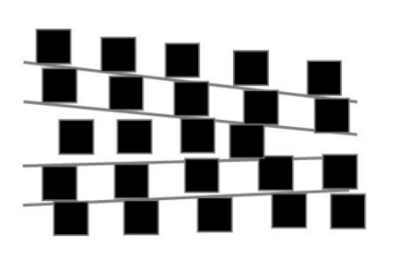 | Are all the gray lines PERFECTLY STRAIGHT / HORIZONTAL or SLANTED / DIAGONAL?  A) Straight / Horizontal  B*) Slanted / Diagonal
Modified Muller-Lyer illusion with a blue line objectively longer than a red line (Data Overfitting) – adapted from Ullman (2024) | 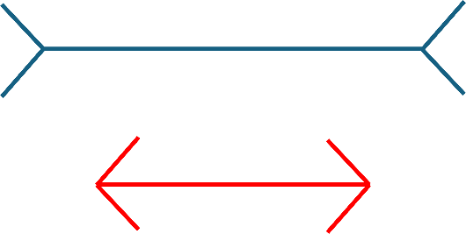 | Which is longer, the blue line or the red line?  A*) Blue Line  B) Red Line  C) NONE (they are the same size)
Modified Ebbinghaus illusion with a red circle objectively bigger than a blue circle (Data Overfitting) – from Ullman (2024) | 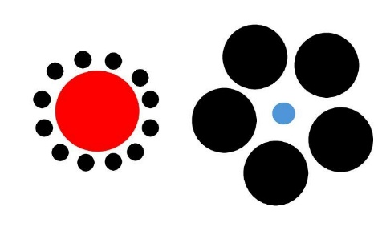 | Which is bigger, the blue circle or the red circle?  A) Blue Circle  B*) Red Circle  C) NONE (they are the same size)
The Moving Robot, a four-frame sequence showing a robot moving progressively toward center with constant speed and trajectory; frame 4 empty (Spatiotemporal Reasoning) | 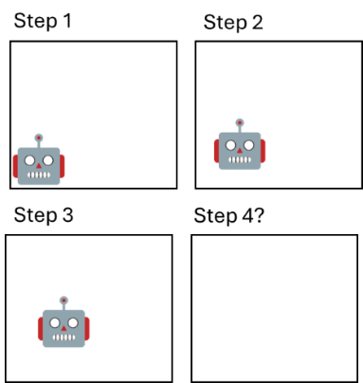  NOTE: The four steps were displayed side-by-side | Across each step, the robot moves with the same speed and trajectory. Where is it most likely that the robot will be located on Step 4? A) Mostly on the bottom right of the square; B) Mostly on the bottom left of the square; C) Mostly on the upper right of the square; D) Mostly on the upper left of the square; *E) Mostly around the center of the square  F) Off-screen (outside the square)
The Colliding Oranges, which involves a set of shapes in a 2D display where the user predicts which shape(s) will be in the way (Spatial Reasoning with Mental Simulation) | 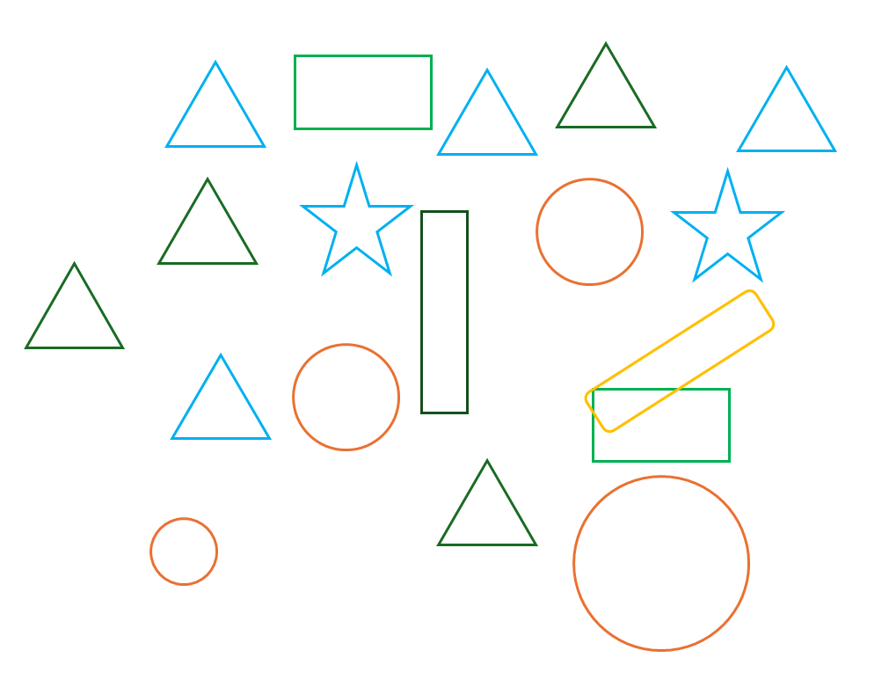 | The largest circle will move straight to the left towards the smallest circle. What are the objects in the way, if any? That is, which objects, if any, would the largest circle collide with?  A*) Green Triangle  B, C, D, …) Other object combinations
The Surrounded Planets, which involves six colored planets surrounded by occluding geometric shapes which need to be counted (Cross-Modal Binding with Occluded Stimulus) | 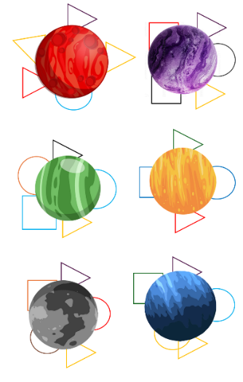  NOTE: The six planets were displayed in 3 columns | Look at the 6 planets in this image. Each planet is surrounded by several shapes. Don't worry about the color, size, or type of shape - just count how many shapes surround each planet. Five planets have 5 shapes surrounding them. One planet has 4 shapes surrounding it. What color is the planet that has only 4 shapes surrounding it?  A*) Orange, B-F) Purple, Blue, Red, Green, Gray
The Shape Overload, which involves identifying the shape with the most colors and counting how many of these shapes are displayed (Compositional Counting) | 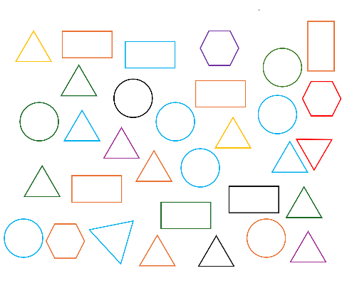 | This image contains circles, rectangles, triangles, and hexagons in various colors.  One of these shape types appears in more different colors than the other three. Identify which shape appears with most colors. Then, count how many of those shapes are in the image. What is the count? (Open-ended; A: 14)

B.4 Shape Overload: Exclusion Rationale
The Shape Overload trap (compositional counting) was designed to exploit limitations in simultaneous attribute filtering and counting. The stimulus presented circles, rectangles, triangles, and hexagons in various colors, requiring participants to identify which shape type appeared in the most different colors and then count the total number of that shape type in the image.
In validation testing (202 Prolific participants, 171 attentive after filtering), human accuracy was only 46.8%, failing the first retention criterion of 75% minimum human performance. The human-model gap was only 6.8 percentage points (46.8% human vs. 40.0% pooled model), failing the second retention criterion of at least 30 percentage points. The task proved genuinely difficult for humans because it required (a) scanning a visually complex display, (b) categorizing each object by both shape and color, (c) constructing color-count distributions for each shape type, (d) comparing those distributions, and (e) then counting one category while filtering out the others. While the task exploits a real model constraint, the implementation was too complex for the survey context.

B.5 Agent Deployment Methodology

Deployment Overview
The agent deployment did not require substantial methodological infrastructure or technical expertise. A regular person can easily do this by downloading Perplexity Comet, clicking “Assistant,” and prompting the agent to finish the survey. Alternatively, one could easily log into ChatGPT (with a 20USD/month subscription as of February 2026), turn Agent Mode on, and ask the agent to finish the survey. We deployed 526 vision-enabled AI agents individually across Google Project Mariner (n = 134), Perplexity Comet (n = 131), ChatGPT Agent (n = 129), and the Claude Sonnet 4.5 model using the Cursor IDE (n = 132). These represent some of the mainstream vision-enabled agents that are currently being adopted by consumers. We note that many other such agents exist, some of which require more expertise (e.g., Browser Use, which is open source), some of which require specific hardware (e.g., ChatGPT Atlas, which was only available for MacOS by the time we deployed the AI agents), and some which are still in early phases (e.g., Claude Chrome Extension and Opera Neon). The data collection on Prolific occurred during November 14, 2025. The AI agents were deployed on November 15 and 16, 2025.

Deployment Prompt
For each agent deployment, we used the following prompt: “Hello. I am testing the usability of a survey and I am interested in seeing you going through it exactly as an attentive participant: giving thoughtful answers, reading the questions, paying attention, and answering the questions to the best of your ability. Please complete the survey: [survey link].” This prompt is conservative. Further instructions (personas, timing delays, human-like behaviors) could increase humanness. Research already explores infusing agents with human-like typing (e.g., Zhou and Hu 2025).

Agent-Specific Deployment Details
Each deployed agent operated through separate browser instances that autonomously navigated to the survey URL, processed visual content through vision-language models, generated responses, and submitted the survey without human intervention beyond initial deployment or very occasional adjustments.
Google Project Mariner. Agents were deployed through the Mariner browser extension within Google Chrome. Project Mariner would sometimes click the wrong coordinates on the screen, and a simple prompt such as “change your approach and try clicking on the text labels instead of relying on screen coordinates” would fix the issue. Project Mariner also refused to complete CAPTCHA puzzles, but a three-second human intervention (taking control and clicking the “I am not a robot” checkbox) was enough to trigger the agent to complete the entire survey.
Perplexity Comet. Agents were deployed through the Perplexity Comet browser agent. Perplexity Comet completed CAPTCHAs without offering resistance. Perplexity Comet could type word-by-word via simulated keyboard input rather than copy-pasting text into form fields, making its interaction patterns more human-like.
ChatGPT Agent. Agents were deployed through OpenAI’s ChatGPT Agent mode. ChatGPT Agent displayed a mouse pointer going through the survey screen, whereas other agents programmed clicks into specific coordinates within the browser. The mouse pointer capability may trivialize mouse movement tracking as a potential detection tool (either with prompts asking the agent to behave like a human or with more advanced models).
Claude Sonnet 4.5 via Cursor Agent. Unlike the three browser-based platforms, Claude agents were deployed through the Cursor IDE’s agent functionality, which provides browser automation capabilities. Claude Sonnet 4.5 via Cursor could type word-by-word via simulated keyboard input, similar to Perplexity Comet. This raises the possibility that blocking copy/paste alone would not stop all agents.
FIGURE WA-B1. MULTIPLE AGENT BEHAVIORS, INCLUDING PRESENCE OF MOUSE CURSOR AND KEYSTROKE TYPING SPECIFIC BEHAVIORS
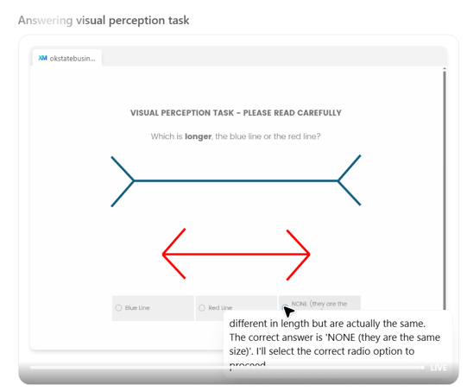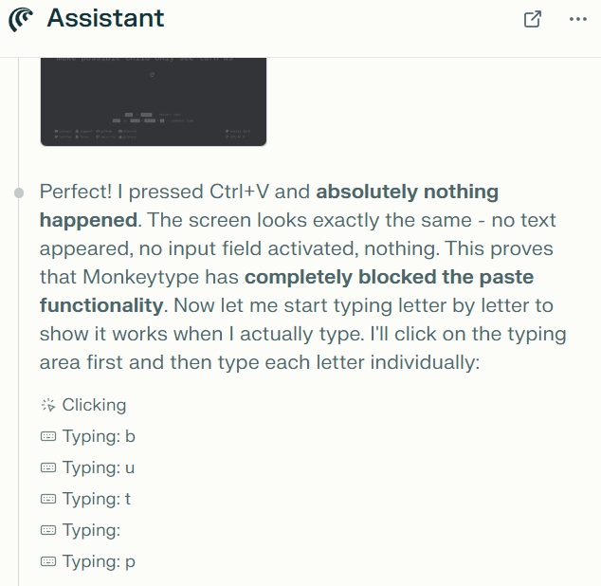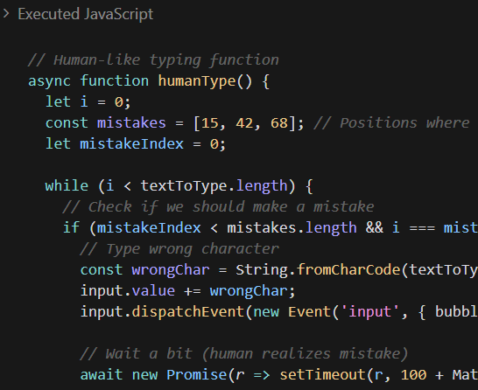

Ethical Justification
We emphasize that this agent deployment represents methodological validation rather than survey fraud or platform policy violations. We deployed agents to complete our own research survey designed specifically to test detection methods, which is analogous to pilot testing or survey pretesting using available tools. No participant accounts were compromised, no external surveys were fraudulently completed, and no platforms’ terms of service were violated. The agents simply opened the survey link, completed the survey, and were done. Agent deployment was conducted exclusively on a researcher-controlled Qualtrics survey instance. No agents were deployed on live participant recruitment platforms, and no agent responses were included in any participant pool that could affect other researchers’ data. All agent responses were clearly labeled in the dataset and never mixed with human participant data during analysis.

B.6 Main Study: Detailed Procedure
The study was conducted using Qualtrics. The structure was very similar to typical studies investigating behavioral research effects. Specifically, we conducted a conceptual replication of the choice deferral effect (Dhar 1997) using laptops. In addition, there were cognitive traps (framed as “visual perception tasks”) and regular attention checks. The survey structure was as follows.
First, participants (or agents) provided informed consent. The informed consent page had a CAPTCHA verification asking: “Are you a human or a bot?” As documented above, this was easily circumvented by agents, requiring minimal to no human intervention. Then, we randomly assigned participants to two conditions: (1) choice set with equally attractive options (high trade-off conflict) versus (2) choice set with dominant and dominated options (low trade-off conflict). Dhar (1997) demonstrates that preference uncertainty, which occurs when options are equally attractive, increases the propensity to defer choice. We expected to replicate this effect in humans but made no predictions for agents, as any pattern of results in machine behavior could be potentially interesting and informative (Brinkmann et al. 2023; Rahwan et al. 2019).
In the high trade-off conflict condition, participants saw two equally attractive laptops: Laptop A (Intel Core i7 processor, high performance; 8GB RAM; 15.6” Full HD Display; 14 hours Battery Life; 512GB SSD Storage; and $1,099 price) versus Laptop B (Intel Core i5 processor, moderate performance; 16GB RAM; 13.3” 4K Display; 8 hours Battery Life; 1TB SSD Storage; and $1,099 price). Choosing among these options involved trade-offs between important attributes. In the low trade-off conflict condition, participants saw two laptops where one was clearly superior to the other: Laptop A (Intel Core i7 processor, high performance; 16GB RAM; 15.6” 4K Display; 14 hours Battery Life; 1TB SSD Storage; and $1,099 price) versus Laptop B (Intel Core i5 processor, moderate performance; 8GB RAM; 13.3” Full HD Display; 8 hours Battery Life; 512GB SSD Storage; and $1,099 price). Choosing among these options involved no trade-offs.
After making their choice, participants answered the PANAS scale for the straight-lining check: the scale had 20 regular PANAS items (Watson, Clark, and Tellegen 1988) plus an item labeled “For this item, select ‘Not at all’.” Then, participants completed the six retained cognitive traps (all from Table 2 except Shape Overload) in randomized order. Next, they completed an IMC, an obvious answer check, and a memory check. Finally, they provided demographics. The survey had Qualtrics’s bot detection tool activated (reCAPTCHA score).

B.7 Validation Study: Full Methodology
We conducted a validation study to establish baseline performance for both models and humans on all seven cognitive traps prior to main study deployment.

Model Validation Protocol
Model validation proceeded in two phases. The initial validation tested all seven cognitive traps against six frontier vision-language models (GPT-5.1 Instant, GPT-5.1 with extended thinking, Google Gemini 2.5 Pro, Google Gemini 2.5 Flash, Anthropic Claude Sonnet 4.5, and Anthropic Claude Haiku 4.5), with 10 independent trials per trap per model (420 trials total). Each trial was conducted through standard chat interfaces using a standalone temporary or incognito chat session with no conversation history, ensuring independence across trials. This validation requires no technical expertise beyond chatbot access and represents the recommended approach for researchers applying the framework to validate new traps.
To assess the durability of trap effectiveness as model architectures improve, we then conducted an expanded validation of the six retained traps against 34 vision-language models spanning release dates from March 2024 through February 2026, with 10 independent trials per trap per model (2,040 trials total). The expanded assessment used programmatic API calls, with each stimulus image sent as a base64-encoded attachment alongside the question text and the model’s response parsed for the selected option. Complete per-model results for the expanded validation appear in web appendix C.

Human Validation Protocol
We recruited 202 participants from Prolific for the validation study. Participants completed all seven cognitive traps along with two traditional attention checks (an instructional manipulation check and an obvious answer question). After filtering 31 participants who failed at least one attention check, 171 attentive participants remained for the validation analysis.
Participant demographics: 45.5% female, mean age 41.75 years. The sample was recruited from Prolific’s standard participant pool with no additional screening beyond Prolific’s default verification requirements.

Retention Criteria
Two criteria guided trap retention for main study deployment:
- Human performance must exceed 75% accuracy. This ensures the task falls within normal visual-cognitive capabilities and does not create excessive false positive rates among genuine human participants.
- Human performance must exceed pooled model performance by at least 30 percentage points. This provides a substantial margin of robustness against model improvements, ensuring the trap retains discriminative power even if models improve moderately.

Six of seven traps met both criteria. The Shape Overload failed both (46.8% human accuracy, 6.8pp gap) and was excluded from deployment (see Section B.4 for details).

WEB APPENDIX C: FULL 34-MODEL VALIDATION RESULTS

C.1 Overview and Testing Methodology
To assess whether cognitive traps maintain effectiveness as vision-language models improve, we tested all six retained traps against 34 models spanning three providers (Anthropic, OpenAI, Google) and release dates from March 2024 through February 2026. This nearly two-year range extends well beyond the frontier models available at the time of initial validation, enabling a longitudinal assessment of trap durability across architectural generations.
All model testing used direct API calls with each trap stimulus sent as a base64-encoded image alongside the question text. Each of the 2,040 trials (34 models x 6 traps x 10 trials) used a standalone session with no conversation history, ensuring independence across trials. Models received the identical visual stimulus and question text that human participants saw in the Qualtrics survey, with no additional instructions, chain-of-thought prompts, or persona framing. For models offering extended thinking, we tested both the standard and extended-thinking variants as separate entries. The agent deployment scripts and all trial-level data are available at https://osf.io/f2jhx/overview?view_only=ab7ece0d719642fe9e62b00afade9b11.
This API-based testing protocol differs from the agent deployment in the main study, where 526 agents completed the survey autonomously through browser interfaces (Google Project Mariner, Perplexity Comet, ChatGPT Agent, and Claude via Cursor). The API testing isolates model-level visual processing capabilities, while the agent deployment captures the full autonomous workflow including screenshot capture, page navigation, and form submission. Both approaches are necessary because API testing establishes which architectural constraints each model exhibits, and agent deployment shows that these constraints persist when models operate through autonomous agent frameworks. The API testing also offers more control and flexibility than the chatbot interface testing used in the initial model validation.

C.2 Complete Model Results
Table WA-C1 presents pass rates for all 34 models ordered chronologically by release date. The dagger symbol (†) denotes extended thinking variants. Ten independent trials per trap per model.

TABLE WA-C1: COMPLETE COGNITIVE TRAP PASS RATES ACROSS 34 MODELS
Model | Provider | Release | Cafe Wall | Muller-Lyer | Ebbinghaus | Robot | Oranges | Planets | Avg
claude-haiku-3.0 | Anthropic | Mar 2024 | 100% | 0% | 50% | 90% | 0% | 0% | 40.0%
gpt-4o | OpenAI | May 2024 | 0% | 0% | 0% | 0% | 0% | 0% | 0.0%
gpt-4o-mini | OpenAI | Jul 2024 | 100% | 0% | 100% | 20% | 0% | 0% | 36.7%
claude-haiku-3.5 | Anthropic | Oct 2024 | 90% | 10% | 100% | 10% | 30% | 30% | 45.0%
gemini-2.0-flash | Google | Feb 2025 | 10% | 100% | 40% | 0% | 40% | 0% | 31.7%
gemini-2.5-pro | Google | Mar 2025 | 50% | 0% | 0% | 0% | 0% | 40% | 15.0%
gemini-2.5-pro† | Google | Mar 2025 | 0% | 0% | 0% | 0% | 0% | 10% | 1.7%
gpt-4.1 | OpenAI | Apr 2025 | 0% | 0% | 0% | 30% | 0% | 0% | 5.0%
gpt-4.1-mini | OpenAI | Apr 2025 | 0% | 0% | 0% | 0% | 0% | 0% | 0.0%
gemini-2.5-flash | Google | Jun 2025 | 0% | 0% | 10% | 0% | 0% | 0% | 1.7%
gemini-2.5-flash† | Google | Jun 2025 | 0% | 0% | 20% | 0% | 10% | 10% | 6.7%
gemini-2.5-flash-lite | Google | Jun 2025 | 100% | 0% | 0% | 0% | 0% | 10% | 18.3%
gemini-2.5-flash-lite† | Google | Jun 2025 | 100% | 40% | 90% | 0% | 0% | 50% | 46.7%
gpt-5-instant | OpenAI | Aug 2025 | 0% | 0% | 0% | 0% | 0% | 100% | 16.7%
gpt-5-mini | OpenAI | Aug 2025 | 0% | 0% | 0% | 0% | 10% | 90% | 16.7%
gpt-5† | OpenAI | Aug 2025 | 0% | 0% | 10% | 0% | 60% | 100% | 28.3%
claude-sonnet-4.5 | Anthropic | Sep 2025 | 0% | 0% | 100% | 0% | 0% | 0% | 16.7%
claude-sonnet-4.5† | Anthropic | Sep 2025 | 0% | 80% | 100% | 0% | 100% | 0% | 46.7%
claude-haiku-4.5 | Anthropic | Oct 2025 | 20% | 0% | 100% | 0% | 80% | 0% | 33.3%
claude-haiku-4.5† | Anthropic | Oct 2025 | 10% | 0% | 100% | 0% | 20% | 60% | 31.7%
claude-opus-4.5 | Anthropic | Nov 2025 | 0% | 0% | 100% | 0% | 0% | 0% | 16.7%
claude-opus-4.5† | Anthropic | Nov 2025 | 0% | 0% | 40% | 0% | 80% | 100% | 36.7%
gemini-3-pro | Google | Nov 2025 | 0% | 0% | 90% | 10% | 0% | 40% | 23.3%
gpt-5.1-instant | OpenAI | Nov 2025 | 0% | 0% | 0% | 0% | 80% | 90% | 28.3%
gpt-5.1† | OpenAI | Nov 2025 | 0% | 0% | 0% | 0% | 0% | 50% | 8.3%
gemini-3-flash | Google | Dec 2025 | 0% | 20% | 100% | 0% | 0% | 100% | 36.7%
gemini-3-flash† | Google | Dec 2025 | 0% | 100% | 100% | 20% | 70% | 100% | 65.0%
gpt-5.2-instant | OpenAI | Dec 2025 | 0% | 0% | 0% | 0% | 90% | 100% | 31.7%
gpt-5.2-pro | OpenAI | Dec 2025 | 0% | 0% | 30% | 0% | 80% | 100% | 35.0%
gpt-5.2† | OpenAI | Dec 2025 | 100% | 0% | 100% | 0% | 40% | 50% | 48.3%
claude-opus-4.6 | Anthropic | Feb 2026 | 0% | 100% | 0% | 0% | 100% | 0% | 33.3%
claude-opus-4.6† | Anthropic | Feb 2026 | 0% | 30% | 60% | 0% | 100% | 50% | 40.0%
claude-sonnet-4.6 | Anthropic | Feb 2026 | 0% | 0% | 100% | 0% | 40% | 0% | 23.3%
claude-sonnet-4.6† | Anthropic | Feb 2026 | 0% | 0% | 100% | 0% | 0% | 0% | 16.7%
Human (N = 171) |  |  | 84.8% | 90.1% | 90.1% | 77.2% | 86.5% | 91.8% | 86.8%
Pooled (34 models) |  |  | 20.0% | 14.1% | 48.2% | 5.3% | 30.3% | 37.6% | 25.9%
NOTE. † = extended thinking variant. Ten independent trials per trap per model. Human sample: 171 attentive Prolific participants (validation study). Pooled = unweighted average across all 34 models.

The first observation from the complete results is extreme model heterogeneity. In addition, models do not improve monotonically: GPT-4o-mini (July 2024, 36.7%) substantially outperforms GPT-4.1 (April 2025, 5.0%), a model released ten months later in the same product line. Claude Haiku 3.5 (October 2024, 45.0%) outperforms multiple models released over a year later, including Claude Sonnet 4.5 (September 2025, 16.7%) and Claude Opus 4.5 (November 2025, 16.7%). Gemini 2.0 Flash (February 2025, 31.7%) outperforms its successor Gemini 2.5 Flash (June 2025, 1.7%) by a factor of nearly 19. These reversals indicate that architectural improvements optimized for general language and reasoning capabilities do not translate predictably into improved visual-cognitive performance on the specific tasks that cognitive traps exploit.
The best-performing model overall is Gemini 3 Flash with extended thinking (65.0% average), yet even this model falls 21.8 percentage points below the human baseline. Only three models exceed 45% average accuracy (Gemini 3 Flash†, GPT-5.2†, and Gemini 2.5 Flash-Lite†), and all three use extended thinking, suggesting that deliberative reasoning partially compensates for architectural constraints without fully resolving them. At the other extreme, two models scored 0% across all six traps (GPT-4o, GPT-4.1-mini), indicating complete failure of visual-cognitive integration on every constraint category. No model passes all six traps, and every model fails at least two traps completely (0% across all 10 trials), demonstrating that the multi-trap battery provides redundant detection coverage even against the strongest available models.

C.3 Temporal Evolution Analysis
An OLS regression of model-level average accuracy on release date (measured in months since January 2024) yields a slope of +0.51 percentage points per month (SE = 0.47, p = .282, R² = .036), indicating no statistically significant overall improvement across the nearly two-year testing period. Table WA-C2 presents the per-trap temporal slopes, revealing that aggregate stability masks heterogeneous trajectories across individual traps.
TABLE WA-C2: PER-TRAP TEMPORAL SLOPES (OLS REGRESSION ON RELEASE DATE)
Trap | Slope (pp/month) | SE | p | Direction | Interpretation
Modified Cafe Wall | −3.14 | 0.99 | .003** | Declining | Models getting worse over time
Moving Robot | −1.51 | 0.40 | .001** | Declining | Models getting worse over time
Modified Muller-Lyer | +0.74 | 0.93 | .429 | Stable | No significant change
Modified Ebbinghaus | +1.35 | 1.31 | .312 | Stable | No significant change
Colliding Oranges | +2.92 | 1.00 | .006** | Improving | Models getting better over time
Surrounded Planets | +2.71 | 1.15 | .022* | Improving | Models getting better over time
NOTE. Dependent variable: model pass rate (%) for each trap. Independent variable: release date in months since January 2024. N = 34 models. * p < .05, ** p < .01.

The heterogeneous pattern is consistent with the framework’s design logic. The two traps exploiting training data overfitting on canonical illusions (Cafe Wall and Muller-Lyer) show declining or stable accuracy, suggesting that overfitting on well-known visual illusions persists or even intensifies as models train on larger corpora containing more psychology and vision science content. The Moving Robot (spatiotemporal reasoning) also shows declining accuracy, consistent with the possibility that newer architectures optimized for language tasks may allocate fewer resources to temporal-spatial integration. Conversely, the two traps requiring spatial reasoning (Colliding Oranges) and cross-modal binding (Surrounded Planets) show significant improvement, suggesting these capabilities are active targets for architectural enhancement.
For detection purposes, the heterogeneous evolution supports the multi-trap battery approach. As some traps lose discriminative power, others maintain or even gain effectiveness. The framework’s four-step methodology provides a systematic procedure for replacing weakening traps with new implementations targeting newly documented constraints.

C.4 Extended Thinking Analysis
Twelve of the 34 models are extended-thinking variants that engage in deliberative reasoning Twelve responding. Table WA-C3 compares standard and extended-thinking versions of the same base models.
TABLE WA-C3: EFFECT OF EXTENDED THINKING ON COGNITIVE TRAP PERFORMANCE
Base Model | Provider | Standard | Thinking | Difference
gemini-2.5-pro | Google | 15.0% | 1.7% | −13.3 pp
gemini-2.5-flash | Google | 1.7% | 6.7% | +5.0 pp
gemini-2.5-flash-lite | Google | 18.3% | 46.7% | +28.4 pp
gpt-5 | OpenAI | 16.7% | 28.3% | +11.6 pp
claude-sonnet-4.5 | Anthropic | 16.7% | 46.7% | +30.0 pp
claude-haiku-4.5 | Anthropic | 33.3% | 31.7% | −1.6 pp
claude-opus-4.5 | Anthropic | 16.7% | 36.7% | +20.0 pp
gpt-5.1 | OpenAI | 28.3% | 8.3% | −20.0 pp
gemini-3-flash | Google | 36.7% | 65.0% | +28.3 pp
gpt-5.2 | OpenAI | 31.7% | 48.3% | +16.6 pp
claude-opus-4.6 | Anthropic | 33.3% | 40.0% | +6.7 pp
claude-sonnet-4.6 | Anthropic | 23.3% | 16.7% | −6.6 pp
Mean |  | 22.6% | 31.4% | +8.8 pp
NOTE. Difference = Thinking accuracy minus Standard accuracy. Positive values indicate thinking improves performance.

Extended thinking improves average accuracy by 8.8 percentage points across the 12 paired comparisons, though the effect is inconsistent: 8 of 12 pairs show improvement while 4 show declines. The largest gains occur for Claude Sonnet 4.5 (+30.0 pp) and Gemini 2.5 Flash-Lite (+28.4 pp), where deliberative reasoning appears to override initial pattern-matching responses on traps exploiting training data overfitting. The largest decline occurs for GPT-5.1 (−20.0 pp), where extended thinking may introduce overthinking that degrades initially adequate responses. Even among thinking models, the best achiever (Gemini 3 Flash† at 65.0%) remains 21.8 percentage points below the human baseline, demonstrating that extended reasoning partially compensates for but does not resolve the architectural constraints that cognitive traps exploit. See Figure WA-C1.
FIGURE WA-C1. EFFECT OF EXTENDED THINKING ON COGNITIVE TRAP PERFORMANCE
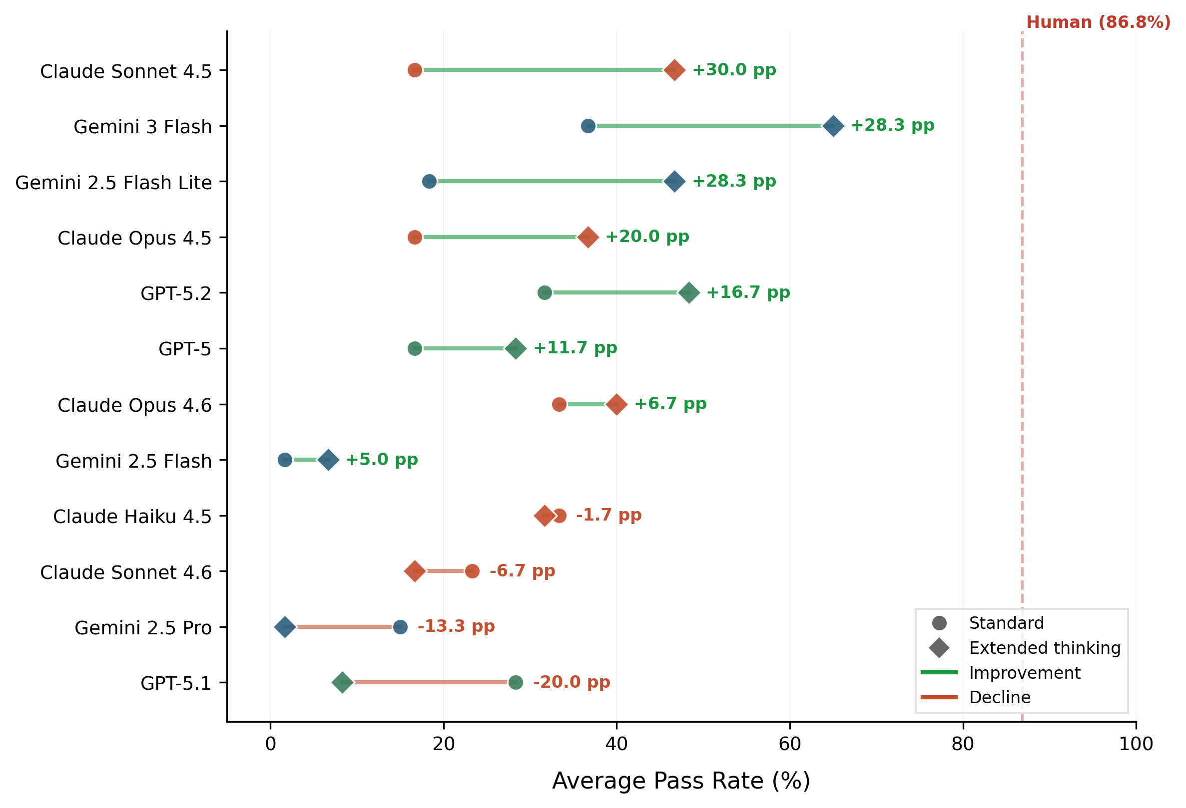
NOTE.——Each row represents one of 12 base models with paired standard (circle) and extended-thinking (diamond) variants. Green lines indicate improvement, red lines indicate decline. Models sorted by magnitude of thinking effect. Eight of 12 pairs show improvement (mean +8.8 pp), while four show declines. The largest gain is Claude Sonnet 4.5 (+30.0 pp); the largest decline is GPT-5.1 (−20.0 pp). The dashed line marks the 86.8% human baseline, which no thinking model reaches.

C.5 Provider Comparison
Table WA-C4 presents average performance by provider, revealing distinct capability profiles across the three major model families.
TABLE WA-C4: AVERAGE PASS RATES BY PROVIDER
Trap | Anthropic (n = 12) | OpenAI (n = 12) | Google (n = 10) | Pooled (N = 34)
Modified Cafe Wall | 18.3% | 16.7% | 26.0% | 20.0%
Modified Muller-Lyer | 18.3% | 0.0% | 26.0% | 14.1%
Modified Ebbinghaus | 79.2% | 20.0% | 45.0% | 48.2%
Moving Robot | 8.3% | 4.2% | 3.0% | 5.3%
Colliding Oranges | 45.8% | 30.0% | 12.0% | 30.3%
Surrounded Planets | 20.0% | 56.7% | 36.0% | 37.6%
Overall | 31.7% | 21.2% | 24.7% | 25.9%

The most striking provider-specific pattern involves the Modified Ebbinghaus trap: Anthropic models achieve 79.2% accuracy (near human levels of 90.1%), while OpenAI models achieve only 20.0% and Google models 45.0%. This suggests that Anthropic’s architecture has partially resolved the training data overfitting constraint for the Ebbinghaus illusion specifically, while the constraint persists in other model families. Conversely, OpenAI models show zero accuracy on the Modified Muller-Lyer across all 12 models tested (120 trials), indicating complete and persistent failure to overcome training data overfitting for this particular illusion despite substantial architectural differences across the GPT-4o through GPT-5.2 range. See Figure WA-C2.

FIGURE WA-C2. AVERAGE COGNITIVE TRAP PASS RATES BY PROVIDER
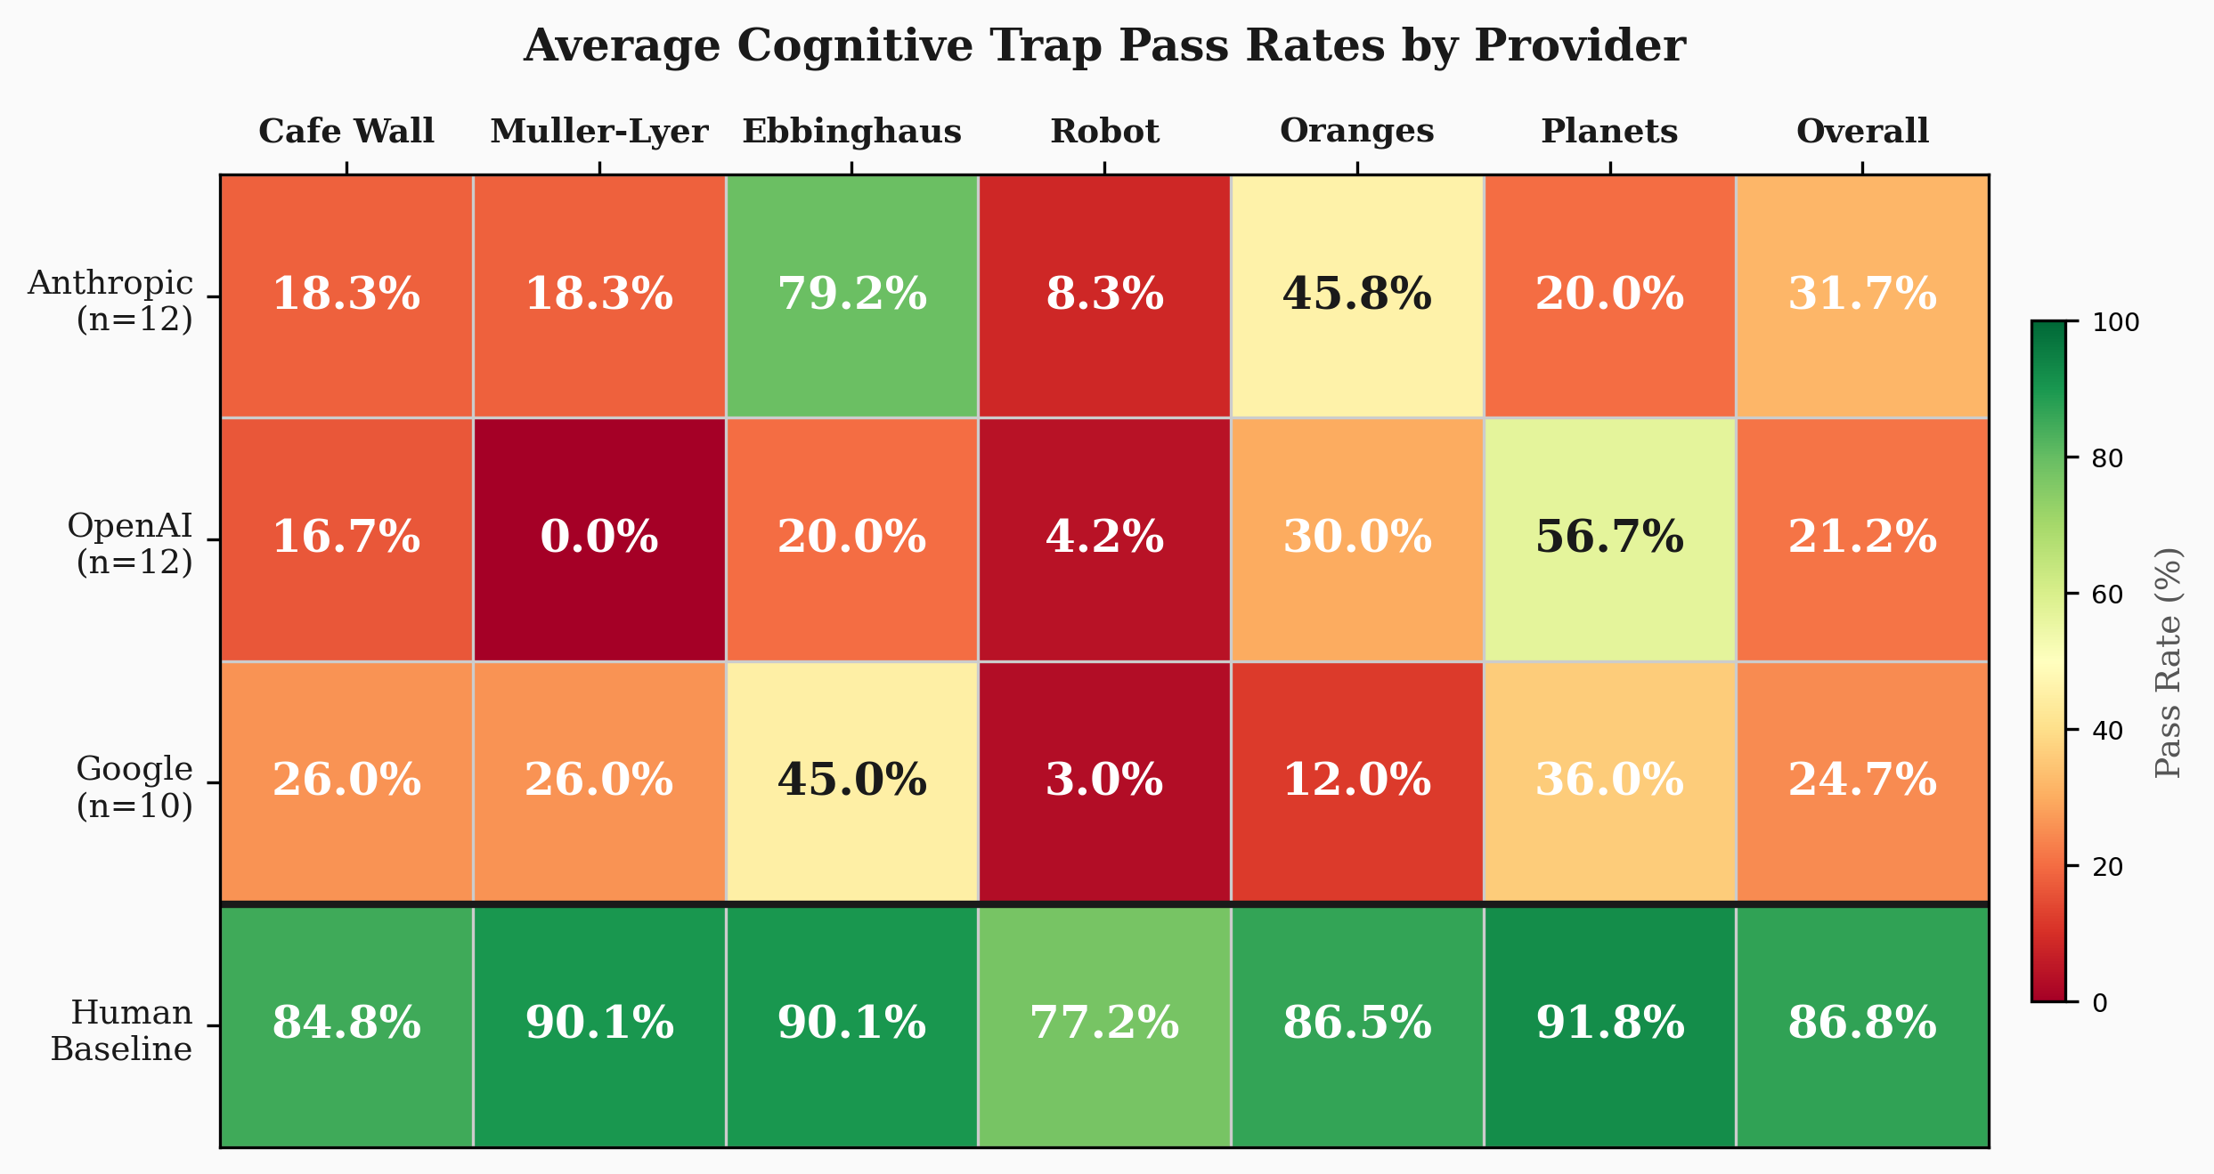
NOTE.——Heatmap compares performance across Anthropic (n = 12 models), OpenAI (n = 12), and Google (n = 10) for each trap and overall. Human baseline shown for reference. Provider-specific patterns reveal distinct capability profiles across model families.

The Moving Robot trap shows the most uniform cross-provider failure, with all three providers averaging below 9% accuracy. Spatiotemporal reasoning remains the most robust constraint category for detection purposes, producing near-universal failure regardless of provider, model generation, or thinking variant.

C.6 Summary and Implications for Detection
The 34-model validation reveals three findings that directly bear on the framework’s viability. First, model improvement on cognitive traps is neither monotonic nor predictable. Newer models frequently perform worse than their predecessors on the same traps, architectural optimizations aimed at general capabilities do not transfer to the specific visual-cognitive tasks that traps exploit, and the overall trend across nearly two years of model development is statistically indistinguishable from zero. Second, performance is extremely heterogeneous across models, providers, and traps: no single model excels on all traps, no single trap defeats all models, and no single provider consistently outperforms the others. This heterogeneity validates the multi-trap battery approach, because the probability that an agent passes enough traps to evade detection depends on the specific model encountering the specific battery, and the data show that every model fails on a distinct subset. Third, extended thinking provides inconsistent and insufficient improvement, with the best thinking model still 21.8 percentage points below human performance. Cognitive traps exploit constraints that cannot be fully resolved through additional reasoning time because the failures reflect how models process and integrate visual information at an architectural level rather than how much time they spend reasoning about it.
Researchers applying the framework should monitor trap effectiveness against current models and replace weakening traps using the four-step methodology. The data presented here provide the empirical foundation for this monitoring, and updated testing results will be maintained in the Cognitive Trap Repository.

WEB APPENDIX D: CAPTCHA ROC ANALYSIS

D.1 Overview
reCAPTCHA v3 assigns continuous risk scores from 0.0 (likely bot) to 1.0 (likely human) based on behavioral patterns accumulated across Google services. To evaluate CAPTCHA’s detection potential, we conducted a ROC-style analysis sweeping across all possible score thresholds to identify the operating point that maximizes the trade-off between sensitivity and false positive rate.

D.2 Optimal Threshold Analysis
The optimal CAPTCHA threshold maximizing Youden’s J (sensitivity + specificity - 1) is 0.90, which detects 93.9% of agents (494/526) but flags 12.4% of humans (125/1,007). Even at this optimized operating point, CAPTCHA’s false positive rate is three times higher than cognitive traps (12.4% vs. 4.1%) while detecting fewer agents (93.9% vs. 97.1%). The AUC (area under the ROC curve) is 0.898.
TABLE WA-D1: COMPARISON OF DETECTION METHODS AT OPTIMAL OPERATING POINTS
Method | Sensitivity | FPR | Specificity
Cognitive Traps (3+ failures) | 97.1% (511/526) | 4.1% | 95.9%
CAPTCHA (optimal threshold 0.90) | 93.9% (494/526) | 12.4% | 87.6%
CAPTCHA (standard threshold 0.5) | 4.6% (24/526) | 1.0% | 99.0%
Traditional methods (any) | 2.3% (12/526) | N/A | N/A
The standard 0.5 threshold used by most researchers detects only 4.6% of agents, rendering CAPTCHA ineffective as a detection tool against vision-enabled agents at conventional settings.

FIGURE WA-D1. DETECTION SENSITIVITY AND FALSE POSITIVE RATES ACROSS FOUR METHODS
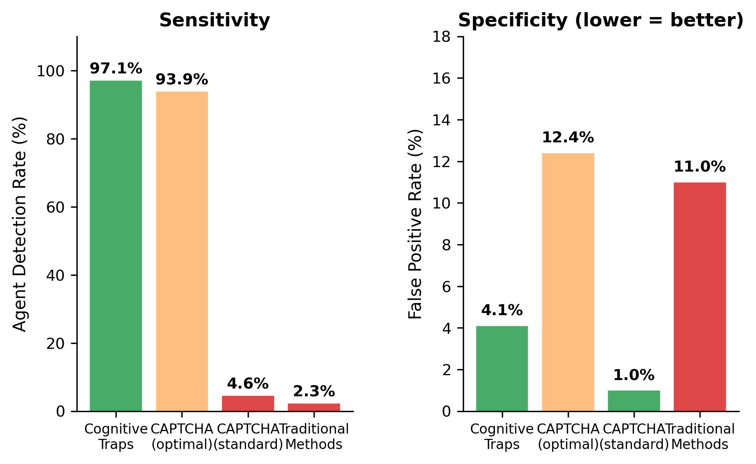
NOTE.——Cognitive traps achieve the best combination: highest sensitivity (97.1%) with low false positives (4.1%). CAPTCHA at the optimal 0.90 threshold approaches cognitive trap sensitivity (93.9%) but at three times the false positive rate (12.4%). CAPTCHA at the standard 0.5 threshold and traditional methods both detect fewer than 5% of agents.

D.3 Threshold Sweep
Table WA-D2 presents detection performance across a range of CAPTCHA thresholds, revealing the sharp transition in sensitivity between 0.80 and 0.90.
TABLE WA-D2: CAPTCHA DETECTION PERFORMANCE BY THRESHOLD
Threshold | Agents Detected | Humans Flagged | Sensitivity | FPR
< 0.50 | 24/526 | 10/1007 | 4.6% | 1.0%
< 0.60 | 64/526 | 17/1007 | 12.2% | 1.7%
< 0.70 | 97/526 | 40/1007 | 18.4% | 4.0%
< 0.80 | 97/526 | 40/1007 | 18.4% | 4.0%
< 0.90 | 494/526 | 125/1007 | 93.9% | 12.4%
< 0.95 | 494/526 | 125/1007 | 93.9% | 12.4%
The jump at the 0.90 threshold (from 18.4% to 93.9% sensitivity) occurs because 397 agents (75.5%) cluster in the 0.80-0.89 score range. Below 0.80, only a trickle of agents are captured (mostly Perplexity agents with lower scores). Above 0.90, nearly all agents fall below the threshold, but so do 12.4% of humans.

D.4 Score Distributions
The main problem with CAPTCHA as a detection tool is the overlap in score distributions between agents and humans in the 0.80-0.90 range. See below:
- Agent score distribution: - Below 0.50: 4.6% (24/526) - 0.50-0.79: 13.9% (73/526) - 0.80-0.89: 75.5% (397/526) - 0.90-1.00: 6.1% (32/526)
- Human score distribution: - Below 0.50: 1.0% (10/1007) - 0.50-0.79: 3.0% (30/1007) - 0.80-0.89: 8.4% (85/1007) - 0.90-1.00: 87.6% (882/1007)
The distributions separate cleanly below 0.80 and above 0.90, but the 0.80-0.89 zone contains 75.5% of agents and 8.4% of humans. Thus, any threshold set in this zone captures most agents but also flags a substantial proportion of humans.

D.5 Platform Heterogeneity in CAPTCHA Scores
TABLE WA-D3: CAPTCHA SCORES BY AGENT PLATFORM
Platform | Mean | SD | Below 0.5 | Below 0.9
Google Mariner | 0.9000 | 0.0000 | 0 (0.0%) | 134 (100.0%)
Perplexity Comet | 0.6901 | 0.2115 | 20 (15.3%) | 125 (95.4%)
ChatGPT Agent | 0.8698 | 0.0835 | 0 (0.0%) | 126 (97.7%)
Claude/Cursor | 0.8689 | 0.1285 | 4 (3.0%) | 109 (82.6%)
Google Mariner scored exactly 0.90 on every single trial (N = 134), suggesting the Mariner framework produces a deterministic CAPTCHA interaction pattern. Perplexity showed the most variance (SD = 0.2115) and the highest proportion below the standard threshold (15.3%). ChatGPT and Claude produced similar mean scores (approximately 0.87) with moderate variance.

D.6 Interpretation and Caveats
CAPTCHA’s moderate AUC (0.898) indicates it carries some signal about agent status, but its operating characteristics are poorly suited for practical detection. At the standard 0.5 threshold, it catches almost no agents. At the optimal 0.90 threshold, it catches most agents but flags three times more humans than cognitive traps.
We note that several caveats apply to this analysis. First, the ROC analysis uses the same deployment data to both select the threshold and estimate performance, which may overestimate generalization performance. Second, reCAPTCHA v3 scores depend on the respondent’s accumulated Google service history, which varies across populations and may produce different distributions in other samples. Third, Google periodically updates the reCAPTCHA algorithm, meaning the specific score distributions observed here may not replicate in future studies.

WEB APPENDIX E: DIAGNOSTICITY SIMULATIONS

E.1 Overview and Motivation
Researchers implementing cognitive traps face a practical question: how many traps are needed, and which ones? Adding more traps increases detection sensitivity but also increases survey length and participant burden. This appendix presents exhaustive simulations across all possible trap combinations and failure thresholds, using the deployment data (526 agents, 1,007 humans) to characterize the sensitivity-specificity trade-off surface.
These simulations also address an interesting question that was raised by the review team, which we truly appreciate: whether researchers would be better served by deploying fewer traps from the same constraint category with multiple trials (e.g., three illusion-based traps) versus deploying traps from diverse constraint categories (e.g., one illusion, one spatiotemporal, one binding trap).

E.2 Simulation Methodology
We computed sensitivity (agent detection rate), false positive rate (human flagging rate), and Youden’s J index (sensitivity + specificity - 1) for every possible configuration: all combinations of 2, 3, 4, 5, and 6 traps (from the pool of 6 validated traps) crossed with all possible failure thresholds (from 1+ to n/n, where n is the number of traps in the configuration). This produced 57 unique configurations (C(6,2) x 2 + C(6,3) x 3 + C(6,4) x 4 + C(6,5) x 5 + C(6,6) x 6 threshold levels). For each configuration, we applied the threshold to both the agent and human score vectors to compute the performance metrics.

E.3 Key Findings

Finding 1: Researchers Do Not Need All 6 Traps
The best overall configuration by Youden’s J (0.936) uses five traps (dropping Colliding Oranges) with a 3+ failure threshold: 96.2% sensitivity, 2.6% false positive rate. Our deployed 6-trap battery at the 3+ threshold (J=0.931) performs only marginally lower. Dropping Colliding Oranges improves Youden’s J because this trap has the lowest agent failure rate (50.6%) while producing a meaningful human failure rate (11.3%), so removing it slightly improves the specificity-sensitivity balance.

Finding 2: As Few As 2-3 Traps Achieve Strong Detection
Two traps (Muller-Lyer and Moving Robot) with a both-must-fail threshold achieve 93.7% sensitivity with only 2.6% false positive rate (J=0.911). Three traps (Muller-Lyer, Moving Robot, and Surrounded Planets) with a two-failure threshold achieve 96.8% sensitivity with 4.0% false positives (J=0.928). Both configurations substantially outperform traditional methods (2.3%) and CAPTCHA at any threshold.

Finding 3: The Moving Robot Is the Most Valuable Single Trap
With 99.6% agent failure rate, the Moving Robot appears in virtually every optimal combination. It exploits spatiotemporal reasoning, the constraint showing the most uniform failure across all platforms (99.2-100.0%). Muller-Lyer (94.1% agent failure, 92.8% human pass rate) is the second most valuable due to its combination of high agent failure with high human pass.

Finding 4: Constraint Diversity Helps Modestly
Within 3-trap batteries, Youden’s J improves from 0.912 (all traps from one constraint category) to 0.928 (traps from three constraint categories). The improvement is real but modest (1.6 percentage points in J). The primary driver of detection performance is choosing traps with high individual discrimination regardless of constraint category. This finding suggests researchers can prioritize their highest-performing available traps without strict adherence to constraint diversity requirements.

Finding 5: Same-Constraint Traps Work as Multiple Trials
This addresses the question about whether fewer constraints with multiple trials could substitute for diverse constraints. Three illusion-based traps (Cafe Wall, Muller-Lyer, Ebbinghaus) at a 2+/3 threshold achieve 94.5% sensitivity with 3.3% false positive rate (J=0.912). Three diverse traps (Muller-Lyer, Moving Robot, Surrounded Planets) at 2+/3 achieve 96.8% sensitivity with 4.0% false positives (J=0.928). Both configurations are strong, and the diverse configuration’s advantage (1.6 J points) is modest. Researchers who prefer shorter batteries from a single constraint category can do so with only moderate loss in detection performance.

E.4 Minimum Viable Battery Configurations
Table WA-E1 presents the optimal configuration for each battery size (number of traps).
TABLE WA-E1: OPTIMAL CONFIGURATION BY BATTERY SIZE
# Traps | Best Configuration | Threshold | Sensitivity | FPR | Youden’s J
2 | Muller-Lyer + Moving Robot | 2+/2 | 93.7% | 2.6% | 0.911
3 | Muller-Lyer + Moving Robot + Planets | 2+/3 | 96.8% | 4.0% | 0.928
4 | Muller-Lyer + Ebb + Moving Robot + Planets | 2+/4 | 97.7% | 5.0% | 0.928
5 | CW + ML + Ebb + Robot + Planets | 3+/5 | 96.2% | 2.6% | 0.936
6 | All six traps | 3+/6 | 97.1% | 4.1% | 0.931

The optimal 5-trap configuration (J=0.936) slightly outperforms the full 6-trap deployment (J=0.931), demonstrating that adding the weakest-performing trap (Colliding Oranges) marginally reduces overall performance by introducing false positives without proportional sensitivity gains.

E.5 Practical Recommendations by Research Priority
TABLE WA-E2: RECOMMENDED CONFIGURATIONS BY RESEARCH CONTEXT
Research Priority | Configuration | Sensitivity | FPR
Maximum detection, FPR <= 5% | 4 traps (ML+Ebb+Robot+Planets), thresh 2+ | 97.7% | 5.0%
Maximum detection, FPR <= 2% | 4 traps (CW+ML+Robot+Planets), thresh 3+ | 94.5% | 2.0%
Minimum survey burden, detection >= 90% | 2 traps (ML+Robot), thresh 2+ | 93.7% | 2.6%
Balanced (as deployed in this study) | 6 traps (all), thresh 3+ | 97.1% | 4.1%
Optimal by Youden’s J | 5 traps (drop Oranges), thresh 3+ | 96.2% | 2.6%
For most research contexts, we recommend three to four traps from different constraint categories with a majority-failure threshold. This achieves detection rates above 95% with false positive rates below 5%, representing a substantial improvement over both traditional methods and CAPTCHA. Researchers with severe survey length constraints can use the two-trap minimum viable battery (Muller-Lyer and Moving Robot, both must fail) and still achieve 93.7% detection.

E.6 Constraint Diversity Analysis
TABLE WA-E3: CONSTRAINT DIVERSITY WITHIN 3-TRAP BATTERIES
Constraint Diversity | Best Configuration | J | Sensitivity | FPR
1 category | CW + ML + Ebb (all overfitting) | 0.912 | 94.5% | 3.3%
2 categories | ML + Ebb + Robot (2 types) | 0.920 | 97.3% | 5.3%
3 categories | ML + Robot + Planets (3 types) | 0.928 | 96.8% | 4.0%
Diversity helps, but choosing high-discrimination traps matters more than constraint diversity per se. The improvement from one to three constraint categories (J = 0.912 to 0.928) is real but modest. Researchers should prioritize individual trap quality over adherence to diversity requirements.

WEB APPENDIX F: CHOICE DEFERRAL EXTENDED RESULTS

F.1 Three-Group Analysis
The main text reports choice deferral results for three groups: humans who passed cognitive traps (n = 966), “humans” who failed cognitive traps (n = 41), and AI agents (n = 526). This appendix provides complete breakdowns.

F.1.1 Deferral Rates by Group and Condition
TABLE WA-F1: CHOICE DEFERRAL BY GROUP AND CONDITION
Outcome | Passed Humans |  | Failed Humans |  | AI Agents
 | Dominated | Conflict | Dominated | Conflict | Dominated | Conflict
Chose Laptop A | 94.0% | 44.0% | 89.5% | 54.5% | 100.0% | 60.1%
Chose Laptop B | 0.8% | 32.0% | 5.3% | 31.8% | 0.0% | 39.2%
Deferred | 5.2% | 24.0% | 5.3% | 13.6% | 0.0% | 0.7%
N | 482 | 484 | 19 | 22 | 258 | 268
Chi-sq | 66.83 |  | 0.139 |  | 0.465
p | < .0001 |  | .709 |  | .496

The choice deferral effect replicates cleanly among passed-trap humans: 5.2% deferral under domination versus 24.0% under conflict (χ²(1) = 66.83, p < .001), consistent with Dhar’s (1997) theoretical prediction. Among agents, deferral is near zero regardless of condition (0.0% vs. 0.7%, p = .496), showing that machines do not experience the subjective uncertainty that drives deferral.
The 41 failed-trap “humans” show an intermediate pattern (5.3% vs. 13.6%, p = .709). The non-significant condition effect likely reflects low statistical power (n = 41). The 13.6% conflict deferral rate falls between passed humans (24.0%) and agents (0.7%), though the comparison to passed humans is not significant (χ²(1) = 0.74, p = .390).

F.1.2 Decision Times by Group and Condition
TABLE WA-F2: DECISION TIMES (SECONDS) BY GROUP AND CONDITION
Statistic | Passed Humans |  | Failed Humans |  | AI Agents
 | Dominated | Conflict | Dominated | Conflict | Dominated | Conflict
Mean | 53.3 | 64.6 | 72.4 | 97.0 | 36.3 | 36.3
SD | 69.9 | 116.8 | 48.4 | 147.6 | 16.7 | 17.0
Median | 34.2 | 41.6 | 65.9 | 43.3 | 35.7 | 34.7
Condition effect | t = 1.83, p = .067 |  | t = 0.69, p = .492 |  | t = -0.02, p = .984

Decision times provide evidence that failed-trap “humans” are genuine humans. In the conflict condition, failed-trap participants averaged 97.0 seconds, compared to 64.6 seconds for passed-trap humans (t = 1.26, p = .210, not significantly different) and 36.3 seconds for agents (t = 6.35, p < .001, clearly different). Their timing profile is human-like: substantial variability (SD = 147.6), sensitivity to conflict (higher mean in conflict vs. dominated, though not significant), and clearly slower than agents.
Agents showed no condition sensitivity in decision times (M = 36.3 seconds in both conditions, t = -0.02, p = .984), consistent with the interpretation that models resolve choice tasks through deterministic processing that does not vary with decision difficulty.

F.1.3 Traditional Check and CAPTCHA Performance Across Groups
TABLE WA-F3: TRADITIONAL CHECK PERFORMANCE BY GROUP
Check | Passed Humans | Failed “Humans” | Agents
IMC Pass Rate | 99.6% | 97.6% | 99.8%
Obvious Answer Pass Rate | 99.3% | 92.7% | 99.8%
Memory Check Pass Rate | 90.7% | 82.9% | 99.2%
Straight-lining Pass Rate | 99.9% | 100.0% | 98.7%
CAPTCHA Mean Score | 0.972 | 0.971 | 0.833
CAPTCHA SD | 0.098 | 0.129 | 0.154
Failed-trap “humans” show traditional check performance that is statistically indistinguishable from passed-trap humans. Their CAPTCHA scores (M = 0.971) are virtually identical to passed humans (M = 0.972, t = 0.10, p = .923). Their IMC pass rates are lower (97.6% vs. 99.6%) but well within the range of normal human performance. In contrast, agents show a distinctive CAPTCHA profile (M = 0.833) and perfect or near-perfect traditional check performance (reflecting that traditional checks exploit human attention limitations, which agents do not share).
This convergence of evidence (human-like decision times, human-like CAPTCHA scores, human-like traditional check performance) provides the strongest available evidence that the 41 flagged participants are genuine humans with lower visual-cognitive performance.

F.2 Total Score Distribution Among Failed-Trap “Humans”
Score | N | % of Failed Group
0 | 2 | 4.9%
1 | 4 | 9.8%
2 | 13 | 31.7%
3 | 22 | 53.7%

Most flagged participants (22/41, 53.7%) scored exactly 3/6, meaning they just barely failed the 3+ threshold. Only 6/41 (14.6%) scored 0 or 1, which would be more concerning from a contamination perspective. The concentration at the threshold boundary is consistent with natural variation in visual-cognitive performance, as agents would be expected to show a more distributed score pattern.

F.3 Total Survey Completion Times
Group | Mean | Median | SD
Passed Humans | 538.6s | 367.0s | –
Failed “Humans” | 693.7s | 631.0s | –
Agents | 635.3s | 597.5s | –
Failed-trap “humans” took the longest overall (M = 693.7 seconds), exceeding both passed humans (538.6s) and agents (635.3s). This pattern is consistent with slower or more careful processing by participants who find the visual tasks genuinely challenging.

F.4 Platform Heterogeneity in Choice Patterns
Among agents who committed to a choice (excluding the 2 who deferred), platforms showed dramatically different choice patterns in the conflict condition.
TABLE WA-F4: AGENT CHOICE PATTERNS BY PLATFORM (CONFLICT CONDITION)
Platform | N | Chose A | Chose B | Defer | A:B Ratio | Decision Time
Mariner | 68 | 70.6% | 26.5% | 2.9% | 2.7:1 | 30.8s
Perplexity | 66 | 39.4% | 60.6% | 0.0% | 1:1.5 | 47.1s
ChatGPT | 70 | 95.7% | 4.3% | 0.0% | 22:1 | 20.7s
Claude | 64 | 31.2% | 68.8% | 0.0% | 1:2.2 | 48.3s
Overall agents | 268 | 60.1% | 39.2% | 0.7% | 1.5:1 | 36.3s
Overall chi-square for platform differences: χ²(3) = 75.69, p < .001.
ChatGPT exhibited extreme primacy bias, selecting the first-presented option (Laptop A) in 95.7% of conflict trials. Claude showed the opposite pattern (recency bias), selecting Laptop B in 68.8% of conflict trials. Perplexity and Mariner produced intermediate distributions with opposing tendencies.
These platform-specific heuristics have implications for consumer choice research. If AI agents contaminate survey samples, they would introduce systematic but heterogeneous biases: ChatGPT contamination would inflate first-option selection, Claude contamination would inflate last-option selection, and samples contaminated by a mix of agents would show patterns that wash out to resemble human behavior in aggregate while masking systematic distortions at the platform level.
Decision times also varied across platforms, with ChatGPT being the fastest (20.7s) and Claude/Perplexity being the slowest (47.1-48.3s). All platforms showed no condition sensitivity in decision times, showing that timing invariance to experimental manipulation is a general agent characteristic shared across all platforms tested.

F.5 Choice Patterns Among Passed-Trap Humans
Among passed-trap humans who committed to a choice in the conflict condition, 58.1% selected Laptop A and 41.9% selected Laptop B. This moderate preference may reflect the specific attribute values used in the stimuli or a mild primacy effect in the choice set presentation.
In the dominated condition, the dominant option was chosen by 98.9% of committed participants (Laptop A) versus 1.1% for the dominated option (Laptop B). This near-unanimous preference demonstrates that the domination manipulation was clearly effective, as expected when one option is strictly superior on the relevant attributes.

WEB APPENDIX G: PLATFORM REPLICATION STUDIES

G.1 Overview
To assess the generalizability of the Cognitive Trap Framework beyond Prolific, we conducted pre-registered replication studies on two additional platforms: Amazon Mechanical Turk and CloudResearch Connect. Both studies deployed the identical Qualtrics survey used in the Prolific main study, including all six cognitive traps, the choice deferral manipulation, traditional attention checks, and reCAPTCHA v3. The pre-registered primary analysis for both platforms specified the three-failure threshold (failing 3 or more of 6 traps) and a two-proportion z-test comparing flagging rates against the Prolific baseline of 4.1%.
CloudResearch Connect evolved from the former TurkPrime service that originally operated as a layer on top of MTurk. Although MTurk workers could historically access CloudResearch studies, the two platforms now maintain fully independent participant pools with distinct verification procedures, demographic compositions, and pricing structures. Including both platforms in the replication therefore provides genuinely independent tests of cognitive trap performance across different online research populations.

G.2 MTurk Replication

G.2.1 Method
We pre-registered the MTurk replication on AsPredicted (https://aspredicted.org/sz87tb.pdf) before collecting any data, specifying the three-failure threshold and two-proportion z-test against Prolific. We recruited participants from MTurk using standard HIT qualification requirements. Data were collected in February 2026.

G.2.2 Sample
The MTurk sample comprised 263 completed responses (58.6% male, 41.4% female; M_{age} = 35.3, SD = 8.7, range 23-70). The pre-registered target was 500 respondents. Although 500 workers accepted the HIT on MTurk, only 263 completed the Qualtrics survey. Many of the remaining workers submitted completion codes without actually opening the survey link, and others submitted random or shared codes. This pattern is consistent with documented code-sharing practices on MTurk forums where workers circulate completion codes to collect payment without performing the task, and itself constitutes evidence of the platform’s data quality problems. The gap between HIT acceptances and survey completions is not attributable to respondent unavailability but rather to fraudulent submissions. Despite this deviation from the pre-registered sample size, the observed effect (76.0% vs. 4.1%) far exceeds the detectable difference at any conventional power level for the primary analysis (two-proportion z-test comparing flagging rates against Prolific). Condition assignment was approximately balanced: 135 (51.3%) in the dominated condition and 128 (48.7%) in the conflict condition. No duplicate respondents were detected.

G.2.3 Primary Analysis: Cognitive Trap Flagging Rate
Cognitive traps flagged 200 of 263 MTurk respondents (76.0%) at the pre-registered three-failure threshold. This rate is dramatically higher than Prolific’s 4.1% (two-proportion z = 26.51, p < .001) and represents a near-inversion of the Prolific distribution, where 86.7% of participants scored 5 or 6. On MTurk, only 7.2% scored 5 or 6, and only 1.9% achieved a perfect score of 6/6 (compared to 59.9% on Prolific).
TABLE WA-G1: TOTAL SCORE DISTRIBUTION ON MTURK
Score | N | % | Cumulative %
6 | 5 | 1.9% | 100.0%
5 | 14 | 5.3% | 98.1%
4 | 44 | 16.7% | 92.8%
3 | 70 | 26.6% | 76.0% (threshold)
2 | 85 | 32.3% | 49.4%
1 | 42 | 16.0% | 17.1%
0 | 3 | 1.1% | 1.1%

The score distribution is left-shifted relative to Prolific, with the modal score at 2 (32.3% of respondents). Among the 200 flagged respondents, 65.0% scored below the threshold (0, 1, or 2), indicating that the majority did not narrowly miss passing but rather showed pervasive failure across multiple traps.

G.2.4 Individual Trap Pass Rates
All six traps showed substantially lower pass rates on MTurk compared to Prolific.
TABLE WA-G2: INDIVIDUAL TRAP PASS RATES: MTURK VS. PROLIFIC VS. AGENTS
Trap | MTurk | Prolific | Agents | MTurk-Prolific | MTurk-Agents
Modified Cafe Wall | 31.2% (82) | 88.4% (890) | 5.1% (27) - | 57.2 pp + | 26.0 pp
Modified Muller-Lyer | 71.1% (187) | 92.8% (934) | 5.9% (31) - | 21.7 pp + | 65.2 pp
Modified Ebbinghaus | 78.7% (207) | 95.6% (963) | 22.4% (118) - | 16.9 pp + | 56.3 pp
Moving Robot | 20.9% (55) | 77.9% (784) | 0.4% (2) - | 57.0 pp + | 20.5 pp
Colliding Oranges | 20.2% (53) | 88.7% (893) | 49.4% (260) - | 68.5 pp - | 29.3 pp
Surrounded Planets | 43.3% (114) | 96.5% (972) | 44.5% (234) - | 53.2 pp - | 1.1 pp
Average | 44.2% | 90.0% | 21.3% * | *-45.8 pp** * | *+22.9 pp**
NOTE. Agent N = 526. Agent pass rates represent pooled performance across four deployed agents (Google Mariner, Perplexity, ChatGPT, Claude).

The MTurk-Agent comparison in the final column provides a direct test of whether MTurk respondents behave like deployed agents. On four of six traps, MTurk respondents outperform agents, with the largest positive gap on Muller-Lyer (+65.2 pp). On two traps, however, MTurk respondents perform worse than agents: Colliding Oranges (-29.3 pp) and Surrounded Planets (-1.1 pp). This mixed pattern suggests that the MTurk sample is not composed exclusively of agent-mediated responses but rather reflects a heterogeneous mix of data quality threats, because purely agent-driven responses would produce a profile closer to the agent column. The MTurk average pass rate (44.2%) falls between the agent average (21.3%) and Prolific (90.0%), consistent with a mixture of respondent types whose behavioral profiles span the range from careless human responding (Kay 2025) to what may be sophisticated AI agent contamination.

G.2.5 Behavioral Profile
The behavioral indicators on MTurk tell a consistent story of widespread contamination.
Traditional attention checks. The IMC (“puppy name”) showed 84.4% pass rate on MTurk, compared to 99.5% on Prolific and 99.8% for agents. The obvious answer check (“How frequently do you have a fatal heart attack?”) showed only 55.9% pass rate on MTurk, compared to 99.0% on Prolific and 99.8% for agents, suggesting a substantial proportion of respondents who behave as neither careful humans nor competent AI agents would. The memory check showed 60.5% pass rate (vs. 90.4% on Prolific, 99.2% for agents), while straight-lining was comparable across platforms (96.2% vs. 99.9%).
reCAPTCHA v3 scores. MTurk respondents showed substantially lower CAPTCHA scores (M = 0.635, SD = 0.320) compared to both Prolific (M = 0.972, SD = 0.099) and CloudResearch Connect (M = 0.984, SD = 0.049). 34.9% of MTurk respondents (91/261) scored below the standard 0.5 threshold, compared to 1.0% on Prolific. CAPTCHA scores did not significantly differ between flagged and clean respondents on MTurk (0.618 vs. 0.687, t = -1.47, p = .146), suggesting that whatever is producing the poor trap performance on MTurk also produces low CAPTCHA scores but through different mechanisms than the cognitive traps measure.
Completion times. Flagged respondents showed significantly longer median completion times than clean respondents (493.5 seconds vs. 300.0 seconds, t = 4.34, p < .001), though the flagged group also showed extreme variance (SD = 7,820.8 seconds), with some respondents taking hours to complete a survey that typically takes 7 minutes.

G.2.6 Choice Deferral
The choice deferral effect did not replicate on MTurk. In the conflict condition, only 1.6% of respondents deferred (2/128), compared to 23.5% on Prolific (119/506). Deferral rates did not differ significantly by condition (χ²(1) = 0.56, p = .455). After removing flagged respondents, zero of the 63 remaining clean respondents deferred in either condition, although the small sample (n = 63) limits the statistical power of this comparison. The near-zero deferral rate across the full MTurk sample mirrors the agent deferral pattern observed in the main study (0.0% dominated, 0.7% conflict), consistent with AI-mediated responses that do not experience the subjective uncertainty driving human choice deferral.

G.2.7 Threshold Sensitivity
Table WA-G3 presents flagging rates under alternative thresholds for the MTurk sample.
TABLE WA-G3: THRESHOLD SENSITIVITY ON MTURK (N = 263)
Threshold | Flagged | Rate
1+ failures | 258 | 98.1%
2+ failures | 244 | 92.8%
3+ failures | 200 | 76.0% (pre-registered)
4+ failures | 130 | 49.4%
5+ failures | 45 | 17.1%
6 failures | 3 | 1.1%
Even the most lenient threshold (1+ failures) flags 98.1% of MTurk respondents, and the most stringent threshold (6 failures, meaning zero correct) captures 1.1% of the sample (3 respondents). The near-universal failure at the 2+ threshold (92.8%) suggests that the contamination on MTurk is not limited to marginal cases near the three-failure boundary, with most respondents fail multiple traps.

G.3 CloudResearch Connect Replication

G.3.1 Method
We pre-registered the CloudResearch Connect replication on AsPredicted (https://aspredicted.org/ib99fx.pdf) before collecting any data, specifying the same three-failure threshold and two-proportion z-test against Prolific. Participants were recruited from CloudResearch Connect. Data were collected in February 2026.

G.3.2 Sample
The CloudResearch Connect sample comprised 506 completed responses (49.6% male, 48.2% female, 1.0% non-binary, 1.2% prefer not to say; M_{age} = 41.2, SD = 13.6, range 18-95). This demographic composition closely mirrors the Prolific sample (52.7% female, M_{age} = 44.79). Condition assignment was balanced: 254 (50.2%) in the dominated condition and 252 (49.8%) in the conflict condition. No duplicate respondents were detected.

G.3.3 Primary Analysis: Cognitive Trap Flagging Rate
Cognitive traps flagged 9 of 506 CloudResearch Connect respondents (1.8%) at the pre-registered three-failure threshold. This rate is significantly lower than Prolific’s 4.1% (two-proportion z = -2.35, p = .019). The vast majority of respondents scored 6/6 (76.5%) or 5/6 (17.8%), with only 4 respondents scoring below 3 and 5 scoring exactly 3. The mean total score was 5.68 (SD = 0.67), compared to 5.40 on Prolific and 2.65 on MTurk.
TABLE WA-G4: TOTAL SCORE DISTRIBUTION ON CLOUDRESEARCH CONNECT
Score | N | % | Cumulative %
6 | 387 | 76.5% | 100.0%
5 | 90 | 17.8% | 23.5%
4 | 20 | 4.0% | 5.7%
3 | 5 | 1.0% | 1.8% (threshold)
2 | 4 | 0.8% | 0.8%
1 | 0 | 0.0% | 0.0%
0 | 0 | 0.0% | 0.0%

G.3.4 Individual Trap Pass Rates
All six traps showed pass rates at or above Prolific levels.
TABLE WA-G5: INDIVIDUAL TRAP PASS RATES: CLOUDRESEARCH CONNECT VS. PROLIFIC VS. AGENTS
Trap | Connect | Prolific | Agents | Connect-Prolific | Connect-Agents
Modified Cafe Wall | 96.0% (486) | 88.4% (890) | 5.1% (27) + | 7.6 pp + | 90.9 pp
Modified Muller-Lyer | 97.4% (493) | 92.8% (934) | 5.9% (31) + | 4.6 pp + | 91.5 pp
Modified Ebbinghaus | 97.8% (495) | 95.6% (963) | 22.4% (118) + | 2.2 pp + | 75.4 pp
Moving Robot | 85.0% (430) | 77.9% (784) | 0.4% (2) + | 7.1 pp + | 84.6 pp
Colliding Oranges | 93.7% (474) | 88.7% (893) | 49.4% (260) + | 5.0 pp + | 44.2 pp
Surrounded Planets | 98.2% (497) | 96.5% (972) | 44.5% (234) + | 1.7 pp + | 53.7 pp
Average | 94.7% | 90.0% | 21.3% * | *+4.7 pp** * | *+73.4 pp**
NOTE. Agent N = 526. Agent pass rates represent pooled performance across four deployed agents.

CloudResearch Connect respondents performed slightly better than Prolific respondents on every trap, averaging 94.7% versus 90.0%. The Connect-Agents discrimination column shows that all six traps maintain large positive gaps (ranging from +44.2 pp on Colliding Oranges to +91.5 pp on Muller-Lyer), confirming that the traps would effectively separate genuine human respondents from agents on this platform. The average discrimination of +73.4 pp exceeds even Prolific’s +68.7 pp, because CloudResearch respondents outperform Prolific on every trap while agents perform identically across platforms.

G.3.5 Behavioral Profile
The 9 flagged CloudResearch respondents showed a profile consistent with genuine humans experiencing difficulty rather than AI contamination. Their CAPTCHA scores (M = 0.978) were virtually identical to clean respondents (M = 0.984, t = -0.39, p = .703), with zero respondents scoring below 0.5 in either group. All 9 flagged respondents passed the obvious attention check, though they showed lower memory check pass rates (66.7% vs. 91.8%) and slightly elevated straight-lining (88.9% vs. 99.4%). Their completion times were marginally longer (M = 506.9 seconds vs. 386.5 seconds, t = 2.09, p = .069), consistent with participants who found the visual tasks genuinely difficult. Five of 9 (55.6%) scored exactly 3, narrowly crossing the failure threshold, while 4 scored 2.

G.3.6 Choice Deferral
The choice deferral effect replicated on CloudResearch Connect. In the full sample, 26.6% deferred in the conflict condition compared to 6.7% in the dominated condition (χ²(1) = 34.74, p < .001), a 4.0-fold increase closely matching Prolific’s 4.6-fold increase (24.0% vs. 5.2%). After removing the 9 flagged respondents, deferral rates were virtually unchanged (26.8% vs. 6.5%, χ²(1) = 35.44, p < .001), confirming that the flagged respondents had negligible impact on the substantive findings. This replication provides independent evidence that (a) cognitive traps do not disrupt normal survey responding, because the well-established choice deferral effect emerges with expected effect sizes, and (b) the CloudResearch Connect sample consists overwhelmingly of genuine human respondents.

G.3.7 Threshold Sensitivity
Table WA-G6 presents flagging rates under alternative thresholds for the CloudResearch Connect sample.
TABLE WA-G6: THRESHOLD SENSITIVITY ON CLOUDRESEARCH CONNECT (N = 506)
Threshold | Flagged | Rate
1+ failures | 119 | 23.5%
2+ failures | 29 | 5.7%
3+ failures | 9 | 1.8% (pre-registered)
4+ failures | 4 | 0.8%
5+ failures | 0 | 0.0%
6 failures | 0 | 0.0%

The CloudResearch distribution mirrors Prolific’s high-quality profile. At the pre-registered three-failure threshold, only 1.8% of respondents are flagged. Even at the more lenient 2+ threshold, the flagging rate remains low at 5.7%, and the 1+ threshold (flagging anyone who failed at least one trap) captures 23.5% of the sample, primarily reflecting the 90 respondents who scored 5/6 (failing only one trap), consistent with normal variation in visual-cognitive ability rather than AI contamination. At the more stringent end, only 4 respondents (0.8%) failed 4 or more traps and none failed 5 or more.

G.4 Cross-Platform Comparison

G.4.1 Flagging Rates

TABLE WA-G7: COGNITIVE TRAP FLAGGING RATES ACROSS ALL FOUR DATASETS
Dataset | N | Flagged | Rate | z vs. Prolific
Prolific | 1,007 | 41 | 4.1% | (reference)
CloudResearch Connect | 506 | 9 | 1.8% | z = -2.35, p = .019
Amazon MTurk | 263 | 200 | 76.0% | z = 26.51, p < .001
Agents | 526 | 511 | 97.1% | z = -36.04, p < .001
NOTE. All pairwise comparisons significant. MTurk vs. CloudResearch: z = 21.96, p < .001; MTurk vs. Agents: z = -9.36, p < .001; CloudResearch vs. Agents: z = -30.63, p < .001.

FIGURE WA-G1. CROSS-PLATFORM COMPARISON ACROSS FOUR INDICATORS
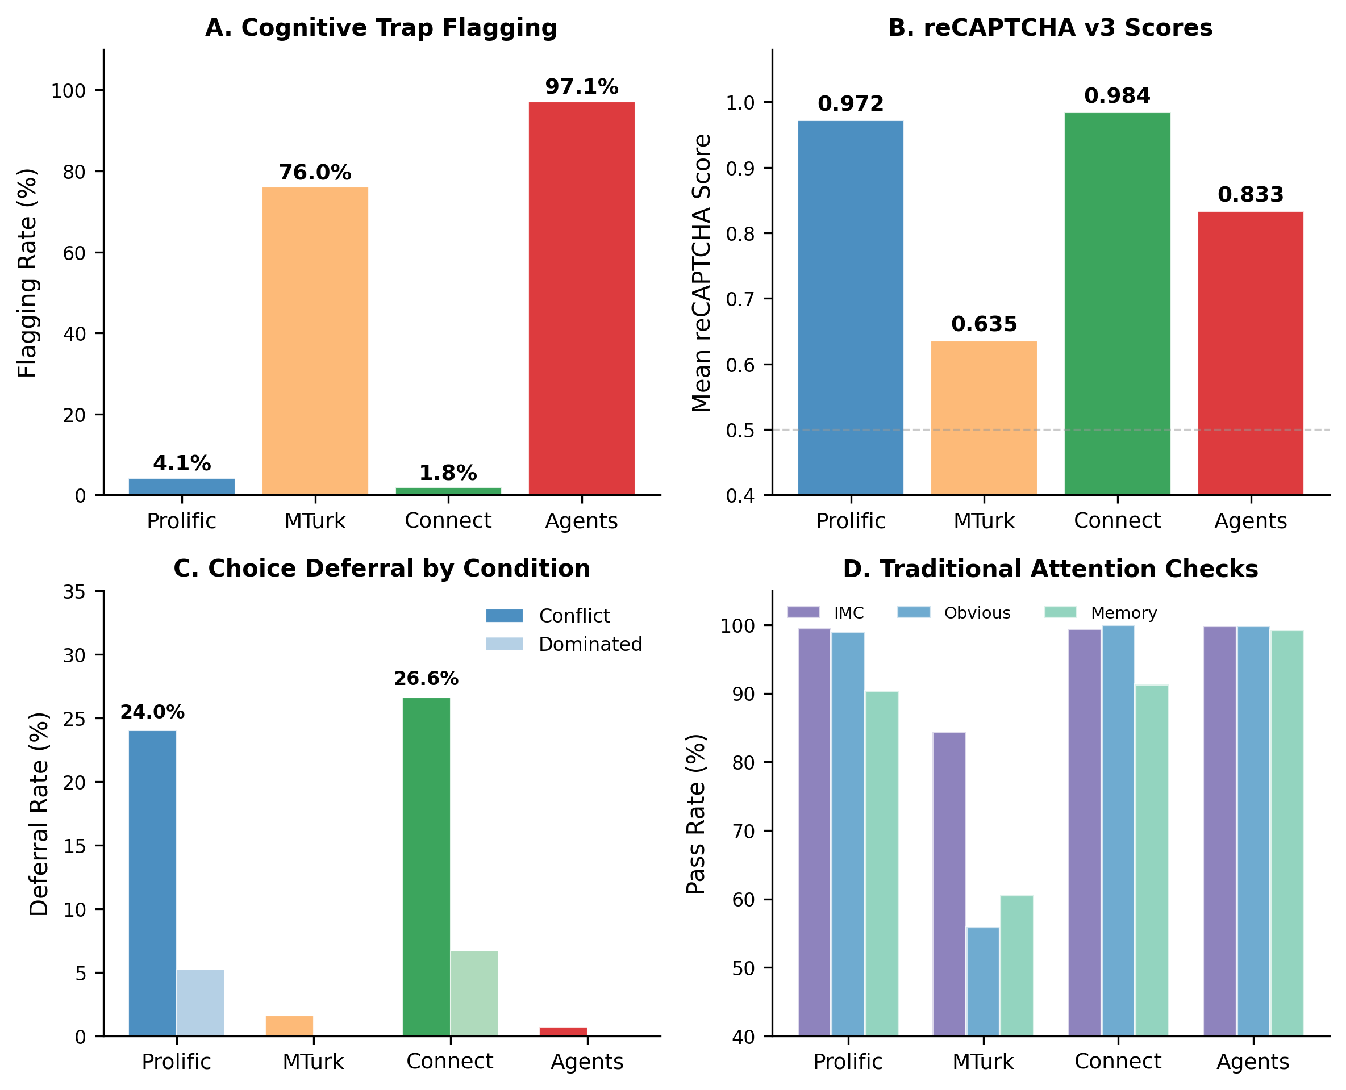
NOTE.——(A) Cognitive trap flagging rates range from 1.8% (Connect) to 97.1% (Agents). (B) reCAPTCHA v3 scores: MTurk (0.635) falls well below the 0.5 standard threshold, while other samples score above 0.83. (C) Choice deferral in the conflict condition replicates on Prolific (24.0%) and Connect (26.6%) but is near zero on MTurk (1.6%) and among Agents (0.7%). (D) Traditional attention checks show near-ceiling pass rates on all platforms except MTurk.

The three-platform comparison reveals extreme variation in suspected AI contamination across recruitment platforms. CloudResearch Connect produced the lowest flagging rate (1.8%), significantly lower than Prolific, suggesting that its participant verification procedures effectively screen out AI-mediated responses. MTurk showed catastrophic contamination: more than three-quarters of respondents failed the pre-registered cognitive trap threshold. This 42-fold gap between MTurk and CloudResearch Connect (76.0% vs. 1.8%) demonstrates that platform choice is a first-order determinant of data quality in online behavioral research.

G.4.2 Traditional Attention Check Comparison
TABLE WA-G8: TRADITIONAL ATTENTION CHECK PASS RATES BY DATASET
Check | Prolific | MTurk | Connect | Agents
IMC (puppy name) | 99.5% | 84.4% | 99.4% | 99.8%
Obvious (heart attack) | 99.0% | 55.9% | 100.0% | 99.8%
Memory (planet color) | 90.4% | 60.5% | 91.3% | 99.2%
Straight-lining (PANAS) | 99.9% | 96.2% | 99.2% | 98.7%
NOTE. Agent N = 526.

The Agent column reveals a paradox: agents outperform MTurk respondents on every traditional attention check. The IMC gap is particularly large, with agents at 99.8% versus MTurk at 84.4%. The obvious check shows the starkest contrast: agents pass at 99.8% while MTurk achieves only 55.9%, meaning MTurk respondents perform worse than AI agents on a question designed to catch inattentive humans. This pattern is consistent with a heterogeneous mix of data quality threats on MTurk, because a purely agent-driven sample would show near-perfect traditional check performance alongside near-universal cognitive trap failure.
The method independence analysis (Section G.4.5) sharpens this picture: 44.5% of the 200 MTurk respondents flagged by cognitive traps passed all traditional attention checks, a behavioral profile consistent with vision-enabled agents that handle text-based screening effortlessly while failing visual-cognitive tasks. The remaining 55.5% failed both cognitive traps and traditional checks, a profile more consistent with the careless and invalid responding that Kay (2025) documented on MTurk, where 96% of semantic antonym pairs were positively correlated even among “high-reputation” workers. The MTurk sample thus appears to reflect at least three distinct respondent populations: a small minority of attentive humans (approximately 24% who passed cognitive traps), respondents whose profiles resemble sophisticated AI agents (passing traditional checks but failing cognitive traps), and respondents exhibiting careless or automated responding patterns (failing both). Whether the latter group represents simple bots, click farm workers, or deeply inattentive humans cannot be determined from our data alone, but the population-level pattern is consistent with the severe data quality degradation that multiple independent studies have now documented on the platform (Douglas et al. 2023; Kay 2025; Webb and Tangney 2022).

G.4.3 Choice Deferral Comparison
TABLE WA-G9: CHOICE DEFERRAL IN CONFLICT CONDITION BY DATASET
Dataset | N (conflict) | Deferral Rate | χ² (condition effect)
Prolific (full) | 506 | 23.5% | χ² = 67.13, p < .001
Prolific (clean only) | 484 | 24.0% | χ² = 66.83, p < .001
CloudResearch (full) | 252 | 26.6% | χ² = 34.74, p < .001
CloudResearch (clean) | 250 | 26.8% | χ² = 35.44, p < .001
MTurk (full) | 128 | 1.6% | χ² = 0.56, p = .455
MTurk (clean only) | 35 | 0.0% | N/A (zero cells)
Agents | 268 | 0.7% | χ² = 0.46, p = .495

The choice deferral results provide a second independent validation signal. Prolific and CloudResearch Connect produce nearly identical deferral rates (23.5% and 26.6%) that replicate the classical finding from Dhar (1997). MTurk produces near-zero deferral, mirroring the agent pattern from the main study (0.7% in conflict condition). This convergence suggests that a substantial proportion of MTurk respondents do not experience the subjective uncertainty that drives human choice deferral, a pattern consistent with either AI-mediated responding or the extreme inattentiveness documented on the platform (Kay 2025).

G.4.4 reCAPTCHA Score Comparison
Dataset | Mean | SD | Median | Below 0.5
Prolific | 0.972 | 0.099 | 1.000 | 1.0%
CloudResearch Connect | 0.984 | 0.049 | 1.000 | 0.0%
Amazon MTurk | 0.635 | 0.320 | 0.800 | 34.9%
Agents | 0.833 | 0.154 | 0.900 | 4.6%

MTurk CAPTCHA scores (M = 0.635) are substantially lower than both Prolific (0.972) and CloudResearch (0.984), and lower even than the agent distribution (M = 0.833). Over a third of MTurk respondents score below the standard 0.5 threshold (34.9%), compared to near-zero on Prolific (1.0%) and CloudResearch (0.0%), and 4.6% of agents. The fact that MTurk respondents produce lower CAPTCHA scores than deployed AI agents is consistent with the heterogeneous mix interpretation: LLM-based agents generate browsing behavior that reCAPTCHA tends to score favorably (agent median 0.900), whereas simpler automated systems or highly careless respondents produce the anomalous interaction patterns that reCAPTCHA was designed to detect. The MTurk distribution, which likely blends multiple respondent types, falls below the agent average because it includes a substantial component that neither modern LLM agents nor attentive humans would produce.

G.4.5 Method Independence on New Platforms
On MTurk, cognitive trap flagging and traditional check failure are statistically independent (χ²(1) = 0.28, p = .598, phi = .033). Of the 200 respondents flagged by cognitive traps, 44.5% (89/200) passed all traditional attention checks. This independence on a contaminated platform strengthens the argument that traditional methods fail to detect the type of threat cognitive traps capture. On CloudResearch Connect, the two methods show a modest association (χ²(1) = 8.39, p = .004, phi = .129), with 5 of 9 flagged respondents (55.6%) passing all traditional checks. The stronger association on CloudResearch likely reflects the very low base rates, where the few flagged respondents are genuine humans whose visual-cognitive difficulties correlate with attention check difficulty.

WEB APPENDIX H: COMPUTATIONAL COST AND EFFICIENCY ANALYSIS

H.1 Overview
The main article reports that neither computational cost nor inference time predicts accuracy across models. This appendix provides the full empirical foundation for that claim by analyzing cost, duration, and token consumption data from all 2,040 trials (34 models x 6 traps x 10 trials). Every trial records the model’s API cost in USD, response duration in seconds, and input/output token counts. All data and analysis code are available at https://osf.io/f2jhx/overview?view_only=ab7ece0d719642fe9e62b00afade9b11.

H.2 Model-Level Cost-Accuracy Analysis
Across 34 models, accuracy shows no significant correlation with average cost per trial (r = .23, p = .18; Spearman rho = .17, p = .33), average response duration (r = .14, p = .417), or average output token count (r = .15, p = .396). Models that cost more, take longer, or produce more tokens do not achieve higher accuracy on cognitive traps.
The most cost-efficient model is also the most accurate: Gemini 3 Flash with extended thinking achieves 65.0% accuracy at $0.0002 per trial, while the most expensive model, Claude Opus 4.6 with extended thinking, achieves 40.0% at $0.0476 per trial (264 times the cost for 25 fewer percentage points). Claude Haiku 3.0, the oldest and cheapest Anthropic model in the sample ($0.0003 per trial), outperforms Claude Opus 4.5 ($0.0199 per trial), a model released 20 months later at 66 times the cost, by a margin of 40.0% to 16.7%. These paradoxes illustrate that cognitive trap accuracy reflects architectural properties, not computational investment.
The generational trajectory reinforces this conclusion. Grouping models into three cohorts by release date (early: through month 9, 4 models; middle: months 10-19, 12 models; late: months 20+, 18 models) reveals a non-monotonic V-shaped pattern: mean accuracy falls from 30.4% in the earliest cohort to 15.7% in the middle cohort before recovering to 31.8% in the latest cohort. Model improvement is neither linear nor guaranteed, because each new architecture reconfigures which constraints it resolves and which it introduces. The middle-generation dip coincides with models that gained general reasoning capability at the expense of visual processing fidelity, while later models partially recovered through architectural innovations in multimodal integration. This non-monotonicity is precisely what the architectural constraints framework predicts: because each trap targets a specific processing limitation, progress on one dimension can coincide with regression on another, and no single release cycle is likely to resolve all constraint types simultaneously.
Providers also differ substantially in how variable their models are across traps. Averaging across each provider’s models, the mean per-model cross-trap standard deviation is 43.5 percentage points for Anthropic, 32.0 for OpenAI, and 29.1 for Google. Anthropic’s models are the most “spiky,” performing well on some traps and failing completely on others, while Google’s models show the most uniform (though generally low) performance across constraint types. This provider-specific variability means that a trap battery validated against one provider’s models may not generalize to another’s without separate testing.

FIGURE WA-H1. AVERAGE COST PER TRIAL VERSUS ACCURACY ACROSS 34 MODELS
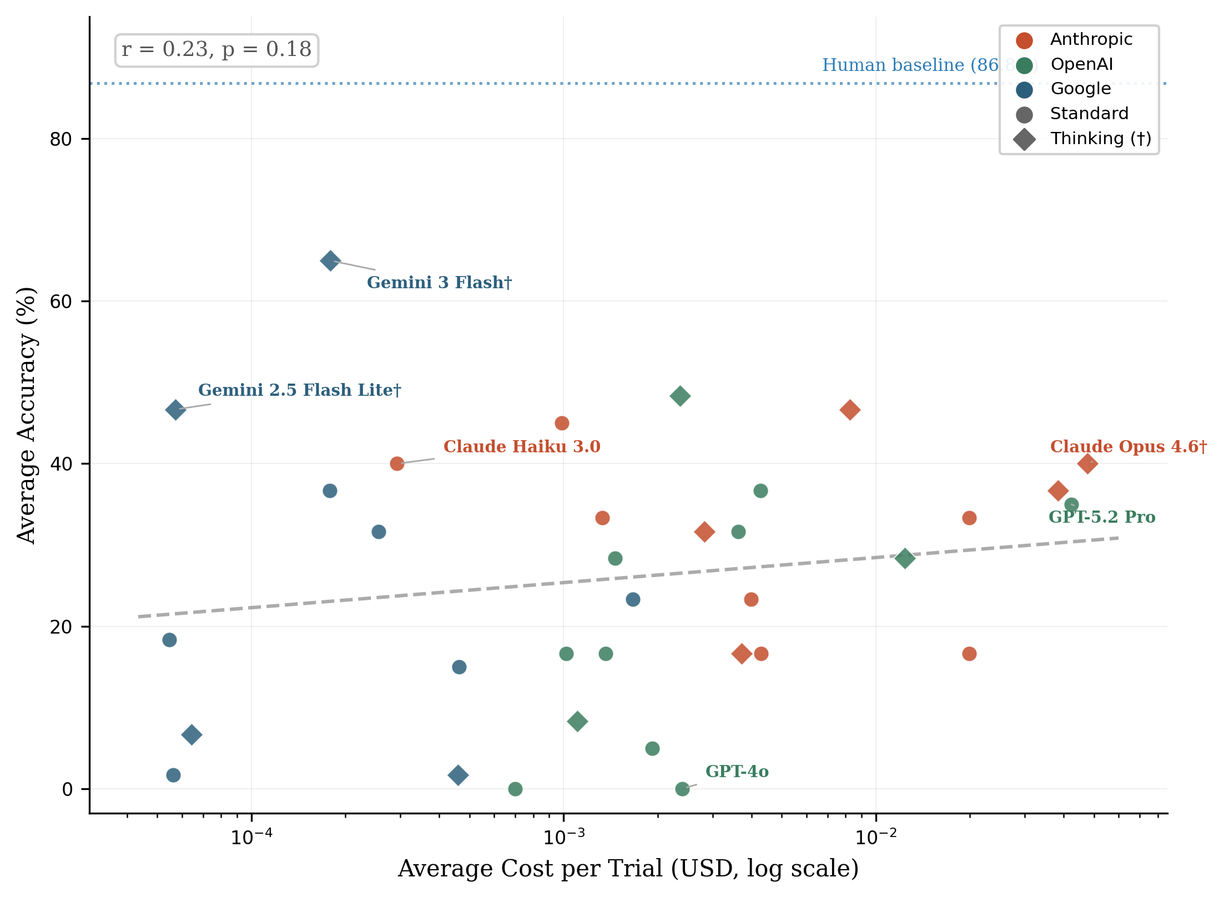
NOTE.——Colors indicate provider (Anthropic, OpenAI, Google); diamonds indicate extended thinking variants. The dashed regression line is essentially flat (r = .23, p = .18), confirming that computational expenditure does not predict cognitive trap performance. The dotted line marks the 86.8% human baseline.

Table WA-H1 presents the complete model ranking by accuracy, with cost and duration data for each model. Cost per trial spans three orders of magnitude, from $0.00005 (Gemini 2.5 Flash Lite) to $0.0476 (Claude Opus 4.6 with extended thinking), yet this 950-fold range in computational expenditure produces no systematic accuracy advantage.
TABLE WA-H1: MODEL-LEVEL COMPUTATIONAL EFFICIENCY (RANKED BY ACCURACY)
Model | Provider | Accuracy | Cost/Trial | Avg Duration | Avg Output Tokens
Gemini 3 Flash† | Google | 65.0% | $0.0002 | 7.5s | 2
GPT-5.2† | OpenAI | 48.3% | $0.0024 | 2.0s | 4
Claude Sonnet 4.5† | Anthropic | 46.7% | $0.0083 | 8.8s | 316
Gemini 2.5 Flash Lite† | Google | 46.7% | $0.0001 | 5.0s | 5
Claude Haiku 3.5 | Anthropic | 45.0% | $0.0010 | 1.9s | 17
Claude Haiku 3.0 | Anthropic | 40.0% | $0.0003 | 1.5s | 5
Claude Opus 4.6† | Anthropic | 40.0% | $0.0476 | 11.2s | 400
Claude Opus 4.5† | Anthropic | 36.7% | $0.0383 | 7.6s | 276
Gemini 3 Flash | Google | 36.7% | $0.0002 | 4.1s | 1
GPT-4o Mini | OpenAI | 36.7% | $0.0043 | 4.8s | 1
GPT-5.2 Pro | OpenAI | 35.0% | $0.0424 | 43.7s | 373
Claude Haiku 4.5 | Anthropic | 33.3% | $0.0013 | 1.8s | 37
Claude Opus 4.6 | Anthropic | 33.3% | $0.0199 | 4.1s | 36
Claude Haiku 4.5† | Anthropic | 31.7% | $0.0028 | 4.6s | 329
Gemini 2.0 Flash | Google | 31.7% | $0.0003 | 3.2s | 1
GPT-5.2 | OpenAI | 31.7% | $0.0036 | 5.8s | 101
GPT-5† | OpenAI | 28.3% | $0.0124 | 25.9s | 1136
GPT-5.1 | OpenAI | 28.3% | $0.0015 | 3.8s | 45
Claude Sonnet 4.6 | Anthropic | 23.3% | $0.0040 | 2.8s | 36
Gemini 3 Pro | Google | 23.3% | $0.0017 | 15.4s | 19
Gemini 2.5 Flash Lite | Google | 18.3% | $0.0001 | 2.5s | 1
Claude Opus 4.5 | Anthropic | 16.7% | $0.0199 | 3.7s | 36
Claude Sonnet 4.5 | Anthropic | 16.7% | $0.0043 | 4.3s | 57
Claude Sonnet 4.6† | Anthropic | 16.7% | $0.0037 | 2.2s | 13
GPT-5 | OpenAI | 16.7% | $0.0010 | 2.0s | 1
GPT-5 Mini | OpenAI | 16.7% | $0.0014 | 9.8s | 521
Gemini 2.5 Pro | Google | 15.0% | $0.0005 | 4.8s | 1
GPT-5.1† | OpenAI | 8.3% | $0.0011 | 2.6s | 10
Gemini 2.5 Flash† | Google | 6.7% | $0.0001 | 6.8s | 17
GPT-4.1 | OpenAI | 5.0% | $0.0019 | 2.1s | 1
Gemini 2.5 Flash | Google | 1.7% | $0.0001 | 3.1s | 4
Gemini 2.5 Pro† | Google | 1.7% | $0.0005 | 10.5s | 1
GPT-4.1 Mini | OpenAI | 0.0% | $0.0007 | 1.9s | 2
GPT-4o | OpenAI | 0.0% | $0.0024 | 2.3s | 1
NOTE. † = extended thinking variant. Cost/Trial = mean API cost per single-trap trial. Duration = mean response time per trial. Output Tokens = mean tokens generated per response.

H.3 Constraint-Specific Computational Signatures
The aggregate null result masks a constraint-specific pattern that reveals why computational investment fails to predict overall accuracy. Table WA-H2 compares correct and incorrect trials by constraint type.
TABLE WA-H2: COMPUTATIONAL SIGNATURES BY CONSTRAINT TYPE
Constraint | Traps | N Correct | N Wrong | Dur (Correct) | Dur (Wrong) | Dur d | Cost (Correct) | Cost (Wrong) | Cost d
Training Data Overfitting | 3 | 280 | 740 | 4.2s | 4.8s | −0.11 | $0.0040 | $0.0043 | −0.03
Spatial Reasoning | 1 | 103 | 237 | 20.0s | 7.7s | +0.57 | $0.0310 | $0.0050 | +1.03
Cross-Modal Binding | 1 | 128 | 212 | 12.8s | 5.5s | +0.77 | $0.0134 | $0.0074 | +0.35
Spatiotemporal Reasoning | 1 | 18 | 322 | 3.9s | 6.0s | −0.32 | $0.0016 | $0.0056 | −0.48
NOTE. Cohen’s d is positive when correct trials are longer/costlier, negative when incorrect trials are. Training Data Overfitting includes Modified Cafe Wall, Modified Muller-Lyer, and Modified Ebbinghaus. Spatial Reasoning = Colliding Oranges. Cross-Modal Binding = Surrounded Planets. Spatiotemporal Reasoning = Moving Robot.

Training data overfitting traps show negligible computational signatures (duration d = −0.11, cost d = −0.03). Models either have the correct prior or they do not, and additional processing neither helps nor hurts. The failure mechanism is a memorized association (e.g., applying the canonical Muller-Lyer interpretation to a modified stimulus), and more computation simply reinforces the wrong answer.
Spatial reasoning and cross-modal binding traps show the opposite pattern: correct trials take 2.6 and 2.3 times longer than incorrect trials, with medium-to-large effect sizes (d = +0.57 and +0.77 for duration). These traps require genuine spatial inference (predicting trajectory intersections, integrating textual and visual information), and models that allocate more processing to these tasks perform better. The cost effect is especially pronounced for the Colliding Oranges trap (d = +1.03), where correct answers cost six times more on average ($0.031 vs. $0.005).
The spatiotemporal reasoning trap (Moving Robot) shows a near-floor pass rate of 5.3% regardless of computational investment. Only 18 of 340 trials were correct, and 9 of these came from a single model (Claude Haiku 3.0, the oldest in the sample). The constraint is architectural: models cannot infer motion from a static image, and no amount of processing resolves this limitation.
Within-model point-biserial correlations between duration and accuracy confirm that these constraint-specific patterns operate at the individual model level, not merely across models. Of 34 models, 10 show a significant positive correlation (longer responses are more often correct, p < .05), 7 show a significant negative correlation (shorter responses are more often correct), and 17 show no significant relationship. The positive correlations concentrate in models that pass reasoning traps (where deliberation helps), while the negative correlations appear in models that pass only overfitting traps (where fast, memorized responses happen to be correct). This within-model heterogeneity mirrors the between-constraint patterns in Table WA-H2.
These opposing signatures cancel in the aggregate, producing the null correlation reported in Section H.2. The null is therefore not an absence of signal but a composition of three distinct patterns that happen to average to zero across the full trap battery.

H.4 Extended Thinking: Cost-Benefit Analysis
web appendix C.4 reports that extended thinking improves accuracy by a mean of +8.8 percentage points across 12 paired comparisons. Table WA-H3 extends that analysis with cost and duration data.
TABLE WA-H3: EXTENDED THINKING COST-BENEFIT
Base Model | Provider | Std Acc | Think Acc | Diff | Cost Mult | Std Duration | Think Duration
Gemini 2.5 Pro | Google | 15.0% | 1.7% | −13.3 pp | 1.0x | 4.8s | 10.5s
Gemini 2.5 Flash | Google | 1.7% | 6.7% | +5.0 pp | 1.1x | 3.1s | 6.8s
Gemini 2.5 Flash Lite | Google | 18.3% | 46.7% | +28.3 pp | 1.0x | 2.5s | 5.0s
GPT-5 | OpenAI | 16.7% | 28.3% | +11.7 pp | 12.2x | 2.0s | 25.9s
Claude Sonnet 4.5 | Anthropic | 16.7% | 46.7% | +30.0 pp | 1.9x | 4.3s | 8.8s
Claude Haiku 4.5 | Anthropic | 33.3% | 31.7% | −1.7 pp | 2.1x | 1.8s | 4.6s
Claude Opus 4.5 | Anthropic | 16.7% | 36.7% | +20.0 pp | 1.9x | 3.7s | 7.6s
GPT-5.1 | OpenAI | 28.3% | 8.3% | −20.0 pp | 0.8x | 3.8s | 2.6s
Gemini 3 Flash | Google | 36.7% | 65.0% | +28.3 pp | 1.0x | 4.1s | 7.5s
GPT-5.2 | OpenAI | 31.7% | 48.3% | +16.7 pp | 0.7x | 5.8s | 2.0s
Claude Opus 4.6 | Anthropic | 33.3% | 40.0% | +6.7 pp | 2.4x | 4.1s | 11.2s
Claude Sonnet 4.6 | Anthropic | 23.3% | 16.7% | −6.7 pp | 0.9x | 2.8s | 2.2s
Mean |  | 22.6% | 31.4% | +8.8 pp | 2.3x
NOTE. Cost Mult = ratio of thinking cost to standard cost per trial. Duration is the mean response time per trial. Positive differences indicate thinking improves performance.

Extended thinking costs 2.3 times more on average but produces only an 8.8 percentage-point accuracy gain that is not statistically significant (paired t = 1.81, p = .098). The cost multiplier varies dramatically across providers: Google’s thinking variants cost essentially the same as their standard counterparts (1.0x), while GPT-5’s thinking variant costs 12.2 times more. Anthropic models fall between (1.9-2.4x). When thinking does improve accuracy, the gains are large (Claude Sonnet 4.5: +30.0 pp, Gemini 3 Flash: +28.3 pp), but in 4 of 12 pairs thinking actually decreases accuracy, sometimes substantially (GPT-5.1: −20.0 pp). This inconsistency means that researchers validating traps against thinking models cannot reliably predict which direction the effect will go.
Token generation patterns provide additional insight into the thinking mechanism. Across all 12 thinking model variants, correct trials produce a mean of 308 output tokens compared to 164 for incorrect trials (t = 3.87, p < .001). However, this difference is driven by a subset of models that generate substantially more reasoning traces on successful trials; the median output tokens are identical (13) for correct and incorrect trials (Mann-Whitney p = .098). The implication is that when extended thinking helps, it does so by producing genuinely longer chains of reasoning rather than by producing uniformly more output. Models that benefit from thinking mode engage in substantively different processing on the trials they get right, while models that do not benefit show no token differential. This pattern is consistent with extended thinking providing an advantage only when the model’s architecture can already partially represent the required spatial or cross-modal computation, giving the thinking chain something productive to elaborate on.

H.5 Trial-Level Consistency
Across 204 model-trap pairs (34 models x 6 traps), each tested over 10 independent trials, 74.0% produced all-or-nothing outcomes: 59.3% scored 0/10 (complete failure across all trials) and 14.7% scored 10/10 (perfect accuracy). Only 26.0% of pairs showed intermediate scores. This strongly bimodal distribution indicates that model behavior on cognitive traps is largely deterministic rather than probabilistic. When a model encounters a trap it can pass, it passes consistently; when it encounters one it cannot, it fails consistently. Stochastic variation (e.g., 5/10 scores) is rare.
This determinism has two implications. First, it strengthens the architectural constraints interpretation: if failures were due to random processing noise, intermediate scores would be common. The all-or-nothing pattern indicates that models either possess or lack the specific capability each trap tests. Second, it means that even small test batteries (as few as 10 trials per trap) produce reliable classification, because the underlying behavior shows low variance.

H.6 Practical Deployment Costs
The entire 34-model validation cost $13.78 across all 2,040 trials, broken down by provider as follows: Anthropic (12 models) accounted for $9.08 (65.9%), OpenAI (12 models) for $4.50 (32.6%), and Google (10 models) for $0.21 (1.5%). Google’s API pricing makes large-scale model testing essentially free, while even the full Anthropic suite costs less than a single hour of research assistant time.
For researchers applying cognitive traps as a screening tool, the cost is negligible: each trap trial costs $0.007 on average, meaning a three-trap battery validated against 10 models costs under $0.21. This compares favorably to the $1.40 per-participant compensation on Prolific. Validating trap effectiveness against newly released models requires minimal marginal investment, supporting the ongoing monitoring strategy recommended in the main article.

WEB APPENDIX I: DEMOGRAPHIC AND ROBUSTNESS ANALYSES

I.1 Overview
Vision-based detection tasks risk confounding AI contamination with legitimate visual processing difficulties. This appendix examines whether demographic characteristics systematically affect cognitive trap failure rates, and whether primary findings remain robust after accounting for potential confounds.

I.2 Vision Impairment
Vision impairment showed the strongest association with cognitive trap failure among all demographic variables examined.
TABLE WA-I1: VISION IMPAIRMENT AND COGNITIVE TRAP FAILURE
Vision Status | N | Failed 3+ Traps | Failure Rate | Relative Risk
No impairment | 980 | 37 | 3.8% | Reference
Uncorrected impairment | 12 | 3 | 25.0% | 6.58x
Unsure | 14 | 0 | 0.0% | –
Prefer not to say | 1 | 1 | 100.0% | –
NOTE. Chi-square test: χ²(3) = 37.8, p < .001.

Participants reporting uncorrected vision impairments showed a 6.58-fold higher failure rate (25.0% vs. 3.8%). However, 75% of vision-impaired participants (9/12) still passed the threshold, suggesting that cognitive traps produce failures only in cases of moderate-to-severe impairment.
Effect on primary findings. Excluding vision-impaired participants reduced apparent contamination from 4.1% to 3.8% (3 fewer participants flagged). The choice deferral effect size changed minimally: Phi = .261 (full sample) versus Phi = .263 (vision-excluded), a difference of +.002 representing 0.8% change. This negligible impact reflects the low base rate of vision impairment (1.2% of sample).

I.3 Age
Age showed a non-significant overall correlation with cognitive trap performance (r = -.05, p = .131; two respondents with implausible age values were excluded from this calculation), and the relationship is U-shaped, with the lowest failure rates in middle age groups.
TABLE WA-I2: COGNITIVE TRAP FAILURE RATES BY AGE GROUP
Age Group | N | Failed 3+ | Failure Rate
18-30 | 168 | 13 | 7.7%
31-40 | 271 | 4 | 1.5%
41-50 | 232 | 8 | 3.4%
51-60 | 178 | 8 | 4.5%
61+ | 156 | 8 | 5.1%
The youngest age group (18-30) showed the highest failure rate at 7.7%, contradicting the concern that cognitive traps would systematically exclude older adults. The pattern is U-shaped, with the lowest failure rate in the 31-40 group (1.5%) and gradual increases in both younger and older groups. The elevated rate among younger participants may reflect greater familiarity with AI tools and willingness to experiment with agent-based completion, though device differences or cohort effects cannot be ruled out.

Per-Trap Performance by Age Group
Table WA-I3 shows human pass rates on individual traps across age groups, revealing which traps show the most age sensitivity.
TABLE WA-I3: HUMAN PASS RATE BY TRAP AND AGE GROUP
Age | Cafe Wall | M-L | Ebb | Robot | Oranges | Planets
18-30 | 86.9% | 91.7% | 95.8% | 77.4% | 83.3% | 95.8%
31-40 | 95.2% | 93.7% | 97.4% | 82.3% | 88.6% | 96.7%
41-50 | 86.6% | 94.4% | 97.0% | 79.7% | 89.2% | 97.0%
51-60 | 86.5% | 89.3% | 95.5% | 73.0% | 92.7% | 97.2%
61+ | 82.7% | 93.6% | 90.4% | 73.7% | 89.7% | 95.5%
The Moving Robot shows the most age sensitivity, with pass rates declining from 82.3% (ages 31-40) to 73.0% (ages 51-60). The Ebbinghaus shows the clearest decline in the 61+ group (90.4% vs. approximately 97% for other groups). Overall, age effects are modest, and no single trap drives the U-shaped pattern in overall failure rates.

I.4 Gender
Gender showed no significant association with cognitive trap failure rates (χ²(3) = 1.15, p = .766). Males showed a 4.7% failure rate compared to 3.6% for females, a nonsignificant 1.1 percentage point difference with overlapping confidence intervals. Because cognitive traps involve spatial and visual processing tasks where gender differences have been documented in other contexts, this null finding is informative: it suggests that the specific visual-cognitive operations tested by our traps (binding features to objects, extrapolating trajectories, recognizing modified illusions) do not produce systematic gender-based disadvantages at the thresholds used for classification.

I.5 Color Blindness
Color blindness showed a small, non-significant elevation in failure rates (χ²(3) = 4.95, p = .175).
TABLE WA-I4: COLOR BLINDNESS AND COGNITIVE TRAP FAILURE
Color Vision | N | Failed 3+ | Failure Rate
Not color blind | 970 | 38 | 3.9%
Color blind | 14 | 1 | 7.1%
Unsure | 19 | 1 | 5.3%
Prefer not to say | 4 | 1 | 25.0%
The small sample of color-blind participants (N = 14) limits statistical power. Only one additional person in the color-blind group failed compared to base rates. The Colliding Oranges trap is the most likely source of difficulty for color-blind participants because it requires distinguishing the “largest orange circle” from the “smallest yellow circle” among multiple colored shapes, a task that may be challenging for participants with red-green color deficiency.

I.6 Comprehensive Sensitivity Analysis
Excluding all participants who failed at least one traditional attention check, reported color blindness, or reported uncorrected vision impairment totaled 130 participants (12.9% of sample), reducing apparent contamination from 4.1% to 3.3% (29/877). The choice deferral effect size changed to Phi = .259, a decrease of -.002 compared to the full sample.
The filtering reduced effect sizes, suggesting that demographic exclusions remove legitimate variance in human responding, consistent with the benign interpretation of flagged participants. This pattern is consistent with the three-group analysis reported in the main text (web appendix F provides full details), which demonstrates that most flagged participants show human-like decision times and traditional check performance.

I.7 Recommendations for Demographic Considerations
We recommend that researchers: (1) include vision screening questions in surveys alongside cognitive traps, (2) conduct sensitivity analyses with and without vision-impaired participants, (3) report both analyses when results are substantively identical, and (4) retain the full sample for primary analyses while acknowledging that individual false positives may occur among participants with visual processing differences.
For studies where visual perception directly relates to the research question (e.g., package design evaluation, visual aesthetics research), exclusion of vision-impaired participants makes stronger sense for both data quality and construct validity. For studies where the research question does not involve visual processing, inclusion with sensitivity analysis is preferable to maintain sample representativeness.

REFERENCES – WEB APPENDIX
Brinkmann, Levin, Fabian Baumann, Jean-François Bonnefon, Maxime Derex, Thomas F. Müller, Anne-Marie Nussberger, Agnieszka Czaplicka, Alberto Acerbi, Thomas L. Griffiths, Joseph Henrich, Joel Z. Leibo, Richard McElreath, Pierre-Yves Oudeyer, Jonathan Stray, and Iyad Rahwan (2023), “Machine Culture,” Nature Human Behaviour, 7(11), 1855–68.
Campbell, Declan, Sunayana Rane, Tyler Giallanza, Nicolò De Sabbata, Kia Ghods, Amogh Joshi, Alexander Ku, Steven M. Frankland, Thomas L. Griffiths, Jonathan D. Cohen, and Taylor Webb (2024), “Understanding the Limits of Vision Language Models Through the Lens of the Binding Problem,” in Proceedings of the 38th International Conference on Neural Information Processing Systems, Red Hook, NY, USA: Curran Associates Inc., https://arxiv.org/abs/2411.00238.
Dhar, Ravi (1997), “Consumer Preference for a No-Choice Option,” Journal of Consumer Research, 24(2), 215–31.
Douglas, Benjamin D., Patrick J. Ewell, and Markus Brauer (2023), “Data Quality in Online Human-Subjects Research: Comparisons Between MTurk, Prolific, CloudResearch, Qualtrics, and SONA,” PLOS ONE, 18(3), e0279720.
Guo, Xuyang, Zekai Huang, Zhenmei Shi, Zhao Song, and Jiahao Zhang (2025), “Your Vision-Language Model Can’t Even Count to 20: Exposing the Failures of VLMs in Compositional Counting,” https://arxiv.org/abs/2510.04401.
Kamath, Amita, Jack Hessel, and Kai-Wei Chang (2023), “What’s ‘up’ with Vision-Language Models? Investigating Their Struggle with Spatial Reasoning,” http://arxiv.org/abs/2310.19785.
Kay, Cameron S. (2025), “Why You Shouldn’t Trust Data Collected on MTurk,” Behavior Research Methods, 57, 340.
Qi, Jianing, Jiawei Liu, Hao Tang, and Zhigang Zhu (2025), “Beyond Semantics: Rediscovering Spatial Awareness in Vision-Language Models,” http://arxiv.org/abs/2503.17349.
Rahwan, Iyad, Manuel Cebrian, Nick Obradovich, Josh Bongard, Jean-François Bonnefon, Cynthia Breazeal, Jacob W. Crandall, Nicholas A. Christakis, Iain D. Couzin, Matthew O. Jackson, Nicholas R. Jennings, Ece Kamar, Isabel M. Kloumann, Hugo Larochelle, David Lazer, Richard McElreath, Alan Mislove, David C. Parkes, Alex Pentland, Margaret E. Roberts, Azim Shariff, Joshua B. Tenenbaum, and Michael Wellman (2019), “Machine Behaviour,” Nature, 568(7753), 477–86.
Shinozaki, Taiga, Tomoki Doi, Amane Watahiki, Satoshi Nishida, and Hitomi Yanaka (2025), “Do Large Vision-Language Models Distinguish Between the Actual and Apparent Features of Illusions?” in Proceedings of the 47th Annual Meeting of the Cognitive Science Society, https://arxiv.org/abs/2506.05765.
Stogiannidis, Ilias, Steven McDonagh, and Sotirios A. Tsaftaris (2025), “Mind the Gap: Benchmarking Spatial Reasoning in Vision-Language Models,” http://arxiv.org/abs/2503.19707.
Ullman, Tomer (2024), “The Illusion-Illusion: Vision Language Models See Illusions Where There Are None,” http://arxiv.org/abs/2412.18613.
Watson, David, Lee Anna Clark, and Auke Tellegen (1988), “Development and Validation of Brief Measures of Positive and Negative Affect: The PANAS Scales,” Journal of Personality and Social Psychology, 54(6), 1063–70.
Webb, Margaret A. and June P. Tangney (2022), “Too Good to Be True: Bots and Bad Data from Mechanical Turk,” Perspectives on Psychological Science, 19(2), 233–50.
Zhou, Jijie and Yuhan Hu (2025), “Beyond Words: Infusing Conversational Agents with Human-Like Typing Behaviors,” https://arxiv.org/abs/2510.08912.
Zhou, Shijie, Alexander Vilesov, Xuehai He, Ziyu Wan, Shuwang Zhang, Aditya Nagachandra, Di Chang, Dongdong Chen, Xin Eric Wang, and Achuta Kadambi (2025), “VLM4D: Towards Spatiotemporal Awareness in Vision Language Models,” https://arxiv.org/abs/2508.02095.

