A Tool for Synthesis by Direct Mapping of Asynchronous Control Circuits from Extended STG Specifications

Felipe Mendes, Duarte L. Oliveira, Higor A. Delsoto, Lester A. Faria
Divisão de Engenharia Eletrônica – Instituto Tecnológico de Aeronáutica – SJC – Brazil
E-mail: felipe2855@gmail.com, duarte@ita.br, higordel@ita.br, lester@ita.br

Abstract— Several proposals have been made to generalize the specifications extended burst-mode (XBM) and signal transition graph (STG), which describe asynchronous controllers and that are popular. All proposals direct to methods for design of controllers by logic synthesis. These methods lead to a complex synthesis that can invalidate the automatic synthesis. In this paper we propose a tool to synthesis by direct mapping of asynchronous controllers that are described by the extended signal transition graph (XSTG) specification. The XSTG specification combines the strong of the specifications XBM and STG and the method by direct mapping has the advantages of simplicity, requires little computational effort thus allows synthesizing large specifications and requires no knowledge of asynchronous logic.

Keywords —asynchronous logic, XBM specification, control cell

Introduction
Asynchronous circuits present several potential advantages over their synchronous counterparts: they tend to be faster, dissipate less power, do not present clock skew nor clock distribution problems, they are more robust in respect to temperature variations and electromagnetic interactions [1]. Concerning to the asynchronous circuits, two remarkable specification styles have been proposed to describe the asynchronous controllers, which lead to an optimized synthesis:

Signals transition graph (STG,) proposed by Chu [2,3], is a subclass of sampled Petri nets, where each transition is sampled as a physical transition of some of the electrical signals. The STG focus primarily in the description of asynchronous circuits that communicate with external environment in input/output mode (M_I/O). In M_I/O, the occurrence of an output event immediately enables the occurrence of an input event. Figure 1 shows a STG specification of the of VME (Versa Module European) cycle-read of the VME-bus interface [5]; and

Burst Mode (BM) is a kind of specification based on the state transition graph, which was firstly proposed by Davis [12] and later formalized by Nowick [13] and improved by Yun [14], as extended burst-mode (XBM), and by Oliveira et al. [15] as multi-burst graph (MBG). This mode allows multiple input changes, being used to describe asynchronous Mealy Finite State Machines (FSM). These machines interact with the environment in “general fundamental mode” (GFM), where a new burst input can only occur if the controller is already stabilized (no electrical activity in the ports and in the lines). Figure 2 shows the XBM specification of the benchmark Biufifo2dma.
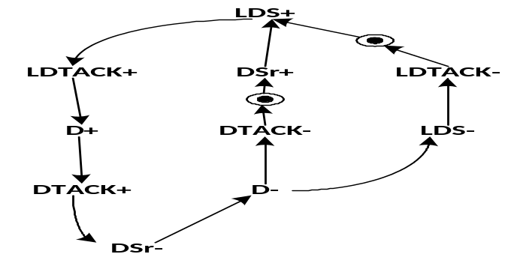Fig. 1. Petri-net description: STG from the VME read cycle.
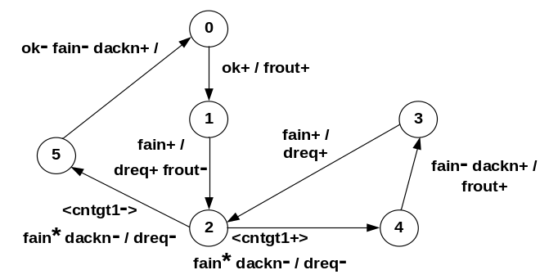
Fig. 2. Extended burst-mode specification of Biufifo2dma

Limitations in STG and XBM specifications
An important and promising area, focusing on the implementation of asynchronous controllers shows to be the different kinds of heterogeneous systems (controllers and/or synchronous processors). In this kind of systems the signals may have non-monotonic behavior and the decisions can be made ​​by “signal level” and not “by transition”. Despite of STG and XBM specifications are well accepted, the existent limitations are evident when it is necessary to describe asynchronous controllers focusing on heterogeneous systems:

The STG is a “per signal” description, having its activation per signal transition. Therefore: a) the STG is able to describe decisions with level sensitive signals (LSS) and non-monotonic behavior, however performing it in a confused and difficult way of description [16,17]; b ) Despite one of the strengths of the STG shows to be its ability to describe sequences and concurrences between inputs and outputs, certain types of concurrence lead the STG to an excessive generation of transitions (explosion); c) many signals lead to a non-compact and hard to interpret specification; and d) describing signals with irrelevant behavior (directed don't-care) leads STG to a confused description [16,17]; and

The XBM is a kind of description based on “signals burst”, therefore some of the the strengths of the XBM are: a) to describe decisions with LSS signals, and non-monotonic behavior with naturally; b) to describe signals with irrelevant behavior (directed don't-care); and c) the description in “burst level” makes the specification more compact. On the other hand, the main weakeness of XBM mode is describing with a limited capacity the signal sequencing and input and output signals concurrence [18]. Weaknesses, sequencing and concurrency between inputs and outputs.

Asynchronous FSMs: differents approaches
The three main approaches commonly used in the designing of asynchronous FSMs are: logic synthesis [4-7], direct mapping [8-13] and de-synchronization [x].
—Logic synthesis: requires a deep knowledge of asynchronous logic. It follows the steps of traditional synthesis, aiming global optimization such as state and logic minimization, state assignment, etc. In the computational complexity theory, these steps show complexity NP-complete or NP-hard, demanding an excessive computation effort and memory requirements. These constraints make it difficult to be applied to large specifications. In the approach by synthesis logic that part of STG, the intermediate structure SG (state graph) is generated and can easily explode. Figure 3 shows a very small STG specification and Fig. 4 shows its SG which required 28 states.
—Direct mapping: the graph specification of a system is translated to a circuit net-list. Each node of the graph corresponds to a memory element and the arcs between these elements represent the interconnections of the circuit. The advantage of the direct mapping method is that it allows the implementation of large specifications with just a little computational effort. It eliminates the steps of state minimization, state assignment and logic minimization. Another advantage is that it does not require any knowledge of the asynchronous logic theory. Different methods for direct mapping have been proposed. In [11], the primitive flow table specification was adopted, while in [12] the adopted specification was the STG. In [13] the Extended Burst-Mode Specification produces XBM_AFSMs.
—De-synchronization: the FSM is synthesized as a synchronous FSM, i.e., using the specification and tools of synchronous paradigm. Later, the synchronous FSM is converted into an AFSM, which is obtained by replacing the flip-flops by latches and the clock signal by a handshake control network. As disadvantages, there is a large increase in area, once it may have an excessive number of delay elements, and also a reduction in performance. There are also the problems cited synthesis of logic, but oriented for synchronous FSMs.
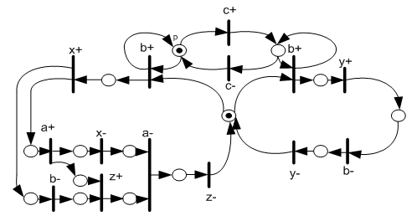

Fig. 3. STG with TSS signal but with behavior of LSS signal [23].
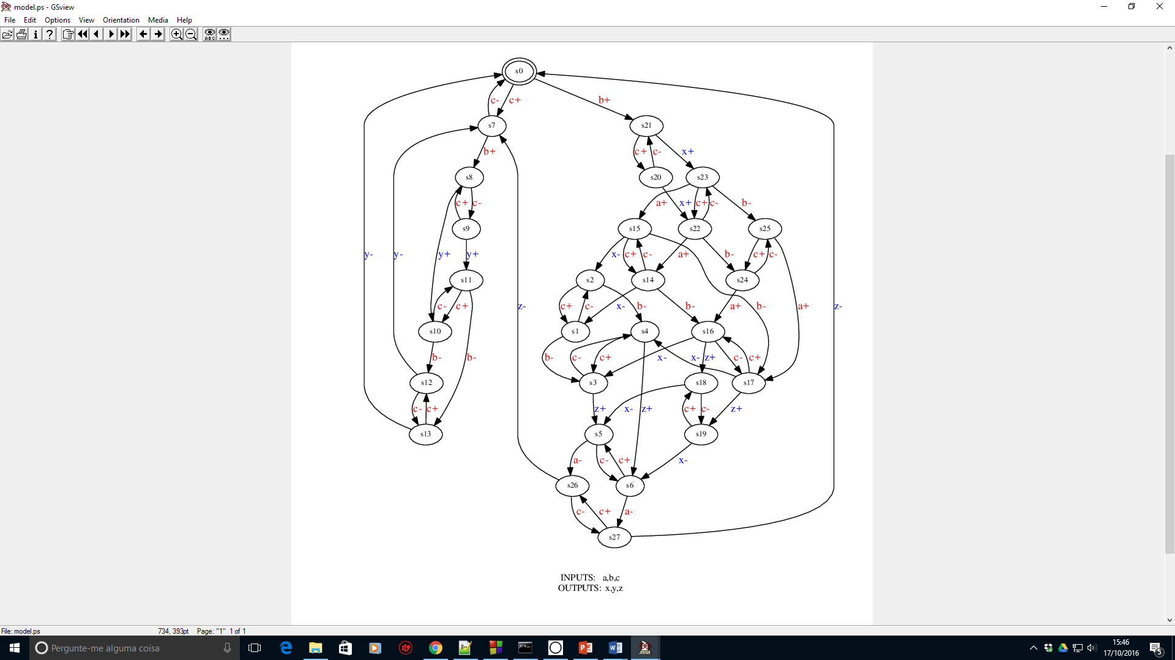
Fig. 4. SG generated by Petrify tool of the STG of Fig.3.

Two limitations appear in this context of the specification and of the approach: due to limitations of the conventional STG, different generalizations were proposed for the GSTG [16,19,20,21]. These generalizations allow describing, in a more easy way, the “directed don't-care” and LSS signals. The implementations [16,19,20] were by synthesis logic, but have never been automated. The proposed of [20] was implemented by synthesis logic as a XBM→STG translator. Another proposal was the specification denominated Bursts Transition Graph (BTG) that is based on Petri-net and incorporates the XBM specification [x], where the proposed approach was per direct mapping, but has never been automated. Another proposal never automated, was the Extended Signal Transition Graph specification (XSTG) [x]. This specification incorporates both STG and XBM specifications, is a more compact specification, with high descriptive capacity and easy to understand.
Based on the strengths and drawbacks previously commented, about logic synthesis, automatic synthesis and specifications in this paper it is proposed a new method for direct mapping synthesis of asynchronous controllers that are described by XSTG specification. The tool called Dirmap was implemented in the python language and accepts as input the XSTG descriptions and generates as output a description VHDL.

Extedend Signal Transition Graph (Xstg)
The extended signal transition graph (XSTG) proposed in [21] is a subclass of sampled Petri nets, where each transition is sampled as a burst. The activation of the burst signals in the enabled transition can happen in any sequence or at any time. The possible signals are classified into three types: a) LSS signals with non-monotonic behavior; b) SST input signals with monotonic behavior, which are the terminal signals or irrelevant signals (directed don't-care); and c) SST output signals. The XSTG obeys to the restrictions of the STG and XBM specifications [3,6]. Figure 5 shows an example of XSTG specification originally in STG of Fig. 3. Where the TSS input signals are a and b. The LSS signal is c, and the output signals are x, y and z. For transitions with fan-in = 1 and fan-out = 1, the “bar” is omitted. Figure 5 the transitions (bar) T1 and T2 present respectively fan-in = 1 and fan-out = 2. The place P1 has the initial TOKEM.
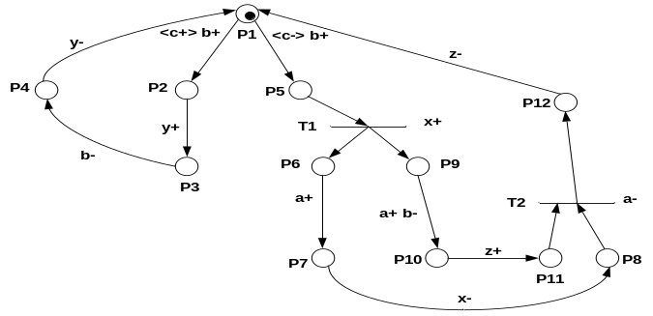
Fig. 5. XSTG specification. Arrumar outro exemplo

Memory Element
The direct mapping uses one memory element (control cell) for each place with input burst of the XSTG specification. The function of the control cell is to enable and disable the sequence of places that are being processed. The control cell has the inputs [Ri, Ai] and outputs [Ro, Ao] was proposed in [x]. The input signal Ri enables the present place. The output signal Ro starts the activation of next place. The output signal Ao starts the disabling of previous place. The input signal Ai disables the place. Figure 6 shows the logic circuit.
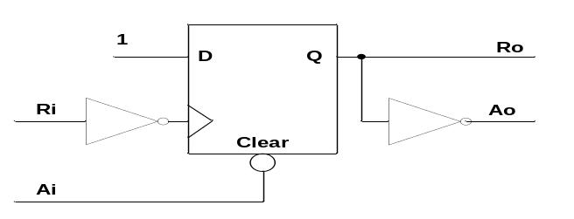
Fig. 6. Logic circuit: control cell (D FF) for PLD.

Automatic SYNTHESIS by Direct Mapping

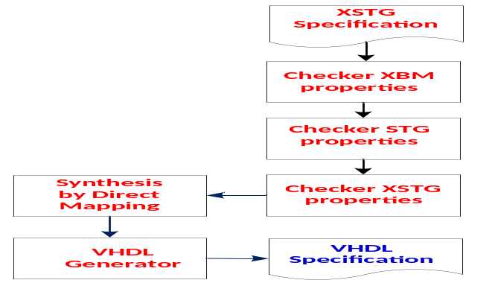 Fig. 7. Dirmap-XSTG tool.
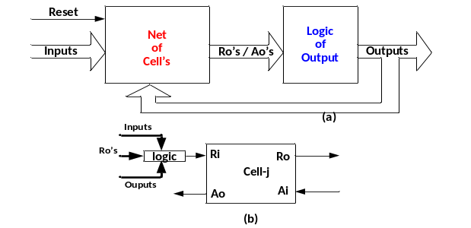
Fig. 8. Target architecture: a) structure; b) control cell

Case Study

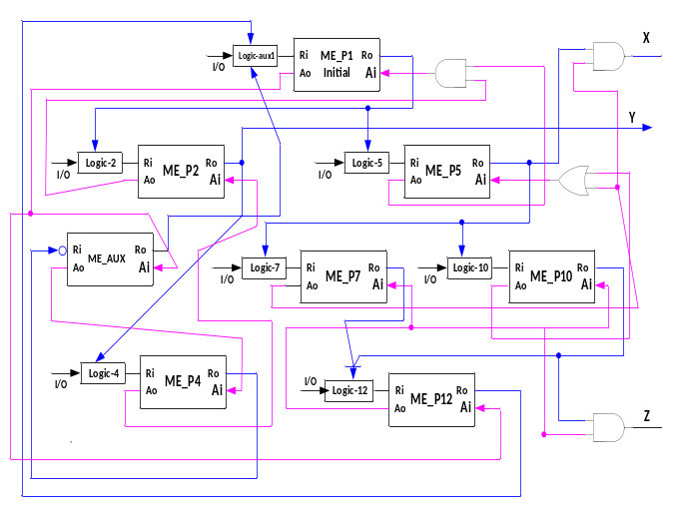Fig. 9. Architecture by direct mapping: xxxxx

Fig. 10. Behavioral VHDL: xxxxxxx

Simulation & Results
The example used in the study case was synthesized in the Dirmap tool generates a VHDL that was simulated and compiled in the tool ALTERA, software QUARTUS II, version 9.1, family CYCLONE II, and device EP2C8T14418. Figure 10 shows the hazard-free waveforms extracted from the simulation of the well-known benchmark xxxxxxx.

Fig. 11. Simulation of case study

Table I show eleven benchmarks that have been described in XSTG and shows the amount of places and transitions for the XSTG. Table I also shows the results in places and transitions that STG needed to describe the XSTG and the number of states of the SG description generated by Petrify tool. It also brings results of area on the implementation of each VHDL in FPGA platform and processing times that the Dirmap tool needed to generate each VHDL. The XSTG description obtained a reduction of x% in places and y% in transitions, when compared with STG. So, in addition to the feature of having a more natural capability of describing LSS signals and input or output bursts, it is also more compact.

TABLE I. RESULTS OF DIRMAP-XSTG TOOL
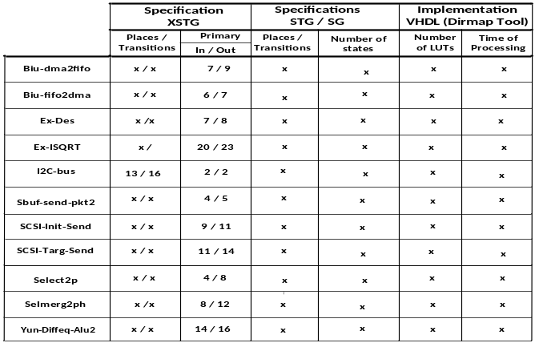

CONCLUSION
In this paper we propose a method by direct mapping for XSTG specification. The XSTG specification combines the strong of the specifications of asynchronous paradigm, which are STG and XBM. The Dirmap tool was developed in the python language, which from XSTG generates VHDL.

References
- C. J. Myers, “Asynchronous Circuit Design,” Wiley & Sons, Inc., 2004, 2ª edition. .
- T. -A. Chu, “Synthesis of Self-Timed VLSI Circuits from Graph-Theory Specifications,” Ph.D. thesis, June, 1987, Dept. of EECS, MIT.
- J. Cortadella, et al., “Petrify: A tool for manipulating concurrent specifications and synthesis of asynchronous controllers,” IEICE Trans. Inf. Syst., vol.E80-D, no. 3, pp.315-325, March 1997.
- D. Sokolov, A. Bystrov and A. Yakovlev, ”Direct mapping of low-latency asynchronous controllers from STGs,” IEEE Trans. CAD of Integration Circuits and Systems, vol. 26, no. 6, June 2007.
- D. Sokolov and A. Yakovlev, “Clockless Circuits and Systems Synthesis,” IEE Proceedings Comput. Digit. Tech., vol. 152, nro. 3, pp. 298-316, May 2005
- E. Pastor, et al., “Structural methods for the synthesis of speed-independent circuits,” IEEE Trans. Computer-Aided Design, vol. 17, pp. 1108-1129, November 1998.
- J. Carmona, “Structural methods for the synthesis of well-formed concurrent specifications,” PhD thesis, Software Dept., Universitat Politécnica de Catalunya, Barcelona, Spain, March 2004.
- J. Carmona, and J. Cortadella, “Encoding Large Asynchronous Controllers with ILP Techniques,” IEEE Trans. on CAD of Integrations Circuits and Systems, vol. 27, nro. 1, pp. 20-33, Januray 2008.
- S. M. Nowick, “Automatic Synthesis of Burst-Mode Asynchronous Controllers,” Ph.D thesis, Stanford University, 1993.
- K. Y. Yun and D. L. Dill, “Automatic Synthesis of Extended Burst-Mode Circuits: Part I (Specification and Hazard-Free Implementation) and Part II (Automatic Synthesis),” IEEE Trans. on CAD of Integrated Circuit and Systems, Vol. 18:2, February, pp. 101-132, 1999
- D. L. Oliveira, M. Strum, W. J. Chau, and W. C. Cunha, “Miriã: a CAD toll synthesize multi-burst controllers for heterogeneous systems,", Microelectronics Reliability, 43, pp. 209-213, 2003.
- Yakovlev, A. V., “On Limitations and Extensions of STG Model for Designing Asynchronous Control Circuits,” , Proc. ICCD, pp. 396-400, 1992.
- Yakovlev, A., “Synthesis of Hazard-free Asynchronous Circuits from Generalized Signal Transition Graphs,” 6th IEEE Int. Conf. on VLSI Design, pp.21-24, 1993.
- Moon, C. W, “Synthesis and Verification of Asynchronous Circuits from Graph Specifications,” PhD thesis, University of California, Berkeley, 1992.
- O. Kraus and M. Pedeffke, “XBM2PLA: A Flexible Synthesis Tool for Extended Burst Mode Machines,” Proc. Of the Design Automation and Test in Europe Conference and Exhibition, , pp.1301-1303, 2003.
- Vanbekbergen, V., et al., “A generalized signal transition graph model for specification of complex interfaces,” European Design and Test Conference, EDAC, March, pp.378-384, 1994.
- D. L. Oliveira, et al., “Synthesis by Direct Mapping of Asynchronous Controllers from Extended Burst-Mode Specification,” XVI Workshop Iberchip, Foz de Iguaçu – Brazil, 2010.
- J. Beister, et al., “From STG to Extended-Burst-Mode Machines,” Proc. Fifth Int. Symposium on Advanced Research in Asynchronous Circuits and Systems, pp.145-156, 1999.

