Strategic Tillage Gas flux analysis Source Code: Reanalysis 2026
- ReadGCReportPDF2021.R & ReadGCReportPDF2022.R
- GCResultsCompilation2021.R & GCResultsCompilation2022.R
- GC_Standards_2021.R
- GC_Standards_2022.R
- StandardCalibration.R
- DataCurationGCAnalysis2021.R
- DataCurationGCAnalysis2022.R
- GCAnalysis2021.R
- GCAnalysis2022.R
- HMR_Analysis.R
- FelipesHMR2.R
- MassFluxCalculation.R
- SoilGasFluxStatisticalAnalysis.R
The error does not seem to be systematic because emissions in blocks 1 and 2 are consistently high in 2021 and 2022, and consistently low in block 3 and 4.
Possible reasons for it?
Slope calculation, Area under the curve calculation.
The calibration regression for the GC based on standards seem to be irrelevant, as the important aspect affecting the emissions is not the particular concentration data point, but the slope of the consequent concentration measurement inside the chamber that result in the emission rate.
The data from the GC does not seems to indicate any mayor difference in the results. The high emissions do not seem to be the result of the GC analysis.
The intercept in the GC standard calibration has an important effect and is wrong in the linear model with free intercept. With the intercept forced through 0 the calibration improves significantly. Plot with free intercept.
After reviewing the standard calibration and forcing it though zero (0) the results did not change.
Plotting the daily emissions (period emissions) against time it is clear that the main factor determining the higher emissions in blocks 1 and 2 are high N2O emission peaks. Those peaks are not present in blocks 3 and 4.
In 2021, Sampling date 20210614, and 20210629 has problems: The red points in the graph below all belong to sampling day 20210614.
The final data for the mass flux calculations was taken from f0 and the missing data from “data error” from LR.f0. For N2O and CH4 all the data has to come from LR.f0.
On 20210702 there was a problem with the GC and samples were processed twice. That led to some problems. The fact that there were two series with the same name caused data problems with the HMR process. Needs to check the HMR data error processed data.

These sampling days have two GC analysis dates:
"20210614.2021-07-01" "20210614.2021-06-30"
"20210702.2021-07-22" "20210702.2021-08-01" "20210702.2021-07-28
"20210805.2021-08-16" "20210805.2021-08-17"
"20210812.2021-08-18" "20210812.2021-08-19"
"20210819.2021-08-24" "20210819.2021-08-25"
"20210929.2021-10-01" "20210929.2021-10-04" "20211027.2021-11-19" "20211027.2021-11-20"
The data flux recalculated because of the HMR data error processed data looks good
The data flux recalculated because of the HMR data error processed data looks good.
The data from 2022 does not look bad at all.
The “data error” corrected HMR flux calculations look good as well.
The records of the GC extracted by Alli in excel, the ones printed directed in PDF and the ones read from the PDF directly into R are all in agreement. The next step is to revise the flux calculations of that sampling day.
Certainly, fluxes of 40 kg-N / ha day are very high. What is happening?
The Standards Names PerSTDA and PerSTD are not consistent through out 2021, therefore need to be selected manually!!!!!!

Checking standards manually

2021-06-04
Has 3 outliers 118, 85, 87
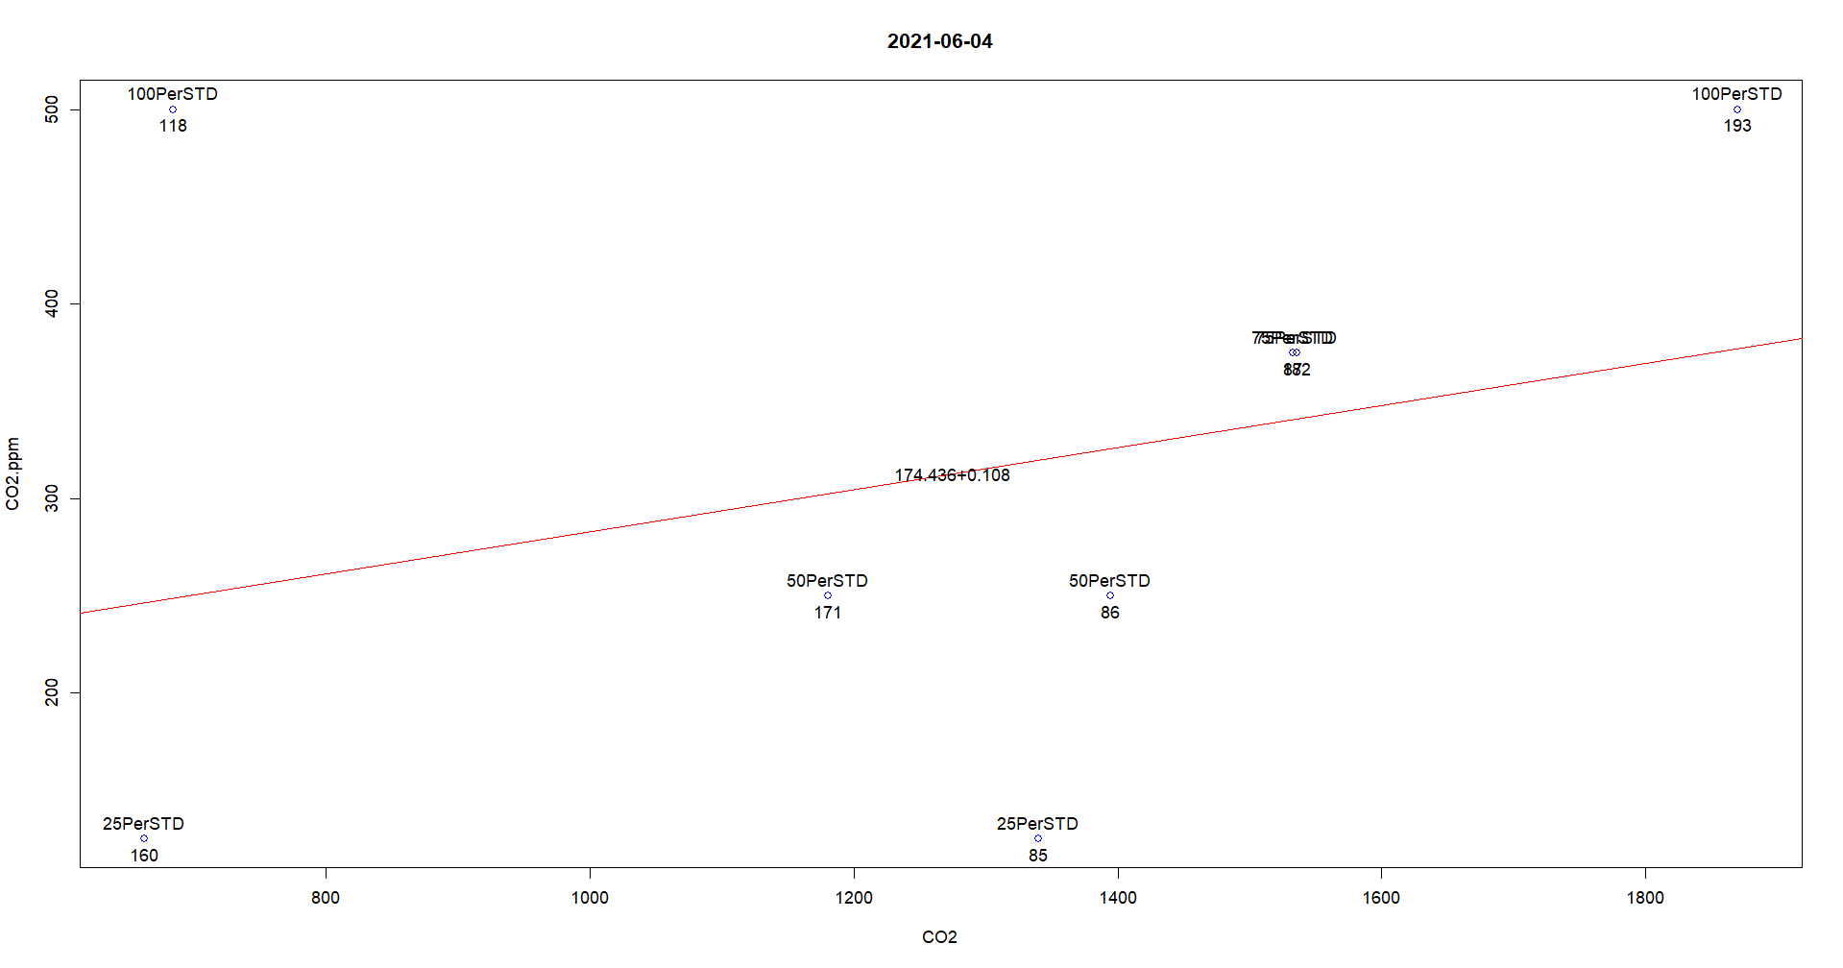

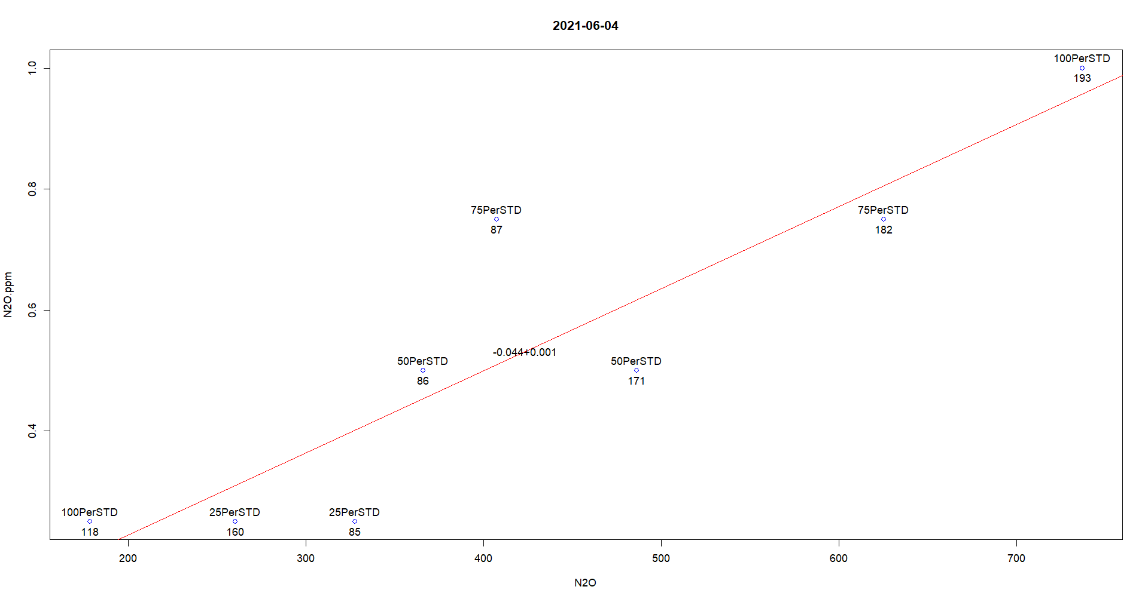
Removed records 118, 85, 87

2021-06-14
Has tow outliers 472 ,473
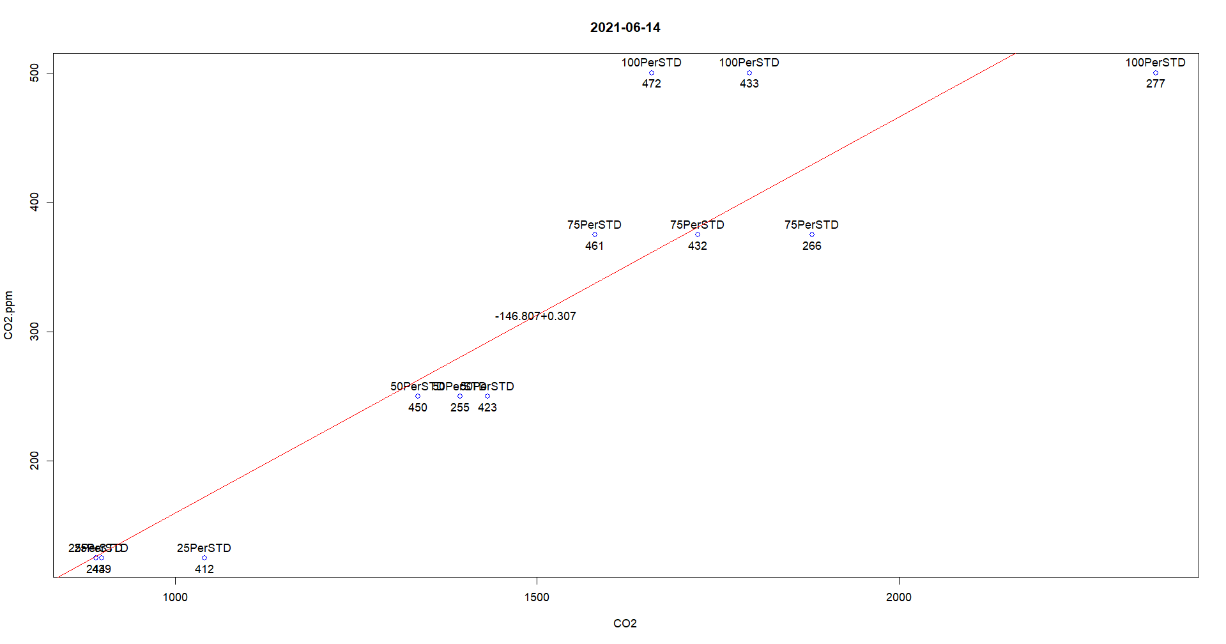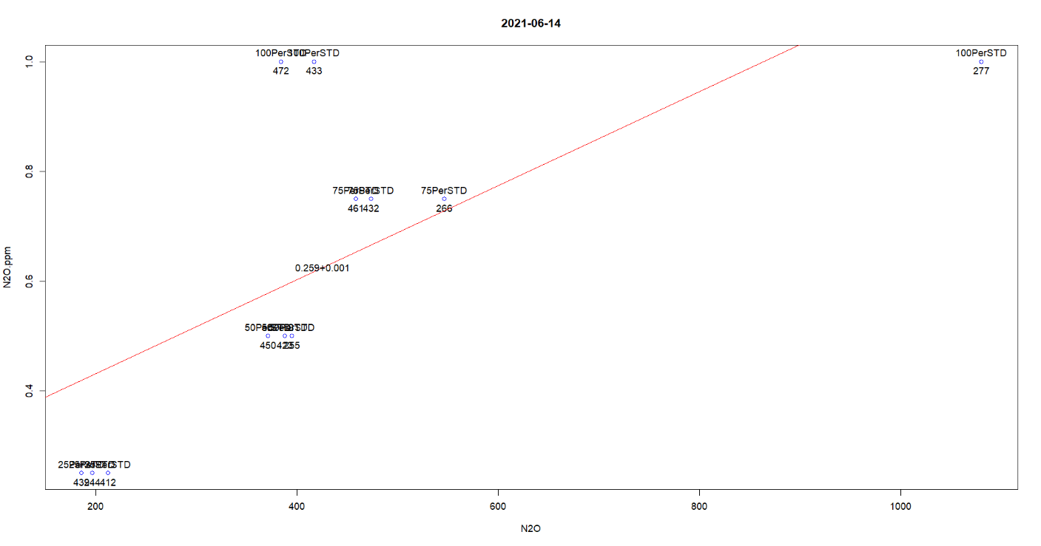
Removed records 472 ,473

2021-06-16
Outlier 500,
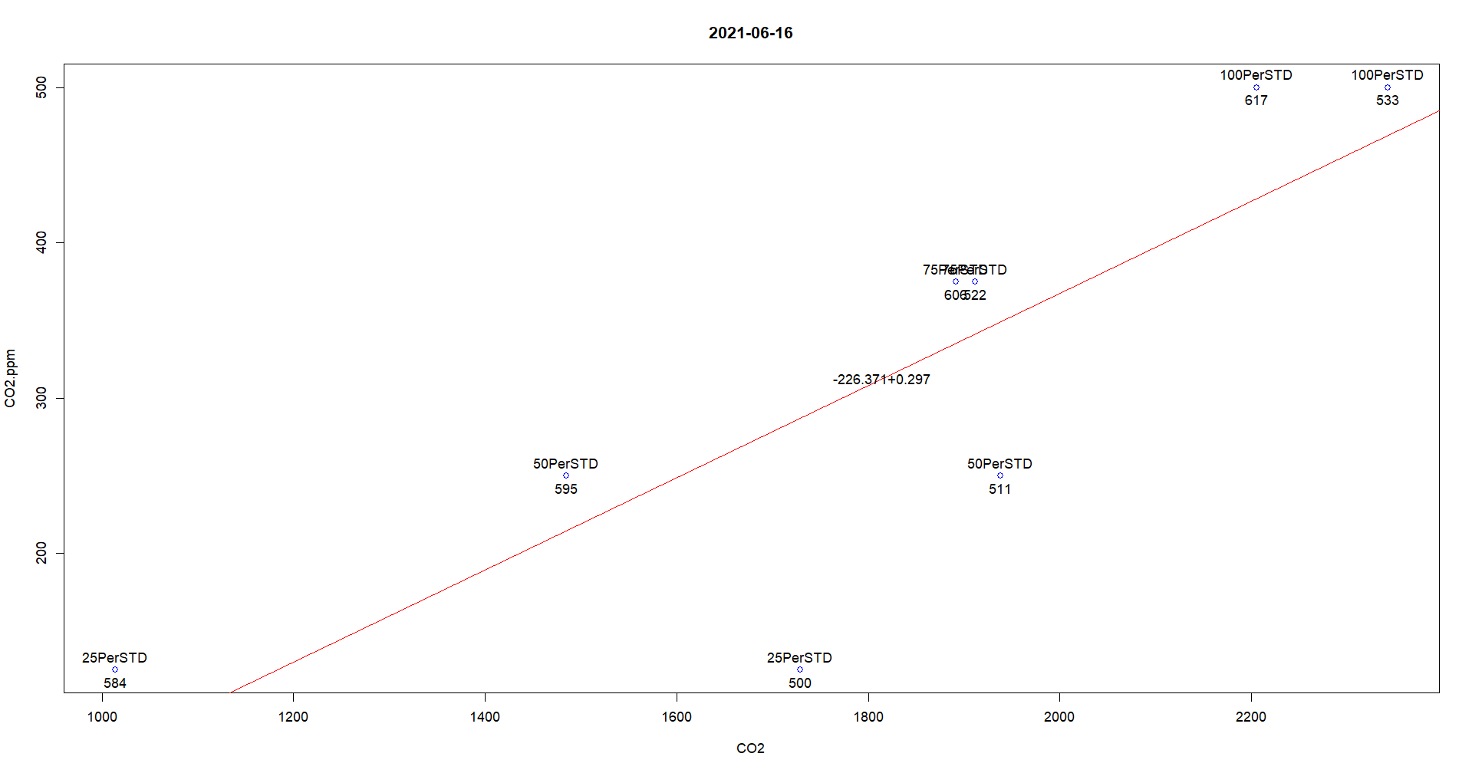
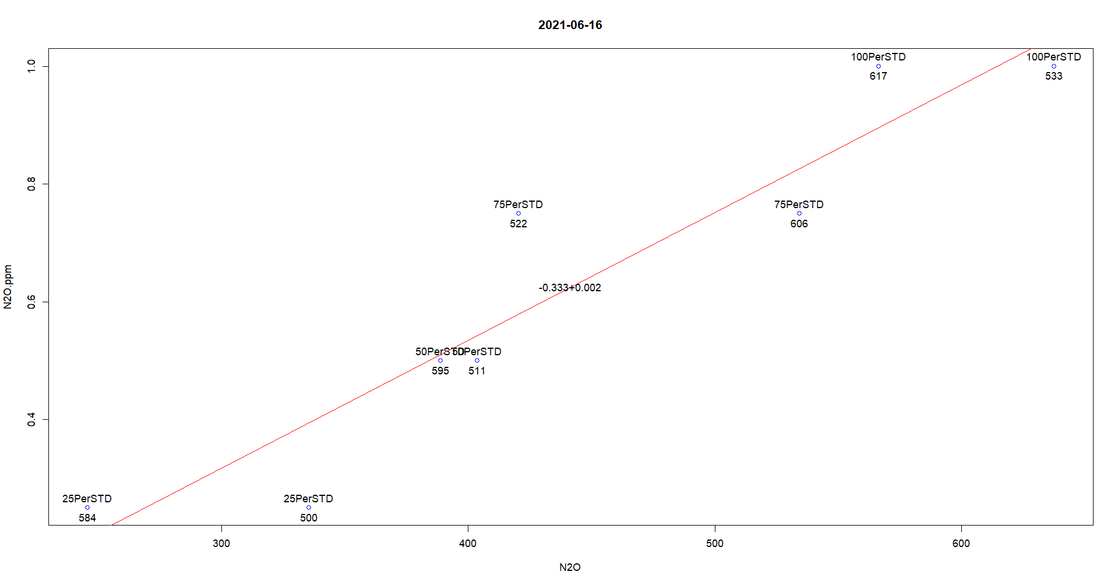
Remove 500

2021-06-21
OK
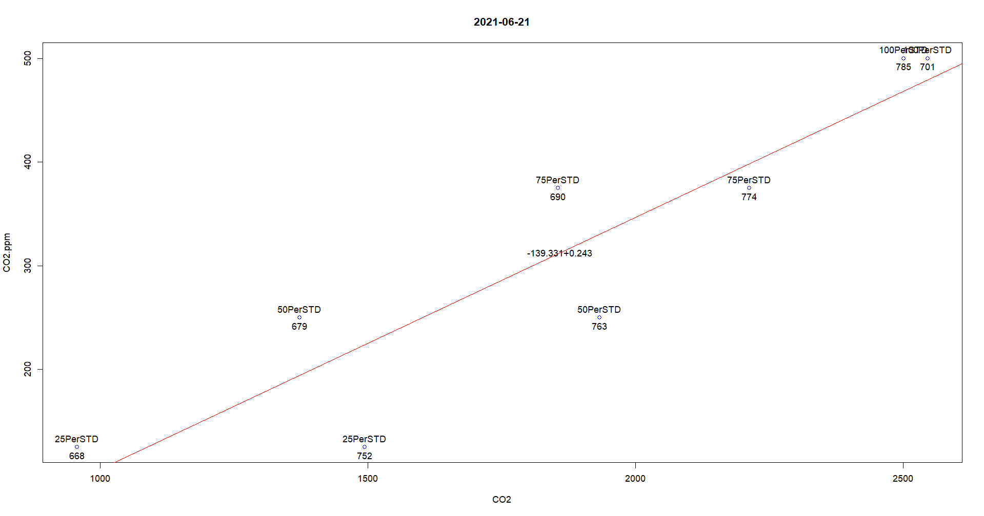

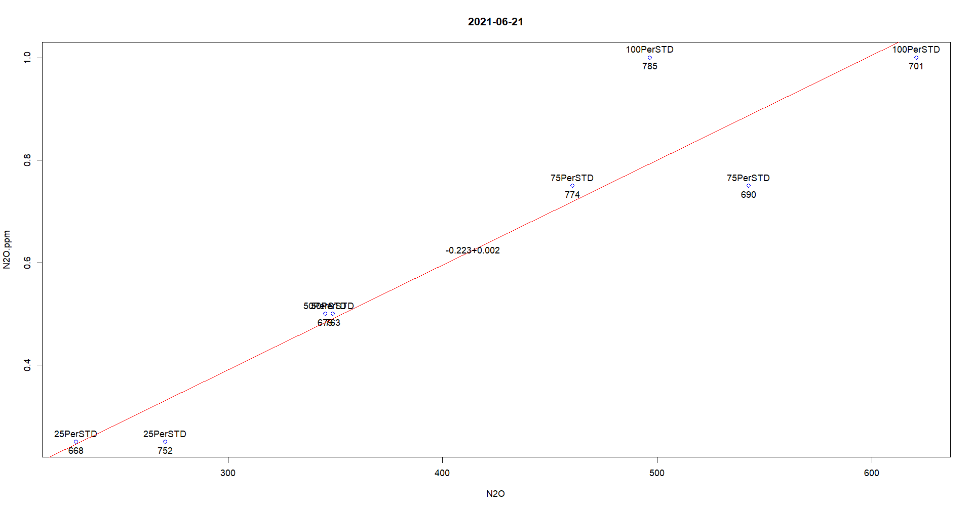

2021-06-23
Outlier 945
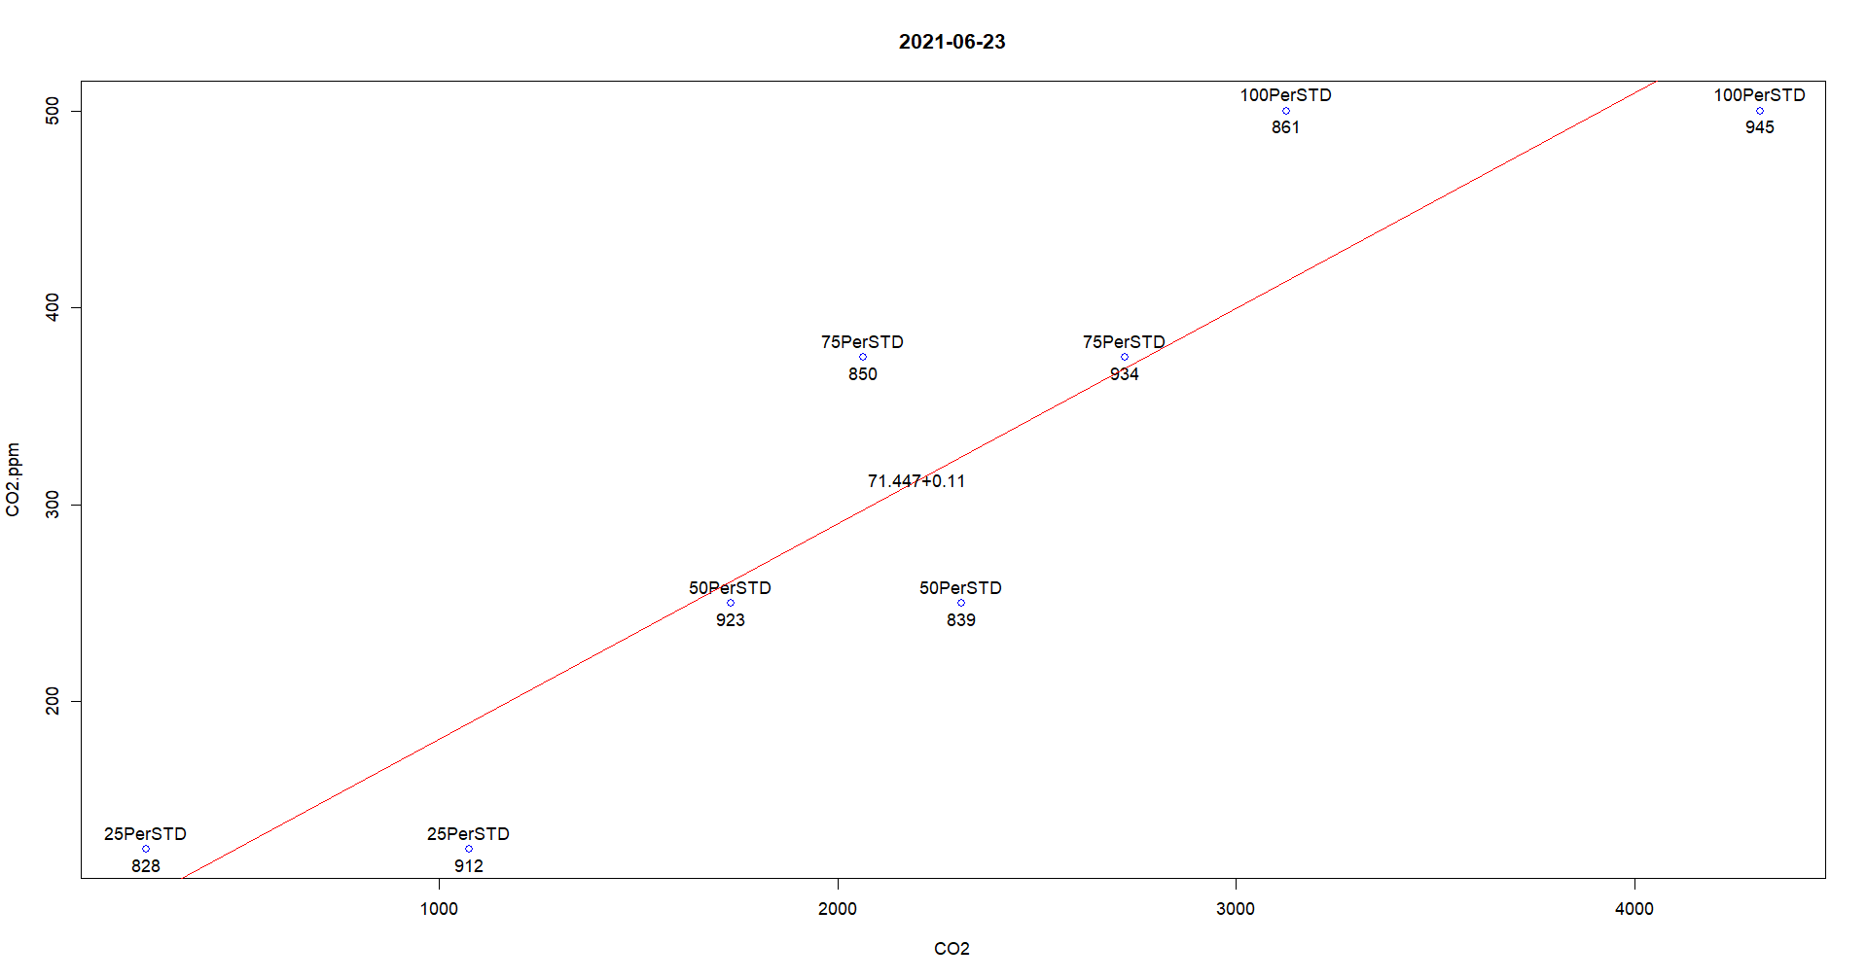
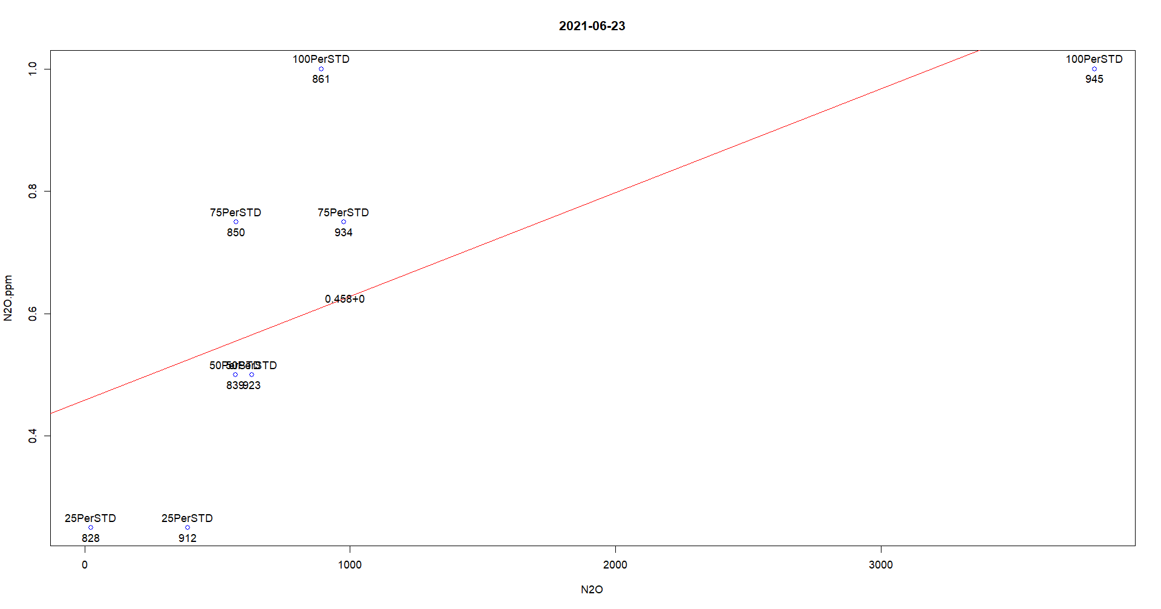
Remove 945

2021-06-29
Outliers 1091 , 1113
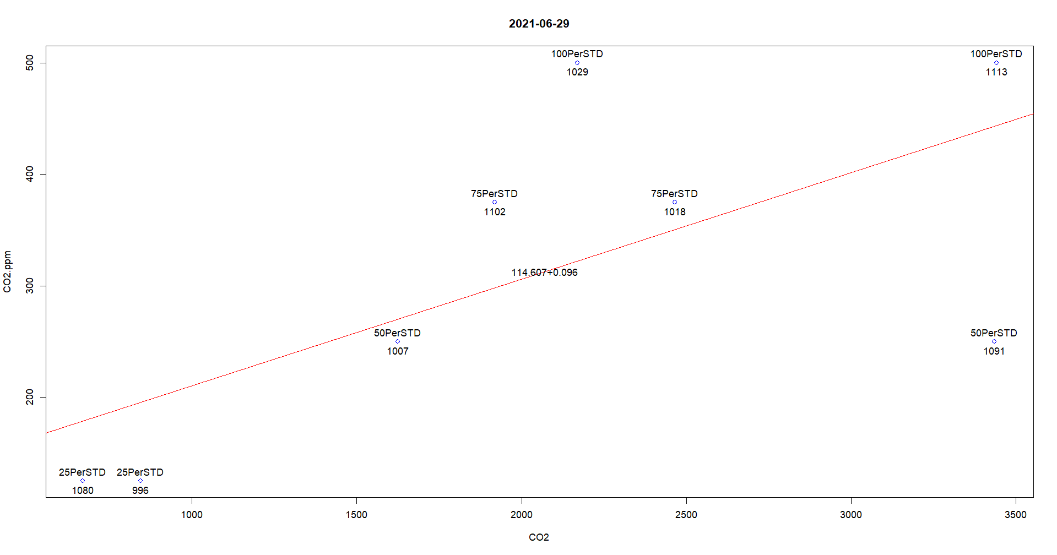
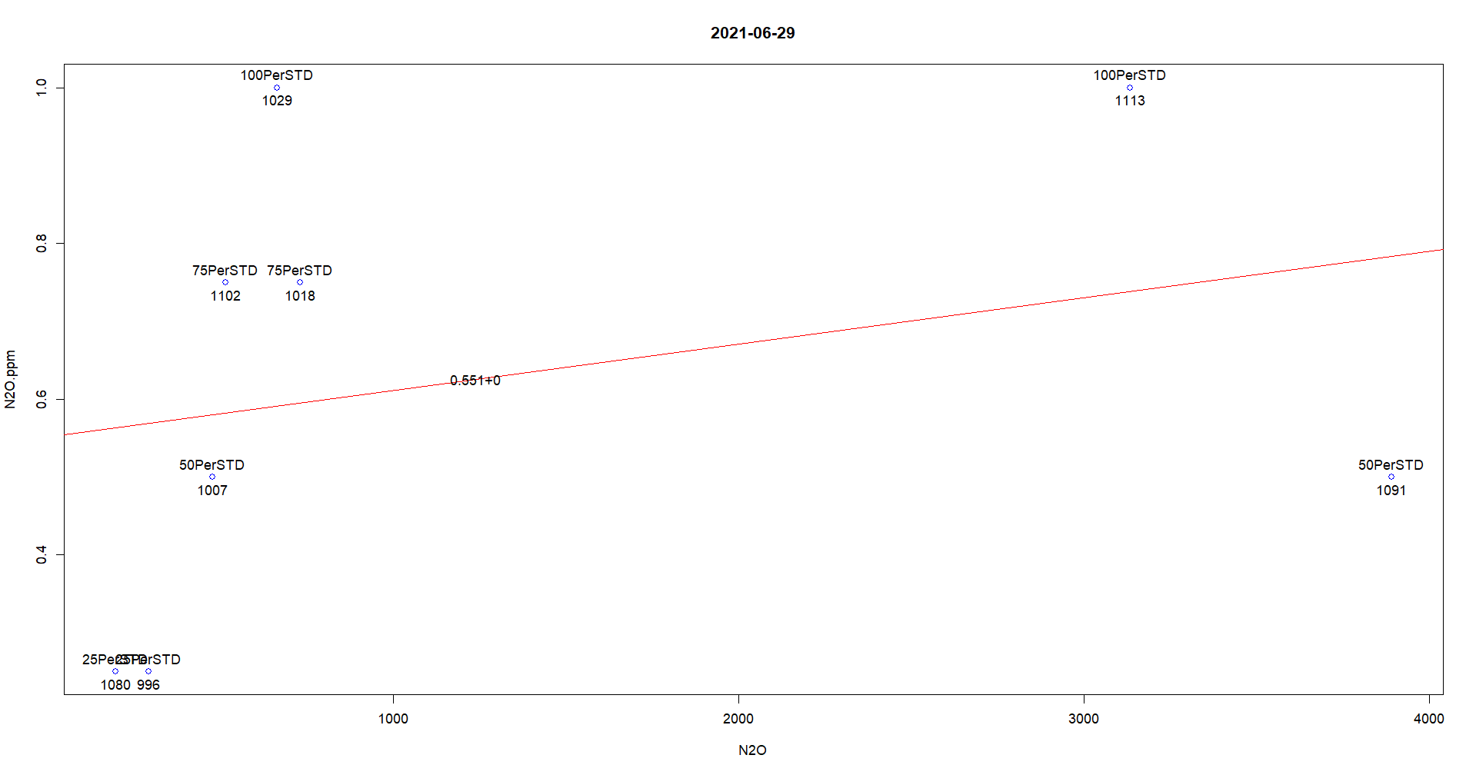
Removed 1091, 1113

2021-07-02
Ok
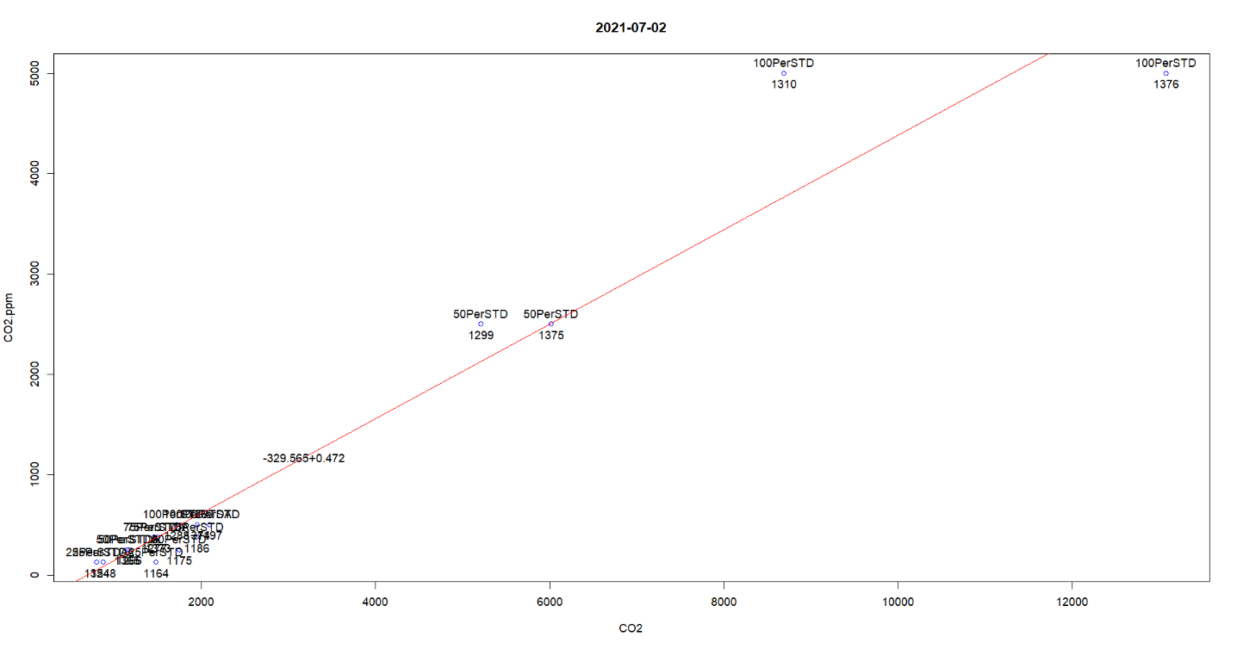
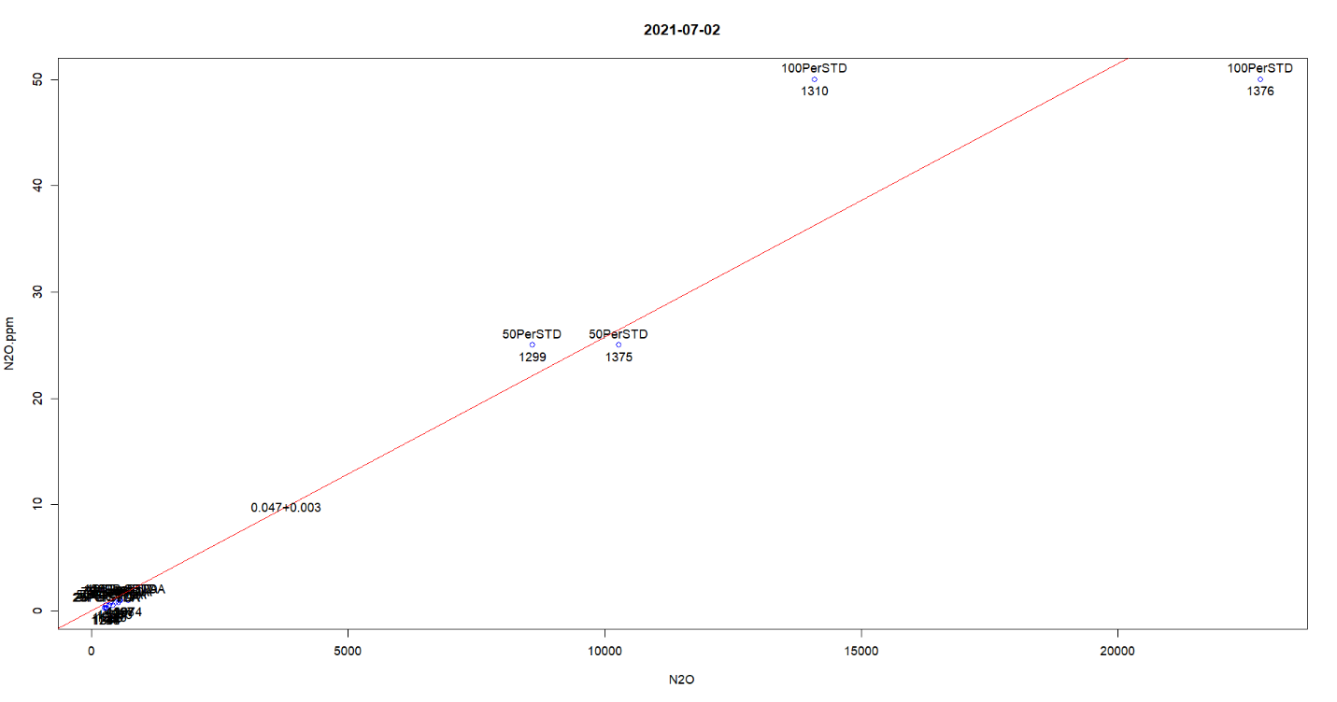

2021-07-07
2021-07-07 Missing 20210702b3b407b2peakareas.pdf ????
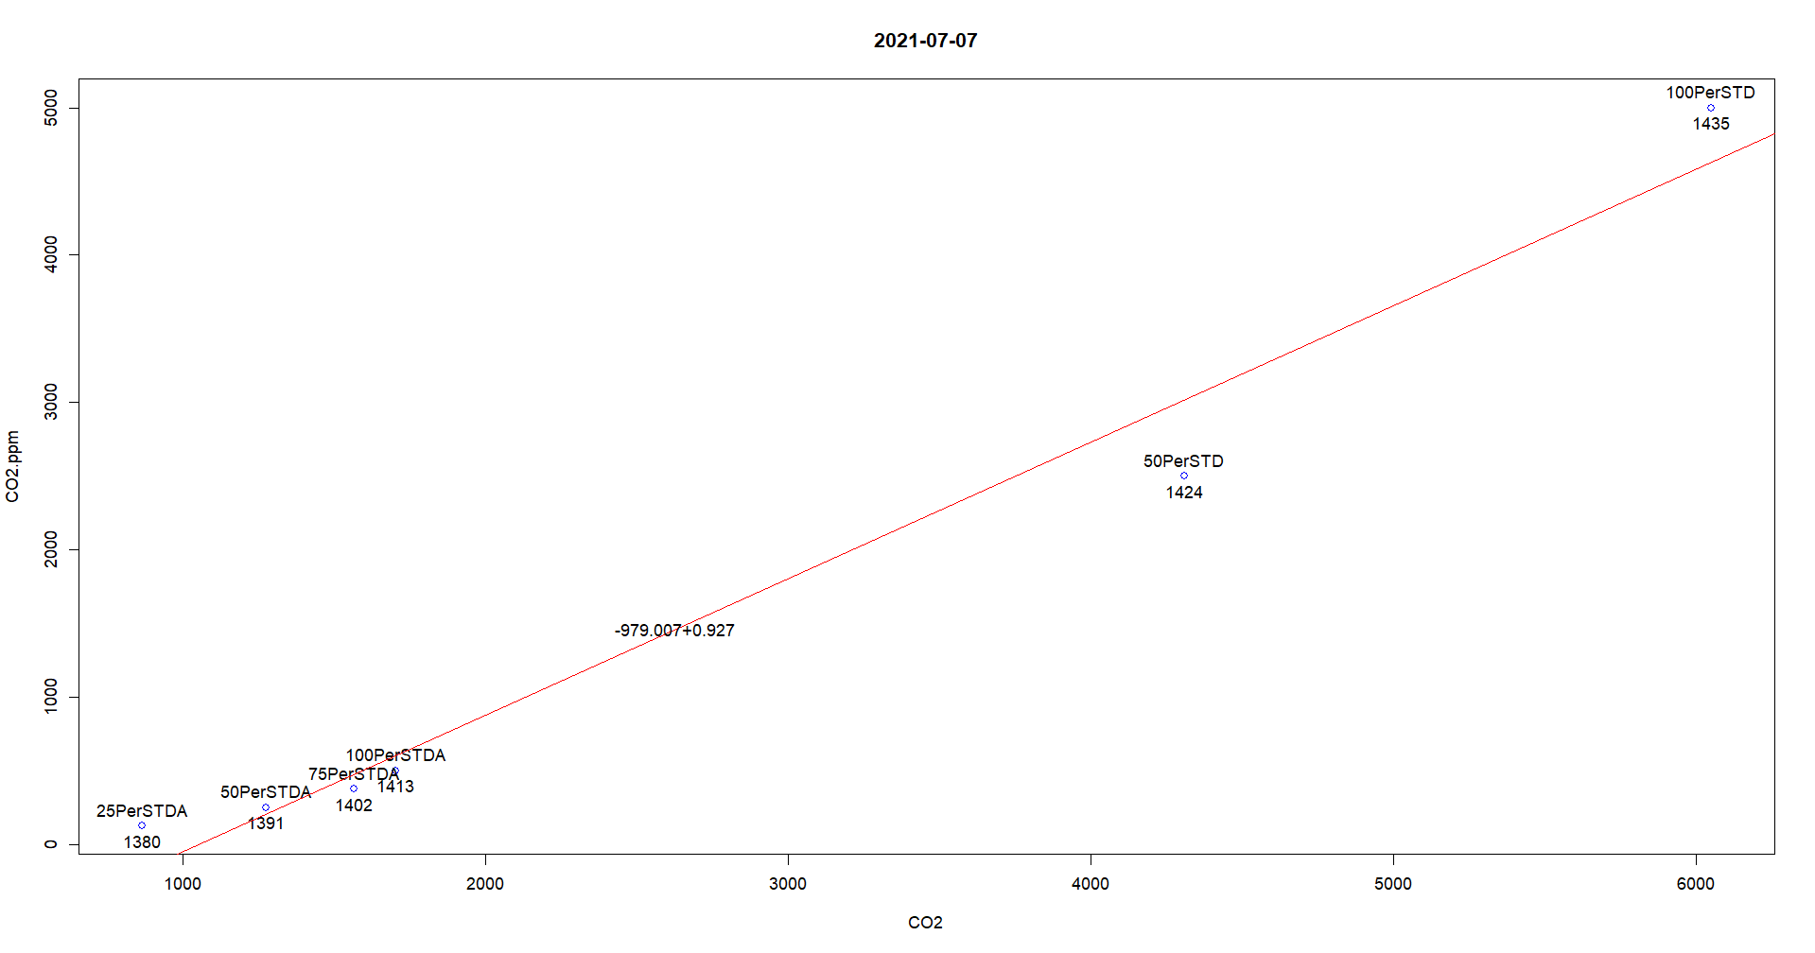
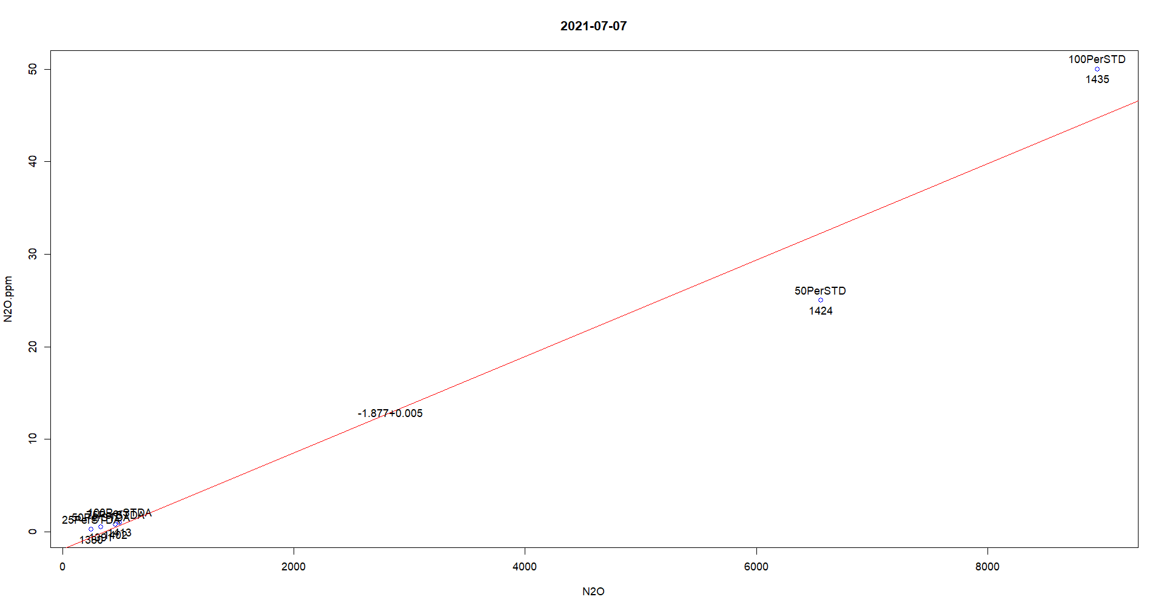
Records 1424 and 1435 are strange. They are from a new standard. And are strangely consistent

2021-07-15
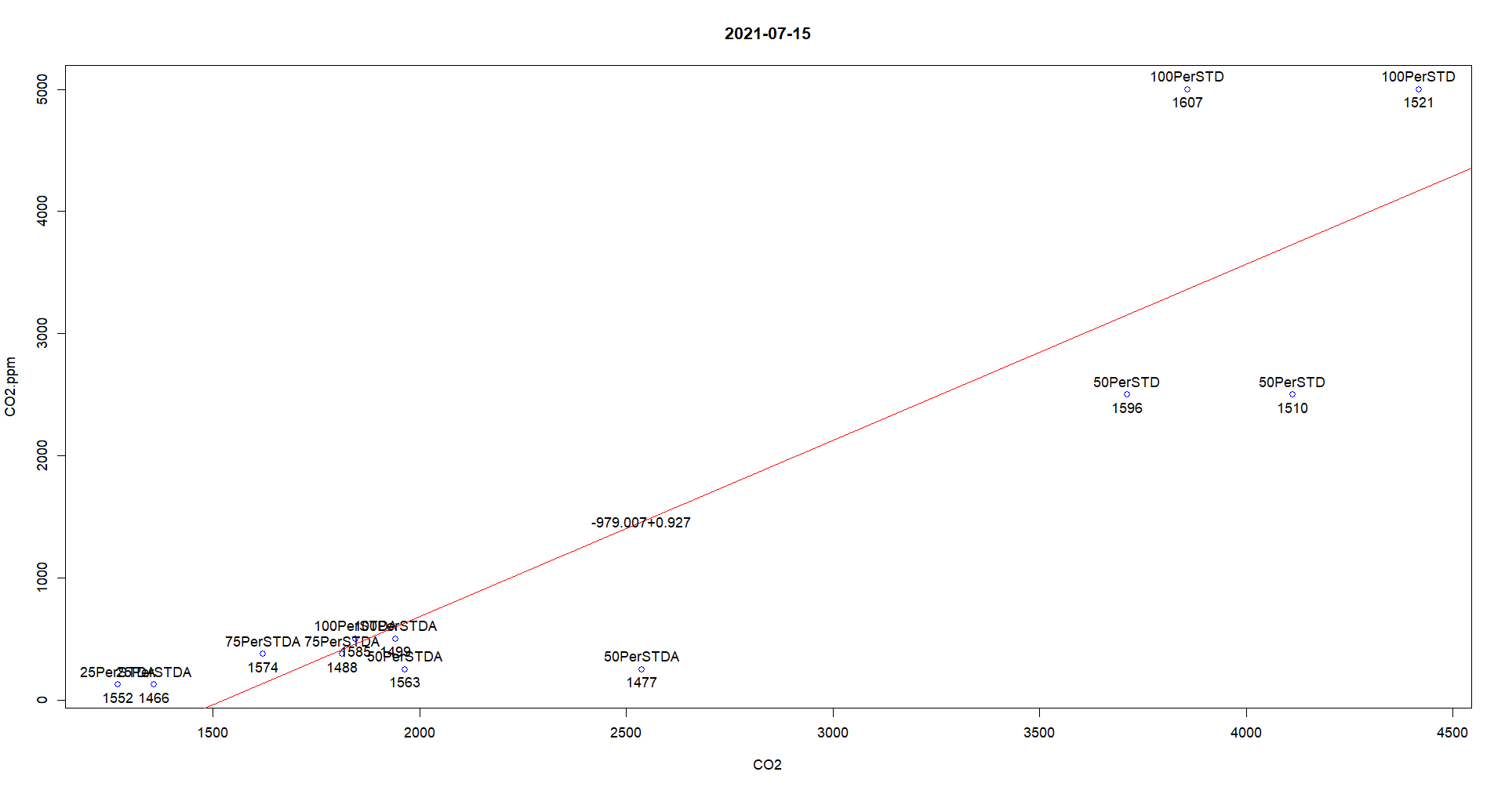
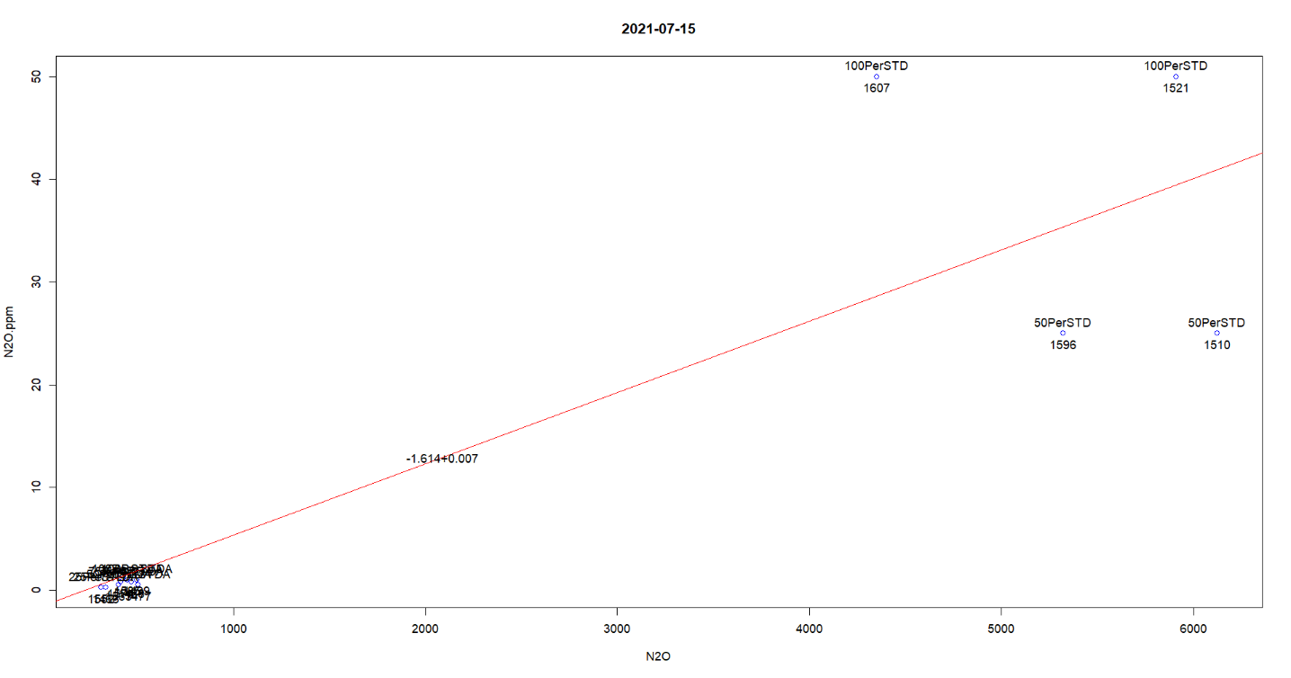
Records 1510, 1521, 1596 , 1607 and 1435 are strange. They are from a new standard. And are strangely consistent.

2021-07-20
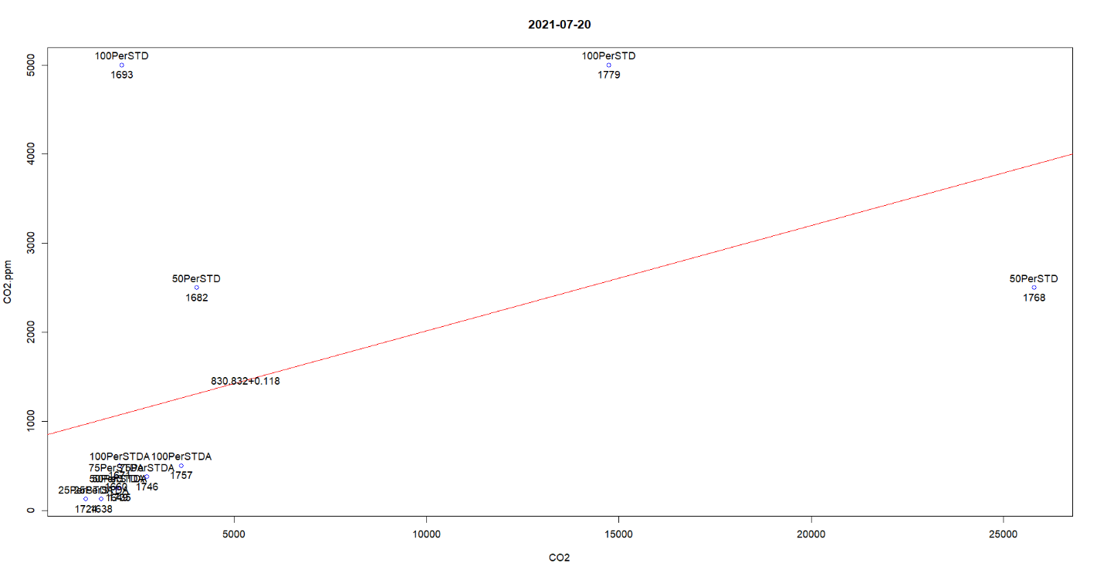
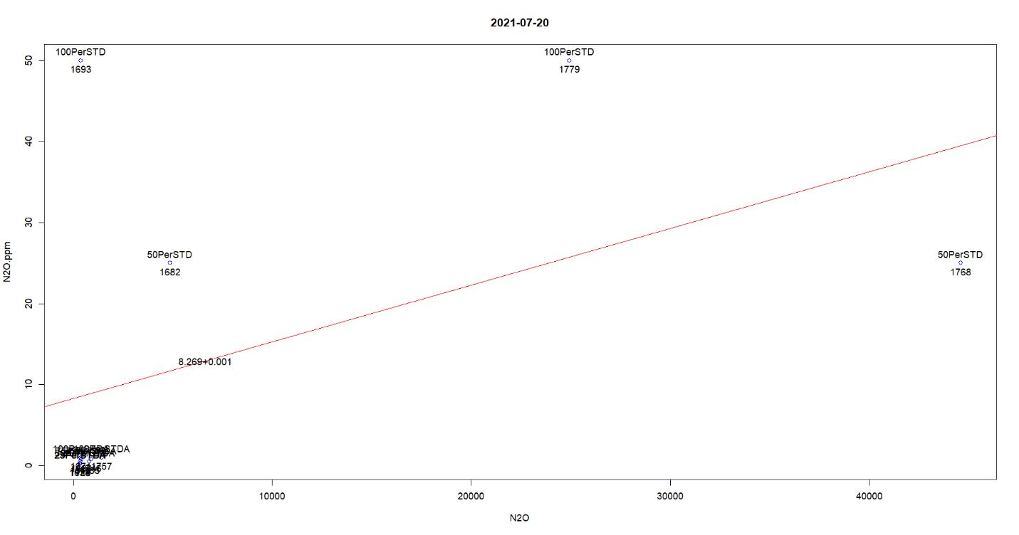
1768 and 1779 seemed switched; 50 is 100 and 100 is 50.
1693 and 1682 are way off
2021-07-30
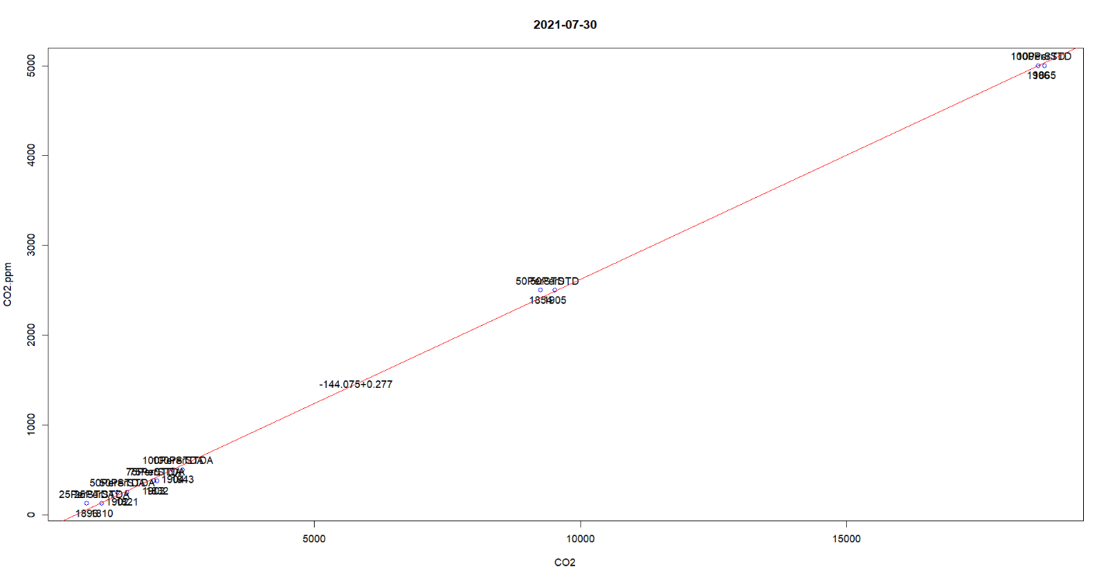
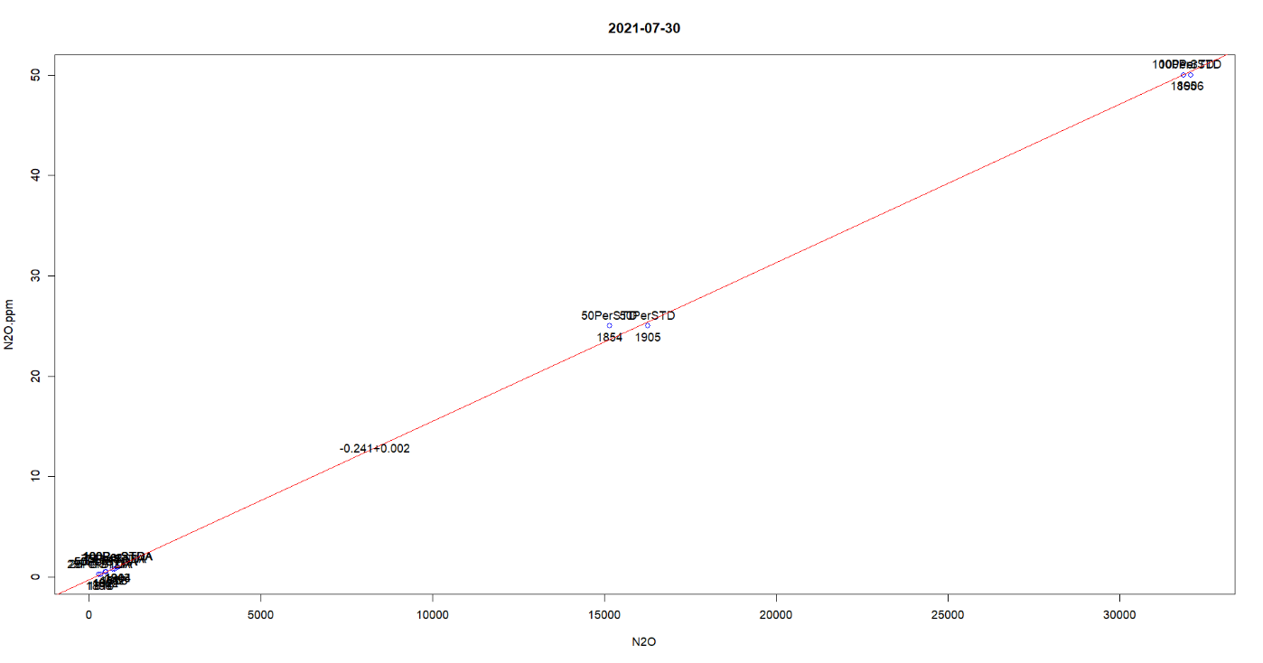
OK

2021-08-05
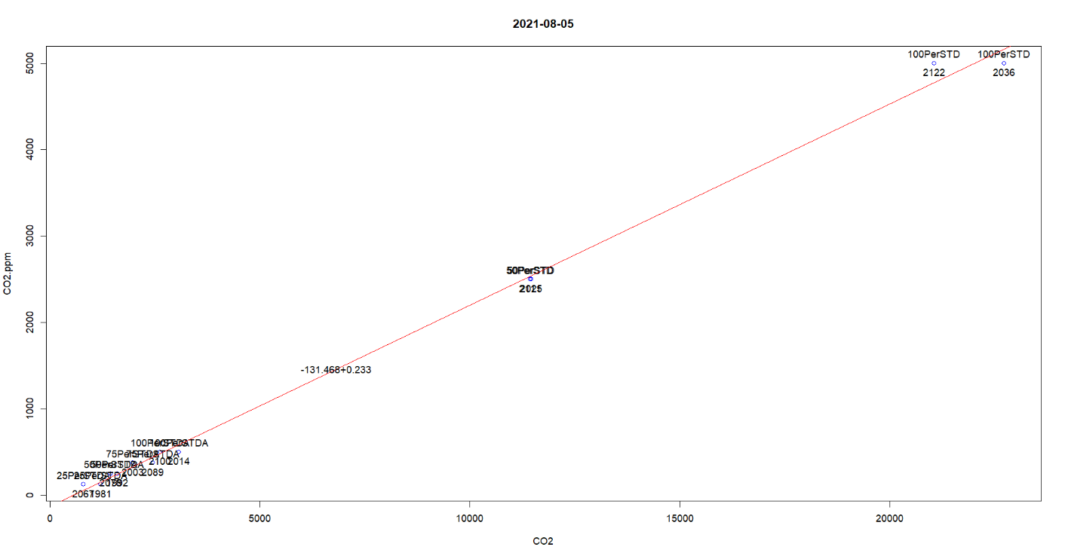
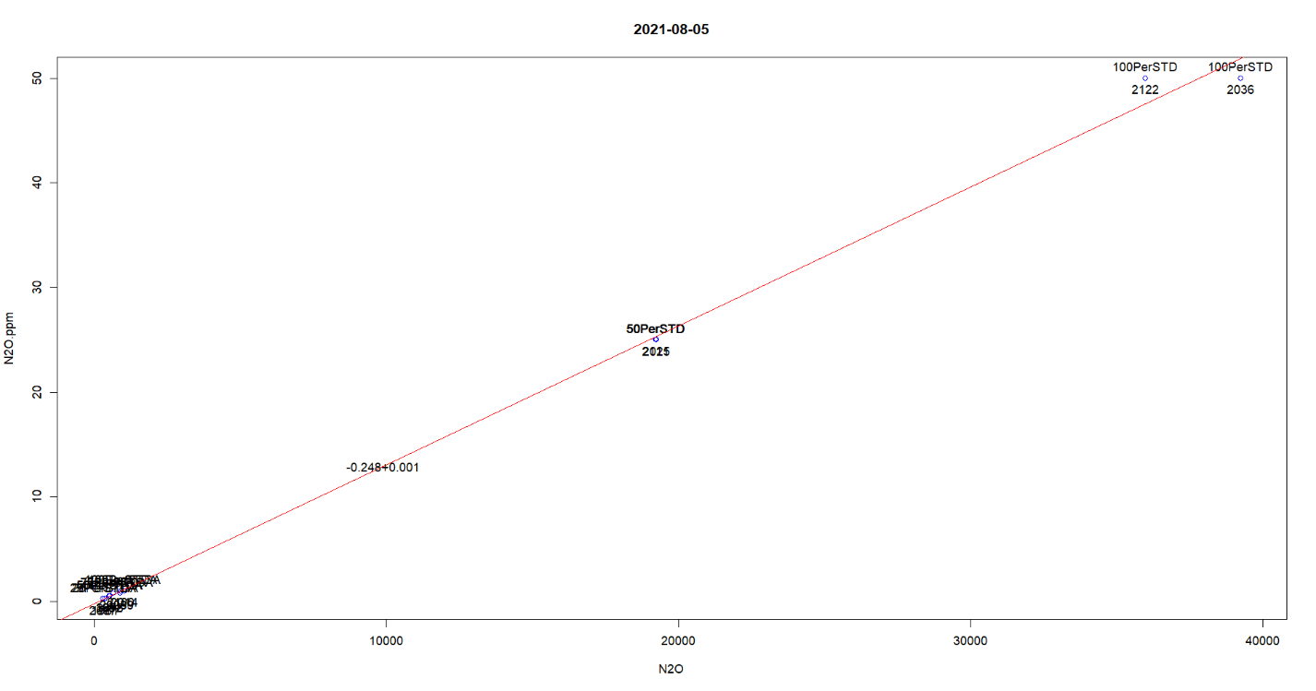
OK

2021-08-12
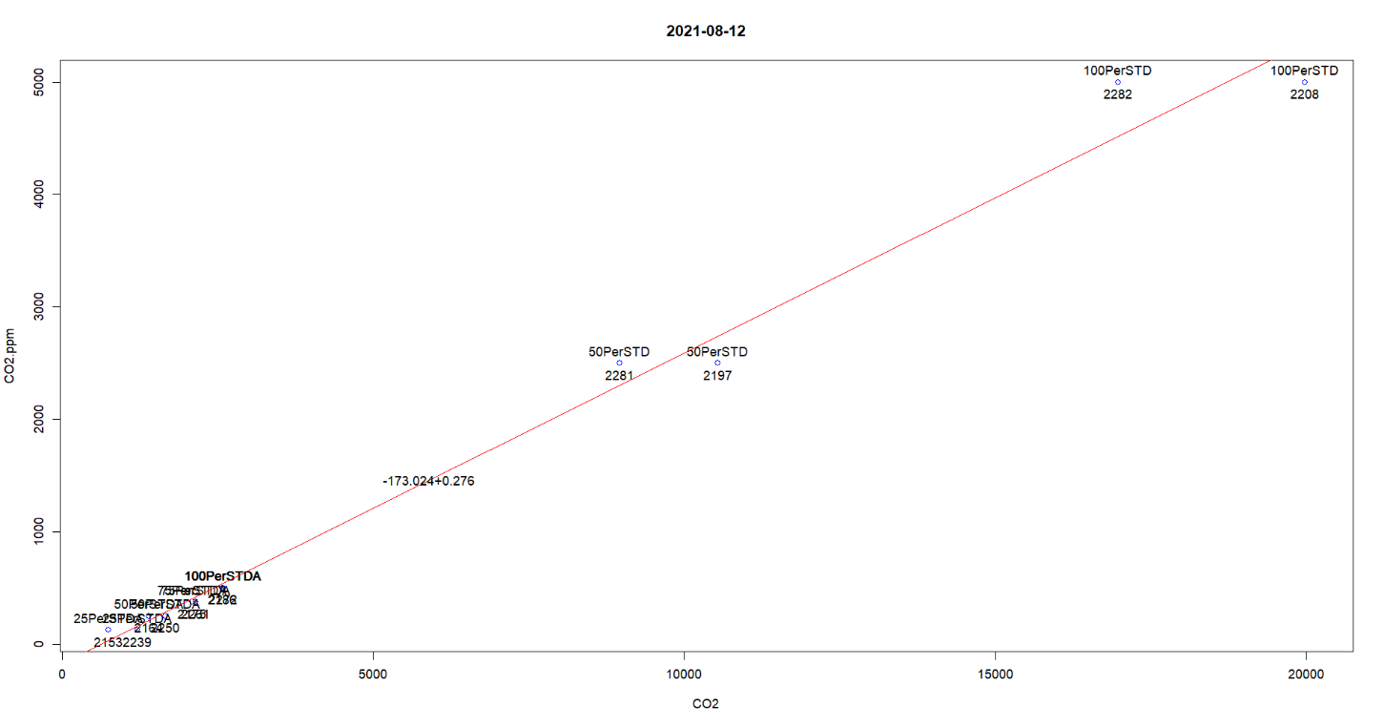
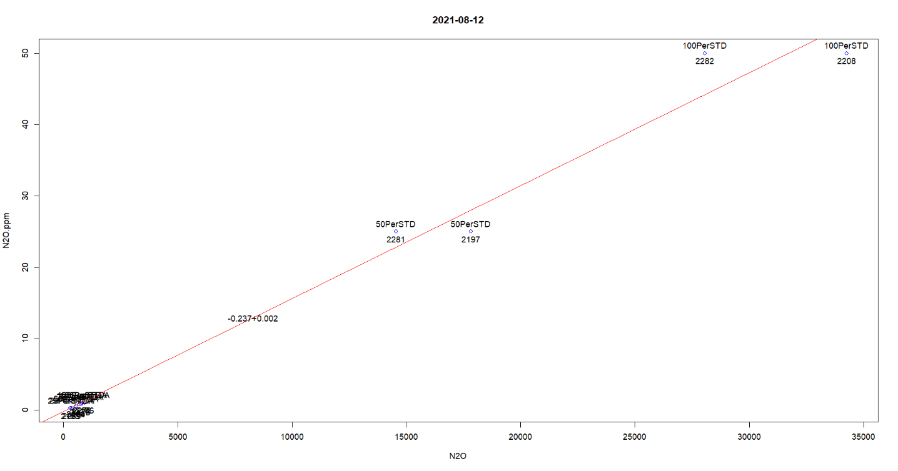
OK

2021-08-19
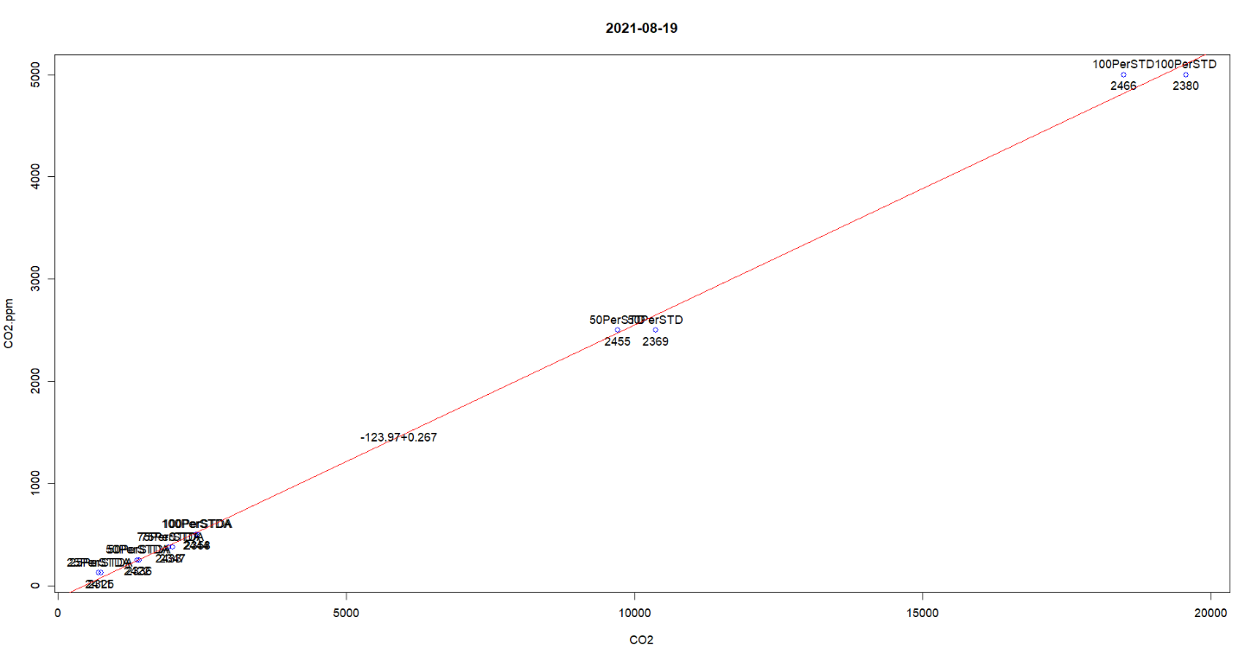
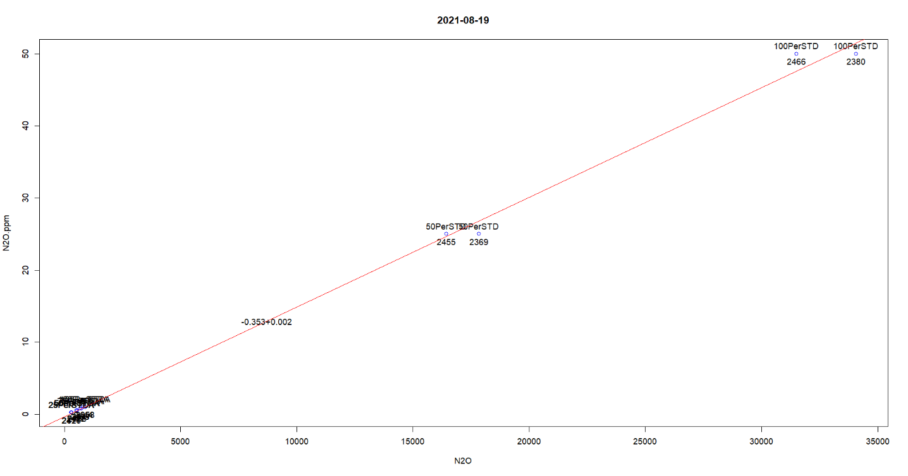
OK

2021-09-02
Record 2638 is an outlier
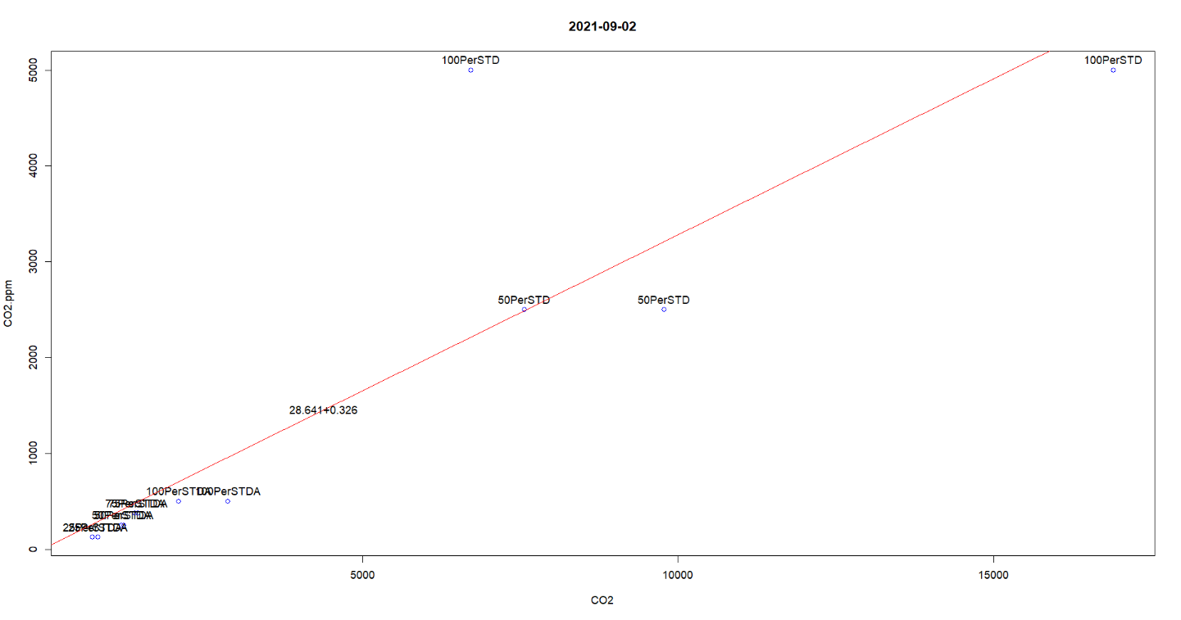
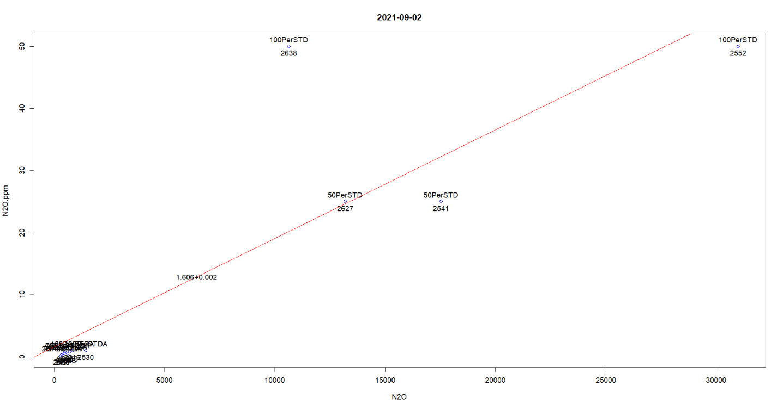
Remove outlier row name 2638

2021-09-17
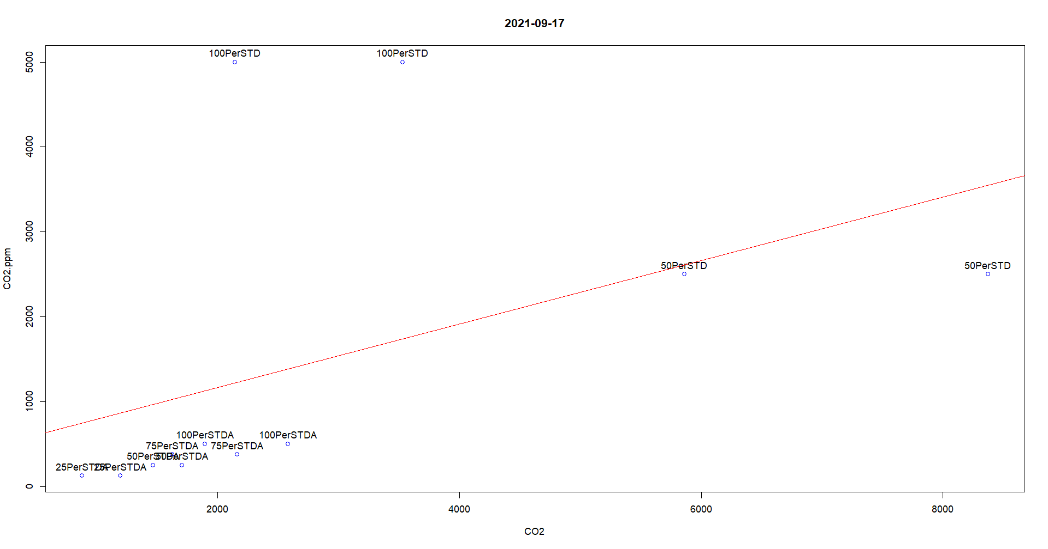
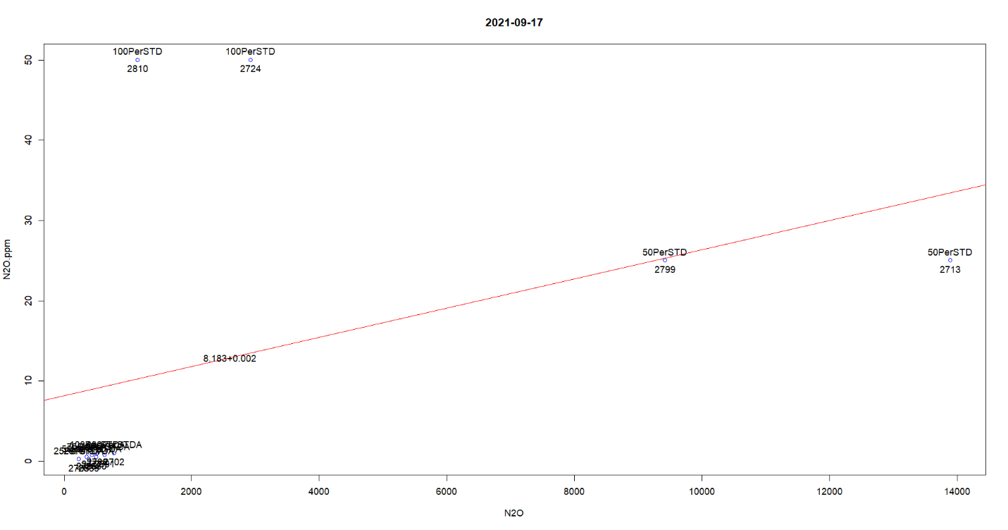
Switch records 2810, 2724, 2799 and 2713

2021-09-29
20210929B1B2peakareas1 is missing!!!!!!!!
20210929B1B2peakareas2 is missing!!!!!!!!
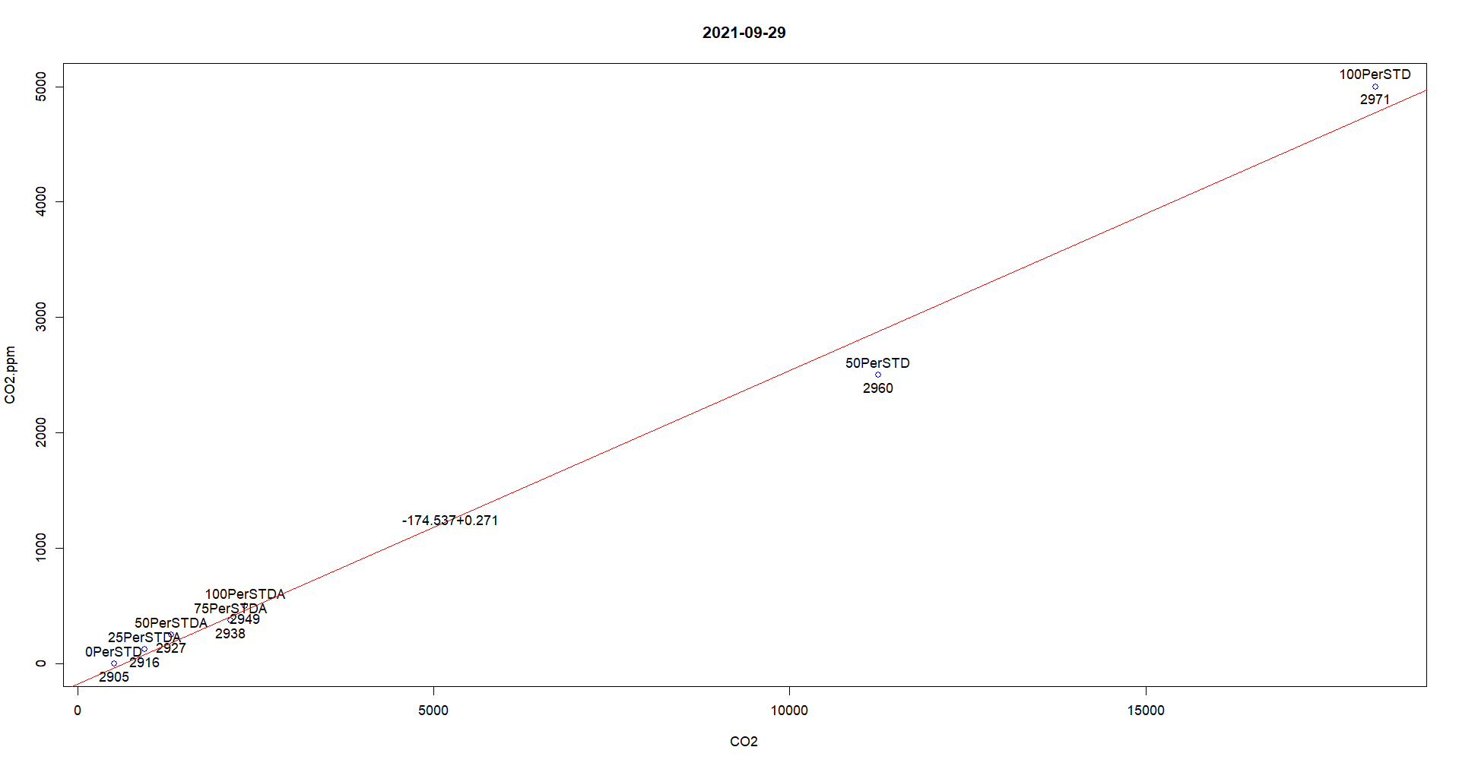
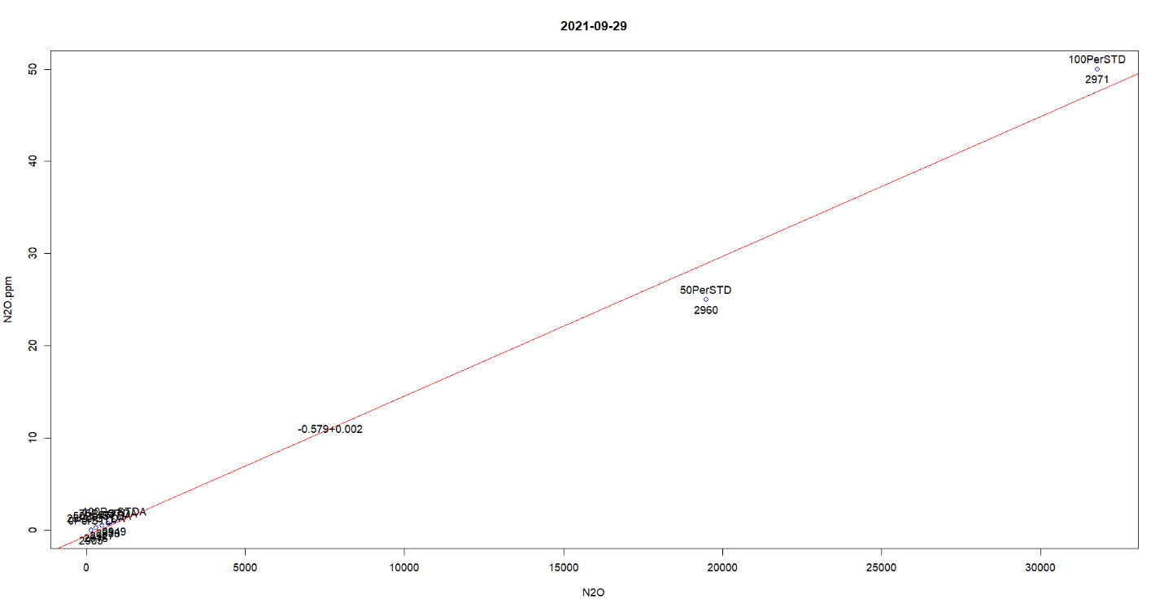
20210929B1B2peakareas1 is missing!!!!!!!!
20210929B1B2peakareas2 is missing!!!!!!!!

2021-10-27
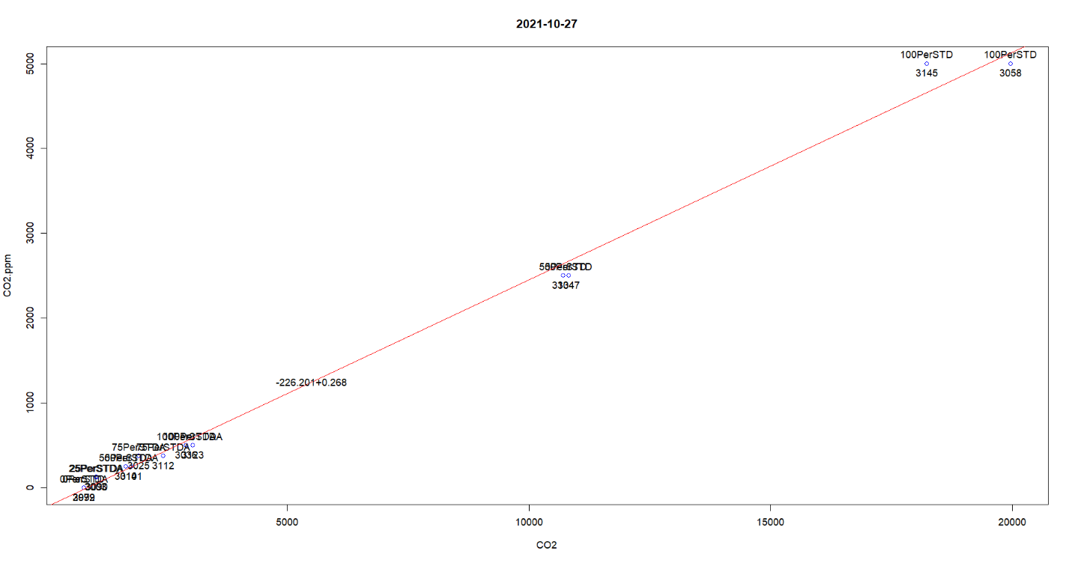
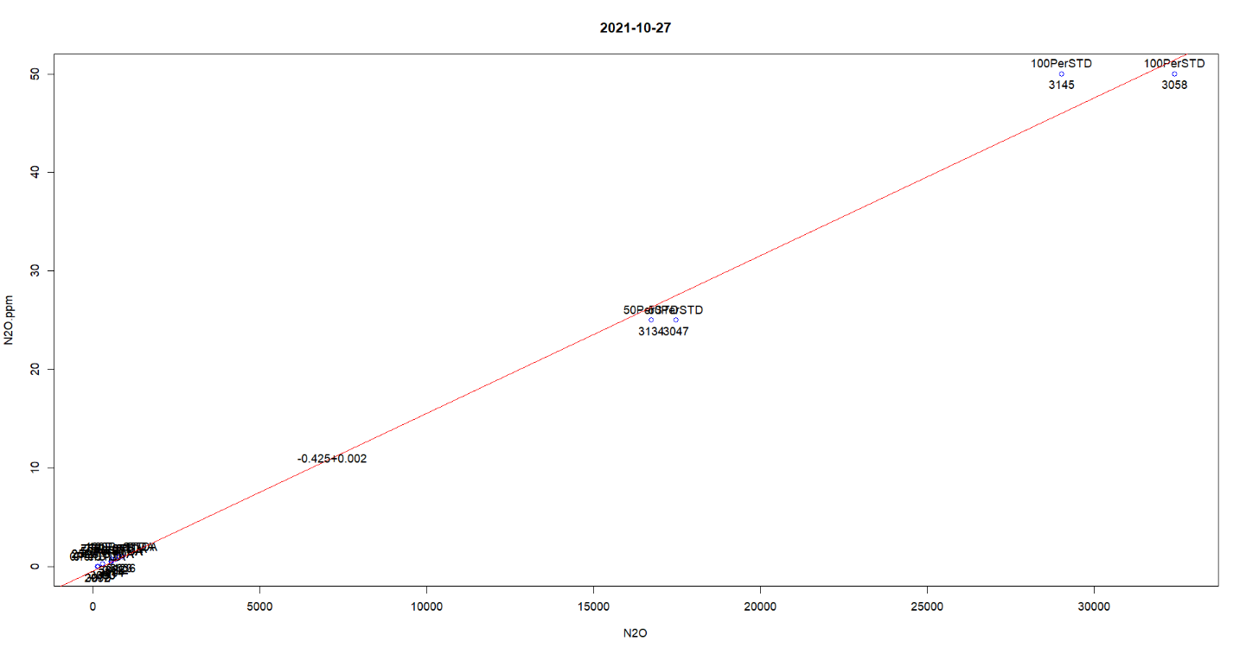
OK

Standards for 2021 and 2022 have been curated and now are ready to be processed.

Final Calibration Sets for 2021
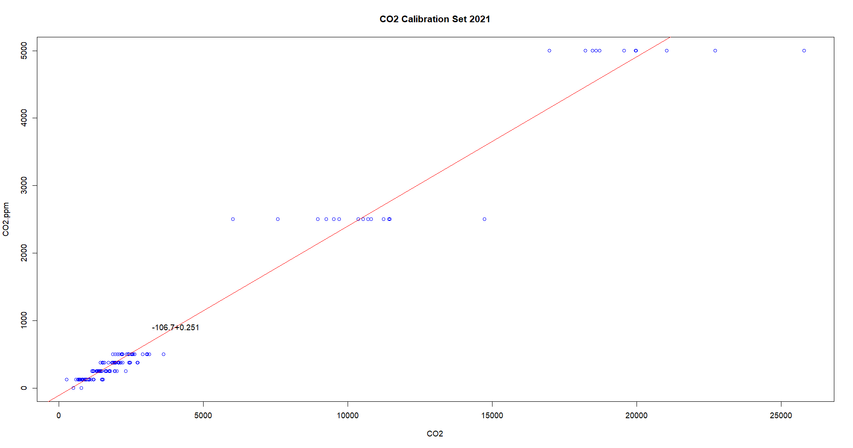
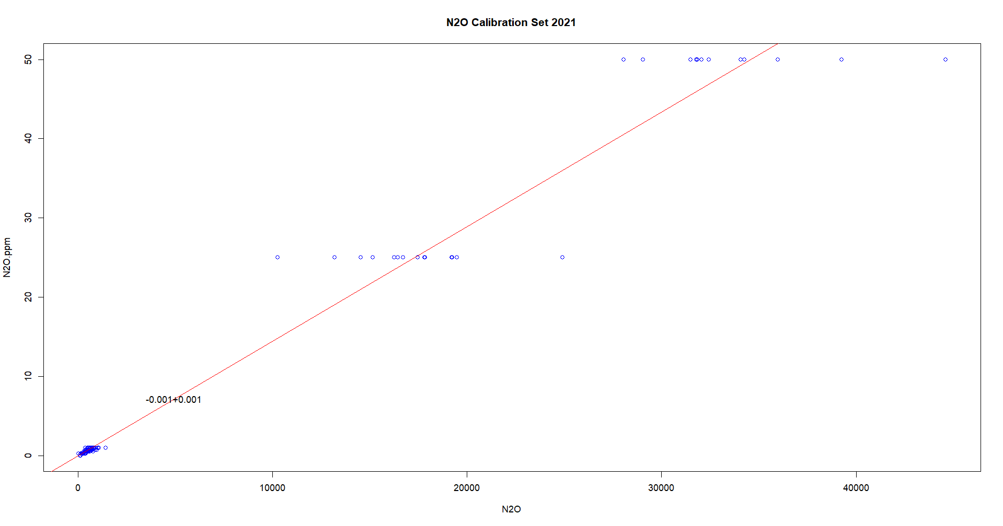

Final Calibration Curves
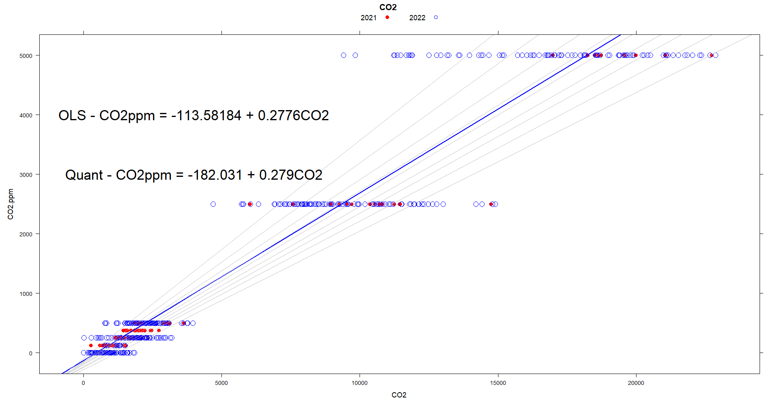
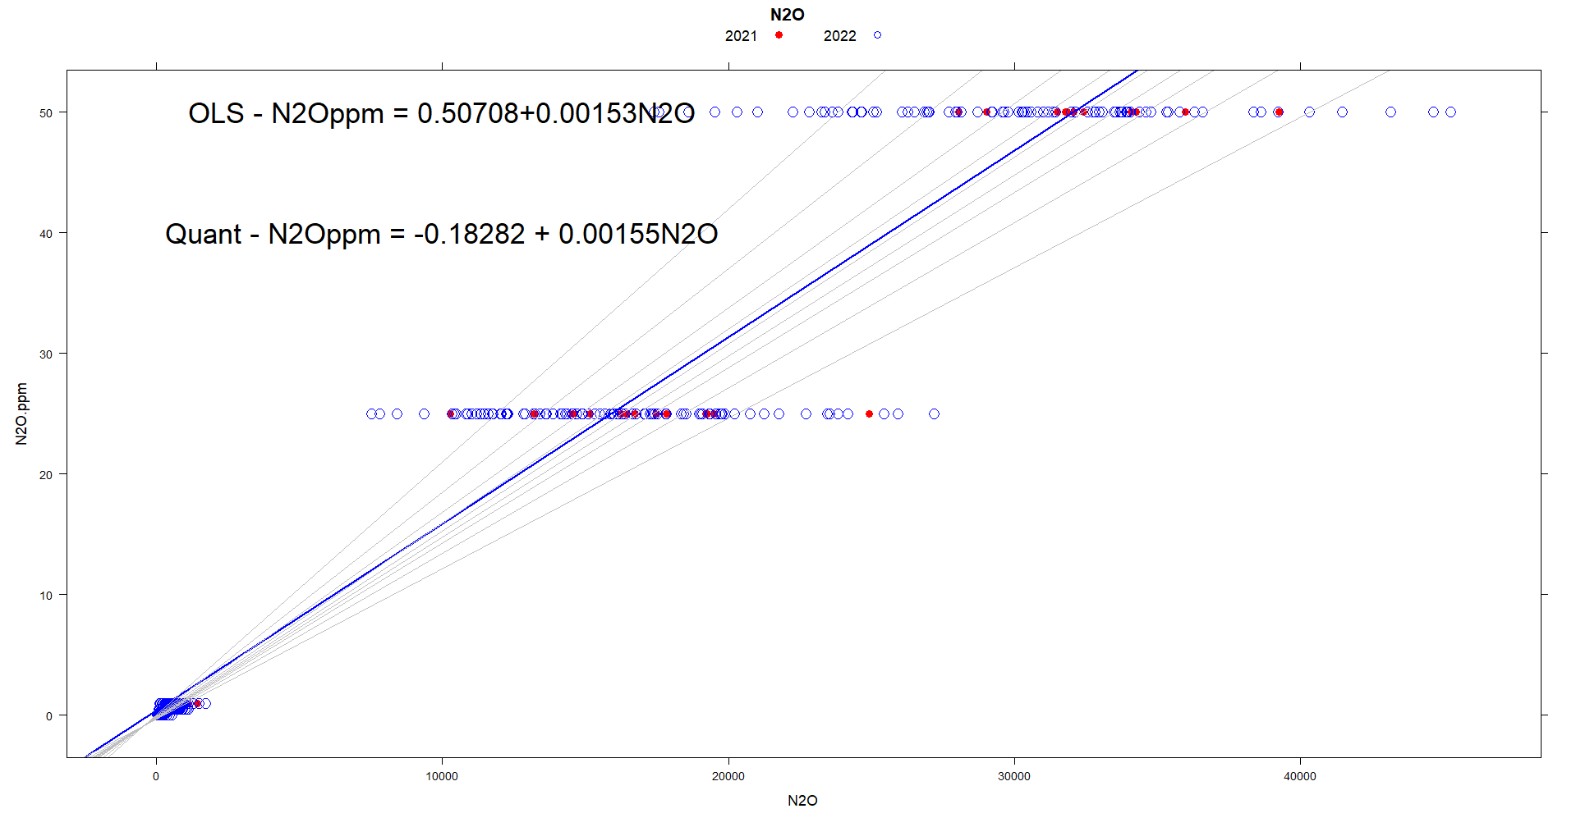
duplicated measurements are in 20210614B1B2summaryreport1.pdf and in 20210614B1B2peakareasMERGED.pdf ###################################

#### The 20210614B1B2peakareasMERGED.pdf GC analysis was done on 06/30/2021 and the 20210614B1B2peakareasMERGED.pdf on 07/01/2021
### Comparing the two data sets 20210614B1B2summaryreport1.pdf and 20210614B1B2peakareasMERGED.pdf #############
### The data are identical, one of the data sets can be removed ####
### 20210614B1B2peakareasMERGED.pdf is removed ###

20210929B1B2peakareas1 is missing!!!!!!!! -> has an GC run problem and has been removed
20210929B1B2peakareas2 is missing!!!!!!!! -> was removed by mistake when 20210929B1B2peakareas1 was removed. This error has been corrected

