How to Download and Configure LM Studio
Step 1: Download LM Studio Installer from browser
- Go to the following link: https://lmstudio.ai/download
- Choose OS, architecture, and Version
- Click Download
- Open Installer file .exe
- If you choose to download for personal user ex. “John” it will be installed in “C:\Users\John\AppData\Local\Programs\LM Studio” on your computer
If you choose to download for all users it will be saved in
“C:\Program Files\LM Studio”
- Confirm Download
- Run LM Studio either from start menu, or from .exe file
“C:\Users\timmy\AppData\Local\Programs\LM Studio\LM Studio.exe” if needed
Step 2: assessing hardware
- Click on the search icon in left hand panel.
- Then click on Hardware in mission control
- Under “Resource Monitor” view Ram + VRAM to use as number for VRAM Requirement below
VRAM Requirements (GB):

Q8 is 8 bits per byte, so 1B per 1GB, not counting other components needed to run inference. Q4 is half the usage, fp16 is double, etc.

LLM Size | Q8 | Q6 | Q5 | Q4 | Q3 | Q2 | Q1
---------|-------|-------|-------|-------|-------|-------|-------
3B | 3.3 | 2.5 | 2.1 | 1.7 | 1.3 | 0.9 | 0.6
7B | 7.7 | 5.8 | 4.8 | 3.9 | 2.9 | 1.9 | 1.3
8B | 8.8 | 6.6 | 5.5 | 4.4 | 3.3 | 2.2 | 1.5
9B | 9.9 | 7.4 | 6.2 | 5.0 | 3.7 | 2.5 | 1.7
12B | 13.2 | 9.9 | 8.3 | 6.6 | 5.0 | 3.3 | 2.2
13B | 14.3 | 10.7 | 8.9 | 7.2 | 5.4 | 3.6 | 2.4
14B | 15.4 | 11.6 | 9.6 | 7.7 | 5.8 | 3.9 | 2.6
21B | 23.1 | 17.3 | 14.4 | 11.6 | 8.7 | 5.8 | 3.9
22B | 24.2 | 18.2 | 15.1 | 12.1 | 9.1 | 6.1 | 4.1
27B | 29.7 | 22.3 | 18.6 | 14.9 | 11.2 | 7.4 | 5.0
33B | 36.3 | 27.2 | 22.7 | 18.2 | 13.6 | 9.1 | 6.1
65B | 71.5 | 53.6 | 44.7 | 35.8 | 26.8 | 17.9 | 11.9
70B | 77.0 | 57.8 | 48.1 | 38.5 | 28.9 | 19.3 | 12.8
74B | 81.4 | 61.1 | 50.9 | 40.7 | 30.5 | 20.4 | 13.6
105B | 115.5 | 86.6 | 72.2 | 57.8 | 43.3 | 28.9 | 19.3
123B | 135.3 | 101.5 | 84.6 | 67.7 | 50.7 | 33.8 | 22.6
205B | 225.5 | 169.1 | 141.0 | 112.8 | 84.6 | 56.4 | 37.6
405B | 445.5 | 334.1 | 278.4 | 222.8 | 167.1 | 111.4 | 74.3

Perplexity Divergence:

Metric | FP16 | Q8 | Q6 | Q5 | Q4 | Q3 | Q2 | Q1
------------------------|----------------------|--------------|------------|-----------|---------|--------|-------|------
Example chance of token | 12.1234567890123456% | 12.12345678% | 12.123456% | 12.12345% | 12.123% | 12.12% | 12.1% | 12%
Loss | 0% | 0.06% | 0.1 | 0.3 | 1.0 | 3.7 | 8.2 | 70≅%
https://www.reddit.com/r/ollama/comments/1hbleji/is_there_a_chart_thats_shows_for_xx_billion/

*Model Formats:
- Formats like GGUF, GPTQ, AWQ, EXL2 are all file formats for how the weights are stored within the single model folder.
- GGUF supports quantization, multiple architecture, and most importantly its ability to run entirely on the CPU or partially offload to the GPU.
https://www.reddit.com/r/LocalLLaMA/comments/1ayd4xr/for_those_who_dont_know_what_different_model/#:~:text=GGML%20and%20GGUF%20refer%20to,includes%20the%20complete%20static%20graph.
- LM Studio only supports GGUF models and MLX Models on Mac, therefore you will most likely only be using GGUF models through LM Studio on your local machine
Step 3: Choose and download a model
- Toggle on developer mode in bottom right hand corner
- Click magnifying glass “Discover” from left hand panel
- Once you see a pop-up window Click “Model Search” from left hand panel
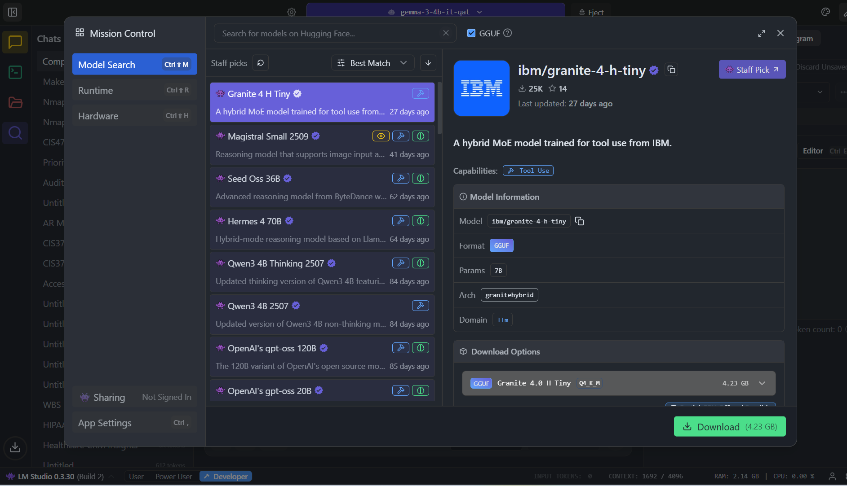
- Toggle the GGUF checkbox to the right of the search bar
- Now without typing any keyword in the search bar you will automatically see staff picked models by LM studio, recognized by the purple gamer icon next to it.
- Alternatively you can find a GGUF model of your choosing on Hugging face (https://huggingface.co/) such as “Qwen/Qwen3-0.6B-GGUF” and then search the model in the LM Studio “Model Search”. You can use the number of likes and downloads to verify it is the same one.
- Once you click on a model you will see a preview of the model’s information on the right. Here you can also see the download options available which may show different quantization versions of the model
- Depending on your hardware and the size of the models some “Download Options” may have warning labels next to them notifying you that the model may only use partial GPU processing or that the model is entirely too large for your machine
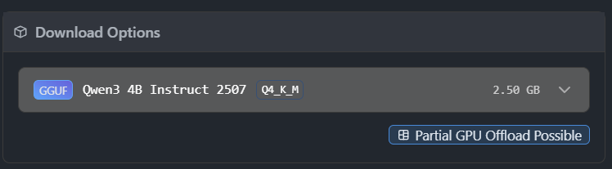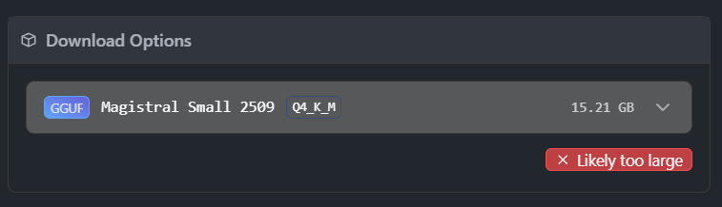
Step 4: Model Configurations
Change Context Length
  - Use Gear Icon to the left of your selected model at the top of your screen
System prompt
  - Use Wrench icon at top right corner of the screen to pull up model settings on the right panel of the screen
  - Click Context on top left of the panel to enter a system prompt to be used throughout your chat
Model settings
  - Temperature means the randomness of the answers
  - Toggle Response length to set a limit in tokens of the models response
  - Toggle All switch next to wrench icon within the right hand panel to show context overflow settings, choosing between the options of Rolling window, Truncate Middle, and Stop at limit

