ML Notes
Model Specifications:
Parameters: refers to how much information the model was trained on.
Ex.
- 1B low end
- 7B medium end
- 70B high end
Quantizaton: refers to how much dummer the original model is made to perform more efficiently, the lower the quantization the less accurate it is.
Ex.
- Int4 (4-bit) lowest precision and accuracy
- Int8 (8-bit)
- Float16 (16-bit)
- Float32 (32-bit) highest precision and accuracy

Parameter Count vs. Quantization
Model Type | Accuracy (Typical) | Speed | Memory Usage | Power Efficiency
Higher parameter, low quant (e.g. int8) | ✅ Often higher | ❌ Slower | ❌ More | ❌ Less efficient
Lower parameter, low quant (e.g. int8) | ❌ Lower | ✅ Faster | ✅ Less | ✅ More efficient
On low performance machines it is generally better to use high parameter models with lower quantization.

Model Structure (file format):
Model Folder: llama3-8b/
Filename | Size | Purpose (Keywords)
model-00001-of-00001.safetensors | ~15.0 GB | Model weights (SafeTensors format)
model.safetensors.index.json | ~176.9 KB | Index mapping for tensors
config.json | ~1.1 KB | Model architecture config
generation_config.json | ~136 B | Text generation parameters
tokenizer.model | ~2.1 MB | SentencePiece tokenizer model
tokenizer_config.json | ~38.6 KB | Tokenizer settings
special_tokens_map.json | ~98 B | Special token ID mapping
added_tokens.json | ~10.3 KB | Extra vocabulary tokens
act_scales.json | ~14.0 KB | Activation scaling factors (quantization)
weight_scales.json | ~13.5 KB | Weight scaling factors (quantization)
training_args.bin | ~2.9 KB | Training hyperparameters
Real Hugging face example: https://huggingface.co/Qwen/Qwen3-8B/tree/main
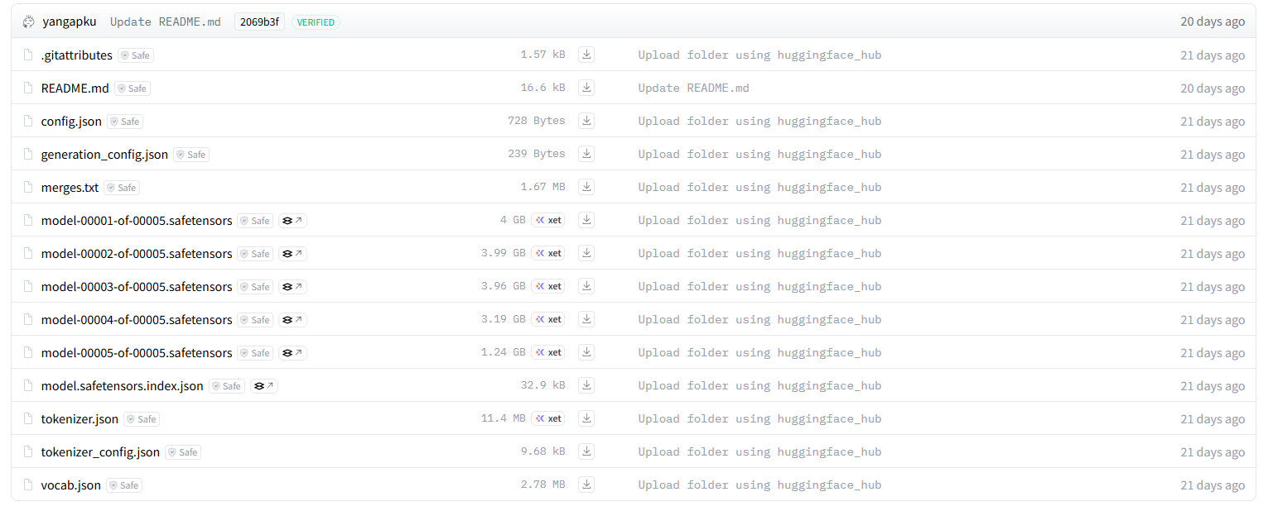

Popular Model Benchmarks:
Benchmark (test):
🧠 General Language Understanding
Benchmark | Description
GLUE | General Language Understanding Evaluation (sentence-level tasks).
SuperGLUE | Harder version of GLUE with more complex reasoning tasks.
MMLU | Massive Multitask Language Understanding (57 subjects, factual reasoning).
HELLASWAG | Commonsense reasoning for sentence completion.
ARC (AI2 Reasoning Challenge) | Science questions from elementary/middle school exams.
BoolQ | Yes/no questions with supporting context.

📚 Reading Comprehension & QA
Benchmark | Description
SQuAD | Stanford Question Answering Dataset (reading comprehension).
TriviaQA | QA benchmark based on trivia-style questions.
NaturalQuestions | Google’s QA dataset using real user questions.
DROP | Discrete reasoning over paragraphs (e.g., arithmetic, sorting).

💬 Multi-turn Dialogue / Instruction Following
Benchmark | Description
AlpacaEval | Measures instruction-following via GPT-4 comparisons.
MT-Bench | Multi-turn chatbot benchmark from LMSYS using Vicuna-style evaluation.
Flan Collection | Instruction-tuning datasets used for multitask evaluations.

🌍 Multilingual & Cross-lingual Understanding
Benchmark | Description
XGLUE | Cross-lingual tasks like NER, QA, and classification.
XTREME / XTREME-UP | Diverse multilingual tasks (QA, NLI, POS tagging, etc.).
FLORES | Machine translation across 100+ languages.

🧠 Reasoning & Math
Benchmark | Description
GSM8K | Grade-school level math word problems.
BigBench (BIG-bench) | Massive multitask benchmark including reasoning and logic.
TheoremQA | Evaluates mathematical proof generation and theorem understanding.
MathQA / MATH | Complex math problem-solving with step-by-step reasoning.

🧪 Emerging / Synthetic Benchmarks
Benchmark | Description
AGIEval | Tests LLMs on tasks like SAT, LSAT, GRE, and other real-world exams.
BBH (Big-Bench Hard) | Subset of BigBench with harder reasoning tasks.
Arena Hard Prompts | LMSYS’s head-to-head model evaluations with tough prompts.

Leaderboards:
- https://huggingface.co/spaces/open-llm-leaderboard/open_llm_leaderboard#/
- https://lmarena.ai/?leaderboard

