  - Technical Report

Hadoop Cluster Using Docker
C00326346 – Felipe Tapanes Gonzalez

Overview
This report covers the deployment of an Apache Hadoop environment using Docker Compose, running on macOS (Apple Silicon). Multi-node Bigtop images are not available for Apple Silicon, so a standard Docker Hadoop image set (bde2020/hadoop-*) was used to implement the required HDFS + YARN cluster. This still provides a multi-node Hadoop environment with NameNode, DataNodes and YARN services, so the design and operations demonstrated here are equivalent to those that would be implemented using Bigtop. If I were working on an Intel/Linux host, I would have used Bigtop as originally specified, but on Apple Silicon this alternative was the most practical way to meet the assignment requirements using docker.
The goal is to create a containerized HDFS and YARN environment that supports:
- Multi-Node HDFS (NameNode + 2 DataNodes)
- A working YARN compute layer (ResourceManager + NodeManager)
- HDFS data ingestion
- Execution of jobs
The Final architecture is five docker containers, each running a dedicated Hadoop service

Phase 0: Environment Setup

Install Docker
Docker Desktop was installed and validated for macOS:
docker run hello-world

Resource allocation:
Docker Desktop – Settings – Resources:
- 4 CPUs
- 4 GB RAM
- 1 GB Swap

Create Project Directory:
- Hadoop_Docker_Cluster/
  - data/ #Local csv mounted into NameNode
  - report/
  - docker-compose.yml
  - Hadoop.env #Cluster config

The Data directory is accessible inside the namenode container as /data

Phase 1: Deployment Using Docker Compose
The final docker-compose.yml defines all five nodes and persistent volumes for HDFS.

NameNode
- Exposes ports 9870 (UI) and 9000 (HDFS RPC)
- Persists metadata in the hadoop_namenode Docker volume
- Mounts the local data/ directory into /data inside the container

DataNode
Both DataNodes wait until the NameNode UI port is reachable:
SERVICE_PRECONDITION=namenode:9870
Once connected, they appear under http://localhost:9870 which will show the two data nodes as 2 live nodes.

Yarn Nodes
- ResourceManager (port 8088) receives submitted jobs
- NodeManager executes them
- They wait for each other using service preconditions
YARN UI available at http://localhost:8088

Environment Configuration
All Hadoop containers share a single environment configuration file hadoop.env.
This file applies cluster-wide settings that control how HDFS and YARN behave. These variables dynamically generate the Hadoop XML configuration files inside each container.

Key Environment Variables
CORE_CONF_fs_defaultFS=hdfs://namenode:9000
- Defines the filesystem for all nodes.
- Ensures every container (NameNode, DataNodes, ResourceManager, NodeManager) connects to the same HDFS master.
HDFS_CONF_dfs_replication=2
- Sets HDFS replication factor to 2.
- Guarantees DataNode1 and DataNode2 both store copies of each block.
HDFS_CONF_dfs_permissions_enabled=false
- Disables HDFS permissions.
- Allows root (and any user) full access without needing to create Hadoop users.
- Prevents permission errors during data ingestion and MapReduce jobs.
HDFS_CONF_dfs_replication=2
- The replication factor is set to 2. This means that each block of data will have 2 copies across the DataNodes.
- Replication is for fault tolerance. If one DataNode fails, the second copy keeps the data available.

Purpose of Using a Shared Environment File
- Ensures consistent configuration across all five containers
- Allows Hadoop XML configs to be set automatically through environment variables, avoiding manual editing

Node Startup
Start up the cluster:

docker compose up -d

check all 5 nodes are up and healthy:

docker ps

Check that the NameNode UI (9870) and ResourceManager UI (8088) both show healthy services:

http://localhost:9870
http://localhost:8088

show both DataNodes, capacity, and replication status:

hdfs dfsadmin -report

Phase 2: HDFS Interactions

Verification
On the mac terminal access the NameNode with:
docker exec -it namenode bash

Verify HDFS directories:
hdfs dfs -ls /

Upload a CSV
CSV placed in local data/ folder appears inside the container as /data/mydata.csv In this case a csv file was created from scratch but any csv file can be uploaded.
Upload to HDFS:
hdfs dfs -mkdir /input
hdfs dfs -put /data/mydata.csv /input
Check:
- hdfs dfs -ls /input

- ps aux | grep -E "NameNode|DataNode|ResourceManager|NodeManager"
  - the above command is used to check if the services are running

Phase 3: Functionality Showcase
To show the functionality of the cluster a map reduce word count job was run on the uploaded csv

WordCount Execution
First we clean all existing outputs
hdfs dfs -rm -r -f /output
if we are in safe mode remove safe mode and try again. First, we check
hdfs dfsadmin -safemode get
Then we remove if it is on
hdfs dfsadmin -safemode leave
Then we run the word count
hadoop jar $HADOOP_HOME/share/hadoop/mapreduce/hadoop-mapreduce-examples-*.jar wordcount /input/mydata.csv /output
This triggers:
- ResourceManager → job submission
- NodeManager → execution
- DataNodes → block reads
- Results written back into HDFS

Viewing Results
- hdfs dfs -cat /output/part-r-00000
Example output:
- hello 3
- felipe 1
- data 2
Job progress and logs appear in YARN UI (port 8088).

Phase 4: Cluster Shutdown
Stop cluster:
docker compose down
Restart later:
docker compose up -d
Because DataNodes and NameNode use Docker volumes, all HDFS data persists after shutdown. YARN nodes don’t need volumes as they do not store data and persistent information

Conclusion
A fully operational 5-container Hadoop cluster was successfully deployed using Docker Compose. The design faithfully separates storage (HDFS) from compute (YARN), mirroring real-world distributed systems.
This environment supports:
- Multi-node distributed HDFS storage
- HDFS replication factor of 2
- YARN scheduling
- MapReduce job execution
- Host → container → HDFS data ingestion
- Persistent and restart-safe volumes
The project demonstrates practical understanding of:
- Distributed filesystem architecture
- Docker-based infrastructure automation
- YARN job lifecycle and scheduling
- MapReduce processing workflows
- Inter-container networking and orchestration
In real-world Hadoop environments, YARN NodeManagers and HDFS DataNodes often run on the same physical machines. However, in this Docker-based deployment, each service runs in its own separate container. This separation makes it easier to observe and demonstrate the individual responsibilities of each component in the cluster.
Using Docker together with a shared environment configuration file provides an easily reproducible setup and allows the cluster’s behaviour, status, and interactions to be examined clearly and consistently.
The containerised design used in this project is fully modular and can be extended with additional Hadoop ecosystem components. For example, services such as Hive (for SQL-style querying) or Apache Spark could be added by adding their respective Docker images into the Compose configuration. Overall, the flexibility of Docker makes it an excellent environment for experimenting with different Hadoop components and rapidly testing cluster configurations without the overhead of traditional VM-based setups.

Appendix A: Cluster Diagram

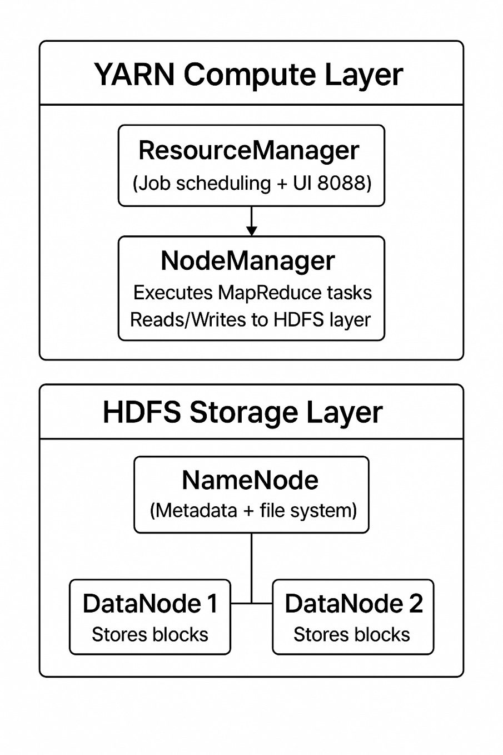
Figure 1 Architecture of the 5-container Hadoop cluster

Appendix B: docker-compose.yml
services:
namenode:
image: bde2020/hadoop-namenode:2.0.0-hadoop3.2.1-java8
container_name: namenode
hostname: namenode
restart: always
ports:
- "9870:9870" # HDFS NameNode web UI
- "9000:9000" # HDFS RPC (fs.defaultFS)
volumes:
- hadoop_namenode:/hadoop/dfs/name
- ./data:/data
environment:
- CLUSTER_NAME=test-cluster
- CORE_CONF_fs_defaultFS=hdfs://namenode:9000
env_file:
- ./hadoop.env

datanode1:
image: bde2020/hadoop-datanode:2.0.0-hadoop3.2.1-java8
container_name: datanode1
hostname: datanode1
restart: always
volumes:
- hadoop_datanode1:/hadoop/dfs/data
environment:
- SERVICE_PRECONDITION=namenode:9870
- CORE_CONF_fs_defaultFS=hdfs://namenode:9000
env_file:
- ./hadoop.env

datanode2:
image: bde2020/hadoop-datanode:2.0.0-hadoop3.2.1-java8
container_name: datanode2
hostname: datanode2
restart: always
volumes:
- hadoop_datanode2:/hadoop/dfs/data
environment:
- SERVICE_PRECONDITION=namenode:9870
- CORE_CONF_fs_defaultFS=hdfs://namenode:9000
env_file:
- ./hadoop.env

resourcemanager:
image: bde2020/hadoop-resourcemanager:2.0.0-hadoop3.2.1-java8
container_name: resourcemanager
hostname: resourcemanager
restart: always
ports:
- "8088:8088" # YARN ResourceManager web UI
environment:
- YARN_CONF_yarn_resourcemanager_hostname=resourcemanager
- CORE_CONF_fs_defaultFS=hdfs://namenode:9000
- SERVICE_PRECONDITION=namenode:9870
env_file:
- ./hadoop.env
depends_on:
- namenode
- datanode1
- datanode2

nodemanager:
image: bde2020/hadoop-nodemanager:2.0.0-hadoop3.2.1-java8
container_name: nodemanager
hostname: nodemanager
restart: always
environment:
- YARN_CONF_yarn_resourcemanager_hostname=resourcemanager
- CORE_CONF_fs_defaultFS=hdfs://namenode:9000
- SERVICE_PRECONDITION=resourcemanager:8088
env_file:
- ./hadoop.env
depends_on:
- resourcemanager
- namenode
- datanode1
- datanode2

volumes:
hadoop_namenode:
hadoop_datanode1:
hadoop_datanode2:

Appendix C: hadoop.env
CORE_CONF_fs_defaultFS=hdfs://namenode:9000
HDFS_CONF_dfs_replication=2
HDFS_CONF_dfs_namenode_name_dir=file:///hadoop/dfs/name
HDFS_CONF_dfs_datanode_data_dir=file:///hadoop/dfs/data
HDFS_CONF_dfs_permissions_enabled=false

Appendix D: mydata.csv
id, name, amount
1, Alice, 10
2, Bob, 15
3, Charlie, 12
4, Dave, 18
5, Elaine, 22
6, Frank, 17
7, Grace, 19
8, Hank, 14
9, Ivy, 16
10, John, 21
11, Jacob, 21
12, Jade, 28
13, Alex, 62
14, Felipe, 26
15, John, 19
16, Felipe, 26
17, Holly, 17
18, Frank, 26
19, Rosy, 30
20, Felipe, 26

