PUC MINAS

MESTRE: Theldo Cruz Franqueira

ALUNO: Rafael Pereira Vilefort

**01.) Fazer as conversões de decimal para binário:**

01a.) manualmente (em arquivo texto)

a.) 26(10) = X(2)

26/2 = 13 = 0

13/2 = 6 = 1

6/2 = 3 = 0

3/2 = 1 = 1

1/2 = 0 = 1

11010(2)

b.) 55(10) = X(2)

55/2 = 27 = 1

27/2 = 13 = 1

13/2 = 6 = 1

6/2 = 3 = 0

3/2 = 1 = 1

1/2 = 0 = 1

110111(2)

c.) 713(10) = X(2)

713/2 = 356 = 1

356/2 = 178 = 0

178/2 = 89 = 0

89/2 = 44 = 1

44/2 = 22 = 0

22/2 = 11 = 0

11/2 = 5 = 1

5/2 = 2 = 1

2/2 = 1 = 0

1/2 = 0 = 1

1011001001(2)

d.) 312(10) = X(2)

312/2 = 156 = 0

156/2 = 78 = 0

78/2 = 39 = 1

39/2 = 18 = 1

18/2 = 9 = 0

9/2 = 4 = 1

4/2 = 2 = 0

2/2 = 1 = 0

1/2 = 0 = 1

100101100(2)

e.) 366(10) = X(2)

366/2 = 183 = 0

183/2 = 91 = 1

91/2 = 45 = 1

45/2 = 22 = 1

22/2 = 11 = 0

11/2 = 5 = 1

5/2 = 2 = 1

2/2 = 1 = 0

1/2 = 0 = 1

101101110(2)

01b.)

a.)26(10) = X(2)

/*

Guia_0101.v

*/

module Guia_0101;

// define data

integer x = 26; // decimal

reg [7:0] b = 0; // binary

// actions

initial

begin : main

$display ( "Guia_0101 - Tests" );

$display ( "x = %d" , x );

$display ( "b = %8b", b );

b = x;

$display ( "b = %8b", b );

end // main

endmodule // Guia_0101

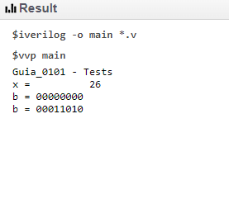

b.) 55(10) = X(2)

/*

Guia_0101.v

*/

module Guia_0101;

// define data

integer x = 55; // decimal

reg [7:0] b = 0; // binary

// actions

initial

begin : main

$display ( "Guia_0101 - Tests" );

$display ( "x = %d" , x );

$display ( "b = %8b", b );

b = x;

$display ( "b = %8b", b );

end // main

endmodule // Guia_0101

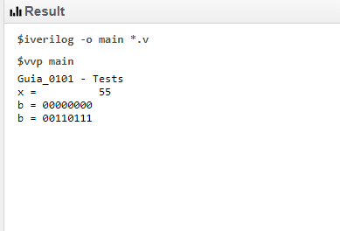

c.) 713(10) = X(2)

/*

Guia_0101.v

*/

module Guia_0101;

// define data

integer x = 713; // decimal

reg [9:0] b = 0; // binary

// actions

initial

begin : main

$display ( "Guia_0101 - Tests" );

$display ( "x = %d" , x );

$display ( "b = %8b", b );

b = x;

$display ( "b = %8b", b );

end // main

endmodule // Guia_0101

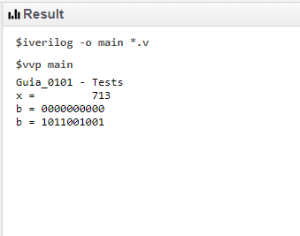

d.) 312(10) = X(2)

/*

Guia_0101.v

*/

module Guia_0101;

// define data

integer x = 312; // decimal

reg [8:0] b = 0; // binary

// actions

initial

begin : main

$display ( "Guia_0101 - Tests" );

$display ( "x = %d" , x );

$display ( "b = %8b", b );

b = x;

$display ( "b = %8b", b );

end // main

endmodule // Guia_0101

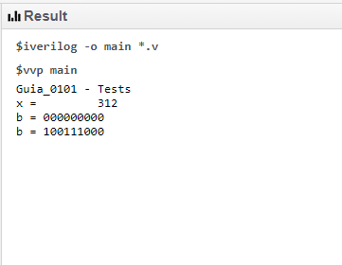

e.) 366(10) = X(2)

/*

Guia_0101.v

*/

module Guia_0101;

// define data

integer x = 366; // decimal

reg [8:0] b = 0; // binary

// actions

initial

begin : main

$display ( "Guia_0101 - Tests" );

$display ( "x = %d" , x );

$display ( "b = %8b", b );

b = x;

$display ( "b = %8b", b );

end // main

endmodule // Guia_0101

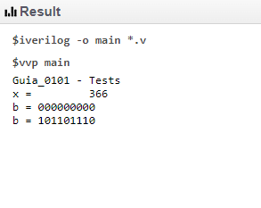

**02.) Fazer as conversões de binário para decimal:**

02a.) manualmente

1. 10101(2) = X(10)

1x2^4 + 0x2^3 + 1x2^2 + 0x2^1 + 1x2^0;

16 + 0 + 4 + 0 + 1

21(10)

1. 11001(2) = X(10)

1x2^4 + 1^2^3 + 1x2^0

16 + 8 + 1

25(10)

1. 101001(2) = X(10)

1x2^5 + 1x^2^3 + 1x2^0

32 + 8 + 1

41(10)

1. 101101(2) = X(10)

1x2^5 + 1x2^3 + 1x2^2 + 1x2^0

32 + 8 + 4 + 1

45(10)

1. 100011(2) = X(10)

1x2^5 + 1x^2^1 + 1x2^0

32+2+1

35(10)

02b.) mediante uso de um programa em Verilog

a)

/*

Guia_0102.v

*/

module Guia_0102;

// define data

integer x = 0; // decimal

reg [7:0] b = 8'b10101; // binary (bits)

// actions

initial

begin : main

$display ( "Guia_0102 - Tests" );

$display ( "x = %d" , x );

$display ( "b = %8b", b );

x = b;

$display ( "b = %d", x );

end // main

endmodule // Guia_0102

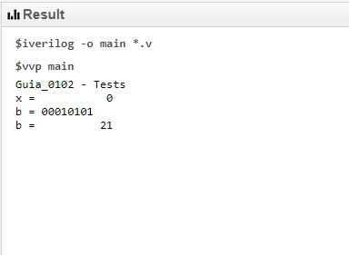

b)

/*

Guia_0102.v

*/

module Guia_0102;

// define data

integer x = 0; // decimal

reg [7:0] b = 8'b11001; // binary (bits)

// actions

initial

begin : main

$display ( "Guia_0102 - Tests" );

$display ( "x = %d" , x );

$display ( "b = %8b", b );

x = b;

$display ( "b = %d", x );

end // main

endmodule // Guia_0102

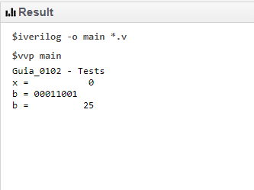

c)

/*

Guia_0102.v

*/

module Guia_0102;

// define data

integer x = 0; // decimal

reg [7:0] b = 8'b101001; // binary (bits)

// actions

initial

begin : main

$display ( "Guia_0102 - Tests" );

$display ( "x = %d" , x );

$display ( "b = %8b", b );

x = b;

$display ( "b = %d", x );

end // main

endmodule // Guia_0102

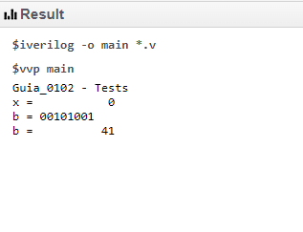

d)

/*

Guia_0102.v

*/

module Guia_0102;

// define data

integer x = 0; // decimal

reg [7:0] b = 8'b101101; // binary (bits)

// actions

initial

begin : main

$display ( "Guia_0102 - Tests" );

$display ( "x = %d" , x );

$display ( "b = %8b", b );

x = b;

$display ( "b = %d", x );

end // main

endmodule // Guia_0102

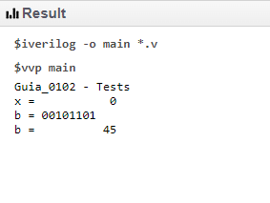

e)

/*

Guia_0102.v

*/

module Guia_0102;

// define data

integer x = 0; // decimal

reg [7:0] b = 8'b100011; // binary (bits)

// actions

initial

begin : main

$display ( "Guia_0102 - Tests" );

$display ( "x = %d" , x );

$display ( "b = %8b", b );

x = b;

$display ( "b = %d", x );

end // main

endmodule // Guia_0102

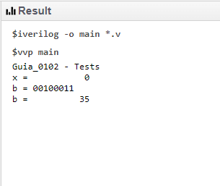

**03.) Fazer as conversões de decimal para a base indicada:**

03a.) manualmente

1. 73(10) = X(4)

73/4 = 18 = 1

18/4 = 4 = 2

4/4 = 1 = 0

1/4 = 0 = 1

1021(4)

1. 47(10) = X(8)

47/8 = 5 = 7

5/8 = 0 = 5

57(8)

1. 61(10) = X(16)

61/16 = 3 = 13

3/16 = 0 = 3

3D(10)

1. 157(10) = X(16)

157/16= 9 = 13

9/16 = 0 = 9

9D(10)

1. 751(10) = X(16)

751/16= 46 = 15

46/16 = 2 = 14

2/16 = 0 = 2

2EF(10)

03b.) mediante uso de um programa em Verilog

a)?

b)

/*

Guia_0103.v

*/

module Guia_0103;

// define data

integer x = 47; // decimal

reg [7:0] b = 0; // binary

// actions

begin : main

$display ( "Guia_0103 - Tests" );

$display ( "x = %d" , x );

$display ( "b = %8b", b );

b = x;

$display ( "b = %B (2) = %o (8) = %x (16) = %X (16)", b, b, b, b );

end // main

endmodule // Guia_0103

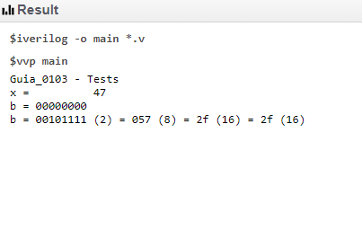

c)

/*

Guia_0103.v

*/

module Guia_0103;

// define data

integer x = 61; // decimal

reg [7:0] b = 0; // binary

// actions

initial

begin : main

$display ( "Guia_0103 - Tests" );

$display ( "x = %d" , x );

$display ( "b = %8b", b );

b = x;

$display ( "b = %B (2) = %o (8) = %x (16) = %X (16)", b, b, b, b );

end // main

endmodule // Guia_0103

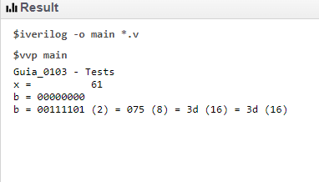

d)

/*

Guia_0103.v

*/

module Guia_0103;

// define data

integer x = 157; // decimal

reg [7:0] b = 0; // binary

// actions

initial

begin : main

$display ( "Guia_0103 - Tests" );

$display ( "x = %d" , x );

$display ( "b = %8b", b );

b = x;

$display ( "b = %B (2) = %o (8) = %x (16) = %X (16)", b, b, b, b );

end // main

endmodule // Guia_0103

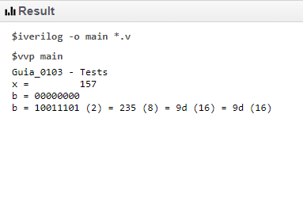

e)

/*

Guia_0103.v

*/

module Guia_0103;

// define data

integer x = 751; // decimal

reg [7:0] b = 0; // binary

// actions

initial

begin : main

$display ( "Guia_0103 - Tests" );

$display ( "x = %d" , x );

$display ( "b = %8b", b );

b = x;

$display ( "b = %B (2) = %o (8) = %x (16) = %X (16)", b, b, b, b );

end // main

endmodule // Guia_0103

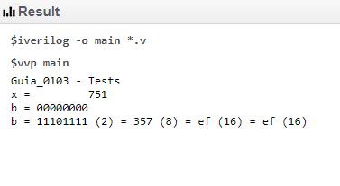

**04.) Fazer as conversões de base entre as bases indicadas por agrupamento:**

04a.) manualmente

1. 10011(2) = X(4)

[01][00][11] =

103(4)

1. 11101(2) = X(8)

[01][11][01]

131(4)

1. 101001(2) = X(16)

[10][10][01]

221(4)

1. 110101(2) = X(8)

[11][01][01]

311(4)

1. 111001(2) = X(4)

[11][10][01]

321(4)

04b.) mediante uso de um programa em Verilog

?

05.) Converter entre símbolos e códigos de representação alfanumérico (ASCII):

05a.) manualmente

1. “PUC-Minas” = X(16_ASCII)

5055432D4D696E6173

1. “2022-1” = X(16_ASCII)

22323032322D3122

1. “Belo Horizonte" = X(2_ASCII)

42656C6F2D486F72697A6F6E7465

1. 124 141 162 144 145(8) = X(ASCII)
2. 42 2E 48 74 65 2E(16) = X(ASCII)

642 3214 648 1124 965 3214

05b.) mediante uso de um programa em Verilog