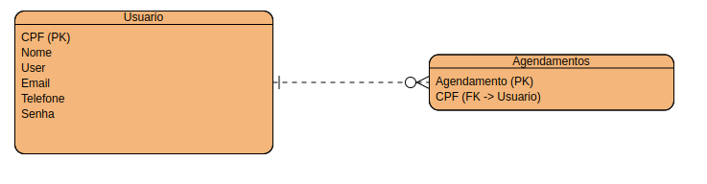

CREATE TABLE usuario (

cpf INT PRIMARY KEY,

nome VARCHAR(100) NOT NULL,

login_usuario VARCHAR(50) NOT NULL UNIQUE,

email VARCHAR(100) NOT NULL UNIQUE,

telefone VARCHAR(20),

senha VARCHAR(20) NOT NULL

);

CREATE TABLE Agendamentos (

agendamento VARCHAR(200) PRIMARY KEY,

cpf int NOT NULL,

FOREIGN KEY (cpf) REFERENCES usuario(cpf) ON DELETE CASCADE

);